

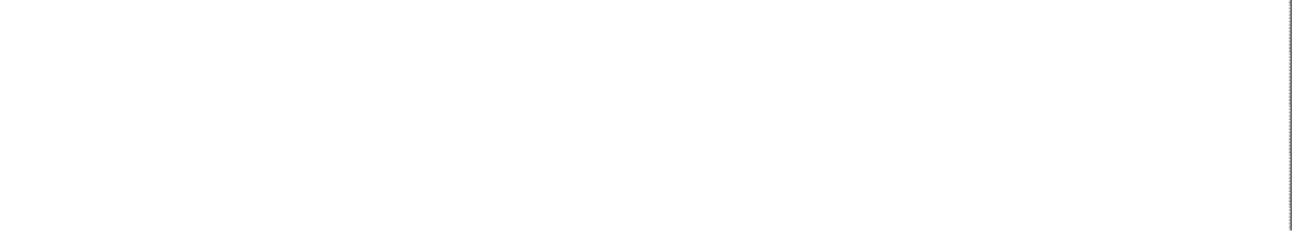
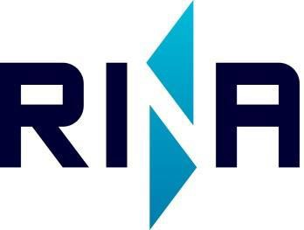

Vidaus vandens kelių direkcija

Supervision during construction of Fuel bunkering unit
No.5

Technical and Economical Offer

Customer | Vi Vidaus vandens kelių direkcija
Customer ref.
Contractor | Rina Netherlands BV
Contractor ref.
Revision | 02
Quotation No. | ANM20220920A1
Date | 20/09/2022
Prepared
Checked
Approved

SCOPE OF THE QUOTATION:

Supervision during construction and classification of “FLOATING FUEL TANK” no.5 at the yard
Vi Vidaus vandens kelių direkcija
. Main characteristics of floating fuel tank
LOA = 5.88 m
B = 3.68 m
D = 2.80 m
Flag: Lithuania
Use: inland navigation.

ECONOMICAL PROPOSAL

Supervision during construction: EUR 7.000,00 per unit

SERVICES INCLUDED

  - Supervision during construction and classification;
  - Survey according to Lithuanian additional requirements;
  - Trials;
  - Issuance of Class, Tonnage certificate and statutory Certificates if applicable;
  - Inclining test approval if required
  - Approval of stability booklet;
  - Tonnage calculation and issuance of tonnage certificate.
  - Travel time fees, travel expenses, lodging and meals and other expenses;

EXCLUSIONS
  - Fees for the certification of materials and components required by Rina rules will be charged separately to the manufacturer according to RINA price list;
  - Revision and approval of documents examined and endorsed as "not approved" as well as re-approval of previously approved documents that have been modified and submitted once again to RINA in any written form;
  - Design and drawings approval if there will be specific and robust modifications to be done;

  - Any additional class notations/statutory documents requested by owner or Flag Administration;
  - Other services which have not been specifically mentioned in point C;
  - Fees for overtime for the attendances expressly requested by the yard on weekends, public holidays and outside the normal office working hours;
  - VAT and any other local taxations, if and as applicable.

TERMS AND CONDITIONS OF PAYMENT
The present offer will be valid 3 months from today.
The amount mentioned in point B will be invoiced as follows:
  - 50% of total amount at order confirmation.
  - 50% of the total amount at delivery.

Payment conditions: within 30 days from invoice date.

GENERAL TERMS AND CONDITIONS – LIABILITY
As far as not specifically provided herein, all the services provided by RINA, including those outside the scope of this agreement, concerning supervision, classification and certification, including extra or accessory services that are not part of services determined in point B) hereto and any other services in favor of Vi Vidaus vandens kelių direkcija shall be performed in compliance with the “Rina Rules for the Classification of Ships” (edition in force and subsequent amendments), which constitutes an integral part of this agreement and which Vi Vidaus vandens kelių direkcija declares it is familiar with and accepts.
In particular, the services provided by RINA and relative liability are subject to the terms and conditions of the “General Conditions” attached to this agreement, which Vi Vidaus vandens kelių direkcija is familiar with and accepts.

Rina Netherlands B.V. Vi Vidaus vandens kelių direkcijais

Pino Spadafora KAUNAS (LT),20/19/2022

