ANNEX 1
to the Contract No. of ______ 2024

TECHNICAL SPECIFICATION FOR A SHIRT OF THE TACTICAL FIELD UNIFORM SUIT

CHAPTER I
GENERAL PROVISIONS

- The Defence Materiel Agency under the Ministry of National Defence (hereinafter referred to as the Contracting Authority) intends to procure Tactical Field Uniform Suit Shirts (hereinafter referred to as the TFU shirts or shirts).
- The shirt must comply with the requirements set out in this Technical Specification.
- The shirt shall be made from a patented concealed (universal) printed fabric (hereinafter referred to as the base fabric), the colours of which are similar to the following colour codes in the PANTONE TEXTILE catalogue, and which, according to the pattern, is grey-green (base) - 13-0607 TP ~ 15% of the area, green 17-0115 TP ~ 30% of the area, brown 17-1417 TP ~ 25% of the area, straw 17-1022 TP ~ 20% of the area, khaki 16-0730 TP ~ 10% of the area, and a monochrome straw colour knitted fabric in a colour similar to the colour code in the PANTONE TEXTILE catalogue - 17-1022 TP.
- The Contracting Authority shall provide the Supplier with basic fabric to be collected by the Supplier from the designated Lithuanian Armed Forces warehouse in Lithuania (fabric shall be issued in accordance with agreed and approved basic fabric consumption rates). All other materials required for the production of the shirts shall be provided by the Supplier.
- The fabrics used for the shirts must comply with minimum environmental criteria set out in Chapter IX “Textiles” of the Description of the Procedure for the Application of Environmental Criteria in the Conduct of Green Procurement, Annex 2 to the Order No. D1-401 of the Minister of the Environment of the Republic of Lithuania of 13 December 2022, “On the Amendment of the Order No. D1-508 of the Minister of the Environment of the Republic of Lithuania of 28 June 2011 “On the approval of the list of products for the procurement and purchase of which environmental criteria are applicable, the list of environmental criteria and the description of the procedure for the application of the environmental criteria to be applied by contracting authorities and contracting entities for the purchase of goods, services or works””.
- The sizes of shirts required for soldiers are given in Table 1, which is based on the size system adopted by the Lithuanian Armed Forces. If necessary, non-standard sizes may be requested up to a maximum of 2 % of the quantity ordered.

Table 1
SHIRT SIZE CHART
Height, cm | Chest circumference, cm
Height, cm | 84 | 88 | 92 | 96 | 100 | 104 | 108 | 112 | 116 | 120 | 124
158 | x | x | x | x | x
164 | x | x | x | x | x | x | x | x | x
170 | x | x | x | x | x | x | x | x | x
176 | x | x | x | x | x | x | x | x | x | x | x
182 | x | x | x | x | x | x | x | x | x | x | x
188 |  | x | x | x | x | x | x | x | x | x | x
194 |  | x | x | x | x | x | x | x | x | x | x
200 |  |  |  | x | x | x | x | x | x | x | x
206 |  |  |  | x | x | x | x | x | x | x | x

- The shirt is made for men. The design of the products shall be based on LST ISO 8559-1 (ISO 8559-1) or an equivalent standard. The shirt shall be designed to ensure a proper fit to the soldier’s body when wearing the field uniform layer system and shall not restrict the soldier’s movement.
- The warranty period for the quality of the products shall be 12 months under active service conditions from the date of issue of the goods from the Buyer’s warehouse and 24 months from the date of the signing of the documents of acceptance of the goods into the warehouse.

CHAPTER II
TECHNICAL REQUIREMENTS

- The design of the shirt is set out in sketches 1 to 3 of the Annex (hereinafter referred to as the Annex) to the technical specification. The dimensions of the sketches are given in centimetres.
- The measurements given in the description and sketches are for a basic size: 188 cm tall, 100 cm chest circumference, 88 cm waist circumference.
- The basic dimensions and tolerances for the basic dimensions of the standard size shirts are given in Table 2:
Table 2
TABLE OF BASIC DIMENSIONS FOR STANDARD SIZES OF TFU SHIRTS
Seq. No. | Name of dimension, area of measurement | Value, cm | Tolerance,  ± cm
1. | Mid-back length (measured from the collar seam to the bottom) | 79,0 | 1,0
2. | Front length (measured from the intersection of the collar and sleeve at the front to the bottom) | 76,0 | 1,0
3. | Chest circumference ½ (measured at the armpits) | 56,0 | 1,0
4. | Waist circumference ½ (measured at 48 cm from the mid-back of the collar) | 50,0 | 1,0
5. | Bottom width ½ | 52,0 | 1,0
6. | Length of sleeve (measured from collar seam to hem) | 82,0 | 1,0
7. | Sleeve width at top ½ (measured at the armpits) | 24,0 | 0,5
8. | Sleeve width at elbow ½ ((measured 28 cm from the bottom) | 21,0 | 0,5
9. | Sleeve width at bottom ½ | 18,5 | 0,5
10. | Collar length ½ (Measure from mid front to mid back, along the seam of the collar) | 23,5 | 0,5
Note: A table with dimensions for all sizes will be agreed with the successful tenderer.

- Unless otherwise specified in Table 2 and in the technical specification, a tolerance of 4 % of the specified dimensions shall be allowed for dimensions up to and including 10 cm, and a tolerance of 2 % of the specified dimensions shall be allowed for dimensions above 10 cm.
- The main parts of the shirt must be cut in one direction.
- Shades of details are not allowed in products.
- The pockets must have angels sewn into them for water drainage.
- The stitch density and seam allowances of the stitches shall ensure that the quality of the product is maintained during its service life.
- All internal seams and edges of the shirt must be finished to prevent fraying.
- The quality of the sewing of the shirt must be such that there is no shrinkage of the seams and/or hems, no warping of the seams and/or hems, no missing, thickened, thinned and/or incorrectly tightened stitches, no broken sewing/hem threads, no tightening of the material, no disintegration of the seams and/or hems at the edges of the details as a result of the lack of anchorage, no damage to the material with the needle of the sewing machine, and so on.
- The seams of the products shall be taped in accordance with the sketches. For single finishing seams (unless otherwise specified in the requirements below), the seam shall be sewn 0,1-0,2 cm from the seam. For double finishing seams, the first finishing seam shall be stitched 0,1-0,2 cm from the seam and the second seam shall be stitched 0,5-0,6 cm from the first seam.
- The paired parts shall be symmetrically arranged.
- Process residues (yarns, fluff, etc.) must be cleaned from the shirt and the products must be neatly ironed.

SECTION ONE
REQUIREMENTS FOR MATERIALS
- The shirt shall be made of a printed all-purpose fabric with a concealed universal print and a cross-knit double-faced interlock knitted single-colour knitted fabric, in a straw colour close to the colour code in the PANTONE TEXTILE catalogue - 17 - 1022 TP. The technical characteristics of the knitted fabric are given in Table 3.
Table 3
TECHNICAL CHARACTERISTICS OF KNITTED FABRIC FOR SHIRTS

Seq. No. | Name of indicator,  dimension | Indicator value | Test method identifier
1. | Fibre composition, % | 100 % Polyester | specify
2. | Surface density g/m² | 220,0 + 20,0/ -10,0 | LST EN 12127 or LST ISO 3801, or equivalent
3. | Dimensional variation after washing and drying (transverse and longitudinal directions), % | Not more than ± 5,0 | LST EN ISO 5077or equivalent
4. | Paint resistance, scores
4.1. | - for dry abrasion | ≥ 4 | LST EN ISO 105-X12,-X16 or equivalent
4.2. | - for wet abrasion | ≥ 3 | LST EN ISO 105-X12,-X16 or equivalent
4.3.  4.4. | - for washing at 40ºC  - for sweat | ≥ 4  ≥ 4 | LST EN ISO 105-C06 or equivalent  LST EN ISO 105-E04 or equivalent
5. | Tendency to fluff and lint (after 2 000 revolutions), degree | ≥ 4 | LST EN ISO 12945-2 or equivalent
6. | Wear resistance, 9kPa, pumps | ≥ 30 000 | LST EN ISO 12947-2 or equivalent
7. | Colour differences, Δ E_{CMC} | ≤ 1,5 | LST EN ISO 105-J03 or equivalent
Notes:
- For tests 3 and 4.3, the washing and drying procedures according to LST EN ISO 6330 (or equivalent) shall be laundering 4N, drying method F. The labelling shall specify washing in automatic washing machines (at a temperature of not less than 40 °C) and tumble drying.
- For indicator 4.3, colour change shall be assessed after 5 washing cycles.
- Indicator 5 applies to both sides of the knitted fabric.
- Indicator 7 “colour difference” Δ E_{CMC} is required during contract performance and defines the permissible colour deviation from the colour of the agreed working sample.

- The textile velcro fasteners shall be non-slip and shall comply with the indicators given in Table 4. All cut edges of the buckle textile fastenings shall be machined to prevent fraying.

Table 4
TECHNICAL CHARACTERISTICS OF TEXTILE VELCRO FASTENERS

Seq. No. | Indicator | Measuring units | Characteristics | Test method identifier
1. | Surface density  soft side (loops)  coarse (hooks) | g/m ² | 340±10  320±10 | LST ISO 3801 or LST EN 12127 or equivalent
2. | Dimensional change after washing and drying | % | ≤ 2 | LST EN ISO 5077 or equivalent
3. | Colour resistance to washing  (discolouration and repainting of material) | scores | ≥ 4 | LST EN ISO 105-C06 or equivalent
4. | Resistance to staining  for dry abrasion  for wet abrasion | scores | ≥ 4  ≥ 3 | LST EN ISO 105-X12 or equivalent
5. | Shear force:  Original  after 5000 open-close cycles | N/cm | ≥ 8  ≥ 4 | LST EN 13780 or equivalent
6. | Separating force:  Original  after 5000 open-close cycles | N/cm | ≥ 1,3  ≥ 0,65 | LST EN 13780 or equivalent

- The zipper must be a spiral zipper that matches the colour of the knitted fabric. The width of the tooth track of the fasteners shall be 0,6 (±0,05) cm when fastened. Zippers shall comply with the specifications given in Table 5.

Table 5
TECHNICAL CHARACTERISTICS OF ZIPPERS
Seq. No. | Name of indicator, dimension | Indicator value | Test method identifier
1. | Lock pendant breaking strength, N | ≥ 250 | LST EN 16732 (EN 16732), Annex B or equivalent
2. | Top braking force, N | ≥ 110 | LST EN 16732 (EN 16732), Annex D or equivalent
3. | Number of clasp-unclasp (open-close) cycles without failure, cycles | ≥ 500 | LST EN 16732 (EN 16732), Annex F or equivalent
4. | transverse strength of the tooth track, N | ≥ 370 | LST EN 16732 (EN 16732), Annex G or equivalent
5. | locking strength of the lock, N | ≥ 40 | LST EN 16732 (EN 16732), Annex I or equivalent
6. | dimensional change after washing*, % | ≤ ± 2 | LST EN ISO 5077 (ISO 5077) or equivalent
7. | Paint resistance, points
7.1. | for artificial light | ≥ 5 | LST EN ISO 105-B02 (ISO 105-B02) or equivalent
7.2. | for washing* | ≥ 4 | LST EN ISO 105-C06 (ISO 105-C06) or equivalent
7.3. | for dry abrasion | ≥ 4 | LST EN ISO 105-X12,-X16 (ISO 105-X12,-X16) or equivalent
7.4. | for wet abrasion | ≥ 3 | LST EN ISO 105-X12,-X16 (ISO 105-X12,-X16) or equivalent
- A holder made of a flat textile strip 1,0 (±0,1) cm wide is attached to the head of the zipper for faster unzipping. To form the holder, the strip shall be placed on the pendant of the zip fastener and the ends of the strip shall be sewn together so that the ends of the strip remain inside the holder.
- The adhesive liner used to reinforce the fittings shall be such as to ensure the necessary rigidity of the fittings and reliable adhesion after repeated washing.
- Sewing/stitching thread - reinforced polyester or at least inferior quality, non-fading. The thickness of the yarn and the density of the stitches must ensure the strength of the seam (tensile, abrasion, washing resistance). The ends of all seams/stitches must be anchored.
- The colour of the threads used for the stitching of the shirt shall be the colour of the main fabric straw, while the colour of the other sewing/hemming threads used in the manufacture of the TFU suit shall be matched to the colour of the materials being sewn/hemmed. Unless otherwise specified in the technical specification, all other fittings used in the tailoring of the printed garments (textile snaps, zippers, textile strips and bands) shall be close to the colour code 18-0617 TP (Covert Green) in the PANTONE TEXTILE catalogue and shall be of a colour code which will give reliable service during use.
- The colours of the materials used to make the shirts shall be matched at the time of fitting the working sample.
- All the materials used to make the shirts must be machine washable (at least 40º C) and drum dryable.

SECTION TWO
REQUIREMENTS FOR THE SHIRT MODEL

- The shirt shall be a fitted shirt with raglan sleeves and a front zip fastening.
- The front, back, sleeve and underarm sleeve details, the inside of the collar and the hem of the zipper shall be cut from knitted fabric. The sleeves and the outer collar detail of the reglan sleeves and collar shall be made of top fabric.
- The collar of the shirt shall be a steep, evenly curved collar, the outer part of the shirt being cut from the top fabric and the inner part from knitted fabric. The outer part shall be covered with an adhesive liner which shall ensure the stability of the shape of the collar. The height of the collar shall be 6 cm at the front fastening and 8,5 cm at the middle of the back in the basic size (sketch 1). The upper edge of the collar is edged with a 0,6 to 0,7 mm wide grey patch and the lower edge with a 0,2 (± 0,1) cm wide grey patch.
- On the inside of the shirt, in the collar seam, there shall be a suspension sewn in from the top fabric.
- Front fastening length shall be 22 (± 0,5) cm. The clasp is finished with a 0,2 (± 0,1) wide stitch.
- At the bottom of the clasp there shall be a double top piece of 1,5 ± 0,1 cm high (sketch 1).
- The zipper must be completely covered on the inside of the product by double knitted fabric trimmings (sketch 1). At the top of the zipper, the corners of the trimmings shall be folded over to the right side of the product so as to cover the zipper and prevent the zipper from coming into contact with the skin. The edges of the hem shall be hemmed to prevent fraying. The knitted hem of the zipper and the top fabric piece at the bottom of the fastening shall be fastened together with a stitch.
- The sleeves must have slanted double patch pockets with flaps (sketch 2). The distance between the highest corner of the pocket and the shoulder seam shall be 20 ± 0,2 cm:
  - Width of the pocket (measured with the pocket not tilted) 15 ± 0,2 cm, height 17,5 ± 0,2 cm, depth 2,5 ± 0,1 cm.
  - There shall be another pocket sewn on the top of the pocket, the width of which shall be the same as the width of the bottom pocket and the height of which shall be 15 ± 0,2 cm.
  - The top edges of the pockets shall be sewn with a closed seam:
    - lower pockets 2,5 ± 0,2 cm wide;
    - upper pockets 1 ± 0,2 cm wide.
  - A rectangular piece of 10 x 13 (± 0,2) cm (± 0,2 cm) velcro fastening loops shall be sewn on the upper pocket.
  - On the upper edge of the lower pocket there shall be sewn two small velcro pieces of 2,5 X 2,5 (± 0,2) cm, spaced 5 (± 0,2) cm apart.
  - Dimensions of the flap: 16 x 7 (± 0,5) cm (see sketch 2).
  - The parts of the velcro fastening hooks sewn to the inner side of the flap shall be 2,5 x 4,5 (± 0,2) cm, with a distance of 5 (± 0,2) cm between them. On the top of the cap, one part of the velcro fasteners shall measure 10 x 5 (± 0,2) cm.
  - A 2,5 ± 0,2 cm (0,5 ± 0,2 cm) unstitched opening shall be made in the seam of the flap pocket on the left sleeve, the edges of which shall be reinforced with a gusset.
  - Left sleeve pocket with additional pen pocket. Dimensions of the pocket 13,5 ± 0,2 cm x 2,5 ± 0,2 cm. The top edge of the pocket shall be sewn with a 1 ± 0,2 cm wide closed seam.
- The TFU shirt shall have a pocket in the elbow area for the insertion of protective equipment (inserts). This is a spatial design (see sketch 3), replicating the shape of the liner:
  - The stripe shall be attached at a slight angle - the distances of the lower corners of the stripe from the bottom of the sleeve may vary. (sketch 3).
  - The seam of the sleeve stripe allowance shall be 0,2 (± 0,1) cm wide, the bottom edge shall not be sewn in, and shall be fastened with a velcro fastener, sewing the coarse (hook) side to the sleeve and the soft (eyelet) side to the stripe part.
- The sleeve shall have a folded hem and shall be sewn with a closed seam 5 ± 0,2 cm wide.
- To adjust the width of the sleeve at the bottom, a ribbon is sewn into the front seam of the sleeve (sketch 1):
  - the button tab shall be detached with a 0,5 ± 0,2 cm wide stitch;
  - for loose fitting of the button tab end to the sleeve, with shaped, flexible textile fastenings:
    - a rough side (with hooks) of a rectangular (4,5 ± 0,2 x 2,5 ± 0,2 cm) textile velcro fastener sewn to the inner side of the button tab;
    - a rectangular (2,5 ± 0,2 x 20 ± 0,2 cm) soft side (with eyelets) of the rectangular, velcro textile fastening sewn to the sleeve. The textile fastening shall be zigzag stitched to the strap for a tighter fit.
- To reduce the circumference of the sleeve, the 11 cm trapezoid-shaped (~ 5 x 10 cm) velcro fasteners are sewn from the bottom of the sleeve as shown in sketch 1. The size and sewing position of these details are finalised during the fitting of the working sample.
- The hem of the blouse is inclined by 2,5 ± 0,2 cm and sewn with a flat seam machine.

CHAPTER III
APPROVAL OF WORKING SAMPLES
- After the contract has been concluded, working samples are coordinated and approved in accordance with the sample held by the Lithuanian Armed Forces (the working samples must be identical to the Lithuanian Armed Forces samples in terms of construction and sewing technology).
- The following shall be delivered for the approval of the working sample:
  - two identical products (basic size);
  - table of measurements for alignment;
  - product care instructions for alignment (to be attached to each product);
  - a technical description of the product (with samples of the materials used in the manufacture of the product and the characteristics proving their conformity with the requirements laid down in the technical specification).
- If necessary, adjustments may be made to the product's dimensions, sewing technology, etc., during the course of the fitting process, as long as they do not impair the product’s appearance or functional characteristics.
- Mass production is only allowed to start after approval of working samples.
CHAPTER IV
LABELLING AND PACKAGING
- The labelling of the products shall comply with the requirements of the Rules for the Labelling and Pricing of Items (Goods) Sold in the Republic of Lithuania, approved by Order No. 170 of the Minister of Economy of the Republic of Lithuania of 15 May 2002 “Approval of the Rules for the Labelling and Pricing of Items (Goods) Sold in the Republic of Lithuania” (the current version or the relevant amending legal act, if any, as adopted), as well as with the requirements set out in this Technical Specification.
- On the inside of each product (location to be agreed at the time of fitting of the working sample), a marking strip shall be sewn on, stating:
- the name or brand of the service provider;
- the manufacturer’s name or brand (if different from the service provider);
- product name;
- fibre composition;
- size;
- date and number of the contract;
- the batch and consignment index;
- batch index of the main fabric;
- date of manufacture;
- maintenance symbols (in accordance with LST EN ISO 3758 (ISO 3758) or equivalent standard);
- sign “Wash without optical brighteners”;
- sign “Made for Lithuanian Armed Forces”.
- The labelling of the products must specify machine washing (at least 40º C) and tumble drying. The labelling strip may additionally contain other information which the service provider considers that every consumer should be aware of.
- The labelling strips shall be made of satin ribbon or equivalent (the edges of the strip must not be sharp). The information on the marking strip shall be easily legible throughout the life of the product.
- Each product shall bear a label stating:
- the name or brand of the service provider;
- the manufacturer’s name or brand (if different from the service provider);
- for imported goods, the country of origin of the goods, if this is not the same as the country in which the manufacturer is registered;
- product name;
- size;
- date and number of the contract;
- the batch and consignment index;
- date of manufacture;
- NSN code issued by the Lithuanian Armed Forces.
- Labels must be securely affixed and the labelling details must be of sufficient size to allow easy reading and understanding of the information provided. The location of the labels must be such that the label can be easily read when the product is packed in a polythene bag.
- Each product must be accompanied by a maintenance manual in Lithuanian. The instructions may be attached to the product or may be provided by a QR code on a marking strip (or on a separate strip attached to the product)
- The blouses shall be individually packed in polythene bags and placed in sturdy cardboard boxes (resistant to long storage and multiple shipments) according to the sizes and quantities agreed between the parties.
- The trousers shall be individually packed in polythene bags and placed in sturdy cardboard boxes (resistant to long storage and multiple shipments) according to the sizes and in quantities agreed by the parties.
- Product packaging must comply with the minimum environmental criteria set out in Annex 2 of the description of the procedure for the application of environmental criteria in the context of green procurement, approved by the Order No. D1-401 of the Minister of the Environment of the Republic of Lithuania of 13 December 2022, “Regarding the Order No. D1-508 “On the approval of the list of products for the procurement and purchase of which environmental criteria are applicable, the list of environmental criteria and the description of the procedure for the application of environmental criteria to be applied by contracting authorities and contracting entities in the procurement of goods, services or works” of the Minister of the Environment of the Republic of Lithuania of 28 June 2011, Chapter II, “Packaging”.
- The weight of carton boxes containing the products must not exceed 10 kg. Each carton box must be labelled with the following clearly visible particulars:
- the name or brand of the service provider;
- the manufacturer’s name or brand (if different from the service provider);
- for imported goods, the country of origin of the goods, if this is not the same as the country in which the manufacturer is registered;
- product name;
- size;
- quantity;
- contract date and number;
- batch and consignment index;
- date of manufacture;
- NSN code issued by the Lithuanian Armed Forces.
CHAPTER V
ACCEPTANCE OF PRODUCTS
- Products are accepted in batches and consignments. Each batch of goods shall be marked with a contractual mark and shall be accompanied by a declaration of conformity of the goods in accordance with form A.2 of LST EN ISO/IEC 17050-1 (ISO/IEC 17050-1), or an equivalent standard.
- The Buyer checks the quality of the goods from the selected batch in accordance with the terms of the contract and may carry out laboratory tests. In the event that the results obtained do not comply with the requirements set out in the technical specification or with the working samples, the entire batch of goods delivered at that time shall be subject to defects.
TACTICAL FIELD UNIFORM SUIT SHIRT
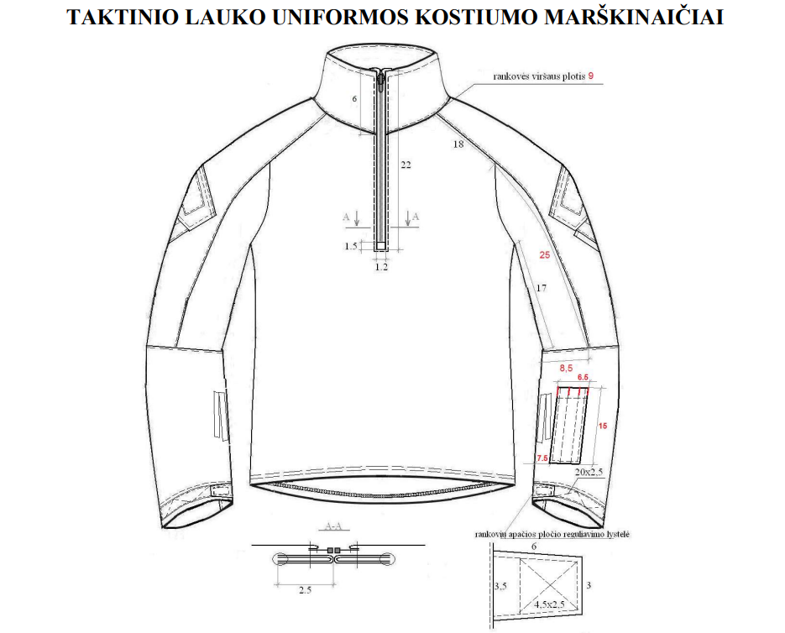
sleeve hem width adjustment tab
width of top of sleeve
width of top of sleeve

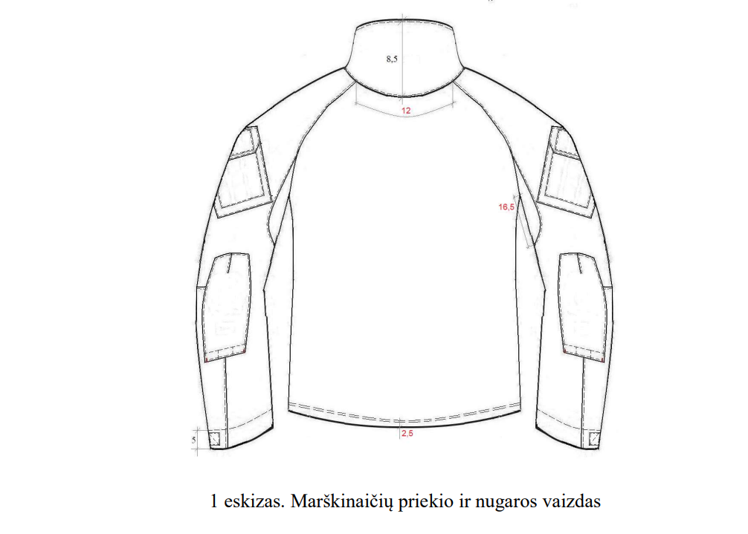
Sketch 1. Front and back view of shirt

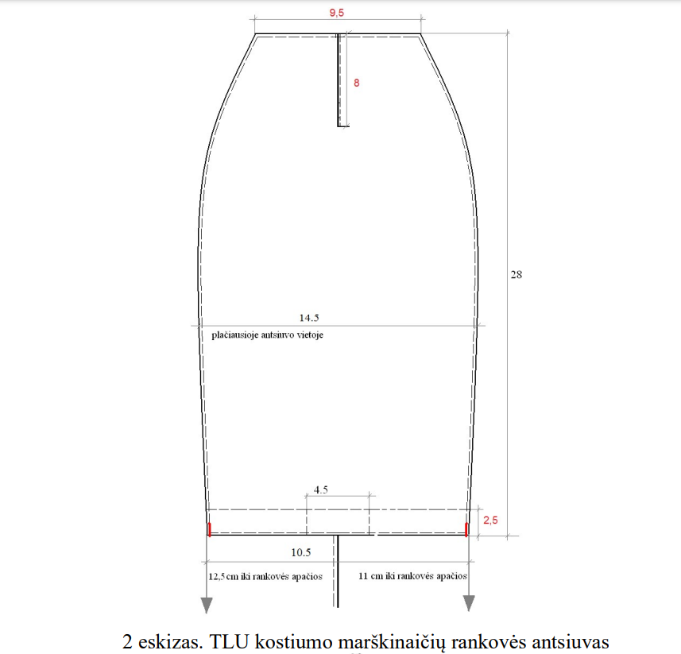
11 cm to the bottom of the sleeve

Sketch 2. TFU suit shirt sleeve stripe
12,5 cm to the bottom of the sleeve
at the widest point on the stripe

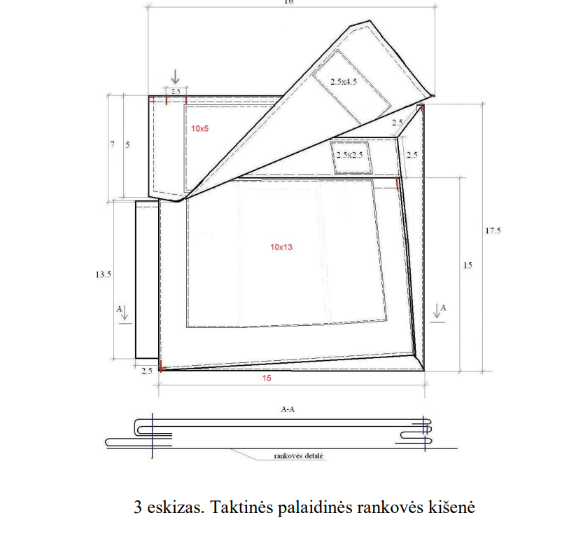
Sketch 3. Tactical shirt sleeve pocket
sleeve detail

