Perversmas kompozitų pasaulyje-viena spalva visai spalvų gamai!!!!

Omnichroma

https://www.tokuyama-us.com/omnichroma-dental-composite/

https://tokuyama-dental.de/en/shop/composite/10112-omnichroma

https://tokuyama-dental.de/en/shop/composite/10113-omnichroma-blocker

One Shade
OMNICHROMA offers a single shade of composite that matches every tooth from A1 to D4 and beyond.
OMNICHROMA follows a standard, easy-to-use procedure for most cases. While opaque-white before curing, OMNICHROMA becomes natural in appearance and matches the color of the surrounding tooth after light curing.
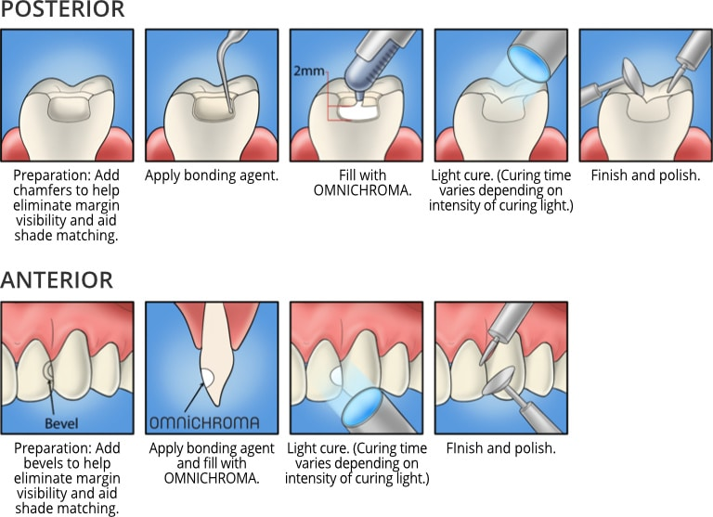
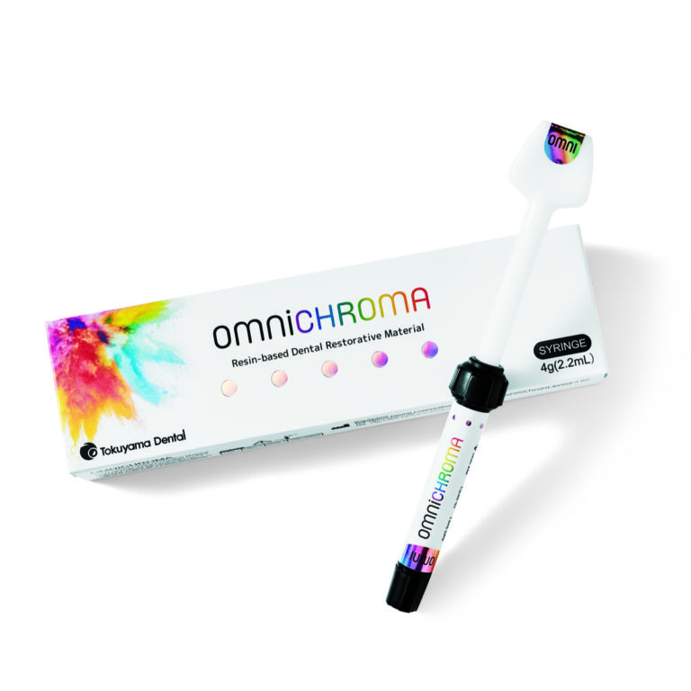

For Large Anterior Cases:
For use with large and extensive anterior cases, Tokuyama offers OMNICHROMA BLOCKER, a supplementary material to be used in conjunction with OMNICHROMA for the direct restoration of extensive Class III and IV cavities.
OMNICHROMA BLOCKER can be used as a lingual layer to prevent shade-matching interference in these cases. OMNICHROMA BLOCKER can also be used to mask slight staining, or to reconstruct a highly opaque tooth.
