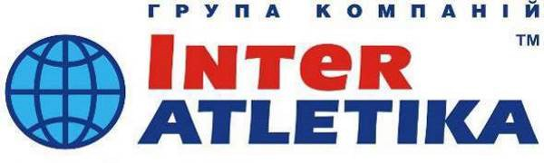

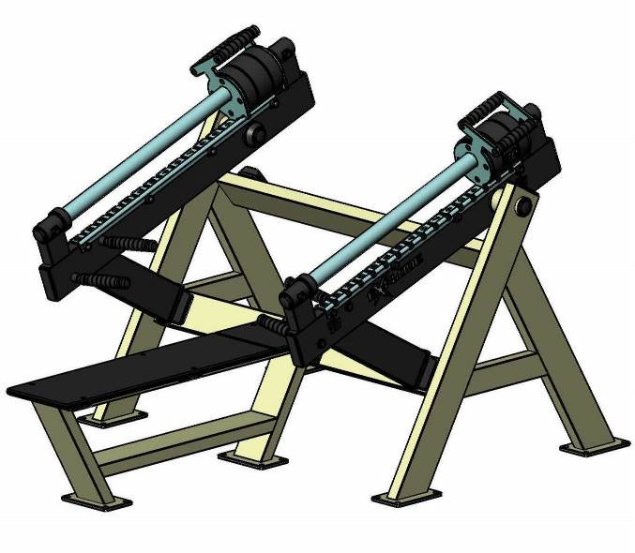
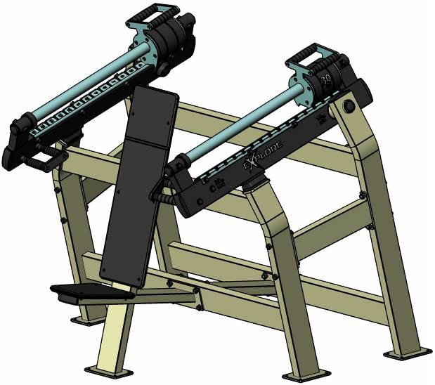
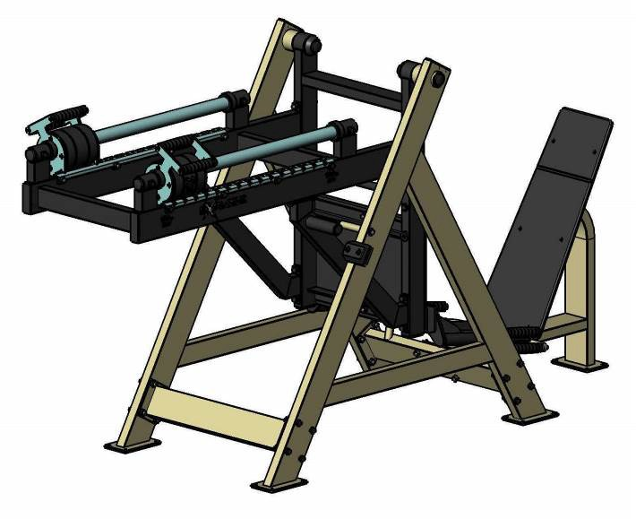
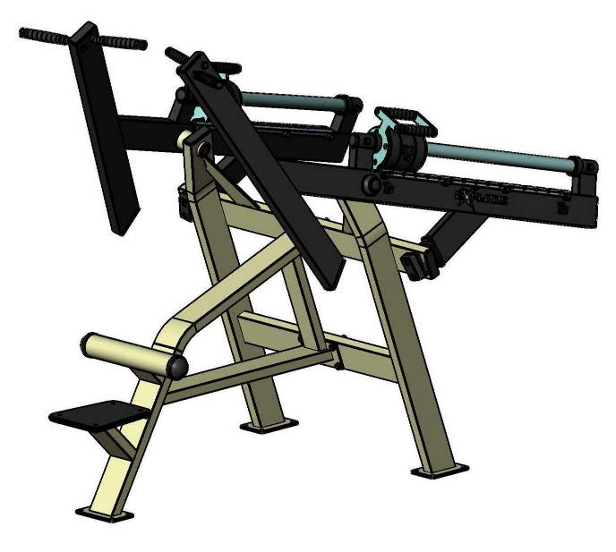
Production and sales of sport goods
export.interatletika.com

KF800-S (-ZEC) outdoor machines
DATA SHEET

1. SPECIFICATIONS

Technical features

No | Art. No | Description | Dimensions, mm |  |  | Weight, kg2 | Fall height, мм | Loading unit, kg | Loading min., kg | Loading max., kg
No | Art. No | Description | Length, mm | Width, mm | Height1, mm
1 | KF801-S | Supine press (prone position) | 2380 | 1450 | 1220 | 203 | 400 | 2х30 | 2х10 | 2х35
2 | KF802-S | Incline press | 1600 | 1630 | 1500 | 238 | 450 | 2х30 | 2х11 | 2х37
3 | KF803-S | Leg press | 2846 | 938 | 1571 | 285 | 280 | 2х30 | 100 | 150
4 | KF804-S | Rowing machine | 1714 | 1222 | 1103 | 186 | 640 | 2х30 | 2х20 | 2х50
5 | KF805-S | Lat pull down machine | 2240 | 1450 | 1910 | 215 | 415 | 2х30 | 2х10 | 2х40
6 | KF806-S | Deadlift | 2390 | 1718 | 1194 | 294 | 0 | 4х30 | 45 | 80
7 | KF807-S | Squat machine | 1514 | 1508 | 1403 | 218 | 0 | 2х30 | 40 | 80
8 | KF808-S | Butterfly machine | 2190 | 2140 | 640 | 216 | 400 | 2х30 | 2х8 | 2х15
9 | KF809-S | Deltoid machine | 858 | 2160 | 1580 | 220 | 0 | 2х30 | 2х5 | 2х10
10 | KF810-S | Biceps machine | 1180 | 1230 | 1050 | 128 | 0 | 30 | 10 | 30
11 | KF811-S | Triceps Dip | 2570 | 1000 | 1140 | 226 | 510 | 2х30 | 2х15 | 2х40
12 | KF812-S | Leg extension | 1437 | 1621 | 1362 | 248 | 610 | 2х30 | 2х10 | 2х25
13 | KF813-S | Leg curl | 1335 | 1782 | 1538 | 215 | 180 | 2х30 | 2х10 | 2х25
14 | KF814-S | Pull-up/Dip/Abdominal Combo | 1590 | 1080 | 2485 | 130 | 1400 | - | - | -
15 | KF815-S | Scott Bench with dumbbells and bench (10-16-24 kg) | 1894 | 2365 | 1055 | 196 | 400 | 2х10-2  х16-2х 24 | 2х10-2  х16-2х 24 | 2х10-2  х16-2х 24
16 | KF815.1-S | Scott Bench with dumbbells (10-16-24 kg) | 750 | 2365 | 1055 | 176 | 0 | 2х10-2  х16-2х 24 | 2х10-2  х16-2х 24 | 2х10-2  х16-2х 24
17 | KF816.3-12 3-S | Hyperextension/Abdominal/Abdo minal reverse | 2846 | 1250 | 1086 | 109 | 920 | - | - | -
18 | KF817-S | Adductor machine | 2155 | 1641 | 1617 | 194 | 310 | 30 | 10 | 45
19 | KF818-S | Abductor machine | 2469 | 1321 | 1617 | 196 | 310 | 30 | 10 | 45
- – Height above ground level (surface).
- – Weight of galvanized machines (ZEC) is 3% bigger.

Maximum user’s weight | Kg : | 150
Working temperature | Со : | від -20 до +30
User’s category  Country of origin | cm :  ---- : | from 130  Ukraine

Supine press (prone position)

KF801-S Incline press KF802-S

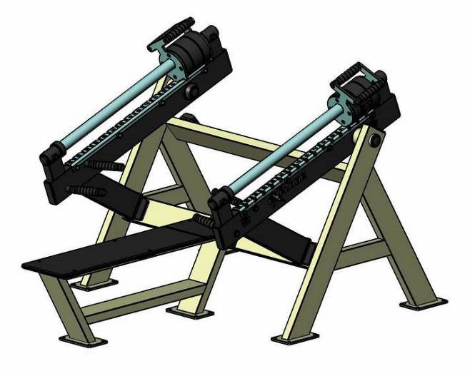
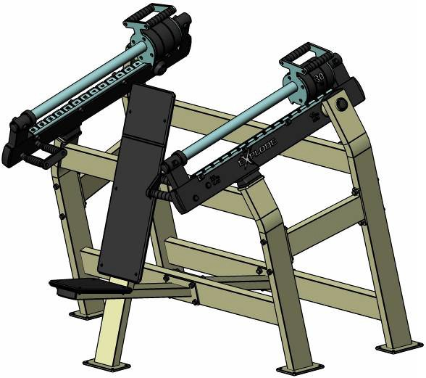
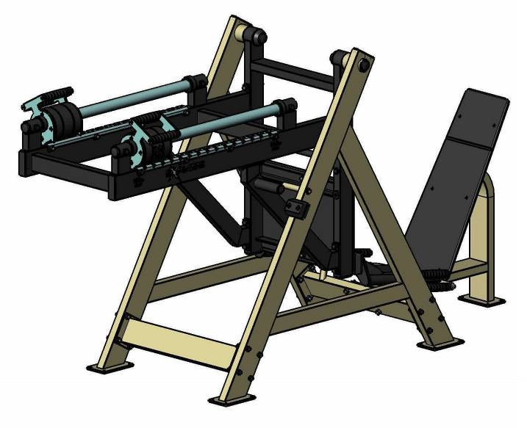
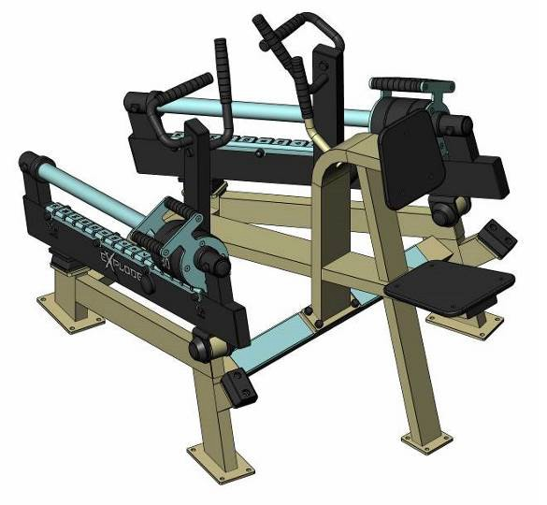
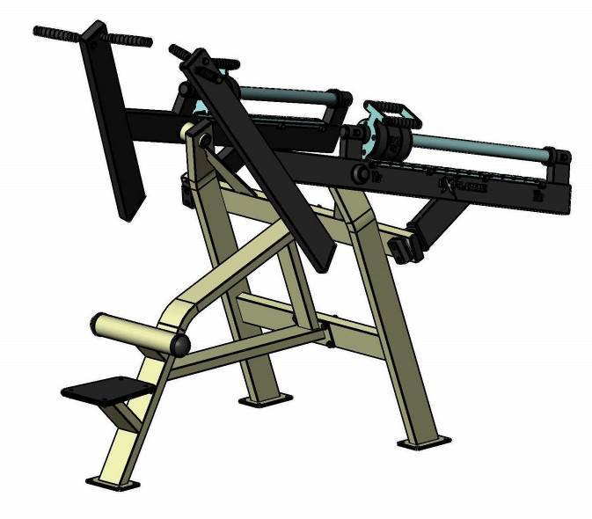
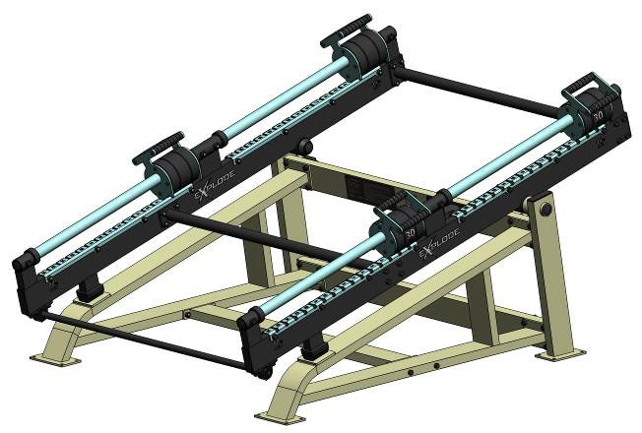

Leg press KF803-S Rowing machine KF804-S

Lat pull down KF805-S Deadlift KF806-S

Squat machine | KF807-S
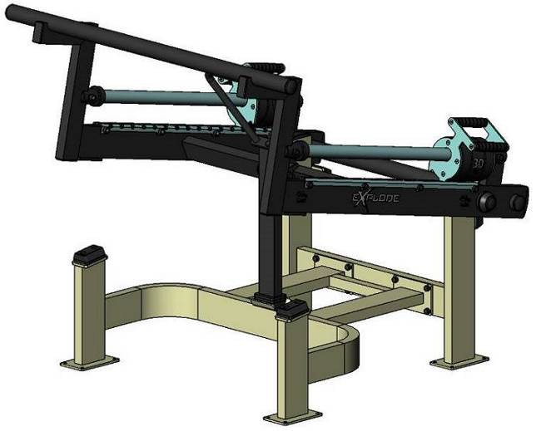

Butterfly machine | KF808-S | Deltoid machine | KF809-S
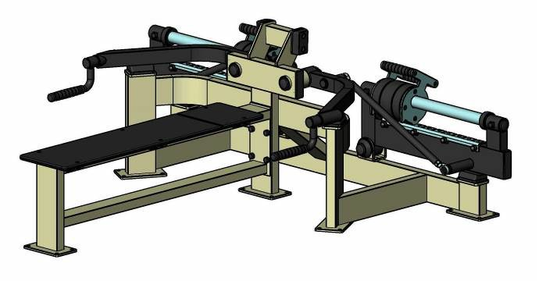 |  | 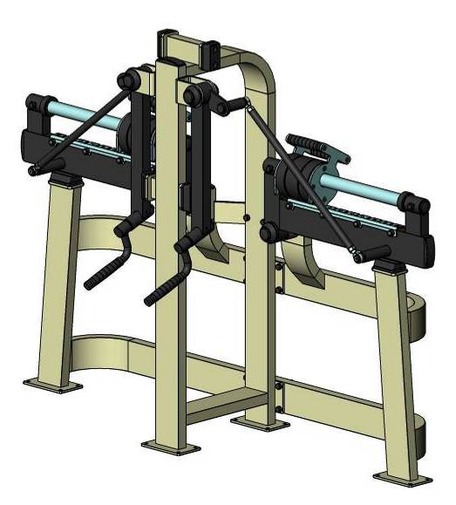
Biceps machine | KF810-S | Triceps machine |  | KF811-S
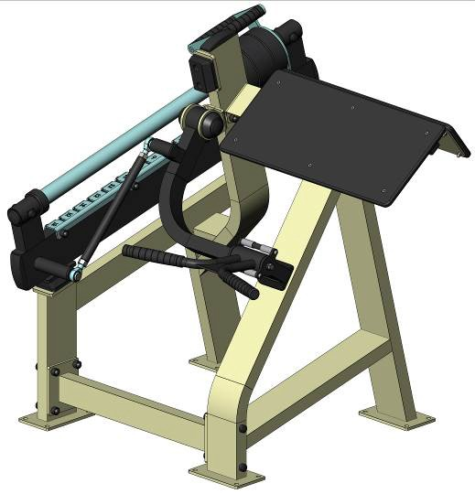 |  | 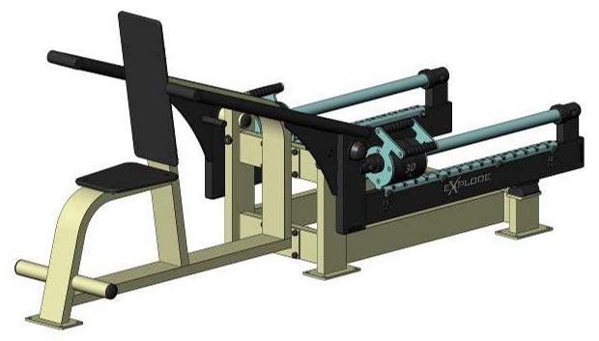

Leg extension KF812-S Leg curl KF813-S

Pull-up/Dip/Abdominal Combo
KF814-S Scott Bench with dumbbells and bench (10-16-24 kg)

KF815-S

Scott Bench with dumbbells
(10-16-24 kg) KF815.1-S

Hyperextension/Abdominal
/Abdominal reverse KF816.3-123-S

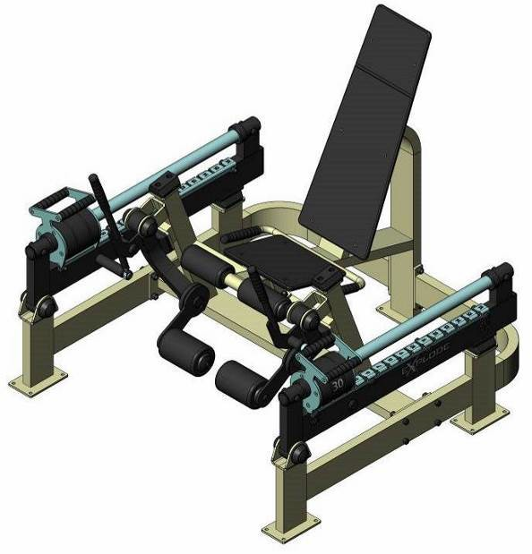
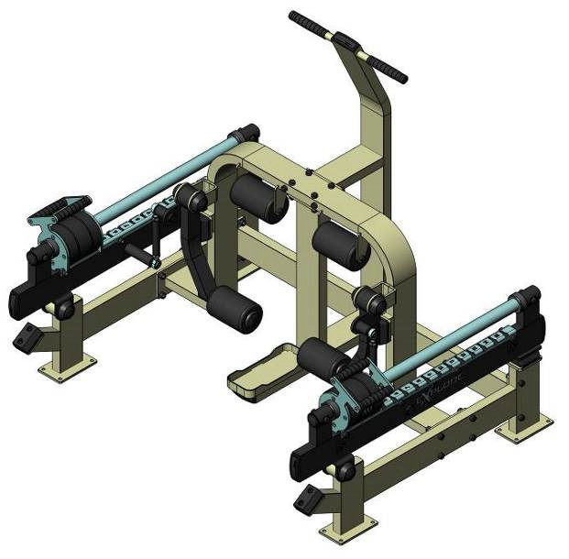
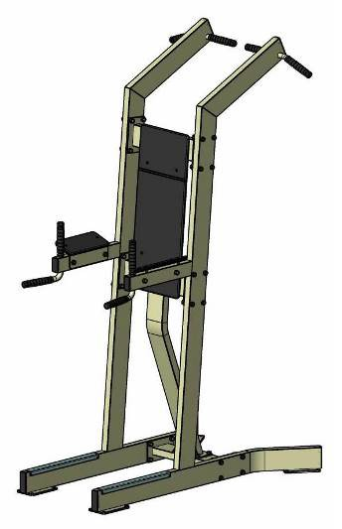
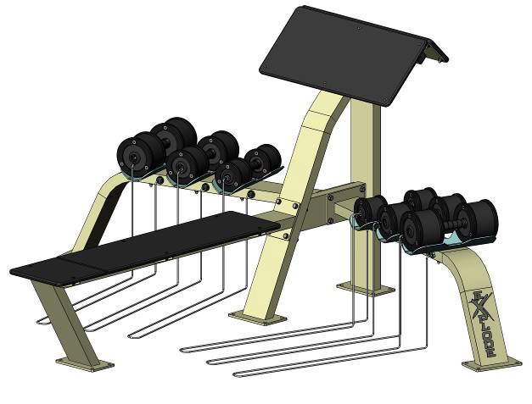
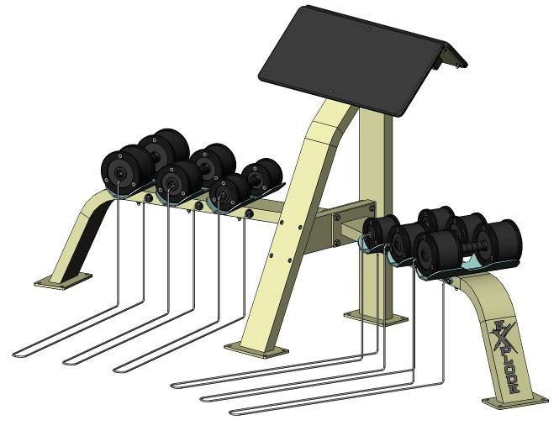
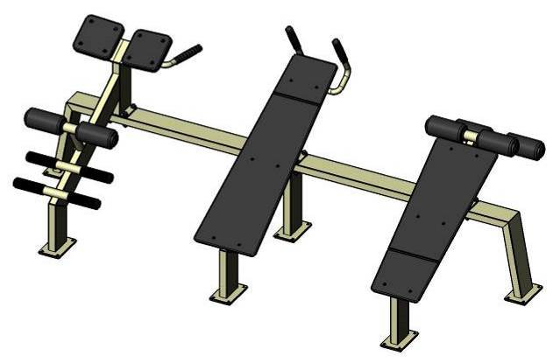

Adductor machine | KF817-S | Abductor machine KF818- | S
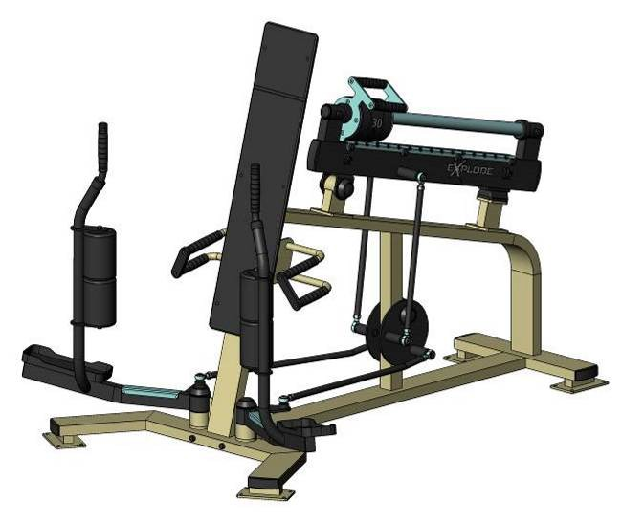 |  | 