G-Premio BOND

One-component light-cured universal adhesive

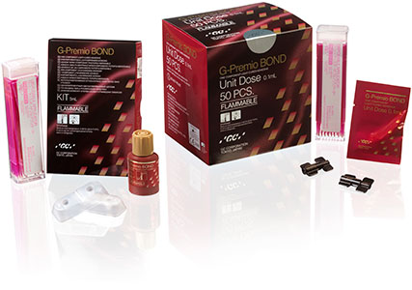
G-Premio BOND is a one-bottle universal bonding agent compatible with all etching modes.
It can be used for direct bonding, but also for repair & hypersensitivity treatment.
Moreover, GC wants to offer this ease of use and versatility without any impact on the quality of the bond.
G-Premio BOND offers the advantages of a universal, but with a top performance in all situations thanks to a unique combination of three functional monomers (4-MET, MDP, MDTP).

G-ænial Universal Flo

High-strength injectable light-cured restorative composite

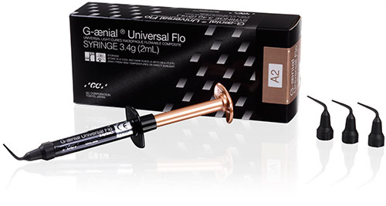
With GC G-ænial Universal Flo you get an exclusive blend of injectable viscosity for easy and convenient placement even in deep cavities, combined with outstanding physical properties for safe and durable restorations.
G-ænial Universal Flo provides the answer to many difficult cases where you do not want to compromise between perfect placement, aesthetics and strength.
Its unique combination of strength and flowability makes it also perfectly adapted to be used as a light-cured composite luting cement.

Fuji IX GP

Packable glass ionomer restorative
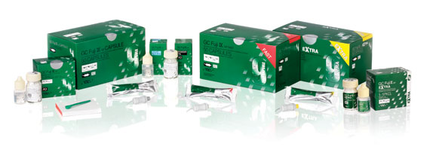
GC Fuji IX GP is one of the world‘s leading glass ionomer restoratives. A conventional, self-curing glass ionomer, it’s easy to pack and contour in the cavity and works splendidly in posterior Class I, II, and V restorations. It’s also ideal for core build-up or as a base.
If speed is of the essence, you’ll want to use Fuji IX GP FAST because you can achieve restorations that last longer in only half the time - only 3 minutes from start of mixing to finish.
If you are looking for extra aesthetics then GC Fuji IX GP EXTRA is the material of choice. The special glass filler used give a very high translucency that changes little over time. The result is natural aesthetics never before achievable with conventional glass ionomer.

