FLEXISTRIPS - Set FS-50
×
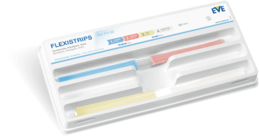
Item No.
9010
Grit
coarse, extra fine, fine, medium
Area of use
Amalgam, Composite, Precious Metal
Packaging unit
50
Packaging
Set
Shape
Stripe
Single-use
Single-use
Set content
25 × FS-60/40 (9111)
25 × FS-20/7 (9112)

