DIACOMP® PLUS RA - Set RA 342
×
Diamond impregnatedBestseller
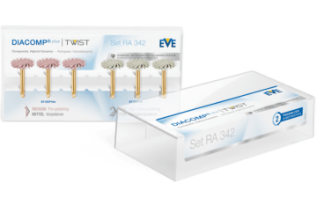
Item No.
9086
Area of use
Composite, Hybrid Ceramic
Grit
fine, medium
Packaging unit
6
MPK (EU)
IIa
RPM (min-1)
3.000 - 8.000
RPM max. (min-1)
20.000
Diamond impregnated
yes
Packaging
Set
Bestseller
yes
Shape
TWIST
Set content
3 × DT-DCP14m (6184)
3 × DT-DCP14f (6284

