DIACOMP® PLUS RA - Set RA 344
×
Diamond impregnatedBestseller
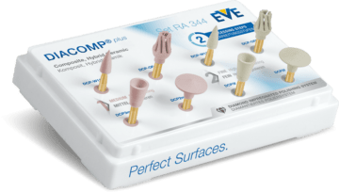
Item No.
9094
Area of use
Composite, Hybrid Ceramic
Grit
fine, medium
Packaging unit
8
MPK (EU)
IIa
RPM (min-1)
3.000 - 8.000
RPM max. (min-1)
20.000
Diamond impregnated
yes
Packaging
Set
Bestseller
yes
Shape
Cup, Lense, OCCLUFLEX, Small Point
Set content
1 × DCP-W11m (6181)
1 × DCP2m (6172)
1 × DCP3m (6173)
1 × DCP-OFm (6175)
1 × DCP-W11f (6281)
1 × DCP2f (6272)
1 × DCP3f (6273)
1 × DCP-OFf (6275)

