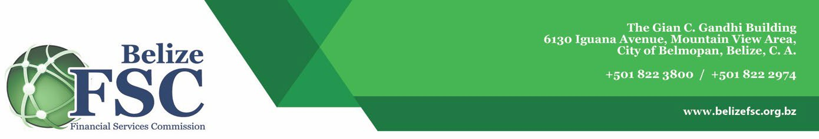

Ref: FSC/ADMIN/003-48

VIA ELECTRONIC MAIL ONLY

14 April 2025

RE: To Whom It May Concern

Through an international tendering procedure, Norway Registers Development AS (NRD AS) was awarded the contract for the "Development of the Belize Companies and Corporate Affairs Registry Online Business Registry System (OBRS)" by the Financial Services Commission (FSC) (formerly the International Financial Services Commission) in July 2021. NRD AS, with the assistance of its subcontractor NRD Systems UAB, successfully implemented the Project on time and within budget. The aim of the project was to establish a business e-Registry system to facilitate fast, efficient, and convenient business registration processes digitally on the backend and frontend, thereby improving access to business registry services for the country and ease of doing business in Belize. We have since engaged NRD for several other services including: Enhancements and expansion of our Online Business Registry System, Development of our Collateral Registry System and currently ongoing the development of our Licensing Management Information System. NRD continues to deliver exceptional services and continues to be a great partner guiding us through the successful implementation of technological solutions.

NRD Systems UAB Experts Involved:
The project was driven by a dedicated team of experts including: Jurgita Ramanauskienė – Project Manager, Darius Ramanauskas – Information Systems Architect, Linas Kvederis – Software Developer, Andrius Kraujelis – Software Developer, Sandra Petraitytė – Information Systems Analyst, Giedrė Butauskienė – Information Systems Analyst, Gintaras Morkūnas – Database Specialist, Raimonda Meinorienė – Information Systems Tester, Romualdas Lečickis – Information Systems Security Specialist, Vilija Žuklienė – UX/UI Specialist and others.

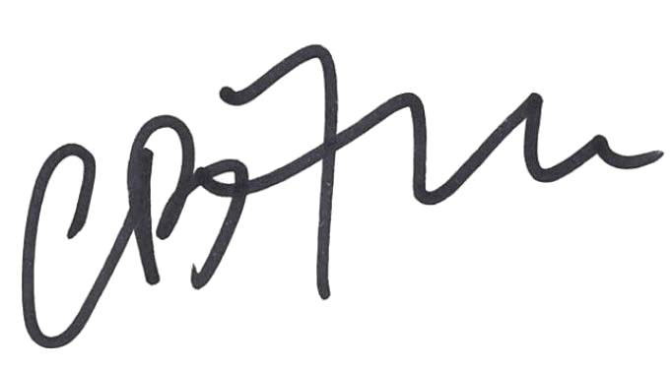
Sincerely,

CLAUDE B.F. HAYLOCK (MR.)
Director General
Financial Services Commission

