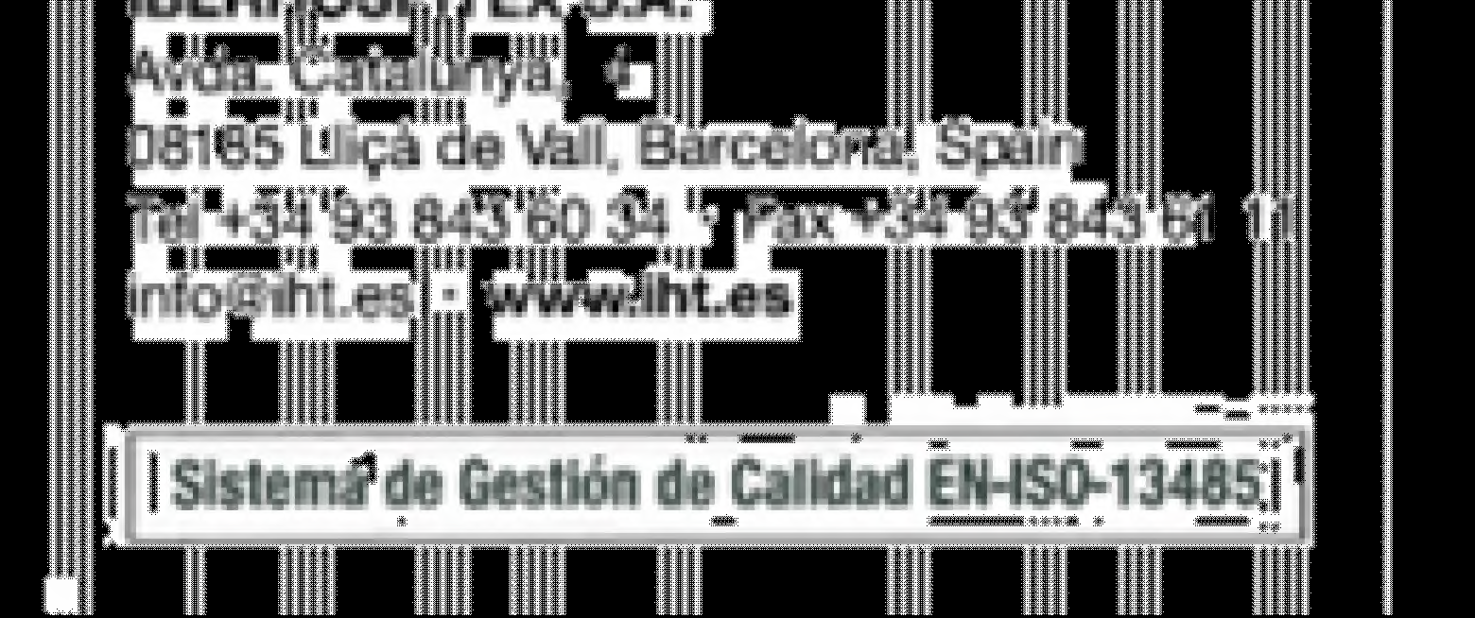
LETTER OF AUTHORIZATION

Barcelona, 02th January 2024

We, IBERHOSPITEX S.A. with address in Avda. de Catalunya 4, 08185 Lliçà de Vall (Barcelona, Spain), authorize the company A. ZAPALSKIO “AZAS” located in Tiekimo g. 2A LT-35100 Panevesys – LITHUANIA to distribute the following products in Lithuania:
Drenofast & drainage accessories
Oper Tape
Oper Tape Clear
Oper Tape Paper
Oper Tape Silk
Oper Film Surgical
Oper Film Protect
Oper Film Protect IV
Oper Dres
Oper Dres Film
Oper Easy
Oper Strip
Oper Cat
Oper Cat Classic

This letter is valid till the end of 2025.

Yours sincerely,
Julia Prusaczyk
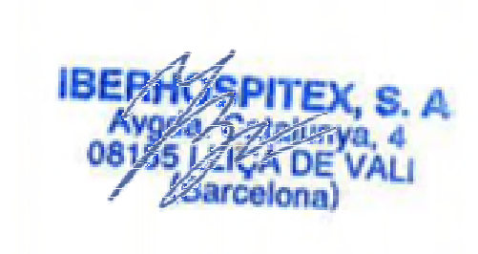

Business Development Manager IBERHOSPITEX S.A.

