DESIGN TASK PLAN OF TYPICAL NODES FOR 400-110 KV VOLTAGE TRANSFORMER SUBSTATIONS AND OPEN SWITCHYARDS

1. Typical layout of site plan surfaces
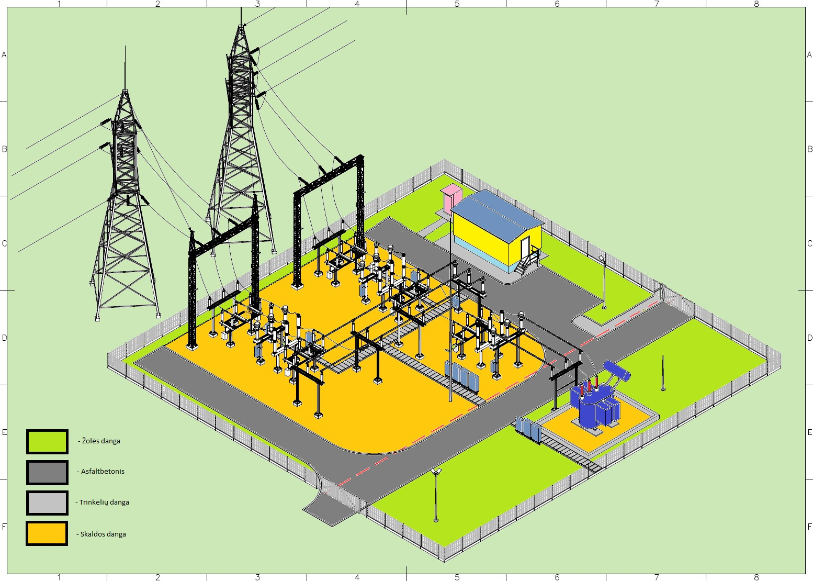

2. Principle diagram of the junction between lawn surface and the road

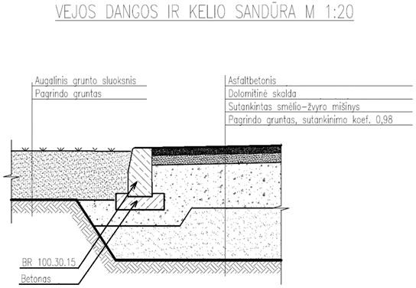

3. Principle diagram of the junction between gravel surface and lawn surface
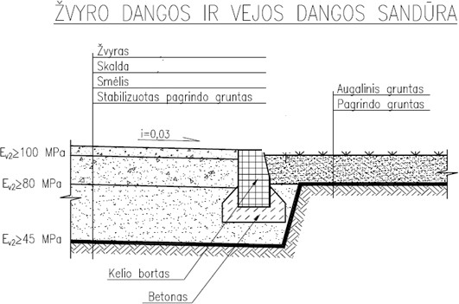

4. Principle diagram of a junction between concrete paving and the road
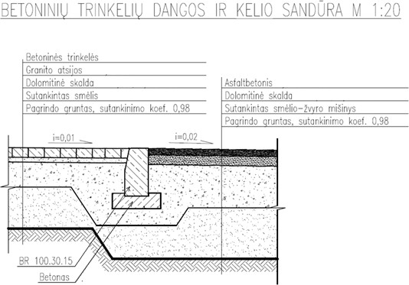

5. Principle diagram of the junction between concrete paving and lawn surface
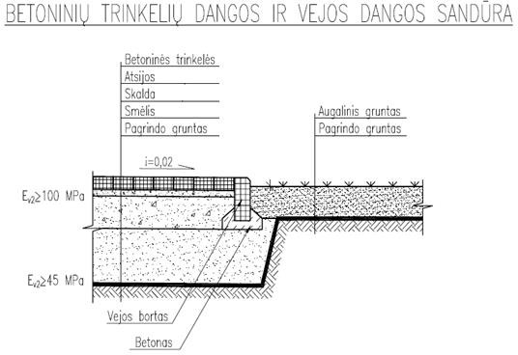

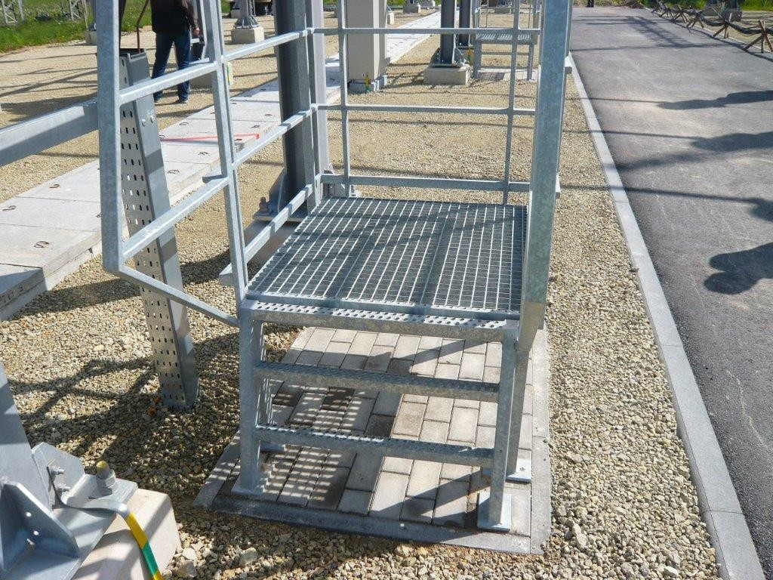
6. Service area

7. Construction of an outdoor toilet
A fixed single g/b toilet shall be designed in the substation area only if the transformer substation does not have a toilet or if an existing toilet is not available in the AB ESO section.
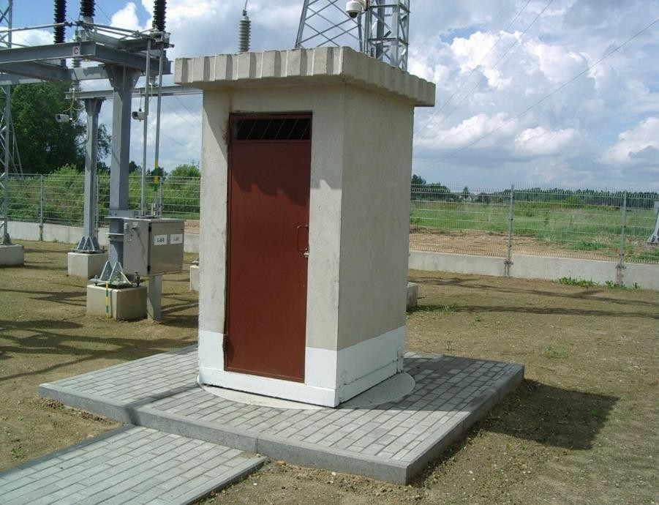

NOTE: In the technical design, the nodes may be adjusted, but only by increasing the requirements, taking into account the actual environmental conditions.

