- Dell Latitude 3390 2in1 Black, 13.3 ", Touchscreen, Full HD, 1920 x 1080 pixels, Intel Core i5, i5-8250U, 8 GB, DDR4, SSD 256 GB, Intel HD, No Optical drive, Windows 10 Pro, 802.11ac, Bluetooth version 4.1, Keyboard language English, Keyboard backlit, Warranty Basic Onsite 36 month(s)
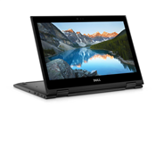
- Dell Latitude 7490 Black, 14 ", Touchscreen, Full HD, 1920 x 1080 pixels, Matt, Intel Core i5, i5-8350U, 8 GB, DDR4, SSD 256 GB, Intel UHD, No Optical drive, Windows 10 Pro, 802.11ac, Bluetooth version 4.2, Keyboard language English, Keyboard backlit, Warranty Basic Onsite 36 month(s)

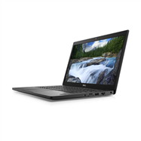
- Dell Latitude 7390 2in1 Black, 13.3 ", Touchscreen, Full HD, 1920 x 1080 pixels, Intel Core i5, i5-8250U, 8 GB, LPDDR3, SSD 256 GB, Intel UHD, No Optical drive, Windows 10 Pro, 802.11ac, Bluetooth version 4.1, Keyboard language English, Keyboard backlit, Warranty Basic Onsite 36 month(s)

