- English
- Česky
- Русский
- Polski
- Site Map
- Print
- Home
- Products
- Service & Support
- Company
- Downloads
- Contact
- Home
- Products
- Filling Materials
- Cements
- Caryosan™
Caryosan™
Zinc oxide-eugenol cement
Cement providing good cavity sealing without irritation of adjacent tissues. Reliable analgesic and disinfecting effect thanks to the content of eugenol.
Indications
- temporary fillings
- cement bases in cavities close to pulp
- permanent root fillings with gutta-percha posts
Characteristics and advantages
- analgesic and bactericidal effect
- “Diagnostic filling” – the symptoms will go off in case of reversible pulpitis
- good biocompatibility
- excellent capability to fulfil the root canal
- good marginal seal of temporary filling
 |  | Article No.
Caryosan™ |  | 4112110
30 g of powder Caryosan Rapid, 30 g of powder Caryosan Normal, 25 g of liquid

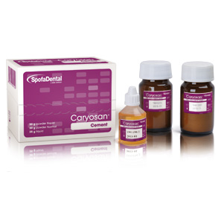

- 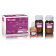

Documents
- Declaration of conformity
- Instruction for use
- Specification
- MSDS
- Other
- © 2011 SpofaDental a.s., All rights reserved
- Contact
- Service & Support

