

APPROVED



EESSI Business Use Case
Ad_BUC_05 Subprocess Forward Case

Table of Contents

1. Introduction 4
1.1. Purpose 4
1.2. Scope 4
1.3. Definitions, Accronyms and Abbreviations 4
1.4. References 5
1.5. Overview 5
2. Description 6
2.1. Business Scenario 6
2.2. Legal Base 6
3. Actors & Roles 7
4. Use Case 8
4.1. RUP Table Representation 8
4.2. Request – Reply SEDs 10
4.3. Attachments Allowed 10
4.4. Artefacts used 10
5. Business Processes 11
6. Appendices 14
6.1. Issues 14

Document Control Information

Settings | Value
Document Title: | Business Use Case  Ad_BUC_05_Subprocess - Forward Case
Project Title: | EESSI (Electronic Exchange of Social Security Information) Project
Document Author: | European Commission, DG EMPL F5
System Owner: | European Commission, DG EMPL D2
Doc. Version: | v4.1.0
Sensitivity: | Public
Date: | 22/08/2018

Document history:
The Document Author is authorized to make the following types of changes to the document without requiring that the document be re-approved:
- Editorial, formatting, and spelling
- Clarification
To request a change to this document, contact the Document Author or Owner.
Revision | Date | Created by | Short Description of Changes
v0.1 | 09/09/14 | Phil Cummings | Initial Draft
v0.2 | 01/03/15 | Phil Cummings | - Removal of step that X007 is sent to the New Participant  - Special requirements added (SR2 to SR4).
v0.3 | 07/10/15 | Eric Briffoz | Special Requirements adaptation (SR4) :  - Any X Sed's shouldn't be sent to the new participant.  - Any invalidated SED's should not be sent to the new participant  - Any Draft SED shouldn't be sent to the new participant  SR5: Added
v0.4 | 11/11/15 | Eric Briffoz | - The X007 should be sent to the New Participant.
v0.99.0 | 27/05/2016 | Anda Mirita | Adding the Additional Chapters 4.2, 4.3 and 4.4  Minor formatting, date, version and grammar changes
v0.99.1 | 12/06/2016 | Phil Cummings | Small grammatical corrections of Actors and Main Process  Addition of sending X007 to New Participant  Update to SR4
v1.0.0 | 14/07/2016 | Phil Cummings | AC APPROVED
v1.0.1 | 08/08/2017 | Eric Briffoz | - Added reference to the BPMN version.  - Removed confidential watermark.  - Adapted reference to BUC confluence page in Configuration Management
v1.0.2 | 15/11/2017 | Heidi Warson | Clarify SR4 in section 4 RUP Table Respresentation – Special Requirements.
v1.0.3 | 05/03/2018 | Novella Bacelli | Rearranged the steps only to align them to the real sequence of the business flow. Moved from the main scenario to post-conditions the new case opened statement and recalled that this condition only takes place upon receiving the starter SED of the main BUC  Added additional BPMN diagrams with full detailed process, only for business documenting purpose
v4.1.0 | 22/08/2018 | Novella Bacelli | - Section 4.4 merged 2 tables (for SED & for Subprocesses) into 1 BUC Artefact table."  - Version adaptations to release 4.1.0.

Introduction

Purpose
The purpose of this document is to construct an external view of, part of, the 'EESSI business system' as described in EC Regulations 883/2004 and 987/2009. The ‘EESSI Business System’ describes the business and expected business processes without consideration as to which part(s) may be realized by an IT System (i.e. the proposed EESSI IT System).
The external view comprises of models and descriptions of business use cases, the services of a business system offered to business actors: customers, business partners, or other business systems.
A business use case is described from an actor's perspective; it describes the interaction between an actor and the business system, meaning it describes the behaviours of the business system that the actor utilizes. The Business Use Case includes Use Case Diagrams and Business Process Models.
Use case diagrams show actors, business use cases, and their relationships. Use case diagrams do not describe procedures. Alternative scenarios also remain hidden. These diagrams give a good overview of the behaviours of the EESSI business system which will direct and govern part of the expected behaviours and functionality delivered by the EESSI IT System.

Scope
This document is limited to the external view of an Administrative process for forwading a case. The different elements like use case description, actors, and business process as well as supporting UML diagrams and BPMN models pertaining to forwarding a case.

Definitions, Accronyms and Abbreviations
Please see the EESSI Project Glossary here.

References
# | Description
1 | EC Regulation 883/2004 | Regulation EC No 883- 2004.pdf
2 | EC Regulation 987/2009 | Regulation EC No 987-2009.pdf
3 | UML 2.x | http://www.omg.org/spec/UML/
4 | BPMN 2.0 | http://www.omg.org/spec/BPMN/index.htm
5 | UML 2.0 In Action | Henriette Baumann, Patrick Grassle & Philippe Baumann, 2005, ISBN 1904811558
6 | RUP@EC standard 5.0 | http://www.cc.cec/RUPatEC_Standard/
7 | RUP op maat | http://www.rupopmaat.nl/

Overview
Chapter 1 introduces the external view on the business system under review and lists the elements of this specification.
Chapter 2 introduces us to the Forward Case business process. The chapter gives a short and detailed description as well as a reference to business process´ legal base.
Chapter 3 lists the actors involved in the Forward Case business process.
Chapter 4 describes in detail the Forward Case business process based on the RUP use case template, as well as the relationship to other use cases.
Chapter 5 describes the Forward Case business process using business process modelling notation (BPMN).

Description

Business Scenario
Situations will occur where a case has started between two or more Institutions. This case may either:
- Have just begun (i.e. a single SED has been exchanged between the institutions)
- Have exchanged multiple SED
In the situation where the case has just begun, it is very possible that the sender of the first SED of the case, made an error when choosing the destination for the SED – this may be due then sender not fully understanding the competence of each institution within the MS they wanted to send a SED to.
In the second situation the case may be progressing between the institutions however, circumstances may change within a Member State and the institution currently handling the case may no longer be competent to do so (examples of such situations could be where an institution is closing or their competence changes due to a merger)
In both situations it is necessary for the institution that is handling the case to pass control of the case to another institution within their Member State, who will then assume responsibility for it.

Legal Base
This Business Use Case document's legal base is described in the following Regulations
- basic Regulation (EC) No 883/2004
- implementing Regulation (EC) No 987/2009
The following matrix specifies the SEDs that are used in this Business Use Case and documents the articles that provide the legal basis for each SED.

 | Basic Reg (883/04
SED | Article 76
X007
Table 1: SED – Legal base relationship matrix

Actors & Roles
This chapter captures details of the actors which are important to understanding the different types of system users. An actor is anyone or anything that exchanges data with the business system. An actor can be a user, external hardware, or another system.
The overarching description of each actor described in this Business Use Case can be found in the Glossary. Below you will find a short description which provides further clarity of this actor within the context of this Business Use Case.

Actor name | Description
Triggering Participant | The triggering participant is an active participant (the Case Owner or a Counterparty) in the main process who triggers this BUC. This will be an Institution where the main process permits their role to do so.
Other Participant(s) | Other Participant(s) represents all other active participants in the main process. This will be one or more Institutions as determined by the main process.
New Participant | The New Participant is institution who, before the excecution of this Business Use Case, was not part of the case.
Table 2: Actors & Roles

Use Case

RUP Table Representation
Use Case ID: | Ad_BUC_05
Use Case Name: | Forward Case
Created By: | Phil Cummings |  | Last Updated By: | Anda Mirita
Date Created: | 09/09/2014 |  | Last Revision Date: | 27/05/2016
Actors: |  | Triggering Participant  Other Participant(s)  New Participant
Description: |  | In a situation where a case is already established and a participant discovers, for some reason, that there is a need to forward the case to another Institution in that Member State.
Trigger: |  | The Triggering Participant needs to forward the case to another Institution
Preconditions: |  | A case exists and calls this BUC  The New participant is in the same Member State as the Triggering Participant
Post conditions: |  | The new participant is added to the case and receives the SEDs they need to actively participate in the case  The new participant has opened a new case in its institution, upon receiving the starter SED, sent by either the Triggering Participant or one of the Other Participants.  The other participants are aware that the new participant has joined the case  The Triggering Participant has left the case
Main Scenario: |  | - The Triggering Participant identifies the institution within their MS that it wishes to forward the case to.  - The Triggering Participant fills out a Forward (X007) SED detailing the reasons for forwarding the case.  - The Triggering Participant sends the X007 to the Other Participants and the New Participant.  - The Triggering participant sends to the New Participant all of the valid, delivered SEDs, originated by it, that it has previously sent to Other Participants.  - The New Participant receives the X007 and other SEDs (see SR4) from the Triggering Participant.  - Each of the Other Participants receives the X007 and takes note of the New Participant and includes it in any further exchanges of SEDs in accordance with the business rules of that case and no longer sends any SED to the Triggering Participant.  - Each of the Other Participants sends to the New Participant all the valid, delivered SEDs, originated by them, they have previously sent to the Triggering Participant to allow the smooth continuation of the case.  - The New Participant receives other SEDs (see SR4) from the Other Participants.  The use case ends here
Alternative Scenarios:
Exceptions: |  | Exception 1:
Includes: |  | This BUC is exclusively used as an <<include>> in other sectorial business processes.
Special Requirements: |  | SR1: Active Participants are those participants defined in the parent process which invoked this BUC  SR2: Any SED that are sent from the Triggering Institution to the New Participant shall be treated by the New Participant as if they had sent the SED themselves (i.e they can update, invalidate the SED as necessary)  SR3: When the Triggering Participant and Other Participants send the SED to the New Participant they must:  - Only send the SED to the New Participant and not to each other (this rule must be respected over any sectorial rule about who to send a SED to)  - Must not increase the version number of the SED.  - Must send only the latest version of the SED's, and not the eventual previous available SEDs versions.  SR4: When sending SEDs they have sent so far in the case, the Triggering Participant (following Main Scenario step 4) and Other Participants (following Main Scenario, step 7) should not send the following SED Types to the New Participant:  - Any X SED (Except for the sending of the "X007" SED to the new participant as per main scenario, step 3).  - Any invalidated SED.  - Any previously sent “Reply” SED to which the request was subsequently invalidated  - Any SED for which you have received a business exception (X050)  - Any Draft SED.  SR5: It must not be possible to Forward a case when a 'Starting' SED is declared invalid (via Invalidate BUC) and a new instance has not been exchanged.  SR6: An Institutiton can only forward to another Institution within the same MS
Assumptions:
Notes and Issues:

Request – Reply SEDs
The following table specifies the SED that have a logical pairing to one another, usually this is known as a request-reply pair.
REQUEST SED | REPLY SED(s)

Attachments Allowed
The following table specifies whether attachments are permitted to be included when sending a SED type.
SED | Attachments
X007 | Not Allowed

Artefacts used
The following table specifies the artefacts that are used in this Business Use Case.
Artefact name | Artefact type
X007 | SED

Business Processes
The following model decribes the Business Use Case Forward Case subprocess using BPMN 2.0.

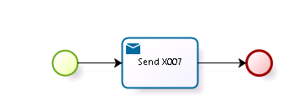

The above BPMN diagram illustrates only the SED X007 that documents the addition of the New Participant. It does not show all other SEDs' types already managed by the main process.

For better clarifying the business subprocess, besides the usual diagram, also the diagrams of the full detailed sub-process are reported hereafter in two scenarios: in the first one the Case Owner is the Triggering Participant, whilst in the second one the Case Owner is one of the Other Participants and the Triggering Participant is just a Counterparty.

First scenario: full business process with the Triggering Participant as the Case Owner of the main case
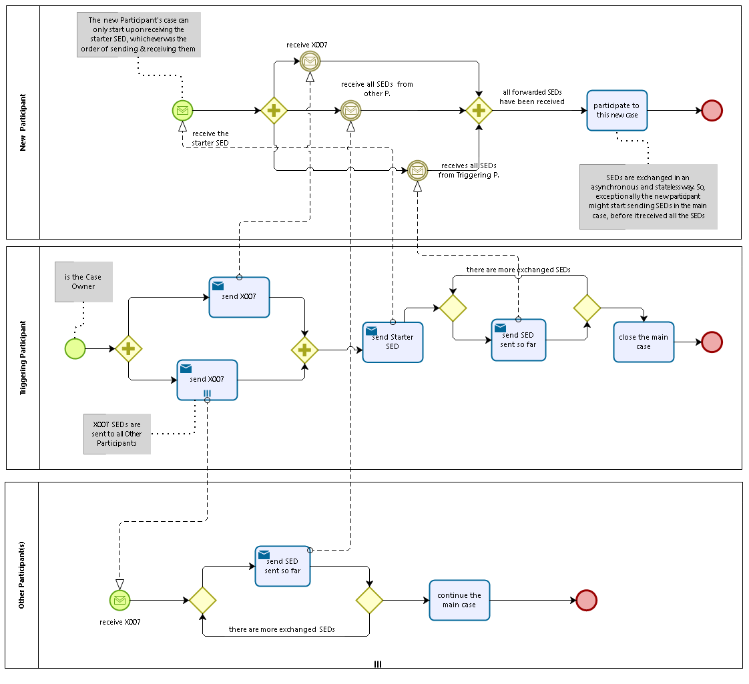
Second scenario: full business process with the one of the Other Participant as the Case Owner of the main case
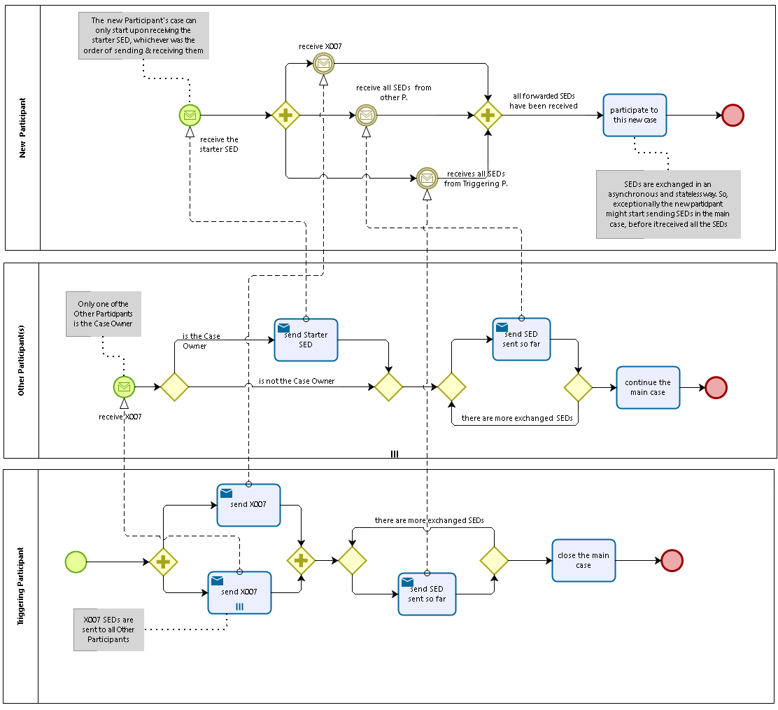

Appendices

Issues
# | Issue date | Description | Replies | Action/Resolution | Close date
1
2
3
4
5
6
7
8
9

