
EESSI Business Use Case

AC APPROVED



AD_BUC_11
Business Exception



Table of Contents

Table of Contents 2
1. Introduction 5
1.1. Purpose 5
1.2. Scope 5
1.3. Definitions, Acronyms and Abbreviations 5
1.4. References 6
1.5. Overview 6
2. Description 7
2.1. Business Scenario 7
2.2. Legal Base 7
3. Actors & Roles 8
4. Use Case 9
4.1. RUP Table Representation 9
4.2. Request – Reply SEDs 11
4.3. Attachments 11
4.4. Artefacts used 11
5. Business Processes 13
5.1. Triggering Participant 13
5.2. Other Participant 13
5.3. Sub Processes 13
6. Appendices 14
6.1. Issues 14

Document Control Information
Settings | Value
Document Title: | Business Use Case  AD_BUC_11_subprocess-Business Exception
Project Title: | EESSI (Electronic Exchange of Social Security Information) Project
Document Author: | European Commission, DG EMPL F5
System Owner: | European Commission, DG EMPL D2
Doc. Version: | v4.1.0
Sensitivity: | Public
Date: | 22/08/2018

Document history:
The Document Author is authorized to make the following types of changes to the document without requiring that the document be re-approved:
- Editorial, formatting, and spelling
- Clarification

To request a change to this document, contact the Document Author or Owner.

Revision | Date | Created by | Short Description of Changes
v0.1.0 | 14/01/2016 | Eric Briffoz  Phil Cummings | Initial Draft
v0.2.0 | 01/02/2016 | Eric Briffoz | Adaptations following the RINA Team comments
v0.3.0 | 25/07/2016 | Carine Molle | Alignment to the standard description and layout of the BUC.
v0.99.0 | 23/09/2016 | Cristina Ezaru | Candidate for AC Approval  1. new layout
v0.99.1 | 26/09/2016 | Phil Cummings | Corrections to document following AC Review
v1.0.0 | 19/10/2016 | Cristina Ezaru | AC APPROVED VERSION
v1.0.1 | 16/11/2016 | Phil Cummings | Typo corrected
v1.0.2 | 08/08/2017 | Eric Briffoz | - Included the BPMN Diagram version in section 5.
v1.0.3 | 19/12/2017 | Eric Briffoz | Clarification following Jira ticket EESSIDEV-11560: The AD_BUC_11 is not triggered on a closed existing case after an incoming X002 – Reopen Case SED;  Updated section 5 to the latest BPMN Diagram version.
v4.1.0 | 22/08/2018 | Novella Bacelli | - Section 4.4 merged 2 tables (for SED & for Subprocesses) into 1 BUC Artefact table."  - Version adaptations to release 4.1.0.

Introduction

Purpose
The purpose of this document is to construct an external view of, part of, the 'EESSI business system' as described in EC Regulations 883/2004 and 987/2009. The ‘EESSI Business System’ describes the business and expected business processes without consideration as to which part(s) may be realized by an IT System (i.e. the proposed EESSI IT System).

The external view comprises of models and descriptions of business use cases, the services of a business system offered to business actors: customers, business partners, or other business systems.

A business use case is described from an actor's perspective; it describes the interaction between an actor and the business system, meaning it describes the behaviours of the business system that the actor utilizes. The Business Use Case includes Use Case Diagrams and Business Process Models.

Use case diagrams show actors, business use cases, and their relationships. Use case diagrams do not describe procedures. Alternative scenarios also remain hidden. These diagrams give a good overview of the behaviours of the EESSI business system which will direct and govern part of the expected behaviours and functionality delivered by the EESSI IT System.

Scope
This document is limited to the external view of the Business Exception process. The different elements like use case description, actors, and business process as well as supporting UML diagrams and BPMN models pertaining to the Business Exception.

Definitions, Acronyms and Abbreviations
Please see the EESSI Project Glossary here.

References
# | Description
1 | EC Regulation 883/2004 | Regulation EC No 883- 2004.pdf
2 | EC Regulation 987/2009 | Regulation EC No 987-2009.pdf
3 | UML 2.x | http://www.omg.org/spec/UML/
4 | BPMN 2.0 | http://www.omg.org/spec/BPMN/index.htm
5 | UML 2.0 In Action | Henriette Baumann, Patrick Grassle & Philippe Baumann, 2005, ISBN 1904811558
6 | RUP@EC standard 5.0 | http://www.cc.cec/RUPatEC_Standard/
7 | RUP op maat | http://www.rupopmaat.nl/

Overview
Chapter 1 introduces the external view on the business system under review and lists the elements of this specification.

Chapter 2 introduces us to the Business Exception business process. The chapter gives a short and detailed description as well as a reference to business process´ legal base.

Chapter 3 lists the actors involved in the Business Exception business process.

Chapter 4 describes in detail the Business Exception business process based on the RUP use case template, as well as the relationship to other use cases.

Chapter 5 describes the Business Exception business process using business process modelling notation (BPMN).

Description

Business Scenario
In a situation where a national application receives an erroneous message (which causes an exception to occur), an exception message should be generated and sent over to the sender of the erroneous message to inform about the error(s) that has (have) occurred.

Legal Base
This Business Use Case document's legal base is described in the following Regulations

- basic Regulation (EC) No 883/2004
- implementing Regulation (EC) No 987/2009
The following matrix specifies the SEDs that are used in this Business Use Case and documents the articles that provide the legal basis for each SED.

- SED | Basic Reg (883/04) | Implementing Reg (987/2009)
- SED | 76 | 2(1) | 2(2)
X050
Article 76 BR and/or Article 2(1)(2
Table 1: SED – Legal base relationship matrix

Actors & Roles
This chapter captures details of the actors which are important to understand the different types of system users. An actor is anyone or anything that exchanges data with the business system. An actor can be a user, external hardware, or another system.
The overarching description of each actor described in this Business Use Case can be found in the Glossary. Below you will find a short description which provides further clarity of this actor within the context of this Business Use Case.

Actor name | Description
Triggering Participant | The triggering participant is an actor (national application) in the main process that receives an unexpected/erroneous Business Message.
Other Participant | The other participant is the actor (national application) that has sent an erroneous Business Message.

Use Case

RUP Table Representation
Use Case ID: | AD_BUC_11
Use Case Name: | Business Exception
Created By: | Eric Briffoz |  | Last Updated By: | Eric Briffoz
Date Created: | 29/01/2016 |  | Last Revision Date: | 27/10/207
Actors: |  | Triggering Participant  Other Participant(s)
Description: |  | In a situation where a national application receives an erroneous message (which causes an exception to occur), an exception message should be created and sent to the sender of the erroneous message to inform about the error(s) that has (have) occurred.  There are 2 categories of erroneous received messages:  - Business exceptions which do not require a waiting period.  - Business exceptions which do require a waiting period.  The reason to wait during a certain period before sending the exception is because the erroneous message could be followed by another message which might correct the problem known as a ‘corrective event’.  For example:  After receiving a SED in the wrong sequence, the case receives shortly after the expected SED in the right sequence. As a consequence, the initial wrongly received message is now in the right sequence, and a business exception does not need to be generated anymore.  The following errors do not require a waiting period:  - Receiving a SED with invalid Business signature  - Receiving a SED / Attachment which failed antimalware checking  The following errors do require a waiting period to expire:  - Receiving a SED for a missing case  - Receiving a SED for a missing setId SED (update for a non existing SED)  - Receiving a SED after the case was removed by  - receiving a X006 SED  - Receiving a SED after the case was forwarded to another participant.  - Received a SED in the case in the wrong sequence/Business Rule not followed  - Received a SED when the case is in "closed" status through exchange of X001, except for SED X002 'Reopen Case SED':  - If SED X002 (Reopen Case) is received on a Case which is in Closed status, a business exception will not be triggered.  Please note that the other types of errors can occur (for example, receiving a wrong SED Type within a Case type, etc…) and these should be blocked at the AP level and will therefore not be part of this business exception BUC.
Trigger: |  | The Triggering Participant received a message (SED) which cannot be accepted in the national application.
Preconditions: |  | A participant receives an erroneous SED.
Post conditions: |  | The following post-conditions are possible:  - A business exception SED (X050) has been generated and sent by the triggering participant to the other participant.  - A business exception SED (X050) has not been generated because, before the waiting period expired, a correcting event has occurred.
Main Scenario: |  | - The Triggering participant receives from another Participant an erroneous SED which does not require a waiting period;  - The received SED does not require to wait a certain period, and so the Triggering participant fills in a Business Exception (X050) SED and specifies within the SED which is/are the reason(s) of the Business Exception;  - The triggering Participant sends the Business Exception (X050) SED to the other participant (the participant that has sent erroneous message);  - The other Participant receives the business Exception SED (X050) and understand the business error that it produced, and will be able to react accordingly based on the information provided in X050;  - The use case ends here.
Alternative Scenarios: |  | - At [Part 1] the Triggering participant has received an erroneous SED from another participant, which does require a waiting period, which has expired.  - The Triggering Participant waits for 24 hours  - After waiting for 24 hours the business situation has not been resolved through a corrective event.  - The Triggering Participant fills in a Business Exception (X050) SED and specifies within the SED which is/are the reason(s) of the Business Exception;  - The Triggering Participant sends the Business Exception (X050) SED to the other participant which has sent erroneous message;  - The other Participant receives the business Exception SED (X050) and understand the business error that it produced, and will be able to react accordingly;  - [This Branch] Ends.
- At [Branch 2, Step 2] the Triggering participant as received a correcting SED/corrective event.

- [This Business Use Case] Ends.

Exceptions: |  | none
Includes: |  | This BUC is exclusively used as an <<include>> in other sectorial business processes.
Frequency of Use:
Special Requirements: |  | SR1: Active Participants are those participants defined in the <Actors> section of Section 3.
Assumptions:
Notes and Issues:

Request – Reply SEDs
The following table specifies the SEDs that have a logical pairing to one another, usually this is known as a request-reply pair.
REQUEST SED | REPLY SED(s)

Attachments
The following table specifies whether attachments are permitted to be included when sending a SED type.
SED | Attachments
X050 | Not allowed

Artefacts used
The following table specifies the artefacts that are used in this Business Use Case.

Artefact name | Artefact type
X050 | SED

Business Processes
This chapter describes the Business Use Case Business Exception using BPMN 2.0.

Triggering Participant
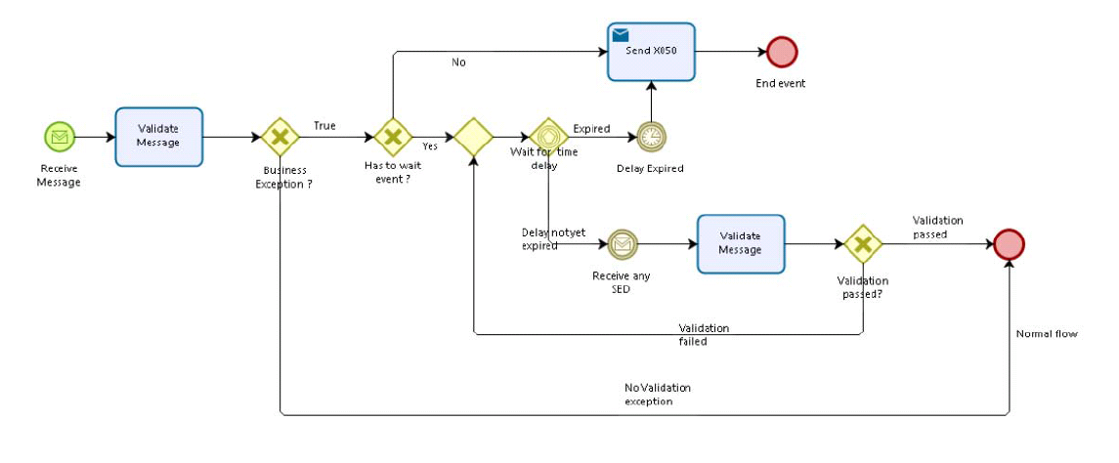

Other Participant
n/a

Sub Processes
n/a

Appendices

Issues
# | Issue date | Description | Replies | Action/Resolution | Close date
1
2
3
4

For a full list of AP Errors please see Part 8 of the EESSI AP Messaging Interface document delivered as part of Architecture Pack 1.0

