
EESSI Business Use Case

Annex Nr.18 to the note AC 370/16rev


FB_BUC_02 -
Discharges of Family Benefits



Table of Contents

Table of Contents 2
1. Introduction 5
1.1. Purpose 5
1.2. Scope 5
1.3. Definitions, Acronyms and Abbreviations 5
1.4. 1.4. References 6
1.5. 1.5. Overview 6
2. Description 7
2.1. Business Scenario 7
2.2. Legal Regulations / Policy Issues / Other Mentions 7
3. Actors & Roles 8
4. Use Case 9
4.1. RUP Table Representation 9
4.2. Request – Reply SEDs 13
4.3. Attachments Allowed 13
4.4. Artefacts used 13
5. Business Processes 14
5.1. Main Scenario – Case Owner and Counterparty 14
5.2. Sub Processes 15
6. Appendices 15
6.1. Related Use Cases 15
6.2. Privacy and Security Assumptions 15
6.3. Issues 16

Document Control Information
Settings | Value
Document Title: | Business Use Case  FB_BUC_02 - Discharges of Family Benefits
Project Title: | EESSI (Electronic Exchange of Social Security Information) Project
Document Author: | European Commission, DG EMPL F5
System Owner: | European Commission, DG EMPL D2
Doc. Version: | v4.1.0
Sensitivity: | Public
Date: | 03/08/2018

Document history:
The Document Author is authorized to make the following types of changes to the document without requiring that the document be re-approved:
- Editorial, formatting, and spelling
- Clarification
To request a change to this document, contact the Document Author or Owner.

Revision | Date | Created by | Short Description of Changes
v0.02 | 07.04.2015 | Mihai Dinca | Changes in the 2.2 section (remove articles)  Remove "clarify" and "reject" branches
v0.03.0 | 29.01.2016 | Violeta Popescu | Added the following sections:  - Request-Reply SED  - Attachments allowed  - SEDs and Sub-Process Versioning
v0.03.1 | 05.04.2016 | Violeta Popescu | Small changes to align with the rest of the BUCs
v0.99.0 | 11.05.2016 | Violeta Popescu | Submitted for AC approval  Added the RUP UC Diagram Representation  Small changes in wording
v0.99.1 | 15.06.2016 | Violeta Popescu | Submitted for AC approval  Small changes following the AC review process (inserted the page numbers), replaced "where the family resides" with "where the child (ren) resides" (point 3. Actors and Roles)  Changed Point 6 in the Main Scenario, in order to reflect the situation when the request is rejected.  Corrected the RUP UC Diagram Representation  Added the reference to decision F2 by the AC under point 2.2 Legal/ Policy Issues/ Other Mentions
v1.0.0 | 06.07.2016 | Violeta Popescu | AC Approved
v1.0.1 | 09.08.2016 | Violeta Popescu | Alignment to the standard description and layout of the BUC
v1.0.2 | 29/06/2017 | Madalina Alecsandrescu | -Added last version of BPMN  -Included the version of the BPMN diagram in section 5  -Correction in the Sub-process table in section 4.5  - Removed Use Case diagram
 |  |  | Align wording for Invalidate SED and Forward participant
v4.1.0 |  | Madalina Alecsandrescu | - Section 4.4 merged 2 tables (for SED & for Sub process) into 1 BUC Artefact table. - Version adaptations to release 4.1.0.  - Add SR regarding Horizontal process H_BUC_07 – Notification of Death,

Introduction

Purpose
The purpose of this document is to construct an external view of, part of, the 'EESSI business system' as described in EC Regulations 883/2004 and 987/2009. The ‘EESSI Business System’ describes the business and expected business processes without consideration as to which part(s) may be realised by an IT System (i.e. the proposed EESSI IT System).

The external view comprises of models and descriptions of business use cases, the services of a business system offered to business actors: customers, business partners, or other business systems.

A business use case is described from an actor's perspective; it describes the interaction between an actor and the business system, meaning it describes the behaviours of the business system that the actor utilises. The Business Use Case includes Use Case Diagrams and Business Process Models.
Use case diagrams show actors, business use cases, and their relationships. Use case diagrams do not describe procedures. Alternative scenarios also remain hidden. These diagrams give a good overview of the behaviours of the EESSI business system which will direct and govern part of the expected behaviours and functionality delivered by the EESSI IT System.

Scope
This document is limited to the external view on the Family Benefits sector process of Exchange of Information.

Definitions, Acronyms and Abbreviations
Please see the EESSI Project Glossary.

References
# | Description
1 | EC Regulation 883/2004 | Regulation EC No 883- 2004.pdf
2 | EC Regulation 987/2009 | Regulation EC No 987-2009.pdf
3 | UML 2.x | http://www.omg.org/spec/UML/
4 | BPMN 2.0 | http://www.omg.org/spec/BPMN/index.htm
5 | UML 2.0 In Action | Henriette Baumann, Patrick Grassle & Philippe Baumann, 2005, ISBN 1904811558
6 | RUP@EC standard 5.0 | http://www.cc.cec/RUPatEC_Standard/
7 | RUP op maat | http://www.rupopmaat.nl/

Overview
Chapter 1 introduces the external view on the business system under review and lists the elements of this specification.
Chapter 2 introduces the Discharges of Family Benefits business processes. The chapter gives a short and detailed description as well as a reference to business process legal base.
Chapter 3 lists the actors involved in the Discharges of Family Benefits business process.
Chapter 4 describes in detail the Discharges of Family Benefits business process based on the RUP use case template, as well as the relationship to other use cases.
Chapter 5 describes the Discharges of Family Benefits business process using business process modelling notation (BPMN).

Description

Business Scenario
The present business process in the Family Benefits sector describes the communication necessary in order to implement the provisions concerning the discharge of the granted family benefits. Situations covered by this process:
- when the person to whom the family benefits are provided for does not use the benefits for the maintenance of the children.
The process can only be started by a request message F016. F017 cannot be used as initiating message, as a previous message has to exist (F016) before sending F017.

Legal Regulations / Policy Issues / Other Mentions
This Business Use Case document's legal base, according to the agreed version 3 Family Benefits guidelines, documented by the expert AHGs, is described in the Basic Regulation (EC) No 883/2004 Article 68a.

According to the Decision F2:
'An institution shall reply promptly to a request for information from another Member State and in any event, no later than:

a. two months after the day of receipt of the request in a case concerning a request for a position on a provisional decision on the priority rules referred to at Article 60(3) of Regulation (EC) No 987/2009), or

b. three months after the day of receipt of the request for information in all other cases.'

The following matrix specifies the SEDs that are used in this Business Use Case and documents the articles that provide the legal basis for each SED.

 | Basic Regulation
SED | 68a
F016
F017
Table 1: SED – Legal base relationship matrix

Actors & Roles
This chapter captures details of the business actors that are important to understanding the business. An actor is anyone or anything that exchanges data with the business system. An actor can be a user, external hardware, or another system.

The overarching description of each actor described in this Business Use Case can be found in the Glossary. Below you will find a short description which provides further clarity of this actor within the context of this Business Use Case.

Actor name | Description
Case Owner | Institution (competent in Family Benefits sector) of the Member State where the child(ren) resides. Initiates the process of discharging the granted family benefits at the petitioner's request.
Counterparty | Institution in the corresponding Member State that handles the Family Benefit Claim on behalf of the Claimant. It discharges the payment of the Family Benefit, at the Case Owner's request.
Petitioner | The person who considers that the person to whom the family benefits are paid does not use the family benefits for the maintenance of the children.
Table 2: Actors & Roles

Use Case

RUP Table Representation
Use Case ID: | FB_BUC_02
Use Case Name: | Discharges of Family Benefit
Created By: | Mihai Dinca |  | Last Updated By: | Violeta Popescu
Date Created: | 06/12/2014 |  | Last Revision Date: | 09/08/2016
Actors: |  | Case Owner  Counterparty  Petitioner
Description: |  | A competent institution from a Member State where the child(ren) is/are residing asks for discharging the family benefits that are being paid by the institution of the corresponding Member State.
Trigger: |  | A person (Petitioner) considers that the person to whom the family benefits are paid does not use the family benefits for the maintenance of the child(ren), contacts the Institution of the Member State where the child(ren) is/are residing and asks for the discharge of benefits from the competent Member State.
Preconditions: |  | A family benefit was granted and paid to a person who is supposed to provide maintenance for the child(ren).
Post conditions: |  | The family benefit will be paid to a new person (or authority).
Main Scenario: |  | Identify Participants  - The Case Owner identifies the EU Member State where the family benefit is being paid;  - The Case Owner then identifies the correct institution (the Counterparty) or institutions in the respective Member State that is paying the family benefits.  Send the request for discharging the family benefits  - The Case Owner fills in a request for discharging the family benefits (F016 SED) by entering the required information;  - The Case Owner sends the F016 SED to the Counterparty(ies);  - The Counterparty(ies) receive(s) the F016 SED.  Send the reply to request for discharging the family benefits  - The Counterparty(ies) reply(ies) to F016 SED by filling in a Reply to Request for Discharging the Family Benefits (F017) SED by indicating whether the request is accepted or not. If the request is accepted, the Counterparty (ies) mention(s) the starting date of the payment and indicate(s) the newly approved beneficiary. If the request is not accepted, the Counterparty (ies) mention(s) the reason for refusal, legal grounds and possible additional information;  - The Counterparty(ies) send(s) their F017 to the Case Owner;  - The Case Owner receives the F017;  - The BUC Ends.
Alternative Scenarios: |  | The Following Branches determine the use of Horizontally Defined Processes within this Business Process
- at any step between [step 5] and [step 7] any Participant may optionally choose to request AdHoc Information from another Participant

- The Participant executes business use case H_BUC_01 – AdHoc Exchange of Info;
- [This Branch] Ends.
- at any step between [step 5] and [step 7] any Participant may optionally choose to determine the residence of the Person with another Participant

- The Participant executes business use case H_BUC_02 – Determine Residence;
- [This Branch] Ends.
- at any step between [step 5] and [step 7] any Participant may optionally choose to notify another Participant of a change of Legislation Applicable

- The Participant executes business use case H_BUC_03a – Change of Legislation Applicable – Notification;
- [This Branch] Ends.
- at any step between [step 5] and [step 7] any Participant may optionally choose to notify another Participant of a change of Legislation Applicable

- The Participant executes business use case H_BUC_03b – Change of Legislation Applicable – Request for Information;
- [This Branch] Ends.
- at any step between [step 5] and [step 7] any Participant may optionally choose to Exchange the PIN of a citizen with another Participant

- The Participant executes business use case H_BUC_05 – Exchange of PIN;
- [This Branch] Ends
- at any step between [step 5] and [step 7] any Participant may optionally choose notify another Participant of a Death of Person

- The Participant executes business use case H_BUC_07 – Notification of Death;
- [This Branch] Ends.
 |  | The Following Branches Determine the use of Administrative Processes within this Business Process
- at any step between [step 5] and [step 9] the Case Owner may choose to Forward this Business Process to another Competent Institution within their MS who assumes responsibility for handing it

- The Case Owner executes business use case AD_BUC_05 – Forward Case;
- [This Branch] Ends.
- at any step between [step 5] and [step 9] the Counterparty may choose to Forward this Business Process to another Competent Institution within their MS who assumes responsibility for handing it

- The Counterparty executes business use case AD_BUC_05 – Forward Case;
- [This Branch] Ends.
- at any step between [step 4] and [step 9] the Case Owner may choose to advise all recipients of their F016 that it is Invalid under Art 5 of 987/09

- The Case Owner executes business use case AD_BUC_06 - Invalidate_SED;
- Optionally, the Case Owner fills in F016, by entering all the required data;
- Optionally, the Case Owner sends F016, including all the attachments, to all Counterparties;
- [This Branch] Ends.
- at any step between [step 7] and [step 9] a Counterparty may choose to advise all recipients that their F017 is Invalid under Art 5 of 987/09

- The Counterparty executes business use case AD_BUC_06 - Invalidate_SED;
2. Optionally, the Counterparty fills in F017, by entering all the required data;
3. Optionally, the Counterparty sends F017, including all the attachments, to all Counterparties;
4. [This Branch] Ends.

- at any step between [step 4] and [step 9] the Case Owner may choose to send an updated version of F016

- The Case Owner executes business use case AD_BUC_10 - Update_SED;
- [This Branch] Ends.
- at any step between [step 6] and [step 9] a Counterparty may choose to send an updated version of F017

- The Counterparty executes business use case AD_BUC_10 - Update_SED;
- [This Branch] Ends
- at any step between [step 5] and [step 9] the Case Owner may optionally choose to send a Reminder to the Counterparty for the return of information they were expecting from that Participant but did not receive

- The Case Owner who invokes this branch executes business use case AD_BUC_07 - Reminder;
- [This Branch] Ends.
Exceptions: |  | Exception 1: at any step between [step 4] and [step 9] the Case Owner may optionally choose to end the process due to unexpected information becoming known to them during the course of their investigations  - The Case Owner executes the business use case AD_BUC_01 – Close Case;  - This BUC Ends.
Includes: |  | See figure 4.4
Frequency of Use:
Special Requirements: |  | SR: Rules about the invoking of Branches:  Horizontals  [Branch 6] – May be invoked only once, per Participant.
Assumptions:
Notes and Issues:

Request – Reply SEDs
The following table specifies the SED that have a logical pairing to one another, usually this is known as a request-reply pair.
REQUEST SED | REPLY SED(s)
F016 | F017

Attachments Allowed
The following table specifies whether attachments are permitted to be included when sending a SED type.
SED | Attachments
F016 | Allowed
F017 | Allowed

Artefacts used
The following table specifies the artefacts that are used in this Business Use Case.
Artefact name | Artefact type
F016 | SED
F017 | SED
H_BUC_01_Subprocess | BUC
H_BUC_02_Subprocess | BUC
H_BUC_03a_Subprocess | BUC
H_BUC_03b_Subprocess | BUC
H_BUC_05_Subprocess | BUC
H_BUC_07_Subprocess | BUC
AD_BUC_01_Subprocess – Close Case | BUC
AD_BUC_05_Subprocess – Forward Case | BUC
AD_BUC_06_Subprocess – Invalidate SED | BUC
AD_BUC_07_Subprocess – Reminder | BUC
AD_BUC_10_Subprocess – Update SED | BUC
AD_BUC_11_Subprocess – Business Exception | BUC
AD_BUC_12_Subprocess – Change of Participant | BUC

Business Processes
This chapter describes the Business Use Case Discharges of Family Benefits for orphans .

Main Scenario – Case Owner and Counterparty

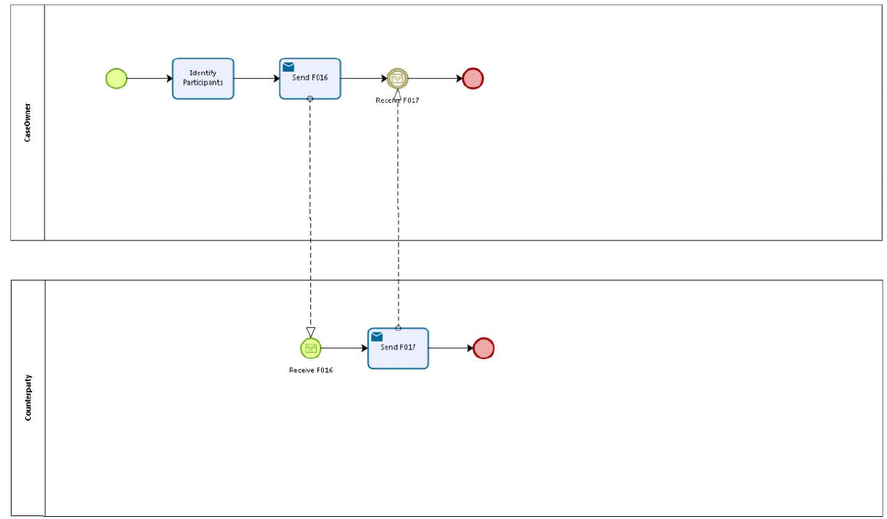

Sub Processes

n/a

Appendices

Related Use Cases
See chapter 4: Use Case.

Privacy and Security Assumptions

Feature | Feature Applicability
Audit Logging | X
Authentication (Person) | X
Authentication (System) | X
Data Integrity Checking | X
Error Handling | X
Holding Messages
Non-repudiation | X
Pseudonymize and Re-Identify
Secure Transport | X
Transmit Disambiguated Identities | X
User Login | X

Issues
# | Issue date | Description | Replies | Action/Resolution | Close date
1
2
3
4

