
EESSI Business Use Case



FB_BUC_04
Information about payment regarding priority right



Table of Contents

Table of Contents 2
1. Introduction 5
1.1. Purpose 5
1.2. Scope 5
1.3. Definitions, Acronyms and Abbreviations 5
1.4. References 6
1.5. Overview 6
2. Description 7
2.1. Business Scenario 7
2.2. Legal Base 7
3. Actors & Roles 8
4. Use Case 9
4.1. RUP Table Representation 9
4.2. Request – Reply SED 11
4.3. Attachments Allowed 11
4.4. Artefacts used 11
5. Business Processes 11
5.1. Case Owner and Counterparty 12
5.2. Sub Processess 12
6. Appendices 12
6.1 Issues 12

Document Control Information
Settings | Value
Document Title: | Business Use Case  FB_BUC_04 - Information about payment regarding priority right
Project Title: | EESSI (Electronic Exchange of Social Security Information) Project
Document Author: | European Commission, DG EMPL F5
System Owner: | European Commission, DG EMPL D2
Doc. Version: | v4.1.0
Sensitivity: | Public
Date: | 03/08/2018

Document history:

The Document Author is authorized to make the following types of changes to the document without requiring that the document be re-approved:
- Editorial, formatting, and spelling
- Clarification

To request a change to this document, contact the Document Author or Owner.

Revision | Date | Created by | Short Description of Changes
v0.1.0 | 01/07/2016 | Violeta Popescu | First draft of the document
v0.2.0 | 28/07/2016 | Violeta Popescu | Integrated the changes suggested by the Rapporteur of the AHG (sections Description, Trigger, Preconditions, Post conditions, Main Scenario)
v0.99.0 | 17/11/2016 | Violeta Popescu | Small changes following the AC review (wording)
v1.0.0 | 15/12/2016 | Violeta Popescu | AC Approved version
v1.0.1 | 28/06/2017 | Madalina Alecsandrescu | -Added the last version of BPMN  -Correction in the table of sub-processes in section 4.5  - Removed Use Case diagram
v1.0.2 | 13/11/2017 | Madalina Alecsandrescu | Align wording for Invalidate SED and Forward participant
v4.1.0 | 03/08/2018 | Madalina Alecsandrescu | - Section 4.4 merged 2 tables (for SED & for Subprocesses) into 1 BUC Artefact table."  - Version adaptations to release 4.1.0.

Introduction

Purpose
The purpose of this document is to construct an external view of, part of, the 'EESSI business system' as described in EC Regulations 883/2004 and 987/2009. The ‘EESSI Business System’ describes the business and expected business processes without consideration as to which part(s) may be realised by an IT System (i.e. the proposed EESSI IT System).

The external view comprises of models and descriptions of business use cases, the services of a business system offered to business actors: customers, business partners, or other business systems.
A business use case is described from an actor's perspective; it describes the interaction between an actor and the business system, meaning it describes the behaviors of the business system that the actor utilises. The Business Use Case includes Use Case Diagrams and Business Process Models.
Use case diagrams show actors, business use cases, and their relationships. Use case diagrams do not describe procedures. Alternative scenarios also remain hidden. These diagrams give a good overview of the behaviors of the EESSI business system which will direct and govern part of the expected behaviors and functionality delivered by the EESSI IT System.

Scope
This document is limited to the external view on the Family Benefits sector process of Information about payment regarding priority right.
The different elements like use case description, actors, and business process as well as supporting UML diagrams and BPMN models pertaining to the Information about payment regarding priority right.

Definitions, Acronyms and Abbreviations
Please see the EESSI Project Glossary here.

References
# | Description
1 | EC Regulation 883/2004 | Regulation EC No 883- 2004.pdf
2 | EC Regulation 987/2009 | Regulation EC No 987-2009.pdf
3 | UML 2.x | http://www.omg.org/spec/UML/
4 | BPMN 2.0 | http://www.omg.org/spec/BPMN/index.htm
5 | UML 2.0 In Action | Henriette Baumann, Patrick Grassle & Philippe Baumann, 2005, ISBN 1904811558
6 | RUP@EC standard 5.0 | http://www.cc.cec/RUPatEC_Standard/
7 | RUP op maat | http://www.rupopmaat.nl/

Overview
Chapter 1 introduces the external view on the business system under review and lists the elements of this specification.
Chapter 2 introduces the Information about payment regarding priority right business process. The chapter gives a short and detailed description as well as a reference to business process' legal base.
Chapter 3 lists the actors involved in the Information about payment regarding priority right business process.
Chapter 4 describes in detail the Information about payment regarding priority right business process based on the RUP use case template, as well as the relationship to other use cases.
Chapter 5 describes the Information about payment regarding priority right business process using business process modelling notation (BPMN).

Description

Business Scenario
The "Information about payment regarding priority right" business process in the Family Benefit sector describes how a Member State can inform another Member State about the payment regarding priority right.

Legal Base
This Business Use Case document's legal base is described in the following Regulations
- Basic Regulation (EC) No 883/2004
- Implementing Regulation (EC) No 987/2009
The following matrix specifies the SEDs that are used in this Business Use Case and documents the articles that provide the legal basis for each SED.

SED | Basic Reg (883/04) |  |  |  | Implementing Reg (987/09)
SED | 1(1) | 11 | 67 | 68 | 2(2) | 59 | 60(1)
F003
Table 1: SED – Legal base relationship matrix

Actors & Roles
This chapter captures details of the actors which are important to understand the different types of system users. An actor is anyone or anything that exchanges data with the business system. An actor can be a user, external hardware, or another system.
The overarching description of each actor described in this Business Use Case can be found in the Glossary. Below you will find a short description which provides further clarity of this actor within the context of this Business Use Case.

Actor name | Description
Case Owner | In this BUC the Case Owner is a Competent Institution that informs the corresponding Competent Institution from another Member State (Counterparty) about the payment regarding priority right.
Counterparty | In this BUC the Counterparty is a Competent Institution that is being notified about the payment regarding priority right.
Petitioner | In this BUC the Petitioner is the beneficiary receiving family benefits from the Case Owner.
Table 2: Actors & Roles

Use Case

RUP Table Representation
Use Case ID: | FB_BUC_04
Use Case Name: | Information about payment regarding priority right
Created By: | Violeta Popescu |  | Last Updated By: | Violeta Popescu
Date Created: | 07/07/2016 |  | Last Revision Date: | 15/12/2016
Actors: |  | Case Owner  Counterparty  Petitioner
Description: |  | A Competent Institution from a Member State notifies about the payment regarding priority right the Competent Institution from the Member State where the Petitioner used to work or where the Petitioner or at least one of his family members was resident.
Trigger: |  | The Petitioner applies for family benefits in the Member State where is resident or is working; the Petitioner was previously insured in another Member State or had residence in another Member State. The trigger may also be the change of Member State of residence for the child(ren) or any other change in the circumstances.
Preconditions: |  | The Petitioner or at least one of his family members changed the residence or changed the Member State where she or he is working. For the Case Owner is clear that the petitioner has no right to family benefits in another Member State. The Case Owner doesn´t need an answer from the Counterparty.
Post conditions: |  | The Competent Institution in the Member State where the Petitioner or at least one of his family members used to work or had previously the residence is informed about the payment regarding priority right.
Main Scenario: |  | Identify Participants  - The Case Owner identifies the Member State where the Petitioner used to work or where the Petitioner or at least one of his family members was resident;  - The Case Owner then identifies the correct institution (the Counterparty) in the respective Member State. The Case Owner and the Counterparty are herein collectively referred to as the Participants.  Send the information about payment regarding priority right  - The Case Owner fills in a F003 SED informing the Counterparty about the payment regarding the priority right;  - The Case Owner sends the F003 SED to the Counterparty;  - The Counterparty receives the F003 SED;  - The BUC Ends.
Alternative branches |  | The Following Branches Determine the use of Administrative Processes within this Business Process
- at any step between [step 4] and [step 6] the Case Owner may choose to Forward this Business Process to another Competent Institution

- The Case Owner executes business use case AD_BUC_05 - Forward;
- [This Branch] Ends.
- at any step between [step 5] and [step 6] the Counterparty may choose to Forward this Business Process to another Competent Institution

- The Counterparty executes business use case AD_BUC_05 - Forward;
- [This Branch] Ends.

- at any step between [step 4] and [step 6] the Case Owner may choose to Add a Participant to this Business Process

1. The Case Owner executes business use case AD_BUC_03 – Add Participant;
2. [This Branch] Ends.

- at any step between [step 5] and [step 6] the Counterparty may choose to Add a Participant to this Business Process

1. The Counterparty executes business use case AD_BUC_03 – Add Participant;
2. [This Branch] Ends.

- at any step between [step 4] and [step 6] the Case Owner may choose to advise all recipients that their F003 in invalid under Art 5 of 987/09

1. The Case Owner executes business use case AD_BUC_06 – Invalidate SED;
2. Optionally, the Case Owner fills in F003, by entering all the required data;
3. Optionally, the Case Owner sends F003, including any attachments, to all Counterparties;
4. [This Branch] Ends.

- at any step between [step 4] and [step 6] the Case Owner may choose to send an updated version of F003

- The Case Owner executes business use case AD_BUC_10 - Update_SED;
- [This Branch] Ends.

Includes |  | See diagram at part 4.4.
Special Requirements: |  | none
Assumptions:
Notes and Issues:
Table 3: BUC Description

Request – Reply SED
The following table specifies the SED that have a logical pairing to one another, usually this is known as a request-reply pair.
REQUEST SED | REPLY SED(s)
none

Attachments Allowed
The following table specifies whether attachments are permitted to be included when sending a SED type.
SED | Attachments
F003 | Allowed

Artefacts used
The following table specifies the artefacts that are used in this Business Use Case.
Artefact name | Artefact type
F003 | SED
AD_BUC_03_Subprocess – Add Participant | BUC
AD_BUC_05_Subprocess – Forward Case | BUC
AD_BUC_06_Subprocess – Invalidate SED | BUC
AD_BUC_10_Subprocess – Update SED | BUC
AD_BUC_11_Subprocess – Business Exception | BUC
AD_BUC_12_Subprocess – Change of Participant | BUC

Business Processes
This chapter describes the Business Use case Information about payment regarding priority right legislation.

Case Owner and Counterparty

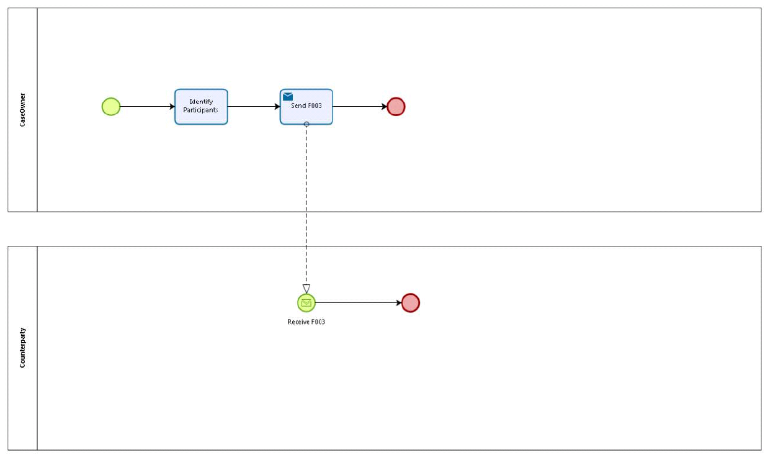

Sub Processess
n/a

Appendices

6.1 Issues

# | Issue date | Description | Solution | Close date
1
2

