

EESSI Business Use Case

Approved

H_BUC_01
Adhoc Exchange of Information



Table of Contents

Table of Contents 2
1. Introduction 6
1.1. Purpose 6
1.2. Scope 6
1.3. Definitions, Acronyms and Abbreviations 6
1.4. References 7
1.5. Overview 7
2. Description 8
2.1. Business Scenario 8
2.2. Legal Base 8
3. Actors & Roles 9
4. Use Case 10
4.1. RUP Table Representation 10
4.2. Request – Reply SEDs 13
4.3. Attachments Allowed 13
4.4. Artefacts used 13
5. Business Processes 15
5.1. Case Owner and Counterparty 15
5.2. Sub Processes 16
6. Appendices 17
6.1. Issues 17

Document Control Information
Settings | Value
Document Title: | Business Use Case  H_BUC_01 - Adhoc Exchange of Information
Project Title: | EESSI (Electronic Exchange of Social Security Information) Project
Document Author: | European Commission, DG EMPL F5
System Owner: | European Commission, DG EMPL D2
Doc. Version: | v4.1.0
Sensitivity: | Public
Date: | 20/07/2018

Document history:
The Document Author is authorized to make the following types of changes to the document without requiring that the document be re-approved:
- Editorial, formatting, and spelling
- Clarification
To request a change to this document, contact the Document Author or Owner.

Revision | Date | Created by | Short Description of Changes
v0.3 | 20/02/14 | Reginald Amade | Initial draft
v0.4 | 28/02/14 | Reginald Amade | Reworked 1.1, 3, 4 & 5
v0.5 | 09/07/14 | Phil Cummings | See Review comments sheet
v0.6 | 10/09/14 | Phil Cummings | Altered Loop to allow H001 to allow a new instance of H001 to be sent after an H001. Branch 1 altered to reflect.  H002 reply sent to all participants
v0.7 | 30/01/15 | Phil Cummings | Exception 1 Removed  Alternative branch 9 Removed
v0.8 | 22/06/15 | Eric Briffoz | - Added branch 2b: possibility for the case owner to do a forward as well.  - Rewording competent institution in par. 3 Actors & Roles.  - Correction Name of the SED H001: "Notification / request for information"
v0.99.0 | 20/11/2015 | Phil Cummings | Candidate for AHG Approval  Inclusion of Request-Reply Table  Inclusion of Attachment Allowed Table  Inclusion of SED & Sub-process Versioning Information
v1.0.0 | 10/03/2016 | Phil Cummings | AC APPROVED VERSION
v1.0.1 | 25/05/2016 | Anda Mirita | Added minor textual changes following the comments received from the AC  Reformulated point 8 in main scenario to state: All participants receive the H002.
v1.0.2 | 28/06/2017 | Dragos Gorjan | -Updated BPMN diagram in "Section 5. Business Processes" to correspond to the described process.  -Included the BPMN diagram version used in section 5.  -Replaced the reference to the BUC on Confluence.
v1.0.3 | 30/10/2017 | Heidi Warson | Updated section 4.1 RUP Table Representation:  - branches 2, 3, 7 and 8 to align forward and invalidate wording to the standard wording;  - all Admin sub process branches: rephrased "The process resumes [at the step at which it branched]" to "The Branch Ends".  Removed Section 4.4 RUP UC Diagram Representation.  Section 4.5 SED and Sub-process Versioning: included H_BUC_04 and H_BUC_10 (as not used for this BUC) in table "Sub processes' Table.  Section 5: rephrase introduction text for this section to the standard text.
v4.1.0 | 20/07/2018 | Novella Bacelli | - Removed SR for main scenario invocation and added SR for branch 1  - Added "revert to step 5" at the end of branch 1, to allow multiple exchange of SEDs  - Removed SR for branch 9  - Added AD_BUC_12 in subprocess table  - Section 4.4 merged 2 tables (for SED & for Subprocesses) into 1 BUC Artefact table."  - Version adaptations to release 4.1.0

Introduction

Purpose
The purpose of this document is to construct an external view of, part of, the 'EESSI business system' as described in EC Regulations 883/2004 and 987/2009. The ‘EESSI Business System’ describes the business and expected business processes without consideration as to which part(s) may be realized by an IT System (i.e. the proposed EESSI IT System).

The external view comprises of models and descriptions of business use cases, the services of a business system offered to business actors: customers, business partners, or other business systems.

A business use case is described from an actor's perspective; it describes the interaction between an actor and the business system, meaning it describes the behaviours of the business system that the actor utilizes. The Business Use Case includes Use Case Diagrams and Business Process Models.
Use case diagrams show actors, business use cases, and their relationships. Use case diagrams do not describe procedures. Alternative scenarios also remain hidden. These diagrams give a good overview of the behaviours of the EESSI business system which will direct and govern part of the expected behaviours and functionality delivered by the EESSI IT System.

Scope
This document is limited to the external view on the horizontal sector process of Adhoc Exchange of Information. The different elements like use case description, business actors, and business process as well as supporting UML diagrams and BPMN models pertaining to Adhoc Exchange of Information.

Definitions, Acronyms and Abbreviations
Please see the EESSI Project Glossary here

References
# | Description
1 | EC Regulation 883/2004 | Regulation EC No 883- 2004.pdf
2 | EC Regulation 987/2009 | Regulation EC No 987-2009.pdf
3 | UML 2.x | http://www.omg.org/spec/UML/
4 | BPMN 2.0 | http://www.omg.org/spec/BPMN/index.htm
5 | UML 2.0 In Action | Henriette Baumann, Patrick Grassle & Philippe Baumann, 2005, ISBN 1904811558
6 | RUP@EC standard 5.0 | http://www.cc.cec/RUPatEC_Standard/
7 | RUP op maat | http://www.rupopmaat.nl/

Overview
Chapter1 introduces the external view on the business system under review and lists the elements of this specification.
Chapter 2 introduces the Adhoc Exchange of Information business process. The chapter gives a short and detailed description as well as a reference to business process´ legal base.
Chapter 3 lists the actors involved in the Adhoc Exchange of Information business process.
Chapter 4 describes in detail the Adhoc Exchange of Information business process based on the RUP use case template, as well as the relationship to other use cases.
Chapter 5 describes the Adhoc Exchange of Information business process using business process modelling notation (BPMN).

Description

Business Scenario
H_BUC_01 is a business process that is used to request, or communicates, information based on the general cooperation requirements described in Article 76 of the basic Regulation (EC) No 883/2004.

Legal Base
This Business Use Case document's legal base is described in the following Regulations

- basic Regulation (EC) No 883/2004
- implementing Regulation (EC) No 987/2009
The following matrix specifies the SEDs that are used in this Business Use Case and documents the articles that provide the legal basis for each SED.

 | Basic Reg. (883/04)
SED | Article 76
H001
H002
Table 1: SED – Legal base relationship matrix

Actors & Roles
This chapter captures details of the actors which are important to understanding the different types of system users. An actor is anyone or anything that exchanges data with the business system. An actor can be a user, external hardware, or another system.
The overarching description of each actor described in this Business Use Case can be found in the Glossary. Below you will find a short description which provides further clarity of this actor within the context of this Business Use Case.
Actor name | Description
Case Owner | In this BUC the Case Owner is an institution that initiates the adhoc exchange of information.
Counterparty | In this BUC the Counterparty is an institution that returns information to the requesting Case Owner.

Use Case

RUP Table Representation
Use Case ID: | H_BUC_01
Use Case Name: | Adhoc Exchange of Information
Created By: | Reginald Amade |  | Last Updated By: | Novella bacelli
Date Created: | 11/11/2013 |  | Last Revision Date: | 20/07/2018
Actors: |  | Case Owner  Counterparty
Description: |  | This business use case describes the scenarios that institutions need to take in order to comply with the Regulation by communicating to each other useful information regarding the case or event that might influence the right to a benefit provided under Regulation (EC) No 883/2004;
Trigger: |  | - An institution becomes aware of useful information regarding the case or event that might influence the right to a benefit  - An institution becomes aware they need additional Information from another institution
Preconditions: |  | - The Case Owner has taken measures to implement Regulation EC No 883/2004  - The Case Owner's legislation has changed which may affect the implementation of Regulation EC No 883/2004  - The Case Owner needs more information
Post conditions: |  | The Case Owner has successfully received the ad-hoc information they need.
Main Scenario: |  | Identify Participants  - The Case Owner identifies the EU Member States they want to send information to or get information from;  - The Case Owner then identifies the correct institution or institutions (the Counterparty(ies)) in each Member State should receive the information or who can send them information. There will be one Counterparty or more. The Case Owner and the Counterparty(ies) are herein collectively referred to as the Participants;  Send Request  - The Case Owner fills in a "Notification / request for Information" (H001) by entering all the required information  - The Case Owner sends the H001, including any attachments, to all Counterparties;  Check and Send Reply  - Each Counterparty receives and reviews the H001 document  - Each Counterparty optionally may choose to fill in a "Reply To request for Information" (H002) by entering all the required information;  - Each Counterparty who filled in a H002 sends their H002, including any attachments to all participants  - All participants receive the H002;  - The use case ends here.
Alternative Scenarios: |  | Branch 1: at any step between [step 4] and [step 9] The Case Owner may need to request more information  - The Case Owner fills in a "Notification / request for Information" (H001) by entering all the required information  - The Case Owner sends the H001, including any attachments, to all Counterparties;  - This Branch Ends and reverts to [step 5] of main scenario
 |  | The Following Branches determine the use of Horizontally Defined Processes within this Business Process
Branch 2: at any step between [step 5] and [step 9] the Counterparty may choose to Forward this Business Process to another Institution within their MS who assumes responsibility for handing it

- The Counterparty executes business use case AD_BUC_05_Subprocess- Forward Case;
- This Branch Ends.

Branch 2b: at any step between [step 4] and [step 9], the Case Owner may choose to Forward this Business Process to another institution within their MS who assumes responsibility for handling it

- The Case Owner executes business use case AD_BUC_05_Subprocess- Forward Case;
- This Branch Ends.

Branch 3: at any step between [step 4] and [step 9] the Case Owner may choose to Remove a Counterparty from this Business Process

- The Case Owner executes business use case AD_BUC_04_Subprocess – Remove Participant;
- This Branch Ends.

Branch 4: at any step between [step 4] and [step 9] the Case Owner may choose to Add a Counterparty to this Business Process

- The Case Owner executes business use case AD_BUC_03_Subprocess – Add Participant;
- This Branch Ends.

Branch 5: at any step between [step 4] and [step 7] the Case Owner may choose to send an updated version of H001

- The Case Owner executes business use case AD_BUC_010_Subprocess - Update_SED;
- This Branch Ends.

Branch 6: at any step between [step 6] and [step 9] a Counterparty may choose to send an updated version of their H002

- The Counterparty executes business use case AD_BUC_10_Subprocess - Update_SED;
- This Branch Ends.

Branch 7: at any step between [step 4] and [step 7] the Case Owner, who sent the H001, may choose to advise all recipients of their H001 that it is Invalid under Art 5 of 987/09

- The Case Owner executes business use case AD_BUC_06_Subprocess - Invalidate_SED;
- Optionally, the Case Owner fills in a "Notification / request for Information" (H001) by entering all the required data;
- Optionally, the Case Owner sends the H001, including any attachments, to all Counterparties;
- This Branch Ends.

Branch 8: at any step between [step 6] and [step 9] the Counterparty, who sent the H002, may choose to advise all recipients of their H002 that it is Invalid under Art 5 of 987/09

- The Counterparty executes business use case AD_BUC_06_Subprocess - Invalidate_SED;
- Optionally, the Counterparty fills in a "Reply To request for Information" (H002) by entering all the required data;
- Optionally, the Counterparty sends the H002, including any attachments, to all participants;
- This Branch Ends.

 |  | Branch 9: - Removed-
Branch 10: at any step between [step 4] and [step 9] any Participant may optionally choose to send a Reminder to another Participant for the return of information they were expecting from that Participant but did not receive.

- The participant who invokes this branch executes business use case AD_BUC_07_Subprocess -_Reminder;
- This Branch Ends.

Exceptions: |  | -Removed-
Includes: |  | See section 4.4
Special Requirements:: |  | SR1: H001 can be used to request/notify information;  SR2: H002 can only be sent after receiving an H001;  SR3: Rules about the destination for each SED type;  - H001 must be sent to all Counterparties;  - H002 may be sent to one or more Active Participants;  SR4: Rules about invoking branches  - The Main Scenario SR on main scenario removed  Administrative  - [Branch 1] may be invoked more than once;  - [Branch 2] may be invoked more than once;  - [Branch 3] may be invoked more than once, provided that at least two Participants (Case Owner & 1 Counterparty) remain;  - [Branch 4] may be invoked more than once;  - [Branch 5] may be invoked more than once;  - [Branch 6] may be invoked more than once;  - [Branch 7] may be invoked more than once;  - [Branch 8] may be invoked more than once;  - [Branch 9] Removed;  - [Branch 10] may be invoked more than once;  SR5: The term "Send/Sent to All Active Participants" does not include sending it himself (i.e. to then senders institution);  SR6: Active Participants are defined as those participants identified at [Step 2] and those participants added through the execution of [Branch 4] and not removed through the execution of [Branch 3];
Assumptions:
Notes and Issues:

Request – Reply SEDs
The following table specifies and SED that have a logical pairing to one another, usually this is known as a request-reply pair.
REQUEST SED | REPLY SED(s)
H001 | H002

Attachments Allowed
The following table specifies whether attachments are permitted to be included when sending a SED type.
SED | Attachments
H001 | Allowed
H002 | Allowed

Artefacts used
The following table specifies the artefacts that are used in this Business Use Case.
Artefact name | Artefact type
H001 | SED
H002 | SED
AD_BUC_03_Subprocess – Add Participant | BUC spec
AD_BUC_04_Subprocess – Remove Participant | BUC spec
AD_BUC_05_Subprocess – Forward Case | BUC spec
AD_BUC_06_Subprocess – Invalidate SED | BUC spec
AD_BUC_07_Subprocess – Reminder | BUC spec
AD_BUC_10_Subprocess – Update SED | BUC spec
AD_BUC_11_Subprocess – Business Exception | BUC spec
AD_BUC_12_Subprocess – Change of Participant | BUC spec

Business Processes
This chapter describes the Business Use Case Adhoc Exchange of Information using BPMN 2.0.

Case Owner and Counterparty

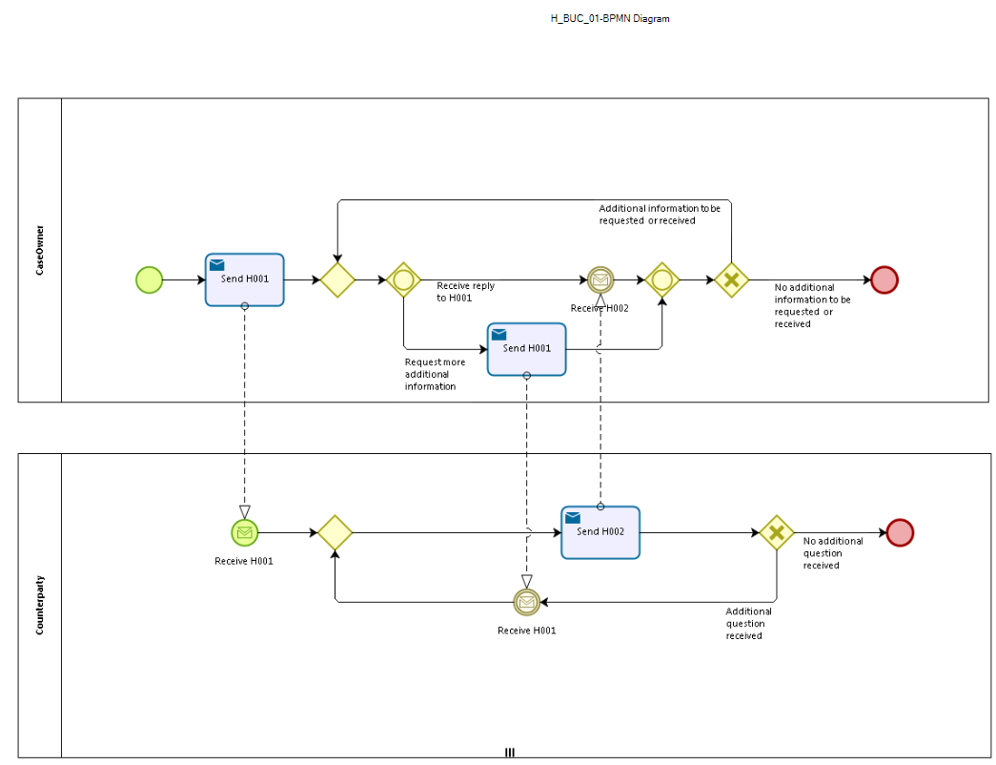

Sub Processes
Not applicable.

Appendices

Issues
The issues listed below need to be added to the issue log and discussed at the proper communication level.
# | Issue date | Description | Solution | Close date
1

