

APPROVED



EESSI Business Use Case
H_BUC_02_Subprocess Determine Residence

Table of Contents

1. Introduction 4
1.1. Purpose 4
1.2. Scope 4
1.3. Definitions, Acronyms and Abbreviations 4
1.4. References 5
1.5. Overview 5
2. Description 6
2.1. Business Scenario 6
2.2. Legal Base 6
3. Actors & Roles 7
4. Use Case 8
4.1. RUP Table Representation 8
4.2. Request – Reply SEDs 11
4.3. Attachments Allowed 11
4.4. Artefacts used 11
5. Business Processes 12
6. Appendices 13
6.1. Issues 13

Document Control Information

Settings | Value
Document Title: | Business Use Case  H_BUC_02_Subprocess-Determine Residence
Project Title: | EESSI (Electronic Exchange of Social Security Information) Project
Document Author: | European Commission, DG EMPL F5
System Owner: | European Commission, DG EMPL D2
Doc. Version: | v4.1.0
Sensitivity: | Public
Date: | 24/08/2018

Document history:
The Document Author is authorized to make the following types of changes to the document without requiring that the document be re-approved:
- Editorial, formatting, and spelling
- Clarification
To request a change to this document, contact the Document Author or Owner.

Revision | Date | Created by | Short Description of Changes
v0.1.0 | 19/07/2016 | Anda Mirita | Initial Draft
v0.2.0 | 29/07/2016 | Anda Mirita | Modified Main Scenario  Added Branch 1 and Branch 2
v0.99.0 | 27/09/2016 | Anda Mirita | Submitted for AC Approval
v1.0.0 | 21/10/2016 | Anda Mirita | AC Approved Version
v1.0.1 | 30/06/2017 | Dragos Gorjan | -Updated BPMN diagram in "Section 5. Business Processes" to correspond to the described process.  - Adapted reference to BUC confluence page in Configuration Management
v1.0.2 | 03/11/2017 | Heidi Warson | Updated section 4.1 RUP Table Representation: branches 3, 4 and 5 to align invalidate wording to the standard wording.
v4.1.0 | 24/08/2018 | Novella Bacelli | - Section 4.4 merged 2 tables (for SED & for Subprocesses) into 1 BUC Artefact table."  - Version adaptations to release 4.1.0

Introduction

Purpose
The purpose of this document is to construct an external view of, part of, the 'EESSI business system' as described in EC Regulations 883/2004 and 987/2009. The ‘EESSI Business System’ describes the business and expected business processes without consideration as to which part(s) may be realized by an IT System (i.e. the proposed EESSI IT System).
The external view comprises of models and descriptions of business use cases, the services of a business system offered to business actors: customers, business partners, or other business systems.
A business use case is described from an actor's perspective; it describes the interaction between an actor and the business system, meaning it describes the behaviours of the business system that the actor utilizes. The Business Use Case includes Use Case Diagrams and Business Process Models.
Use case diagrams show actors, business use cases, and their relationships. Use case diagrams do not describe procedures. Alternative scenarios also remain hidden. These diagrams give a good overview of the behaviours of the EESSI business system which will direct and govern part of the expected behaviours and functionality delivered by the EESSI IT System.

Scope
This document is limited to the external view on the horizontal sector process Determine Residence. The different elements like use case description, actors, and business process as well as supporting UML diagrams and BPMN models pertaining to the ending of a process.

Definitions, Acronyms and Abbreviations
Please see the EESSI Project Glossary.

References
# | Description
1 | EC Regulation 883/2004 | Regulation EC No 883- 2004.pdf
2 | EC Regulation 987/2009 | Regulation EC No 987-2009.pdf
3 | UML 2.x | http://www.omg.org/spec/UML/
4 | BPMN 2.0 | http://www.omg.org/spec/BPMN/index.htm
5 | UML 2.0 In Action | Henriette Baumann, Patrick Grassle & Philippe Baumann, 2005, ISBN 1904811558
6 | RUP@EC standard 5.0 | http://www.cc.cec/RUPatEC_Standard/
7 | RUP op maat | http://www.rupopmaat.nl/

Overview
Chapter 1 introduces the external view on the business system under review and lists the elements of this specification.
Chapter 2 introduces us to the Determine Residence business process. The chapter gives a short and detailed description as well as a reference to business process´ legal base.
Chapter 3 lists the actors involved in Determine Residence business process.
Chapter 4 describes in detail the Determine Residence business process based on the RUP use case template, as well as the relationship to other use cases.
Chapter 5 describes the Determine Residence business process using business process modelling notation (BPMN).

Description

Business Scenario
H_BUC_02_Subprocess is a sub process that allows a Member State determine the persons residence in accordance with EU law.

Legal Base
This document's legal base is found in the following EC Regulations:
- basic Regulation (EC) No 883/2004
- implementing Regulation (EC) No 987/2009

The following matrix specifies the SEDs that are used in this Business Use Case and documents the articles that provide the legal basis for each SED.

SED | implementing Regulation 987/2009 |  | Basic Regulation 883/2004
SED | 11 | 76
H003
H004
H005
H006

Table 1: SED – Legal base relationship matrix

Actors & Roles
This chapter captures details of the actors which are important to understanding the different types of system users. An actor is anyone or anything that exchanges data with the business system. An actor can be a user, external hardware, or another system.
The overarching description of each actor described in this Business Use Case can be found in the Glossary. Below you will find a short description which provides further clarity of this actor within the context of this Business Use Case.

Actor name | Description
Triggering Participant | The Triggering Participant is an active participant in the main process who triggers this BUC. This will be an Institution where the main process permits their role to do so
Other Participant(s) | Other Participant(s) represents all other active participants in the main process. This will be one or more Institutions as determined by the main process.
Table 2: Actors & Roles

Use Case

RUP Table Representation
Use Case ID: | H_BUC_02_Subprocess
Use Case Name: | Determine Residence
Created By: | Anda Mirita |  | Last Updated By: | Heidi Warson
Date Created: | 19/07/2016 |  | Last Revision Date: | 03/11/2017
Actors: |  | Triggering Participant  Other Participant(s)
Description: |  | H_BUC_02_Subprocess is a sub process that allows a Member State determine the persons residence in accordance with EU law.
Trigger: |  | Triggering Participant requests Person Residence Information from one or more other Participant(s).
Preconditions: |  | A case exists and triggers this BUC.
Post conditions: |  | The Person's Residence is established.
Main Scenario: |  | - The Triggering Participant fills in a Request for Information on Residence (H005) by entering all the required Information;  - The Triggering Participant sends the H005, including any attachments, to all other Participant (s);  - Each other Participant (s) receives and views an H005, and attachments;  - Each other Participant(s) fills in a Reply to Request for Information on Residence (H006) by entering all required information;  - Each other Participant(s) sends their H006, including any attachments, to all Participants;  - The Triggering Participant receives all (H006) replies, views them and determines the Person's Residence;  The use case ends here.
Alternative Scenarios: |  | Branch 1: at [step1] or immediately after [step1] of the main scenario, the Triggering Participant wants to notify the State of Residence by sending H003  - The Triggering Participant fills in a Proposal/Notification on State of Residence (H003);  - The Triggering Participant sends the H003 to all other Participant (s);  - Each other Participant(s) receives, views the H003;  - Each other Participant(s) fills in a Reply to Proposal on Residence (H004);  - This [Branch] Ends.
Branch 2: at [step1] or immediately after [step1] of the main scenario, the Triggering Participant wants to send a Reply to Proposal on State of Residence/Disagreement with decision on State of Residence by sending H004
- The Triggering Participant fills in a Proposal on State of Residence/Disagreement with decision on State of Residence (H004);
- The Triggering Participant sends the H004 to all other Participant (s);
- Each other Participant(s) receives, views the H004;
- This [Branch] Ends.

 |  | The Following Branches determine the use of Administrative Defined Processes within this Business Process
Branch 3: after [step 5] of the main scenario, the Triggering Participant may choose to advise all recipients of their H005 SED that it is Invalid under Art 5 of 987/09
- The Triggering Participant executes business use case AD_BUC_06_ Subprocess -Invalidate_SED;
- Optionally, the Triggering Participant fills in a Request for Information on Residence (H005) by entering all the required data;
- Optionally, the Triggering Participant sends the H005, including any attachments, to all other Participant(s);
- [This Branch] Ends.

Branch 4: after [step 9] of the main scenario, the other Participant(s) may choose to advise all recipients of their H006 SED that it is Invalid under Art 5 of 987/09
- The other Participant executes business use case AD_BUC_06_ Subprocess -Invalidate_SED;
- Optionally, the other Participant fills in a Reply to Request for Information on Residence (H006) by entering all the required data;
- Optionally, the other Participant sends the H006, including any attachments, to all Participants;
- [This Branch] Ends.

Branch 5: At any step any participant may choose to advise the other receiving participant of their H003 SED that it is Invalid under Art 5 of 987/09.

- The Triggering participant executes business use case AD_BUC_06_ Subprocess -Invalidate_SED;
- Optionally, the Triggering participant fills in a new H003 SED by entering all the required data;
- Optionally, the Triggering participant sends the H003 SED, including any attachments, to the receiving participant(s).
- [This Branch] Ends.

Branch 6: At any step any SED has been sent, any participant which created that SED may choose to send an updated version of that SED

- The Triggering participant executes business use case AD_BUC_10-Subprocess - Update_SED;
- [This Branch] Ends.

Exceptions:
Includes: |  | This BUC is exclusively used as an <<include>> in other sectorial business processes.
Special Requirements: |  | SR1: Rules about the invoking of Branches:  [Branch 1] – May be invoked more than once;  [Branch 2] – May be invoked more than once;  Administrative  [Branch 3] – May be invoked more than once;  [Branch 4] – May be invoked more than once;  [Branch 5] – May be invoked more than once;  [Branch 6] – May be invoked more than once;  SR2: Rules about the destination for each SED Type:  H003 – Must be Sent to all Active Participants;  H004 - Must be Sent to all Active Participants;  H005 – Must be Sent to all active Participants;  H006 – Must be Sent to Requester;  SR3: The term "Send/Sent to All Active Participants" does not include sending it himself (i.e. to then senders institution).
Assumptions:
Notes and Issues:

Request – Reply SEDs
The following table specifies the SED that have a logical pairing to one another, usually this is known as a request-reply pair.
REQUEST SED | REPLY SED(s)
H003 | H004
H005 | H006

Attachments Allowed
The following table specifies whether attachments are permitted to be included when sending a SED type.
SED | Attachments
H003 | Allowed
H004 | Allowed
H005 | Allowed
H006 | Allowed

Artefacts used
The following table specifies the artefacts that are used in this Business Use Case.
Artefact name | Artefact type
H003 | SED
H004 | SED
H005 | SED
H006 | SED

Business Processes
The following model describes the Business Use Case Determine Residence subprocess using BPMN 2.0.

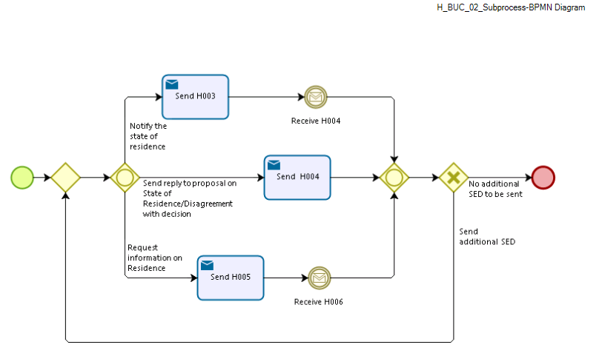
Figure 1

Appendices

Issues
# | Issue date | Description | Replies | Action/Resolution | Close date
1
2
3
4
5
6
7
8
9

