

EESSI Business Use Case

Approved

H_BUC_02c -
Determine Residence – Notification on state of residence



Table of Contents

Table of Contents 2
1. Introduction 5
1.1. Purpose 5
1.2. Scope 6
1.3. Definitions, Acronyms and Abbreviations 6
1.4. References 7
1.5. Overview 7
2. Description 8
2.1. Business Scenario 8
2.2. Legal Base 8
3. Actors & Roles 9
4. Use Case 10
4.1. RUP Table Representation 10
4.2. Request – Reply SEDs 13
4.3. Attachments Allowed 13
4.4. Artefacts used 13
5. Business Processes 14
5.1. Case Owner & Counterparty (ies) 15
5.2. Sub Processes 16
6. Appendices 17
6.1. Issues 17

Document Control Information
Settings | Value
Document Title: |  | Business Use Case  H_BUC_02c – Determine Residence – Notification on State of residence
Project Title: |  | EESSI (Electronic Exchange of Social Security Information) Project
Document Author: |  | European Commission, DG EMPL F5
System Owner: |  | European Commission, DG EMPL D2
Doc. Version: |  | V4.1.0
Sensitivity: |  | Public
Date: |  | 30/08/2018

Document history:
The Document Author is authorized to make the following types of changes to the document without requiring that the document be re-approved:
- Editorial, formatting, and spelling
- Clarification
To request a change to this document, contact the Document Author or Owner.

Revision | Date | Created by | Short Description of Changes
v0.1 | 21/04/2015 | Eric Briffoz | Following AHG Horizontal Meeting 07-08/04/2015, it was agreed to split the original H_BUC_02 (Determine Residence) into 3 BUC's:  a: Request for information on residence  b: Disagreement procedure  c: Notification procedure (this document)
v0.2 | 06/05/2015 | Eric Briffoz | Adaptations following comments received on v0.1 from FI.
v0.3 | 18/05/2015 | Eric Briffoz | Adaptations following comments received on v0.2 from SR:  - Modified starting Step from Branch 3 – Remove Participant  - Modified Starting Step from Branch 6 – Request Clarification.  - Removed references to H004, H005 and H006
v0.4 | 10/06/2015 | Eric Briffoz | - Branch 7 added for the possibility to dispute the Residence.  - Use Case Diagram: Added H_BUC_02-b_SubProcess-Determine Residence- Disagreement Procedure.
v0.5 | 28/07/2015 | Eric Briffoz | Adaptations following review from testing team:  - Correction Branch 5 (Update only if document was not invalidated)  - Correction Branch 7 (Step number)
v0.99.0 | 03/02/2016 | Eric Briffoz | Candidate for AHG Approval  Inclusion of Request-Reply Table  Inclusion of Attachment Allowed Table  Inclusion of SED & Sub-process Versioning Information
v1.0.0 | 10/06/2016 | Phil Cummings | AC APPROVED VERSION
v1.0.1 | 15/06/2016 | Anda Mirita | Updated following AC comments  Removed Claimant from the list of actors  Update case owner description
v1.0.2 | 01/08/2016 | Anda Mirita | Removed Branch 7
v1.0.3 | 29/06/2017 | Dragos Gorjan | - Updated BPMN diagram in "Section 5. Business Processes" to correspond to the described process.  -Replaced the reference to the BUC on Confluence.
v1.0.4 | 18/12/2017 | Heidi Warson | Alignment to the standard description and layout of the BUC:  - Section 2.2 changed title to 'Legal base' and rephrased introduction text;  - Updated section 4.1 RUP Table Representation:  branches 1 and 4 to align forward and invalidate wording to the standard wording;  - Removed Section 4.4 RUP UC Diagram Representation.  - Included H_BUC_04 and H_BUC_10 (as not used for this BUC) in table "Sub processes' Table + H_BUC_02 sub process is not used for this BUC.  - Section 5: rephrase introduction text for this section to the standard text.  - Section 6: removed all subsections except for subsection 'Issues'.
v4.1.0 | 30/08/2018 | Novella Bacelli | - Section 4.4 merged 2 tables (for SED & for Subprocesses) into 1 BUC Artefact table."  - Version adaptations to release 4.1.0.

Configuration Management: Document Location
The latest version of this controlled document is stored in https://webgate.ec.europa.eu/CITnet/confluence/display/EESSI/EESSI+Project+Documentation#PD-2050083

Introduction

Purpose
The purpose of this document is to construct an external view of, part of, the 'EESSI business system' as described in EC Regulations 883/2004 and 987/2009. The ‘EESSI Business System’ describes the business and expected business processes without consideration as to which part(s) may be realized by an IT System (i.e. the proposed EESSI IT System).
The external view comprises of models and descriptions of business use cases, the services of a business system offered to business actors: customers, business partners, or other business systems.
A business use case is described from an actor's perspective; it describes the interaction between an actor and the business system, meaning it describes the behaviours of the business system that the actor utilizes. The Business Use Case includes Use Case Diagrams and Business Process Models.
Use case diagrams show actors, business use cases, and their relationships. Use case diagrams do not describe procedures. Alternative scenarios also remain hidden. These diagrams give a good overview of the behaviours of the EESSI business system which will direct and govern part of the expected behaviours and functionality delivered by the EESSI IT System.

Scope
This document is limited to the external view on the horizontal sector process Determine Residence – Notification of Residence. The different elements like use case description, actors, and business process as well as supporting UML diagrams and BPMN models pertaining to Determine Residence – Notification of Residence.

Definitions, Acronyms and Abbreviations
Please see the EESSI Project Glossary.

References
# | Description
1 | EC Regulation 883/2004 | Regulation EC No 883- 2004.pdf
2 | EC Regulation 987/2009 | Regulation EC No 987-2009.pdf
3 | UML 2.x | http://www.omg.org/spec/UML/
4 | BPMN 2.0 | http://www.omg.org/spec/BPMN/index.htm
5 | UML 2.0 In Action | Henriette Baumann, Patrick Grassle & Philippe Baumann, 2005, ISBN 1904811558
6 | RUP@EC standard 5.0 | http://www.cc.cec/RUPatEC_Standard/
7 | RUP op maat | http://www.rupopmaat.nl/

Overview
Chapter 1 introduces the external view on the business system under review and lists the elements of this specification.
Chapter 2 introduces us to the Determine Residence (c) – Notification business process. The chapter gives a short and detailed description as well as a reference to business process´ legal base.
Chapter 3 lists the actors involved in the Determine Residence (c) – notification business process.
Chapter 4 describes in detail the Determine Residence (c) – notification business process based on the RUP use case template, as well as the relationship to other use cases.
Chapter 5 describes the Determine Residence business process using business process modelling notation (BPMN).

Description

Business Scenario
This Business use case is used to notify an institution in another Member State of the decision concerning residence made in another Member State.
The SED concerned in this BUC is H003, where one Member State informs the other(s) Member State(s) of the person’s Member State of Residence.

Legal Base
This Business Use Case document's legal base is described in the following Regulations
- Implementing Regulation (EC) No 987/2009 Article 11.
- Basic Regulation (EC) No 883/2004 Article 76
The following matrix specifies the SEDs that are used in this Business Use Case and documents the articles that provide the legal basis for each SED.

 | implementing Reg. (987/2009) | Basic Reg. (883/2004)
 | 11 | 76
H003
Table 1: SED – Legal base relationship matrix

Actors & Roles
This chapter captures details of the actors which are important to understanding the different types of system users. An actor is anyone or anything that exchanges data with the business system. An actor can be a user, external hardware, or another system.
The overarching description of each actor described in this Business Use Case can be found in the Glossary. Below you will find a short description which provides further clarity of this actor within the context of this Business Use Case.

Actor name | Description
Case Owner | The case owner is the competent institution of the place of residence which makes the decision on the residence.  This BUC starts with just a notification of the state of residence from the competent institution that has made such a decision.
Counterparty (ies) | The Counterparty (ies) is (are) Competent Institutions who participate in the case initiated by the case owner who will be notified of the state of residence from the competent institution.  In this BUC, there can be more than one counterparty.
Table 2: Actors & Roles

Use Case

RUP Table Representation
Use Case ID: | H_BUC_02c
Use Case Name: | Determine Residence – Notification on State of residence
Created By: | Reginald Amade |  | Last Updated By: | Novella Bacelli
Date Created: | 24/02/2014 |  | Last Revision Date: | 30/08/2018
Actors: |  | Case Owner  Counterparty (ies)
Description: |  | This Business Use Case describes the possibility to notify an institution in another Member State of the decision concerning residence made in another Member State.  This SED can be used independently, like described in this BUC, by starting directly with the SED H003 (Proposal/Notification on State of Residence).
Trigger: |  | - An exchange of information on person's residence has been performed.  - A decision on the person’s residence has been made in a MS
Preconditions: |  | - A notification of residence would be useful to be communicated to other member state (s).
Post conditions: |  | A notification was communicated by the Case owner to one or more counterparties.
Main Scenario: |  | Identify Participants  - The Case Owner identifies the EU Member States where the person lives or works or where the person has previously lived or worked;  - The Case Owner identifies the Competent Institution(s) (the Counterpart(y)(ies)) in each Member State.  There will be one or more Counterpart(y)(ies). The Case Owner and the Counterpart(y)(ies) are herein collectively referred to as the Participants;  Send Request for Information on Residence  - The Case Owner fills in a "Proposal/Notification on State of Residence" (H003) by entering all the required Information on Residence data;  - The Case Owner sends the H003, including any attachments, to all Counterparties;  - Each Counterparty receives and views an H003, and attachments;  - The use case ends here.
Alternative Scenarios: |  | The Following Branches Determine the use of Administrative Processes within this Business Process
Branch 1: at any step after [step 4] , the Counterparty may choose to Forward the Business Process to a new Participant within their MS who assumes responsibility for handling it

- The Counterparty executes business use case AD_BUC_05_Forward Case;
- [This Branch] Ends.

Branch 2: at any step after [step 4] the Case Owner may choose to Add a Counterparty to this Business Process

- The Case Owner executes business use case AD_BUC_03_Add Participant;
- [This Branch] Ends.

Branch 3: at any step after [step 2], the Case Owner may choose to Remove a Counterparty from this Business Process

- The Case Owner executes business use case AD_BUC_04_Remove Participant;
- [This Branch] Ends.

Branch 4: after [step 4] has been executed, the Case Owner may choose to advise all recipients of their H003 that it is invalid under Art 5 of 987/09

- The Case Owner executes business use case AD_BUC_06_Invalidate SED;
- Optionally, the Case Owner fills in a "Proposal/Notification on State of Residence" (H003) by entering all the required data;
- Optionally, the Case Owner sends the H003, including any attachments, to all Counterparties
- [This Branch] Ends.

Branch 5: at any step after [step 4], the Case Owner may choose to send an updated version of H003, provided H003 was not invalidated.

- The Case Owner executes business use case AD_BUC_010 - Update_SED;
- [This Branch] Ends.

Branch 6: at any step after [step 5], the Counterparty may optionally choose to Request the Case Owner to provide clarification of the SED H003.

- The Counterparty executes business use case AD_BUC_08 - Clarify Content;
- [This Branch] Ends.

 |  | Branch 7: [Removed]
Includes: |  | See section 4.4
Special Requirements: |  | SR1: Rules about the invoking of Branches:  [Branch 1] – May be invoked more than once;  [Branch 2] – May be invoked more than once;  [Branch 3] – May be invoked more than once;  [Branch 4] – May be invoked more than once; (Provided a new H003 has been created after invalidation).  [Branch 5] – May be invoked more than once;  [Branch 6] – May be invoked more than once;  SR2: Rules about the destination for each SED Type:  H003 – Must be Sent to all Participants;  SR3: The term "Send/Sent to All Active Participants" does not include sending it himself (i.e. to then senders institution).  SR4: Active Participants are defined as those participants identified at [Step 2] and those participants added through the execution of [Branch 2] and not removed through the execution of [Branch 3].
Assumptions:
Notes and Issues: |  | [List any additional comments about this use case or any remaining open issues or TBDs (To Be Determined) that must be resolved. e.g.

Request – Reply SEDs
The following table specifies and SED that have a logical pairing to one another, usually this is known as a request-reply pair.
REQUEST SED | REPLY SED(s)

Attachments Allowed
The following table specifies whether attachments are permitted to be included when sending a SED type.
SED | Attachments
H003 | Allowed

Artefacts used
The following table specifies the artefacts that are used in this Business Use Case.
Artefact name | Artefact type
H003 | SED
AD_BUC_03_Subprocess – Add Participant | BUC spec
AD_BUC_04_Subprocess – Remove Participant | BUC spec
AD_BUC_05_Subprocess – Forward Case | BUC spec
AD_BUC_06_Subprocess – Invalidate SED | BUC spec
AD_BUC_08_Subprocess – Clarify Content | BUC spec
AD_BUC_10_Subprocess – Update SED | BUC spec
AD_BUC_11_Subprocess – Business Exception | BUC spec
AD_BUC_12_Subprocess – Change of Participant | BUC spec

Business Processes
This chapter describes the Business Use Case Determine residence – Notification on State of Residence, using BPMN 2.0.

Case Owner & Counterparty (ies)
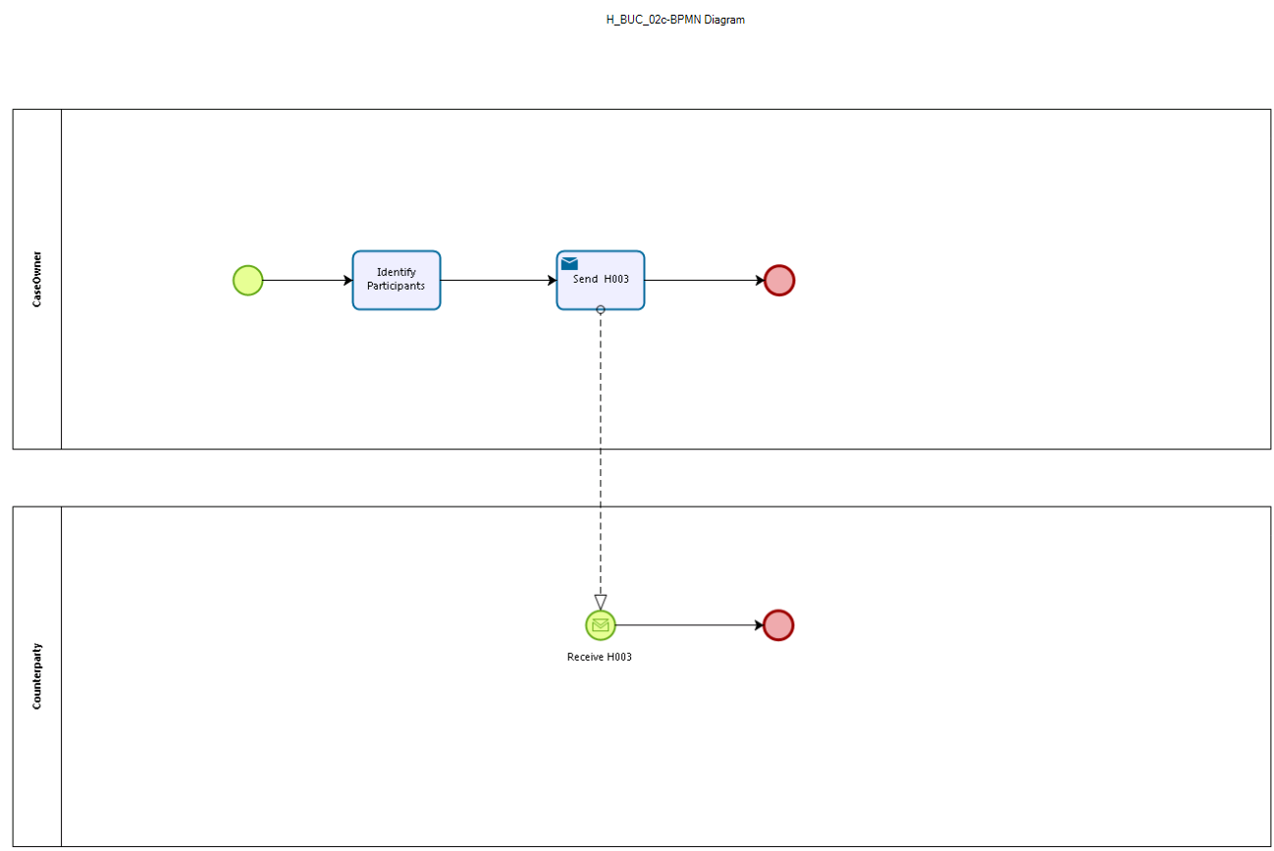

This picture depicts the use case end-to-end, from a high level, using the BPMN 2.0 collaboration diagram

Sub Processes
Not Applicable.

Appendices

Issues
The issues listed below need to be added to the issue log and discussed at the proper communication level.
# | Issue date | Description | Solution | Close date

