

EESSI Business Use Case

Annex Nr.3 to the note AC 370/16rev

ApprovED

H_BUC_03a
Change of Legislation applicable - Notification



Table of Contents

Table of Contents 2
1. Introduction 6
1.1. Purpose 6
1.2. Scope 6
1.3. Definitions, Acronyms and Abbreviations 6
1.4. References 7
1.5. Overview 7
2. Description 8
2.1. Business Scenario 8
2.2. Legal Base 8
3. Actors & Roles 9
4. Use Case 10
4.1. RUP Table Representation 10
4.2. Request – Reply SEDs 13
4.3. Attachments Allowed 13
4.4. Artefacts used 14
5. Business Processes 15
5.1. Case Owner and counterparty(ies) 15
5.2. Sub Processes 16
6. Appendices 17
6.1. Issues 17

Document Control Information
Settings | Value
Document Title: |  | H_BUC_03a -Change of Legislation Applicable - Notification
Project Title: |  | EESSI (Electronic Exchange of Social Security Information) Project
Document Author: |  | European Commission, DG EMPL F5
System Owner: |  | European Commission, DG EMPL D2
Doc. Version: |  | v4.1.0
Sensitivity: |  | Public
Date: |  | 05/07/2018

Document history:
The Document Author is authorized to make the following types of changes to the document without requiring that the document be re-approved:
- Editorial, formatting, and spelling
- Clarification
To request a change to this document, contact the Document Author or Owner.
Revision | Date | Created by | Short Description of Changes
v0.1 | 22/04/2015 | Eric Briffoz | Updated version following AHG Review : it was decided to split H_BUC_03 in 2 separated BUC's:  - H_BUC_03a – Notification (this document)  - H_BUC_03b – Request for information on change of Legislation applicable
v0.99.0 | 25/04/2016 | Eric Briffoz | Candidate for AHG Approval  -Inclusion of Request-Reply Table  -Inclusion of Attachment Allowed Table  -Inclusion of SED & Sub-process Versioning Information
v0.99.1 | 10/06/2016 | Anda Mirita | Updated following comments received from AC  Added Branch 2
v1.0.0 | 06/07/2016 | Phil Cummings | AC Approved Version
v1.0.1 | 29/06/2017 | Dragos Gorjan | -Updated BPMN diagram in "Section 5. Business Processes" to correspond to the described process.
v1.0.2 | 24/11/2017 | Heidi Warson | Alignment to the standard description and layout of the BUC:  - Included a scope section 1.2;  - Section 2.1 changed title to 'Business Scenario' instead of 'Detailed description;  - Section 2.2 changed title to 'Legal base' and rephrased introduction text;  - Updated section 4.1 RUP Table Representation:  Branch 1 and 2: removed step 2, to align wording for the use of H_BUC_01_sup process with the other horizontal BUCs;  branches 3 and 7 to align forward and invalidate wording to the standard wording;  Used 'Case Owner' instead of 'Process Owner for all Admin subprocess branches;  - Removed Section 4.4 RUP UC Diagram Representation.  - Included H_BUC_04 and H_BUC_10 (as not used for this BUC) in table "Sub processes' Table.  - Section 5: rephrase introduction text for this section to the standard text.
v1.0.3 | 15/12/2017 | Novella BACELLI | Moved start of branches 1, 2, 5 and 6 after the Starter SED has been sent and aligned branch 4 & 9 (to step 5 as start step for CP).
v4.1.0 | 05/07/2018 | Novella BACELLI | -Moved the start of branch 3 to step 5, when the Starter SED has already been received by Counterparty  - Section 4.4 merged 2 tables (for SED & for Subprocesses) into 1 BUC Artefact table."  - Version adaptations to release 4.1.0.

Introduction

Purpose
The purpose of this document is to construct an external view of, part of, the 'EESSI business system' as described in EC Regulations 883/2004 and 987/2009. The ‘EESSI Business System’ describes the business and expected business processes without consideration as to which part(s) may be realized by an IT System (i.e. the proposed EESSI IT System).
The external view comprises of models and descriptions of business use cases, the services of a business system offered to business actors: customers, business partners, or other business systems.

A business use case is described from an actor's perspective; it describes the interaction between an actor and the business system, meaning it describes the behaviours of the business system that the actor utilizes. The Business Use Case includes Use Case Diagrams and Business Process Models.
Use case diagrams show actors, business use cases, and their relationships. Use case diagrams do not describe procedures. Alternative scenarios also remain hidden. These diagrams give a good overview of the behaviours of the EESSI business system which will direct and govern part of the expected behaviours and functionality delivered by the EESSI IT System.

Scope
This document is limited to the external view on the horizontal sector process of Change of Legislation Applicable - Notification. The different elements like use case description, business actors, and business process as well as supporting UML diagrams and BPMN models pertaining to Change of Legislation Applicable – Notification.

Definitions, Acronyms and Abbreviations
Please see the EESSI Project Glossary.

References
# | Description
1 | EC Regulation 883/2004 | Regulation EC No 883- 2004.pdf
2 | EC Regulation 987/2009 | Regulation EC No 987-2009.pdf
3 | UML 2.x | http://www.omg.org/spec/UML/
4 | BPMN 2.0 | http://www.omg.org/spec/BPMN/index.htm
5 | UML 2.0 In Action | Henriette Baumann, Patrick Grassle & Philippe Baumann, 2005, ISBN 1904811558
6 | RUP@EC standard 5.0 | http://www.cc.cec/RUPatEC_Standard/
7 | RUP op maat | http://www.rupopmaat.nl/

Overview
Chapter 1 introduces the external view on the business system under review and lists the elements of this specification.
Chapter 2 introduces us to the change of legislation applicable (Notification) business process. The chapter gives a short and detailed description as well as a reference to business process´ legal base.
Chapter 3 lists the actors involved in the change of legislation applicable (Notification) business process.
Chapter 4 describes in detail the business process based on the RUP use case template, as well as the relationship to other use cases.
Chapter 5 describes the business process using business process modelling notation (BPMN).

Description

Business Scenario
This Business Use Case contains the process on change of legislation applicable – Notification, designed to implement Article 20 (2) of Regulation (EC) No 987/2009.

This article describes the cooperation between institutions in situations when a person has become subject to a new Member States legislation.

The Business Use Case can be used to notify the institution in the former Member State on the date when the new Member State’s legislation became applicable to the person concerned.

Legal Base
This Business Use Case document's legal base is described in the following Regulations
- Implementing Regulation (EC) No 987/2009.

The following matrix specifies the SEDs that are used in this Business Use Case and documents the articles that provide the legal basis for each SED.

 | Implementing Reg. (987/09)
 | 20 (2) | 2(2)
H010
Table 1: SED – Legal base relationship matrix

Actors & Roles
This chapter captures details of the actors which are important to understanding the different types of system users. An actor is anyone or anything that exchanges data with the business system. An actor can be a user, external hardware, or another system.
The overarching description of each actor described in this Business Use Case can be found in the Glossary. Below you will find a short description which provides further clarity of this actor within the context of this Business Use Case.

Actor name | Description
Case Owner | In this Business Use Case the Case Owner is the Competent Institution who initiated the notification of change of Legislation Applicable.
Counterparty(ies) | In this Business Use Case the counterpart(y)(ies) is/are the competent Institution who participate in the case for this notification of change of Legislation applicable process.

Use Case

RUP Table Representation
Use Case ID: | H_BUC_03a
Use Case Name: | Change of Legislation Applicable - Notification.
Created By: | Eric Briffoz |  | Last Updated By: | Novella Bacelli
Date Created: | 22/04/2015 |  | Last Revision Date: | 05/07/2018
Actors: |  | Case Owner  Counterpart(y)(ies)
Description: |  | This Business Use Case describes the exchange of the following SED:  - H010 : Notification of Change of Legislation Applicable  It is used by a member state that became competent to notify the previously competent member state of the change of legislation applicable.  Depending on the situation communication may run between two or more Participants.
Trigger: |  | The Case Owner wishes to notify the institution in the former member state of the date when the Legislation became applicable to the person concerned.
Preconditions: |  | Cooperation is needed between MS in situations when a person has become subject to the legislation of the other Member State.
Post conditions: |  | Institution in the former MS has been notified of the date when the legislation became applicable to the person concerned.
Main Scenario: |  | Identify Participants  - The Case Owner identifies the EU Member State(s) with which cooperation is needed regarding a change in legislation applicable for the concerned person.  - The Case Owner identifies the relevant e.g. Competent or designated Institution(s) or liaison body (the Counterpart(y)(ies)) in each Member State that are part of the Legislation applicable Information.  There will be one or more Counterpart(y)(ies). The Case Owner and the Counterpart(y)(ies) are herein collectively referred to as the Participants;  - The Case Owner fills in a Notification of Change of Legislation applicable (H010) by entering all the necessary information regarding Legislation applicable.  - The Case Owner sends the H010 to all counterparties;  - The Counterparty(ies) receives the notification of change of legislation applicable H010 SED.  - The use case ends here.
Alternative scenarios |  | The Following Branches determine the use of Horizontally Defined Processes within this Business Process
Branch 1: at any step after step [4], the Case Owner identifies that more information (usually as regards to Person Identification and insurance sector coverage) is needed to process the Notification
- The Case Owner starts H_BUC_01 – Adhoc Exchange of Information;
- [This Branch] Ends.

Branch 2: at any step after step [5], the Counterparty identifies that more information (usually as regards to Person Identification and insurance sector coverage) is needed to process the Notification
- The Counterparty starts H_BUC_01 – Adhoc Exchange of Information;
- [This Branch] Ends.

 |  | The Following Branches determine the use of Administrative Defined Processes within this Business Process
Branch 3: at any step after [step 5] the Counterparty may choose to Forward this Business Process to another institution within their MS who assumes responsibility for handling it

- The Counterparty executes business use case AD_BUC_05_Forward Case;
- [This Branch] Ends.

Branch 4 : at any step after [step 5], the Counterparty may choose to Add a new counterparty to this Business Process

- The Counterparty executes business use case AD_BUC_03_ Add Participant;
- [This Branch] Ends.

Branch 5: at any step after [step 4], the Case Owner may choose to Add a new Counterparty to this Business Process

1. The Case Owner executes business use case AD_BUC_03_ subProcess Add Participant;
2. [This Branch] Ends.

Branch 6: at any step after [step 4], the Case Owner may choose to Remove a Counterparty from this Business Process

- The Case Owner executes business use case AD_BUC_04_ subProcess Remove Participant;
- [This Branch] Ends.

Branch 7: At any step after [step 4], the Case Owner may choose to advise all recipients of their H010 that it is invalid under Art 5 of 987/09

- The Case Owner executes business use case AD_BUC_06_ subProcess Invalidate SED;
- Optionally, the Case Owner fills in a Notification of Change of Legislation applicable (H010) by entering all the required data;
- Optionally, the Case Owner sends the H010, including any attachments, to all Counterparties;
- [This Branch] Ends.

Branch 8: at any step after [step 4] the Case Owner may choose to send an updated version of H010

- The Case Owner executes business use case AD_BUC_010 - subProcess Update_SED;
- [This Branch] Ends.

Branch 9: at any step after [step 5] the Counterparty may optionally choose to Request the Case Owner to provide clarification of the data that they have sent.

- The Counterparty executes business use case AD_BUC_08 subProcess - Clarify Content;
- [This Branch] Ends.

Includes: |  | See section 4.4
Special Requirements: |  | SR1: H010 can be used to notify on change of legislation application.  SR2: Rules about the invoking of Branches:  [Branch 1] – May be invoked more than once;  [Branch 2] – May be invoked more than once;  [Branch 3] – May be invoked more than once;  [Branch 4] – May be invoked more than once;  [Branch 5] – May be invoked more than once;  [Branch 6] – May be invoked more than once;  [Branch 7] – May be invoked more than once;  [Branch 8] – May be invoked more than once;  SR3: Rules about the destination for each SED Type:  H010 – Must be Sent to all Participants;  SR4: The term "Send/Sent to All Participants" does not include sending it himself (i.e. to then senders institution).  SR5: Participants are defined as those participants identified at [Step 2] and those participants added through the execution of [Branches 3 or 4] and not removed through the execution of [Branch 5].
Assumptions:
Notes and Issues: |  | [List any additional comments about this use case or any remaining open issues or TBDs (To Be Determined) that must be resolved. e.g.

Request – Reply SEDs
The following table specifies and SED that have a logical pairing to one another, usually this is known as a request-reply pair.
Not Applicable

Attachments Allowed
The following table specifies whether attachments are permitted to be included when sending a SED type.
SED | Attachments
H010 | Allowed

Artefacts used
The following table specifies the artefacts that are used in this Business Use Case.
Artefact name | Artefact type
H010 | SED
H_BUC_01_Subprocess | BUC spec
AD_BUC_03_Subprocess – Add Participant | BUC spec
AD_BUC_04_Subprocess – Remove Participant | BUC spec
AD_BUC_05_Subprocess – Forward Case | BUC spec
AD_BUC_06_Subprocess – Invalidate SED | BUC spec
AD_BUC_08_Subprocess – Clarify Content | BUC spec
AD_BUC_10_Subprocess – Update SED | BUC spec
AD_BUC_11_Subprocess – Business Exception | BUC spec
AD_BUC_12_Subprocess – Change of Participant | BUC spec

Business Processes
This chapter describes the Business Use Case Change of Legislation applicable - Notification, using BPMN 2.0.

Case Owner and counterparty(ies)
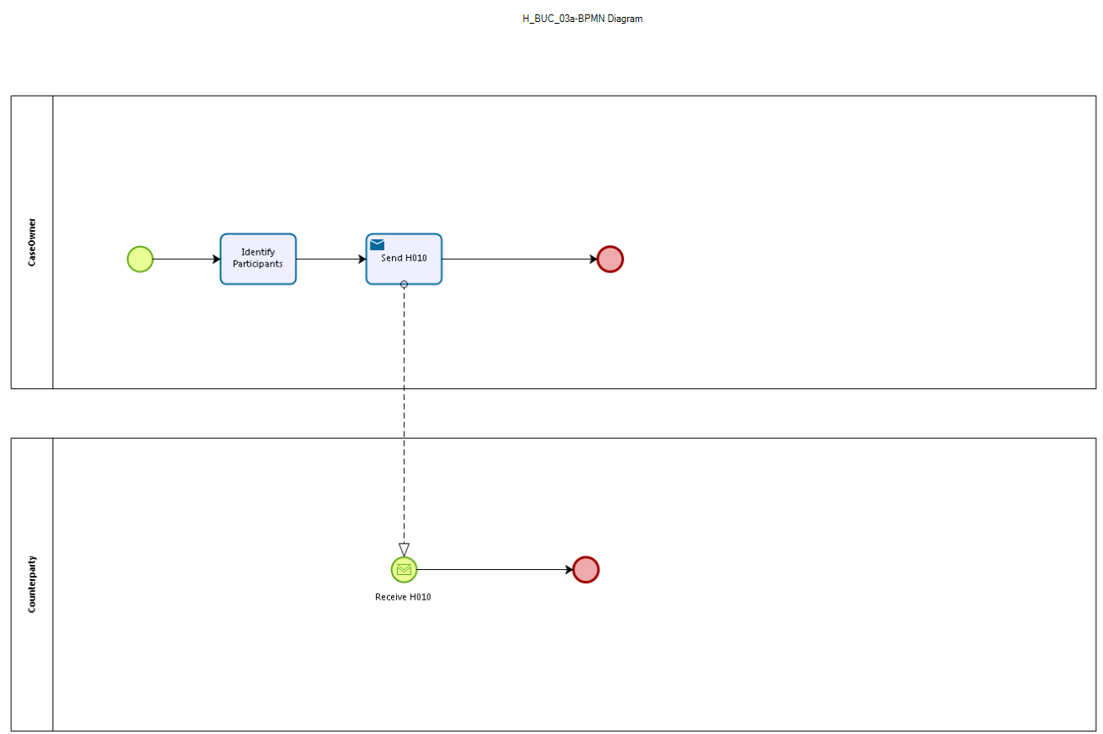
Figure: depicts the use case end-to-end, from a high level, using the BPMN 2.0 collaboration diagram. Based on BPMN Diagram version 1.0.0.4.

Sub Processes
Not Applicable

Appendices

Issues
The issues listed below need to be added to the issue log and discussed at the proper communication level.
# | Issue date | Description | Solution | Close date

