

EESSI Business Use Case

Annex Nr.4 to the note AC 370/16rev

APPROVED

H_BUC_03b – Change of Legislation applicable – Request for information



Table of Contents

Table of Contents 2
1. Introduction 6
1.1. Purpose 6
1.2. Definitions, Acronyms and Abbreviations 6
1.3. Scope 7
1.4. References 7
1.5. Overview 7
2. Description 8
2.1. Business Scenario 8
2.2. Legal Base 8
3. Actors & Roles 9
4. Use Case 10
4.1. RUP Table Representation 10
4.2. Request – Reply SEDs 15
4.3. Attachments Allowed 15
4.4. Artefacts used 15
5. Business Processes 16
5.1. Case Owner and Counterpart(y)(ies) 16
5.2. Sub Processes 17
6. Appendices 18
6.1. Issues 18

Document Control Information
Settings | Value
Document Title: |  | H_BUC_03b Change of Legislation Applicable – Request for information
Project Title: |  | EESSI (Electronic Exchange of Social Security Information) Project
Document Author: |  | European Commission, DG EMPL F5
System Owner: |  | European Commission, DG EMPL D2
Doc. Version: |  | v4.1.0
Sensitivity: |  | Public
Date: |  | 23/07/2018

Document history:
The Document Author is authorized to make the following types of changes to the document without requiring that the document be re-approved:
- Editorial, formatting, and spelling
- Clarification
To request a change to this document, contact the Document Author or Owner.
Revision | Date | Created by | Short Description of Changes
v0.1.0 | 22/04/2015 | Eric Briffoz | New version following AHG Review : it was decided to split H_BUC_03 in 2 separated BUC's:  - H_BUC_03a – Notification  - H_BUC_03b – Request for information on change of Legislation applicable (This document)
v0.99.0 | 25/04/2016 | Eric Briffoz | Candidate for AHG Approval  Inclusion of Request-Reply Table  Inclusion of Attachment Allowed Table  Inclusion of SED & Sub-process Versioning Information
v0.99.1 | 13/06/2016 | Anda Mirita | Updated following comments received from AC
v1.0.0 | 06/07/2016 | Phil Cummings | AC Approved Version
v1.0.1 | 29/06/2017 | Dragos Gorjan | - Updated BPMN diagram in "Section 5. Business Processes" to correspond to the described process.  - Replaced the reference to the BUC on Confluence.
v1.0.2 | 18/12/2017 | Heidi Warson | Alignment to the standard description and layout of the BUC:  - Included a scope section 1.2;  - Section 2.1 changed title to 'Business Scenario' instead of 'Detailed description;  - Section 2.2 changed title to 'Legal base' and rephrased introduction text;  - Updated section 4.1 RUP Table Representation:  branches 2, 9 and 11 to align forward and invalidate wording to the standard wording;  Used 'Case Owner' instead of 'Process Owner for all Admin subprocess branches;  Branch 1: removed step 2, to align wording for the use of H_BUC_01_sup process with the other horizontal BUCs;  - Removed Section 4.4 RUP UC Diagram Representation.  - Included H_BUC_04 and H_BUC_10 (as not used for this BUC) in table "Sub processes' Table.  - Section 5: rephrase introduction text for this section to the standard text.
v4.1.0 | 23/07/2018 | Novella Bacelli | - Updated SR4: H012 must be sent to all participants to align SR with the main description of the BUC  - Section 4.4 merged 2 tables (for SED & for Subprocesses) into 1 BUC Artefact table."  - Version adaptations to release 4.1.0.

Introduction

Purpose
The purpose of this document is to construct an external view of, part of, the 'EESSI business system' as described in EC Regulations 883/2004 and 987/2009. The ‘EESSI Business System’ describes the business and expected business processes without consideration as to which part(s) may be realized by an IT System (i.e. the proposed EESSI IT System).

The external view comprises of models and descriptions of business use cases, the services of a business system offered to business actors: customers, business partners, or other business systems.

A business use case is described from an actor's perspective; it describes the interaction between an actor and the business system, meaning it describes the behaviours of the business system that the actor utilizes. The Business Use Case includes Use Case Diagrams and Business Process Models.
Use case diagrams show actors, business use cases, and their relationships. Use case diagrams do not describe procedures. Alternative scenarios also remain hidden. These diagrams give a good overview of the behaviours of the EESSI business system which will direct and govern part of the expected behaviours and functionality delivered by the EESSI IT System.

Definitions, Acronyms and Abbreviations
Please see the EESSI Project Glossary.

Scope
This document is limited to the external view on the horizontal sector process of Change of Legislation Applicable – Request of Legislation Applicable. The different elements like use case description, business actors, and business process as well as supporting UML diagrams and BPMN models pertaining to Change of Legislation Applicable – Notification.

References
# | Description
1 | EC Regulation 883/2004 | Regulation EC No 883- 2004.pdf
2 | EC Regulation 987/2009 | Regulation EC No 987-2009.pdf
3 | UML 2.x | http://www.omg.org/spec/UML/
4 | BPMN 2.0 | http://www.omg.org/spec/BPMN/index.htm
5 | UML 2.0 In Action | Henriette Baumann, Patrick Grassle & Philippe Baumann, 2005, ISBN 1904811558
6 | RUP@EC standard 5.0 | http://www.cc.cec/RUPatEC_Standard/
7 | RUP op maat | http://www.rupopmaat.nl/

Overview
Chapter 1 introduces the external view on the business system under review and lists the elements of this specification.
Chapter 2 introduces us to the change of legislation applicable – Request for information business process. The chapter gives a short and detailed description as well as a reference to business process´ legal base.
Chapter 3 lists the actors involved in the legislation applicable – Request for information business process.
Chapter 4 describes in detail the business process based on the RUP use case template, as well as the relationship to other use cases.
Chapter 5 describes the business process using business process modelling notation (BPMN).

Description

Business Scenario
This Business Use Case contains the process on change of legislation applicable – Request for information, designed to implement Article 20 (2) of Regulation (EC) No 987/2009.

This article describes the cooperation between institutions in situations when a person has become subject to a new Member States legislation.

The Business Use Case can be used in order to make the information (as well as the date on which the application of that legislation took effect) available to the former Member State upon the request of that Member State.
Depending on the situation, the communication may run between two or more Member States.

If an exchange of information or request for additional information is required (in addition to that provided in this BUC), for example in order to identify the person concerned, H_BUC_01 "Ad-hoc exchange of information" can be used.

Legal Base
This Business Use Case document's legal base is described in the following Regulations
- Implementing Regulation (EC) No 987/2009.
The following matrix specifies the SEDs that are used in this Business Use Case and documents the articles that provide the legal basis for each SED.

 | Implementing Reg. (987/09)
 | 20 (2) | 2(2)
H011
H012
Table 1: SED – Legal base relationship matrix

Actors & Roles
This chapter captures details of the actors which are important to understanding the different types of system users. An actor is anyone or anything that exchanges data with the business system. An actor can be a user, external hardware, or another system.
The overarching description of each actor described in this Business Use Case can be found in the Glossary. Below you will find a short description which provides further clarity of this actor within the context of this Business Use Case.

Actor name | Description
Process Owner | In this Business Use Case the Case Owner is the Competent Institution who requests information on the change of Legislation Applicable.
Counterparty(ies) | In this Business Use Case the counterpart(y)(ies) is/are the competent Institution who participate in the case for this exchange of information for change of Legislation Applicable process.

Use Case

RUP Table Representation
Use Case ID: | H_BUC_03b
Use Case Name: | Change of Legislation Applicable – Request for information
Created By: | Eric Briffoz |  | Last Updated By: | Novella Bacelli
Date Created: | 22/04/2015 |  | Last Revision Date: | 23/07/2018
Actors: |  | Case Owner  Counterpart(y)(ies)
Description: |  | This Business Use Case describes the following exchanges of SED's:  -H011 : "Request of date of change of Legislation Applicable"  -H012: "Reply to request of date of change of Legislation Applicable".  If an exchange of information or request for additional information is required in addition to that provided for in these SED's, H001/H002 may be used.
Trigger: |  | The Case Owner wishes to request information on the change of legislation applicable for the person concerned.
Preconditions: |  | Cooperation is needed between MS in situations when a person has become subject to the legislation of the other Member State.  (Depending on the situation communication may run between two or more Participants.)
Post conditions: |  | The requested information on change of legislation applicable has been provided by the counterparty.
Main Scenario: |  | Identify Participants  - The Case Owner identifies the EU Member State(s) with which cooperation is needed regarding a change in legislation applicable for the concerned person.  - The Case Owner identifies the relevant e.g. Competent or Designated Institution(s) or Liaison Body (the Counterpart(y)(ies)) in each Member State that are part of the Legislation applicable Information).  There will be one or more Counterpart(y)(ies). The Case Owner and the Counterpart(y)(ies) are herein collectively referred to as the Participants;  Send Request on  - The Case Owner fills in a "Request of date of change of Legislation Applicable" (SED H011) by entering all the necessary information regarding the person concerned and Legislation applicable.  - The Case Owner sends the SED H011, including , if necessary attachment(s), to all Participants;  Process Request & Send Reply  - Each Counterparty receives and views an H011, and the possible attachment(s);  - Each Counterparty fills in a " Reply to request of date of change of Legislation Applicable " (H012) by entering all required information;  - Each Counterparty sends their H012, including, if necessary attachments, to all Participants;  Process Replies  - The Case Owner receives all (H012) replies, and reads them;  - The use case ends here.
Alternative scenarios |  | The Following Branches determine the use of Horizontally Defined Processes within this Business Process
- at any step after step [4] the Counterparty identifies that more information (usually as regards to Person identification and insurance sector coverage) is needed to process the request
- The Counterparty starts H_BUC_01– Adhoc Exchange of Information;
- [This Branch] Ends

 |  | The Following Branches determine the use of Administrative Defined Processes within this Business Process
Branch 2: at any step after [step 4] the Counterparty may choose to Forward this Business Process to another institution within their MS who assumes responsibility for handling it

- The Counterparty executes business use case AD_BUC_05_Subprocess Forward Case;
- [This Branch] Ends

Branch 3 : at any step after [step 4], the Counterparty may choose to Add a new counterparty to this Business Process

- The Counterparty executes business use case AD_BUC_03_Subprocess Add Participant;
- [This Branch] Ends

Branch 4: at any step after [step 2], the Case Owner may choose to Add a new Counterparty to this Business Process

- The Case Owner executes business use case AD_BUC_03_Subprocess Add Participant;
- [This Branch] Ends

Branch 5: at any step after [step 2], the Case Owner may choose to Remove a Counterparty from this Business Process

- The Case Owner executes business use case AD_BUC_04_ Subprocess Remove Participant;
- [This Branch] Ends

Branch 6: at any step after [step 4] the Case Owner may optionally choose to send a Reminder to the counterparty for the return of information they were expecting from that participant but did not receive.

- The Case Owner who invokes this branch executes business use case AD_BUC_07_ Subprocess Reminder;
- [This Branch] Ends

Branch 7: at any step after [step 4] any Participant may optionally choose to Request another participant who previously sent them Information provides clarification of the data that they have sent.

- The participant executes business use case AD_BUC_08_ Subprocess Clarify Content;
- [This Branch] Ends

Branch 8: at any step after [step 4], the Case Owner
may choose to send an updated version of H011

- The Case Owner executes business use case AD_BUC_010_ Subprocess Update_SED;
- [This Branch] Ends

Branch 9: At any step after [step 4], the Case Owner may choose to advise all recipients of their H011 that it is invalid under Art 5 of 987/09

- The Case Owner executes business use case AD_BUC_06_ Subprocess Invalidate SED;
- Optionally, the Case Owner fills in a "Request of date of change of Legislation Applicable" (SED H011) by entering all the required data;
- Optionally, the Case Owner sends the H011, including any attachments, to all Counterparties;
- [This Branch] Ends

Branch 10: at any step after [step 7], the Counterparty may choose to send an updated version of H012

- The Counterparty executes business use case AD_BUC_010_ Subprocess Update_SED;
- [This Branch] Ends

Branch 11: at any step after [step 7], the Counterparty may choose to advise all recipients of their H012 that it is invalid under Art 5 of 987/09

- The Counterparty executes business use case AD_BUC_06_ Subprocess Invalidate SED;
- Optionally, the Counterparty fills in a " Reply to request of date of change of Legislation Applicable " (H012) by entering all the required data;
- Optionally, the Counterparty sends the H012, including any attachments, to all participants;
- [This Branch] Ends

Includes: |  | See section 4.4
Special Requirements: |  | SR1: H011 can be used to request information.  SR2: H012 can be used to return information as a reply to H011; it can only be sent after H011.  SR3: Rules about the invoking of Branches:  [Branch 1] – May be invoked more than once;  [Branch 2] – May be invoked more than once;  [Branch 3] – May be invoked more than once;  [Branch 4] – May be invoked more than once;  [Branch 5] – May be invoked more than once;  [Branch 6] – May be invoked more than once;  [Branch 7] – May be invoked more than once;  [Branch 8] – May be invoked more than once;  [Branch 9] – May be invoked more than once;  [Branch 10] – May be invoked more than once;  [Branch 11] – May be invoked more than once;  SR4: Rules about the destination for each SED Type:  H011 – Must be Sent to all Participants;  H012 – Must be Sent to all Participants;  SR5: The term "Send/Sent to All Participants" does not include sending it himself (i.e. to then senders institution).  SR6: Participants are defined as those participants identified at [Step 2] and those participants added through the execution of [Branches 3 and 4] and not removed through the execution of [Branch 5].
Assumptions:
Notes and Issues: |  | [List any additional comments about this use case or any remaining open issues or TBDs (To Be Determined) that must be resolved. e.g.

Request – Reply SEDs
The following table specifies and SED that have a logical pairing to one another, usually this is known as a request-reply pair.
REQUEST SED | REPLY SED(s)
H011 | H012

Attachments Allowed
The following table specifies whether attachments are permitted to be included when sending a SED type.
SED | Attachments
H011 | Allowed
H012 | Allowed

Artefacts used
The following table specifies the artefacts that are used in this Business Use Case.
Artefact name | Artefact type
H011 | SED
H012 | SED
H_BUC_01_Subprocess | BUC spec
AD_BUC_03_Subprocess – Add Participant | BUC spec
AD_BUC_04_Subprocess – Remove Participant | BUC spec
AD_BUC_05_Subprocess – Forward Case | BUC spec
AD_BUC_06_Subprocess – Invalidate SED | BUC spec
AD_BUC_07_Subprocess – Reminder | BUC spec
AD_BUC_08_Subprocess – Clarify Content | BUC spec
AD_BUC_10_Subprocess – Update SED | BUC spec
AD_BUC_11_Subprocess – Business Exception | BUC spec
AD_BUC_12_Subprocess – Change of Participant | BUC spec

Business Processes
This chapter describes the Business Use Case Change of Legislation applicable – Request for information, using BPMN 2.0.

Case Owner and Counterpart(y)(ies)
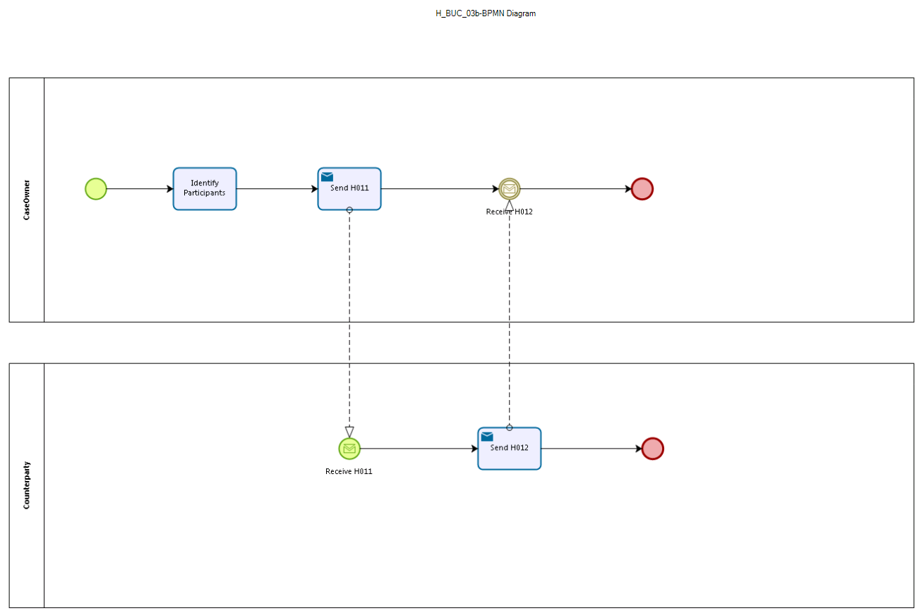
Figure: depicts the use case end-to-end, from a high level, using the BPMN 2.0 collaboration diagram..

Sub Processes

Appendices

Issues
The issues listed below need to be added to the issue log and discussed at the proper communication level.
# | Issue date | Description | Solution | Close date

