

EESSI Business Use Case

ApprovED

H_BUC_04
Reimbursement of Administrative Check or Medical Information



Table of Contents

Table of Contents 2
1. Introduction 7
1.1. Purpose 7
1.2. Scope 7
1.3. Definitions, Acronyms and Abbreviations 7
1.4. References 8
1.5. Overview 8
2. Description 9
2.1. Business Scenario 9
2.2. Legal base 9
3. Actors & Roles 10
4. Use Case 11
4.1. RUP Table Representation 11
4.2. Request – Reply SEDs 14
4.3. Attachments Allowed 14
4.4. Artefacts used 14
5. Business Processes 15
5.1. Case Owner and Counterparty 15
5.2. Sub Processes 15
6. Appendices 16
6.1. Issues 16

Document Control Information
Settings | Value
Document Title: |  | Business Use Case H_BUC 04 -  Reimbursement Administrative Check or Medical Information
Project Title: |  | EESSI (Electronic Exchange of Social Security Information) Project
Document Author: |  | European Commission, DG EMPL F5
System Owner: |  | European Commission, DG EMPL D2
Doc. Version: |  | v4.1.0
Sensitivity: |  | Public
Date: |  | 31/08/2018

Document history:
The Document Author is authorized to make the following types of changes to the document without requiring that the document be re-approved:
- Editorial, formatting, and spelling
- Clarification
To request a change to this document, contact the Document Author or Owner.
Revision | Date | Created by | Short Description of Changes
v0.1 | 08/01/2015 | Eric Briffoz | Initial draft
v0.2 | 22/01/2015 | Eric Briffoz | Update after review from Phil Cummings.
v0.3 | 13/04/2015 | Eric Briffoz | Updates following AHG meeting on 07-08/04/2015.  - Removed AD_BUC_06-Invalidate SED (only update of SED and notion of "credit note")  - Removed AD_BUC_01-End Case  - Removed AD_BUC_02-Reopen Case  - Removed AD_BUC_09-Reject Case
v0.4 | 24/04/2015 | Eric Briffoz | Adaptations following the comments received from Poland on 22/03/2015.  Main changes are:  - Branch 1 added (total reject of the claim)  - Branch 2 added (partial reject of the claim)  - Adaptation of the BPMN accordingly  - Further description of the definition of the Case Owner and the Counterparty
v0.5 | 27/04/2015 | Eric Briffoz | - Correction on 4.1 RUP Table – Description.  - Updated Issues Table, Issue#1.
v0.6 | 19/10/2015 | Eric Briffoz | Minor editorial correction on branch 2.
v0.7.0 | 26/05/2016 | Anda Mirita | H_BUC_04 moved to M_BUC_04  H prefix SEDs moved to M prefix  Updated RUP UC Diagram Representation
v0.8.0 | 14/09/2016 | Anda Mirita | Alignment to the standard description and layout of the BUC.
v0.9.0 | 13/10/2016 | Anda Mirita | As per decision of AHG Horizontal on October 6th, M_BUC_04 has been transferred back to H_BUC_04.  BUC name and SEDs have been updated accordingly.
v0.10.0 | 04/11/2016 | Anda Mirita | Updated following discussion with AHG and comments received from AC  "Process Owner" has been replaced by "Case Owner"  Table of Sub-processes has been updated.
v0.11.0 | 22/11/2016 | Anda Mirita | Updated 4.4 RUP Diagram
v0.12.0 | 23/02/2017 | Anda Mirita | Updated following comments received from AC
v0.13.0 | 27/02/2017 | Anda Mirita | Updated following comments received from AHG  Align BUC Name "H_BUC_04 Reimbursement of costs - administrative check/ medical information" with H_BUC_08 and H_BUC_10  Align SED Names  Branch 6 Updated – "Counterparty" replaced with "Other Participant"  Description of Case Owner and Counterparty has been updated to:  "In this BUC the Case Owner is the Creditor Institution of the Member State of Residence or Stay that claims the reimbursement of administrative check or medical examination requested by the Competent State."  "In this BUC the Counterparty is the Debtor Institution of the Competent Member State that replies for the claim of reimbursement of administrative check or medical examination.  The debtor institution is usually the requesting institution but may differ from the requesting Institution in accordance with the national organization."  Branch 4 – removed – as per Rapporteur decision  Branch 5 – removed- as per Rapporteur decision  Added the Admin BUC invalidate SED after step 4 (4. The Case Owner sends the H020 to the Counterparty) and before step 6 (6. The Counterparty fills in a "Reply to Claim for Reimbursement – Administrative check/Medical examination" (H021)). The invalidate SED can be helpful in case of sending mistakenly a request to an institution or in case the sender realizes that he made a mistake in the claim sent.
v0.99.0 | 28/02/2017 | Anda Mirita | Candidate for AC Approval
v1.0.0 | 16/03/2017 | Anda Mirita | AC Approved version
v1.0.1 | 29/06/2017 | Dragos Gorjan | -Updated Section 5.1 Case Owner – Counterparty – added new diagram H_BUC_04_Diagram v1.0.0.3  Deleted Sub-process section content  Added Not Applicable
v1.0.2 | 18/12/2017 | Heidi Warson | - Updated section 4.1 RUP Table Representation with following clarifications:  Main scenario rephrased from "Process Request & Send Reply" to "Process Request & Send Reply to accept the claim";  Branches 3 and 9 to align forward and invalidate wording to the standard wording;  - Removed Section 4.4 RUP UC Diagram Representation.  - Included H_BUC_04 and H_BUC_10 (as not used for this BUC) in table "Sub processes' Table.
v4.1.0 | 31/08/2018 | Novella Bacelli | - Section 4.4 merged 2 tables (for SED & for Subprocesses) into 1 BUC Artefact table."  - Version adaptations to release 4.1.0

Introduction

Purpose
The purpose of this document is to construct an external view of, part of, the 'EESSI business system' as described in EC Regulations 883/2004 and 987/2009. The ‘EESSI Business System’ describes the business and expected business processes without consideration as to which part(s) may be realized by an IT System (i.e. the proposed EESSI IT System).

The external view comprises of models and descriptions of business use cases, the services of a business system offered to business actors: customers, business partners, or other business systems.

A business use case is described from an actor's perspective; it describes the interaction between an actor and the business system, meaning it describes the behaviours of the business system that the actor utilizes. The Business Use Case includes Use Case Diagrams and Business Process Models.
Use case diagrams show actors, business use cases, and their relationships. Use case diagrams do not describe procedures. Alternative scenarios also remain hidden. These diagrams give a good overview of the behaviours of the EESSI business system which will direct and govern part of the expected behaviours and functionality delivered by the EESSI IT System.

Scope
This document is limited to the external view on the horizontal sector process Reimbursement of Administrative Check or Medical Information. The different elements like use case description, actors, and business process as well as supporting UML diagrams and BPMN models pertaining to Determine Residence – Notification of Residence.

Definitions, Acronyms and Abbreviations
Please see the EESSI Project Glossary.

References
# | Description
1 | EC Regulation 883/2004 | Regulation EC No 883- 2004.pdf
2 | EC Regulation 987/2009 | Regulation EC No 987-2009.pdf
3 | UML 2.x | http://www.omg.org/spec/UML/
4 | BPMN 2.0 | http://www.omg.org/spec/BPMN/index.htm
5 | UML 2.0 In Action | Henriette Baumann, Patrick Grassle & Philippe Baumann, 2005, ISBN 1904811558
6 | RUP@EC standard 5.0 | http://www.cc.cec/RUPatEC_Standard/
7 | RUP op maat | http://www.rupopmaat.nl/

Overview
Chapter 1 introduces the external view on the business system under review and lists the elements of this specification.
Chapter 2 introduces us to the Reimbursement of Administrative Check or Medical Information business process. The chapter gives a short and detailed description as well as a reference to business process´ legal base.
Chapter 3 lists the actors involved in the Reimbursement of Administrative Check or Medical Information business process.
Chapter 4 describes in detail the business process based on the RUP use case template, as well as the relationship to other use cases.
Chapter 5 describes the business process using business process modelling notation (BPMN).

Description

Business Scenario
This BUC contains the cases on reimbursement of administrative check. This BUC is designed to implement Article 87 of Regulation (EC) No 987/2009.

It may be used only after administrative checks / medical exams should be requested, confirmed and provided within a sector case. Its aim is to enable money transfers between institutions of two Member States after the medical examination has been carried out or administrative assistance was provided.

However, whenever a specific sector reimbursement process is defined, this sector specific process should be used.

The following SED's are used in the process:
-H020: Claim for Reimbursement – Administrative Check/Medical Information.
-H021: Reply to Claim for Reimbursement – Administrative Check / Medical Information.

Legal base
This Business Use Case document's legal base is described in the following Regulations
- Implementing Regulation (EC) No 987/2009
The following matrix specifies the SEDs that are used in this Business Use Case and documents the articles that provide the legal basis for each SED.

SED | Implementing Reg. (987/2009)
SED | 87
H020
H021
Table 1: SED – Legal base relationship matrix

Actors & Roles
This chapter captures details of the actors which are important to understand the different types of system users. An actor is anyone or anything that exchanges data with the business system. An actor can be a user, external hardware, or another system.
The overarching description of each actor described in this Business Use Case can be found in the Glossary. Below you will find a short description which provides further clarity of this actor within the context of this Business Use Case.

Actor name | Description
Case Owner | In this BUC the Case Owner is the Creditor Institution of the Member State of Residence or Stay that claims the reimbursement of administrative check or medical examination requested by the Competent State.
Counterparty | In this BUC the Counterparty is the Debtor Institution of the Competent Member State that replies for the claim of reimbursement of administrative check or medical examination.  The debtor institution is usually the requesting institution but may differ from the requesting Institution in accordance with the national organization.
Table 2: Actors & Roles

Use Case

RUP Table Representation
Use Case ID: | H_BUC_04
Use Case Name: | Reimbursement of Administrative Check or Medical Information.
Created By: | Eric Briffoz |  | Last Updated By: | Novella Bacelli
Date Created: | 09/01/2015 |  | Last Revision Date: | 31/08/2018
Actors: |  | Case Owner  Counterparty
Description: |  | This Business Use Case describes the following exchanges of SED's:  - H020: Claim for – Reimbursement – Administrative Check / Medical Information.  - H021: Reply to Claim for Reimbursement – Administrative check/Medical Information.  The main scenario of this BUC will be the approval of the total requested amount.  Alternative scenarios will include :  - Rejection of the whole claim (global)  - Rejection of a part of the requested amount of the claim (one of the individual claims or part of the individual claim)
Trigger: |  | The Case Owner wants to claim a reimbursement for Administrative check(s) / Medical Examination(s).
Preconditions: |  | Administrative check / Medical examination were requested; confirmed and provided within another sectorial case.  The reimbursement of costs of which is required
Post conditions: |  | The claim for reimbursement has been sent and a reply to the request has been received.
Main Scenario: |  | Identify Participants  - The Case Owner identifies the EU Member State that originally requested the Administrative check(s) or Medical report(s) for which reimbursement is requested;  - The Case Owner identifies the Competent Institution the Counterparty in the debtor state.  There will be only one Counterparty.  The Case Owner and the Counterparty are herein collectively referred to as the Participants;  Send Claim for – Reimbursement – Administrative check /Medical information  - The Case Owner fills in a "Claim for - Reimbursement - Administrative check/Medical Information" (H020) by entering all the necessary information regarding the claim;  - The Case Owner sends the H020 to the Counterparty, including any attachment(s) if necessary  Process Request & Send Reply to accept the claim  - The Counterparty receives and views an H020, and any possible attachment(s);  - The Counterparty fills in a "Reply to Claim for Reimbursement – Administrative check/Medical Information" (H021);  - The Counterparty sends its H021 to the Case Owner, including any attachment(s) if necessary;  - The Case Owner receives the "Reply to Claim for Reimbursement – Administrative check/Medical Information" (H021);  - The use case ends here.
Alternative Scenarios: |  | Branch 1: at Step 6, the Counterparty wants to reject the whole claim.  - The Counterparty fills in a "Reply to Claim for Reimbursement – Administrative check/Medical Information" (H021) by entering necessary information regarding the reject of the whole claim;  - The Counterparty sends its H021 to the Case Owner, including any attachment(s) if necessary;  - The Case Owner receives the H021 reply, including any attachments if provided, and verifies its content and sees that the whole claim was rejected;  - [This Branch] Ends and Process Reverts to [Step 3] of the Main Scenario in order to potentially send another claim.
Branch 2: at Step 6, the Counterparty wants to reject a part of the requested amount of the claim.
- The Counterparty fills in a "Reply to Claim for Reimbursement – Administrative check/Medical Information" (H021) by entering necessary information regarding the partial rejection;
- The Counterparty sends its H021 to the Case Owner, including any attachment(s) if necessary;
- The Case Owner receives the H021 reply, including any attachments if provided, verifies its content and takes note that part of the requested amount of the claim was rejected;
- [This Branch] Ends and;
- Process Reverts to [Step 3] of the Main Scenario in order to potentially send another claim.
 |  | The Following Branches Determine the use of Administrative Processes within this Business Process
Branch 3: at any step after [step 5], the Counterparty may choose to Forward the Business Process to a new Participant within their MS who assumes responsibility for handling it.
- The Counterparty executes business use case AD_BUC_05_Subprocess Forward Case;
- [This Branch] Ends.

 |  | Branch 4: Removed
 |  | Branch 5: Removed
Branch 6: at any step between [step 4] and [step 8] any Participant may optionally choose to send a Reminder to other Participant for the return of information they were expecting from that participant but did not receive.
- The participant who invokes this branch executes business use case AD_BUC_07_Subprocess _Reminder;
- [This Branch] Ends.

Branch 7: at any step between [step 4] and [step 8] any Participant may optionally choose to Request another participant who previously sent them Information provides clarification of the data that they have sent.
- The participant executes business use case AD_BUC_08_Subprocess Clarify Content;
- [This Branch] Ends.

 |  | The Following Branches Determine the use of Horizontal Processes within this Business Process
Branch 8: at any step after step [4], any Participant may wish to request Adhoc information to the other party.
- The participant starts H_BUC_01_Subprocess–Adhoc Exchange of Information;
- [This Branch] Ends.

 |  | The Following Branches Determine the use of Administrative Processes within this Business Process
Branch 9: at any step between step[4] and step[6] the Case Owner may choose to advise all recipients of their H020 that it is Invalid under Art 5 of 987/09
- The Case Owner executes business use case AD_BUC_06_Subprocess - Invalidate_SED;
- Optionally, the Case Owner fills in a "Claim for - Reimbursement - Administrative check/Medical Information" (H020) by entering all the required data;
- Optionally, the Case Owner sends the H020, including any attachments, to the Counterparty;
- [This Branch] Ends.

Exceptions: |  | None
Includes: |  | See section 4.4
Special Requirements: |  | SR1: H020 can be used to do a claim for Reimbursement of Administrative Check or Medical Information.  SR2: H021 can be used as a reply to H020; it can only be sent after H020.  SR3: Rules about the invoking of Branches:  [Branch 1] – May be invoked more than once;  [Branch 2] – May be invoked more than once;  [Branch 3] – May be invoked once;  [Branch 4] – Removed  [Branch 5] – Removed  [Branch 6] – May be invoked more than once;  [Branch 7] – May be invoked more than once;  [Branch 8] – May be invoked more than once;  [Branch 9] – May be invoked more than once;  SR4: Rules about the destination for each SED Type:  H020 – Must be Sent to the Counterparty;  H021 – Must be Sent to the Case Owner;
Assumptions:
Notes and Issues:

Request – Reply SEDs
The following table specifies and SED that have a logical pairing to one another, usually this is known as a request-reply pair.
REQUEST SED | REPLY SED(s)
H020 | H021

Attachments Allowed
The following table specifies whether attachments are permitted to be included when sending a SED type.
SED | Attachments
H020 | Allowed
H021 | Allowed

Artefacts used
The following table specifies the artefacts that are used in this Business Use Case.
Artefact name | Artefact type
H020 | SED
H021 | SED
H_BUC_01_Subprocess | BUC spec
AD_BUC_05_Subprocess – Forward Case | BUC spec
AD_BUC_06_Subprocess – Invalidate SED | BUC spec
AD_BUC_07_Subprocess – Reminder | BUC spec
AD_BUC_08_Subprocess – Clarify Content | BUC spec
AD_BUC_11_Subprocess – Business Exception | BUC spec
AD_BUC_12_Subprocess – Change of Participant | BUC spec

Business Processes
This chapter describes the Business Use Case Reimbursement of Administrative Check or Medical Information using BPMN 2.0.

Case Owner and Counterparty
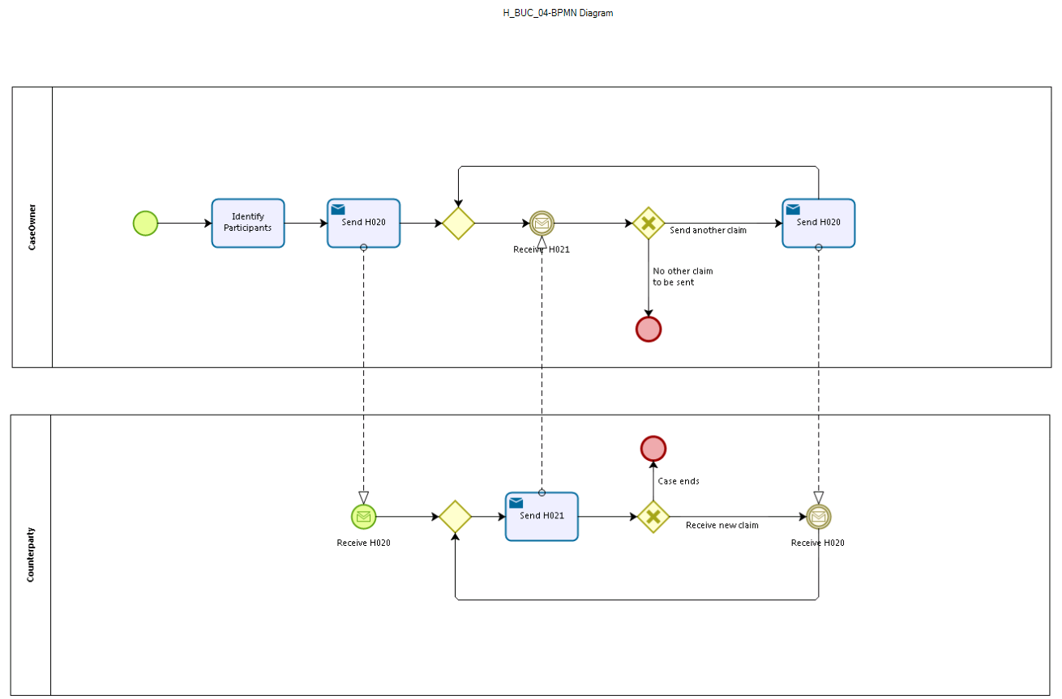

Sub Processes
Not applicable

Appendices

Issues

# | Issue date | Description | Solution | Close date
1 |  | Can claims be mixed? ie can you send a claim (M020) for both Administrative Check & for Medical Information? | No, claims should not be mixed, ie we should expect to receive individual invoices for each type of medical report undertaken.
2 |  | What happens if there is a dispute over the rejected invoices? | To be discussed during next AHG meeting
3 |  | Should the M020 specify whether the invoice is for an Admin Check or Medical Report? (either at global claim or individual claim level) | The content of SED M020 has been transferred to SED H020 and updated as part of SED v4 Batch 2
4 |  | Conversion of the BPMN model to split between Case Owner and Counterparty | Scheduled for Update

