

EESSI Business Use Case

Annex Nr.5 to the note AC 370/16rev

APPROVED

H_BUC_05 –
Exchange of PINs



Table of Contents

Table of Contents 2
1. Introduction 6
1.1. Purpose 6
1.2. Scope 6
1.3. Definitions, Acronyms and Abbreviations 6
1.4. References 7
1.5. Overview 7
2. Description 8
2.1. Business Scenario 8
2.2. Legal Base 8
3. Actors & Roles 9
4. Use Case 10
4.1. RUP Table Representation 10
4.2. Request – Reply SEDs 14
4.3. Attachments Allowed 14
4.4. Artefacts used 15
5. Business Processes 16
5.1. Case Owner – Counterparty 16
5.2. Sub Processes 16
6. Appendices 17
6.1. Issues 17

Document Control Information
Settings | Value
Document Title: | Business Use Case  H_BUC_05 – Exchange of PINs
Project Title: | EESSI (Electronic Exchange of Social Security Information) Project
Document Author: | European Commission, DG EMPL F5
System Owner: | European Commission, DG EMPL D2
Doc. Version: | v4.1.0
Sensitivity: | Public
Date: | 31/08/2018

Document history:
The Document Author is authorized to make the following types of changes to the document without requiring that the document be re-approved:
- Editorial, formatting, and spelling
- Clarification
To request a change to this document, contact the Document Author or Owner.
Revision | Date | Created by | Short Description of Changes
v0.1 | 24/03/2014 | Mirko Brusca | Initial draft
v0.2 | 21/01/2015 | Eric Briffoz | Update of the document.
v0.3 | 13/04/2015 | Eric Briffoz | Update following AHG review meeting on 07-08/04/2015.
v0.4 | 23/04/2015 | Eric Briffoz | Corrections based on review from PL.
v0.5 | 24/04/2015 | Eric Briffoz | Corrected the implementing regulation reference.
v0.6 | 26/08/2015 | Eric Briffoz | Correction in the BPMN for the Counterparty, possibility to request ad-hoc information to the Case owner. (Branch 1)
v0.7 | 15/09/2015 | Eric Briffoz | Adaptations following review by the AHG and following playground testing:  - Adaptation Branch 11: "Remove Participant" admin function from the CP, allowed only to remove himself, according to SR2 AD-BUC-04.  - Added step 8 of the main scenario.  - Reminder should possible until all SED's have been sent, as it does not make sense to send it after that: we will address this concern globally for all the BUC's.
v0.99.0 | 31/03/2016 | Anda Mirita | Candidate for AHG Approval  Inclusion of Request-Reply Table  Inclusion of Attachment Allowed Table  Inclusion of SED & Sub-process Versioning Information
v0.99.1 | 13/06/2016 | Anda Mirita | Updated following comments received from AC
v1.0.0 | 06/07/2016 | Phil Cummings | AC APPROVED VERSION
v1.0.1 | 29/06/2017 | Dragos Gorjan | -Updated Section 5.1 Case Owner – Counterparty – added new diagram H_BUC_05_Diagram v1.0.0.4  -Deleted Sub-process section content  Added Not Applicable  -Replaced the reference to the BUC on Confluence.
v1.0.2 | 18/12/2017 | Heidi Warson | Alignment to the standard description and layout of the BUC:  - Section 2.1 changed title to 'Business Scenario' instead of 'Detailed description;  - Section 2.2 changed title to 'Legal base' and rephrased introduction text;  - Updated section 4.1 RUP Table Representation: branches 2, 2b, 10 and 11 to align forward and invalidate wording to the standard wording;  - Removed Section 4.4 RUP UC Diagram Representation.  - Included H_BUC_04 and H_BUC_10 (as not used for this BUC) in table "Sub processes' Table, AD_BUC_11 is used for this BUC.  - Section 5: rephrase introduction text for this section to the standard text.
v4.1.0 | 31/08/2018 | Novella Bacelli | - Section 4.4 merged 2 tables (for SED & for Subprocesses) into 1 BUC Artefact table."  - Version adaptations to release 4.1.0

Introduction

Purpose
The purpose of this document is to construct an external view of, part of, the 'EESSI business system' as described in EC Regulations 883/2004 and 987/2009. The ‘EESSI Business System’ describes the business and expected business processes without consideration as to which part(s) may be realized by an IT System (i.e. the proposed EESSI IT System).

The external view comprises of models and descriptions of business use cases, the services of a business system offered to business actors: customers, business partners, or other business systems.

A business use case is described from an actor's perspective; it describes the interaction between an actor and the business system, meaning it describes the behaviours of the business system that the actor utilizes. The Business Use Case includes Use Case Diagrams and Business Process Models.
Use case diagrams show actors, business use cases, and their relationships. Use case diagrams do not describe procedures. Alternative scenarios also remain hidden. These diagrams give a good overview of the behaviours of the EESSI business system which will direct and govern part of the expected behaviours and functionality delivered by the EESSI IT System.

Scope
This document is limited to the external view on the horizontal sector process Exchange of Personal Identification Numbers (PINs). The different elements like use case description, actors, and business process as well as supporting UML diagrams and BPMN models pertaining to Exchange of Personal Identification Numbers.

Definitions, Acronyms and Abbreviations
Please see the EESSI Project Glossary.

References
# | Description
1 | EC Regulation 883/2004 | Regulation EC No 883- 2004.pdf
2 | EC Regulation 987/2009 | Regulation EC No 987-2009.pdf
3 | UML 2.x | http://www.omg.org/spec/UML/
4 | BPMN 2.0 | http://www.omg.org/spec/BPMN/index.htm
5 | UML 2.0 In Action | Henriette Baumann, Patrick Grassle & Philippe Baumann, 2005, ISBN 1904811558
6 | RUP@EC standard 5.0 | http://www.cc.cec/RUPatEC_Standard/
7 | RUP op maat | http://www.rupopmaat.nl/

Overview
Chapter 1 introduces the external view on the business system under review and lists the elements of this specification.
Chapter 2 introduces us to the Exchange of Personal Identification Numbers business process. The chapter gives a short and detailed description as well as a reference to business process´ legal base.
Chapter 3 lists the actors involved in the Exchange of Personal Identification Numbers business process.
Chapter 4 describes in detail the Exchange of Personal Identification Numbers business process based on the RUP use case template, as well as the relationship to other use cases.
Chapter 5 describes the Exchange of Personal Identification Numbers business process using business process modelling notation (BPMN).

Description

Business Scenario
This case concerns the need of exchanging Personal Identification Numbers (PIN) of an insured person between Member States. The process is based on the general cooperation requirement found in Article 2 (2) and the exchange of information in Article 52 (1) (a) of Regulation (EC) No 987/2009.

Legal Base
This Business Use Case document's legal base is described in the following Regulations
- Implementing Regulation (EC) No 987/2009 Article 2 (2)
- Implementing Regulation (EC) No 987/2009 Article 52(1) (a)
The following matrix specifies the SEDs that are used in this Business Use Case and documents the articles that provide the legal basis for each SED.

 | Implementing Reg. (987/09)
 | 2 (2) | 52(1)(a)
H061
H062
Table 1: SED – Legal base relationship matrix

Actors & Roles
This chapter captures details of the actors which are important to understanding the different types of system users. An actor is anyone or anything that exchanges data with the business system. An actor can be a user, external hardware, or another system.
The overarching description of each actor described in this Business Use Case can be found in the Glossary. Below you will find a short description which provides further clarity of this actor within the context of this Business Use Case.

Actor name | Description
Case Owner | In this BUC the Case Owner is the Competent Institution in a Member State that Exchange of/Request for confirmation of Personal Identification Number (PIN).
Counterparty(ies) | In this BUC the Counterparty(ies) is the Competent Institution in the (other(s)) Member State(s) that receives the Case Owner's Institution's PIN and reply confirming/not confirming the identification of the person.

Use Case

RUP Table Representation
Use Case ID: | H_BUC_05
Use Case Name: | H_BUC_05 – Exchange of PINs
Created By: | Mirko Brusca |  | Last Updated By: | Novella Bacelli
Date Created: | 24/03/2014 |  | Last Revision Date: | 31/08/2018
Actors: |  | Case Owner  Counterpart(y)(ies)
Description: |  | Under Article 52 (1) (a), Member States are supposed to exchange or make available the elements for identifying persons who change from one applicable national legislation to another and ensure that the personal identification number (PIN) for the purpose of social security administration should be provided with the information.  This BUC is mainly used for the exchange of PIN's for aims of implementing Article 52 (1) (a) of Regulation (EC), meaning that in other sectors this BUC should not be used, but instead sectorial SEDs if they exist.  Normally the goal of this BUC is not to perform exchanges of historical data.  The Competent Institutions of Member States address the participant(s) to a Business Use Case Exchanging/Requesting Personal Identification Number for confirmation. The Counterparty(ies) confirms/do not confirms of the identification of the insured person.
Trigger: |  | The Case Owner sends the Exchange of/Request for confirmation of Personal Identification Number to the Counterparty(ies).
Preconditions: |  | The person has been insured in more than one Member State, and PIN's should be exchanged with each other.
Post conditions: |  | These are the possible post-conditions at the end of this BUC:  - The identification of the person is confirmed or could not be confirmed.  - The identification PIN's for the purpose of social security administration has been provided or could not be provided.
Main Scenario: |  | Identify Participant  - The Case Owner identifies the EU Member State(s) where the person concerned was previously insured.  - The Case Owner identifies the Competent Institution (the Counterpart(y)(ies)) in each Member State where the person was previously insured;  Send Request/confirmation of PIN  - The Case Owner fills in a Notification/Request of Personal Identification Number (H061) by entering as many information as possible about the concerned person;  - The Case Owner sends the H061 SED to the Counterparty(ies);  Process Request  - The Counterpart(y)(ies) will receive the Notification/Request of Personal Identification Number (H061) SED, after which the investigation will start;  - The Counterpart(y)(ies) fills in a Confirmation/Reply to Request of Personal Identification Number (H062) SED by entering all known information about the concerned person.  - The Counterpart(y)(ies) sends the H062 to the Case Owner ad to all other participants.  - The Case Owner and all other participants receive H062 SED.  - The use case ends here
Alternative Scenarios: |  | The Following Branches determine the use of Horizontally Defined Processes within this Business Process
- At any step after step [4], the Counterparty identifies that more information is needed to process the Notification/ to process the request
- The Counterparty starts H_BUC_01 – Ad-hoc Exchange of Information;
- This Use Case resumes at [step 6].
- [This Branch] Ends

 |  | The Following Branches Determine the use of Administrative Processes within this Business Process
- at any step after step [4] the Case Owner may choose to advise all recipients of their H061 that it is invalid under Art 5 of 987/09
- The Case Owner executes business use case AD_BUC_06_Invalidate SED;
- Optionally, the Case Owner fills a Notification/Request of Personal Identification Number (H061) by entering all the required data;
- Optionally, the Case Owner sends the H061, including any attachments, to all Counterparties;
- [This Branch] Ends

Branch 2b: at any step after step [7], the Counterparty may choose to advise all recipients of their H062 that it is invalid under Art 5 of 987/09
- The Counterparty executes business use case AD_BUC_06_Invalidate SED;
- Optionally, the Counterparty fills a Confirmation/Reply to Request of Personal Identification Number (H062) by entering all the required data;
- Optionally, the Counterparty sends the H062, including any attachments, to all participants;
- [This Branch] Ends

- at any step after step [4] the Case Owner chooses to send an update version of H061
- The Case Owner executes business use case AD_BUC_10_Update SED;
- [This Branch] Ends
Branch 3b: at any step after step [7] the Counterparty chooses to send an update version of H062
1. The Counterparty executes business use case AD_BUC_10_Update SED;
2. [This Branch] Ends
- from step [5] the Case Owner optionally chooses to send a Reminder to another Participant for the return of the information he was expecting but did not receive yet
- The Case Owner executes Business Use Case AD_BUC_07_Reminder;
- [This Branch] Ends

- at any step after step [4], any Participant may optionally choose to Request another Participant who previously sent him information to provide clarification about the data that they have sent.
- The Participant executes Business Use Case AD_BUC_08_Clarify Content;
- [This Branch] Ends

- At any step after step [2], the Case Owner may choose to add another Participant in the case:

- The Case Owner executes Business Use Case AD_BUC_03_Add Participant;
- [This Branch] Ends

- At any step after step [4], the Counterparty may choose to add another Participant in the case:

- The Counterparty executes Business Use Case AD_BUC_03_Add Participant;
- [This Branch] Ends

- At any step after step [2], the Case Owner may choose to remove another participant in the case:

- The Case Owner executes Business Use Case AD_BUC_04_Remove Participant;
- [This Branch] Ends

- At any step after step [4], any Counterparty may choose to remove himself in the case
- The Counterparty executes Business Use Case AD_BUC_04_Remove Participant;
- [This Branch] Ends

- At any step after step [2], the Case Owner may choose to forward this Business Process to a new Case Owner within their MS who assumes responsibility for handling it:

- The Case Owner executes Business Use Case AD_BUC_05_Forward Case;
- [This Branch] Ends

- At any step after step [4], any counterparty may choose to forward this Business Process to a new participant within their MS who assumes responsibility for handling it:

- The Counterparty executes Business Use Case AD_BUC_05_Forward Case;
- [This Branch] Ends

Includes: |  | See section 4.4
Special Requirements: |  | SR1: H061 can be sent only once (even though updates can be created for this SED).  SR2: Rules about the invoking of Branches:  Administrative  [Branch 1] – May be invoked more than once  [Branch 2] – May be invoked more than once  [Branch 2b] – May be invoked more than once  [Branch 3] – May be invoked more than once  [Branch 3b] – May be invoked more than once  [Branch 4] – May be invoked more than once  [Branch 5] – May be invoked more than once  [Branch 6] – May be invoked more than once  [Branch 7] – May be invoked more than once  [Branch 8] – May be invoked more than once  [Branch 9] – May be invoked more than once  [Branch 10] – May be invoked more than once  [Branch 11] – May be invoked more than once  SR3: Rules about the destination for each SED Type:  - H062 has multiple destination recipients, the Case Owner + all other Counterparties and it is sent only as reply of H061.
Assumptions:
Notes and Issues: |  | [List any additional comments about this use case or any remaining open issues or TBDs (To Be Determined) that must be resolved. e.g.

Request – Reply SEDs
The following table specifies and SED that have a logical pairing to one another, usually this is known as a request-reply pair.
REQUEST SED | REPLY SED(s)
H061 | H062

Attachments Allowed
The following table specifies whether attachments are permitted to be included when sending a SED type.
SED | Attachments
H061 | Allowed
H062 | Allowed

Artefacts used
The following table specifies the artefacts that are used in this Business Use Case.
Artefact name | Artefact type
H061 | SED
H062 | SED
H_BUC_01_Subprocess | BUC spec
AD_BUC_03_Subprocess – Add Participant | BUC spec
AD_BUC_04_Subprocess – Remove Participant | BUC spec
AD_BUC_05_Subprocess – Forward Case | BUC spec
AD_BUC_06_Subprocess – Invalidate SED | BUC spec
AD_BUC_07_Subprocess – Reminder | BUC spec
AD_BUC_08_Subprocess – Clarify Content | BUC spec
AD_BUC_10_Subprocess – Update SED | BUC spec
AD_BUC_11_Subprocess – Business Exception | BUC spec
AD_BUC_12_Subprocess – Change of Participant | BUC spec

Business Processes
This chapter describes the Business Use Case Exchange of Pins, using BPMN 2.0.

Case Owner – Counterparty
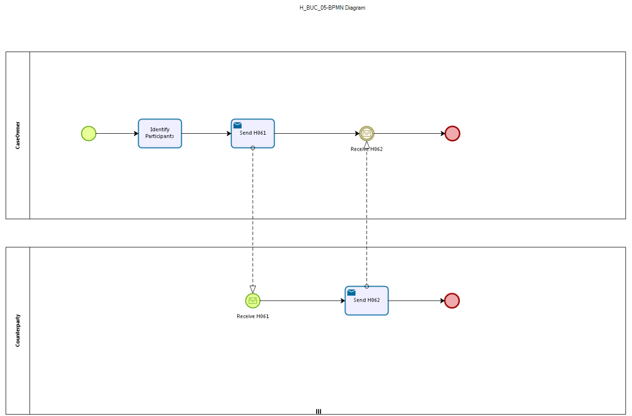

Figure 1: depicts the use case end-to-end, from a high level, using the BPMN 2.0 collaboration diagram..

Sub Processes
Not Applicable.

Appendices

Issues
The issues listed below need to be added to the issue log and discussed at the proper communication level.
# | Issue date | Description | Solution | Close date
1 | 26/05/2015 | Even though the following administrative SED's are possible to be used in the specification of the BUC, they ought to be tested during the Dry-run activities in order to later decide/evaluate their relevance inside this BUC:  - Clarify SED  - Invalidate SED  - Reminder SED | Usage of Administrative BUCs seems to be supported by testing of the Dry run activities. | 31/03/2016
2 | 26/08/2015 | Should the exchange of PINs remain in the Horizontal sector or should it be integrated within the pension sector, as it is initially designed to accelerate the pension calculation process according to Article 52 of Regulation 987/2009. | AHGs decided to include this process inside the Horizontal sector.

