

EESSI Business Use Case

Annex Nr.6 to the note AC 370/16rev

approvED

H_BUC_06 –
Transmission of Claim /document/information



Table of Contents

Table of Contents 2
1. Introduction 5
1.1. Purpose 5
1.2. Scope 5
1.3. Definitions, Acronyms and Abbreviations 6
1.4. References 7
1.5. Overview 7
2. Description 8
2.1. Business Scenario 8
2.2. Legal Base 8
3. Actors & Roles 9
4. Use Case 10
4.1. RUP Table Representation 10
4.2. Request – Reply SEDs 13
4.3. Attachments Allowed 14
4.4. Artefacts used 14
5. Business Processes 15
5.1. Case Owner and Counterparty 15
5.2. Sub Processes 16
6. Appendices 17
6.1. Issues 17

Document Control Information
Settings | Value
Document Title: | Business Use Case  H_BUC_06 – Transmission of Claim/document/information.
Project Title: | EESSI (Electronic Exchange of Social Security Information) Project
Document Author: | European Commission, DG EMPL F5
System Owner: | European Commission, DG EMPL D2
Doc. Version: | v4.1.0
Sensitivity: | Public
Date: | 31/08/2018

Document history:
The Document Author is authorized to make the following types of changes to the document without requiring that the document be re-approved:
- Editorial, formatting, and spelling
- Clarification
To request a change to this document, contact the Document Author or Owner.
Revision | Date | Created by | Short Description of Changes
v0.1 | 21/01/2015 | Eric Briffoz | Initial draft
v0.2 | 12/02/2015 | Eric Briffoz | Adaptations following review of P. Cummings.
v0.3 | 25/03/2015 | Eric Briffoz | Update following review of the AHG on the BUC.
v0.4 | 10/08/2015 | Eric Briffoz | Minor editorial corrections
v0.5 | 24/08/2015 | Eric Briffoz | Correction:  - Branch 7: Forwarding of the Case from the Counterparty to another institution within the same Member State by using the forward administrative.
v0.6 | 07/10/2015 | Eric Briffoz | Added branch 8, containing the possibility to forward the case to another member state.
v0.7.0 | 23/10/2015 | Eric Briffoz | - Description of 4.1 corrected to reflect Branch 8:  1) Forwarding the case within the same member state can be performed by using the "Forward" administrative SED.(branch 7)  2) Forwarding the case to another member state can be done by adding the new participant in the case. (branch 8)  - Correction in the Use Case Diagram.
v0.99.0 | 25/04/2016 | Eric Briffoz | Candidate for AHG Approval  -Inclusion of Request-Reply Table  -Inclusion of Attachment Allowed Table  -Inclusion of SED & Sub-process Versioning Information
v0.99.1 | 06/06/2016 | Anda Mirita | Minor editorial corrections following comments received from AC review
v1.0.0 | 06/07/2016 | Phil Cummings | AC APPROVED VERSION
v1.0.1 | 29/06/2017 | Dragos Gorjan | Updated Section 5.1 Case Owner – Counterparty – added new diagram H_BUC_06_Diagram v1.0.0.8  Deleted Sub-process section content  Added Not Applicable  -Replaced the reference to the BUC on Confluence.
v1.0.2 | 22/11/2017 | Heidi Warson | Alignment to the standard description and layout of the BUC:  - Section 2.2 changed title to 'Legal base' and rephrased introduction text;  - Updated section 4.1 RUP Table Representation:  branches 2, 5 and 7 to align forward and invalidate wording to the standard wording & updated special requirement to allow for branch 2 and 5 to be invoked more than once;  - Removed Section 4.4 RUP UC Diagram Representation.  - Included H_BUC_04 and H_BUC_10 (as not used for this BUC) in table "Sub processes' Table.
v4.1.0 | 31/08/2018 | Novella Bacelli | - Section 4.4 merged 2 tables (for SED & for Subprocesses) into 1 BUC Artefact table."  - Version adaptations to release 4.1.0

Introduction

Purpose
The purpose of this document is to construct an external view of, part of, the 'EESSI business system' as described in EC Regulations 883/2004 and 987/2009. The ‘EESSI Business System’ describes the business and expected business processes without consideration as to which part(s) may be realized by an IT System (i.e. the proposed EESSI IT System).

The external view comprises of models and descriptions of business use cases, the services of a business system offered to business actors: customers, business partners, or other business systems.

A business use case is described from an actor's perspective; it describes the interaction between an actor and the business system, meaning it describes the behaviours of the business system that the actor utilizes. The Business Use Case includes Use Case Diagrams and Business Process Models.
Use case diagrams show actors, business use cases, and their relationships. Use case diagrams do not describe procedures. Alternative scenarios also remain hidden. These diagrams give a good overview of the behaviours of the EESSI business system which will direct and govern part of the expected behaviours and functionality delivered by the EESSI IT System.

Scope
This document is limited to the external view on the horizontal sector process Transmission Of Claim/Document/Information. The different elements like use case description, actors, and business process as well as supporting UML diagrams and BPMN models pertaining to Transmission Of Claim/Document/Information

Definitions, Acronyms and Abbreviations
Please see the EESSI Project Glossary.

References
# | Description
1 | EC Regulation 883/2004 | Regulation EC No 883- 2004.pdf
2 | EC Regulation 987/2009 | Regulation EC No 987-2009.pdf
3 | UML 2.x | http://www.omg.org/spec/UML/
4 | BPMN 2.0 | http://www.omg.org/spec/BPMN/index.htm
5 | UML 2.0 In Action | Henriette Baumann, Patrick Grassle & Philippe Baumann, 2005, ISBN 1904811558
6 | RUP@EC standard 5.0 | http://www.cc.cec/RUPatEC_Standard/
7 | RUP op maat | http://www.rupopmaat.nl/

Overview
Chapter 1 introduces the external view on the business system under review and lists the elements of this specification.
Chapter 2 introduces us to the Transmission of Claim / document / information business process. The chapter gives a short and detailed description as well as a reference to business process´ legal base.
Chapter 3 lists the actors involved in the Transmission of claim / document / information business process.
Chapter 4 describes in detail the Transmission of Claim / document / information business process based on the RUP use case template, as well as the relationship to other use cases.
Chapter 5 describes the Transmission of Claim / document / relevant information business process using business process modelling notation (BPMN).

Description

Business Scenario
This Business Use Case allows for an institution to transfer a claim, a document or any relevant information to the institution in the member state which is competent to process a claim under the Regulations.
The receiving institution will then have to respond indicating if they accept, refuse or forward the transmission.
Basically, this business use case can be used in 2 different situations:
- When the claim has been sent to an institution in which the relevant benefit does not exist
- When the claim/document/relevant information has been submitted mistakenly by a person to an institution in the territory of a Member State other than that in which the institution designated in accordance to the Regulations (EC) 987/2009.
If needed, the receiving institution may choose to transfer the claim / document / information to the relevant institution within the same Member State (Branch 7), or in another Member State (Branch 8) and optionally inform the sending state, by using section 5.1.1 from SED H066.

Legal Base
This Business Use Case document's legal base is described in the following Regulations
- Implementing Regulation (EC) No 987/2009.
The following matrix specifies the SEDs that are used in this Business Use Case and documents the articles that provide the legal basis for each SED.

Implementing Reg. (987/2009)
Art. 2 (3) (4)
H065
H066
Table 1: SED – Legal base relationship matrix

Actors & Roles
This chapter captures details of the actors which are important to understanding the different types of system users. An actor is anyone or anything that exchanges data with the business system. An actor can be a user, external hardware, or another system.
The overarching description of each actor described in this Business Use Case can be found in the Glossary. Below you will find a short description which provides further clarity of this actor within the context of this Business Use Case.

Actor name | Description
Case Owner | In this Business Use Case the Case Owner is the Institution in a Member State that needs to transfer a claim / a document or some information to another institution.
Counterparty | In this Business Use Case the Counterparty is the Competent Institution in the (other) Member State that receives the Case Owner's claim/ document or information and reply by deciding if they accept, refuse the transfer of if they decide to forward to another institution.

Use Case

RUP Table Representation
Use Case ID: | H_BUC_06
Use Case Name: | H_BUC_06 – Transmission of Claim / Document / Information.
Created By: | Eric Briffoz |  | Last Updated By: | Novella Bacelli
Date Created: | 23/01/2015 |  | Last Revision Date: | 31/08/2018
Actors: |  | Case Owner  Counterparty
Description: |  | In a situation where an institution received a claim, a document or any relevant information and that institution is not competent in accordance with the Regulation (EC) 987/2009, the claim should be resubmitted without delay directly to the competent institution or indirectly via the liaison body.  For that purpose , the following pair of SED's will be used :  H065/ H066.  - The H065 will be used to submit the claim/information and/or document to the competent institution.  - The H066 can be used to reply to the sending institution by stating if they accept, if they refuse or if they will forward the case to a different institution. (by selecting point 5.1.1 SED H066).  - Forwarding the case within the same member state can be performed by using the "Forward" administrative SED.(branch 7)  - Forwarding the case to another member state can be done by adding the new participant in the case. (branch 8)
Trigger: |  | A case needs to be transmitted to a competent institution in accordance to the Regulation (EC) 987/2009 2 (3) (4).
Preconditions: |  | 2 possible preconditions:  - a claim exists within an institution in which the relevant benefit does not exist  - a claim/document/relevant information exists within an institution in the territory of a Member State other than that in which the institution designated in accordance to the Regulations (EC) 987/2009.
Post conditions: |  | - The receiving institution has replied to the transmission of the claim to accept or to refuse with SED H066.  Or  - The receiving institution has forwarded the claim/document/information to the relevant institution and informs the sending institution (point 5.1.1 in SED H066).
Main Scenario: |  | Identify Participant  - The Case Owner identifies the EU Member State where the claim/document/information should be transmitted.  - The Case Owner identifies the Competent Institution (the Counterparty) in the selected Member State. There will be only one counterparty.  Send Transmission of claim/document/information  - The Case Owner fills in a Transmission of claim/document/information (H065) by entering all the needed fields regarding the claim/ the document(s) and or the information which will be transmitted to the Counterparty;  - The Case Owner sends the H065 to the Counterparty;  Process Request  - The Counterparty will receive the Transmission of claim/document/information (H065) SED, after which the decision process will be taken;  - The Counterparty fills in a reply to transmission of the claim / document / information that was transmitted (H066) SED by entering a decision on the transmission: Acceptance / Refusal / [Optionally Forwarding] to another institution in Section 5 (5.1.1 decision).  - The Counterparty sends the H066 back to the Case Owner.  - The Case Owner receives the H066 containing the decision.  - The use case ends here.
Alternative Scenarios: |  | The Following Branches determine the use of Horizontally Defined Processes within this Business Process
- At any point after step [4] the Counterparty identifies that more information is needed to process the request
- The Counterparty starts H_BUC_01 – Ad hoc Exchange of Information;
- [This Branch] Ends and the Use Case resumes at the step following the step calling this branch.

 |  | The Following Branches Determine the use of Administrative Processes within this Business Process
- at step [5] the Case Owner may choose to advice the Counterparty of their H065 that it is invalid under Art 5 of 987/09
- The Case Owner executes business use case AD_BUC_06_Invalidate SED;
- Optionally, the Case Owner fills in a Transmission of claim/document/information (H065) by entering all the required data;
- Optionally, the Case Owner sends the H065, including any attachments, to the Counterparty;
- [This Branch] Ends

- at step [5] the Case Owner chooses to send an updated version of H065
- The Case Owner executes business use case AD_BUC_10_Update SED;
- [This Branch] Ends

- After [Step 7], the Counterparty may choose to send an update of the H066
- The Counterparty executes business use case AD_BUC_10_Update SED;
- [This Branch] Ends

- After [Step 7], the Counterparty may choose to advice the Counterparty of their H066 that it is invalid under Art 5 of 987/09
- The Counterparty executes business use case AD_BUC_6_Invalidate SED;
- Optionally, the Counterparty fills in a reply to transmission of the claim / document / information (H060) by entering all the required data;
- Optionally, the Counterparty sends the H066, including any attachments, to the Case Owner;
- [This Branch] Ends

- After [Step 4] and before [Step 7] the Case Owner optionally chooses to send a Reminder to the Counterparty for the return of the information he was expecting but did not receive
1. The Case Owner executes business use case AD_BUC_07_Reminder;
2. [This Branch] Ends

- After [Step 5], the Counterparty may optionally choose to forward this Business Process to another institution within their Member State who assumes responsibility for handling it.
- The Counterparty executes business use case AD_BUC_05_Forward Case;
- [This Branch] Ends.

- After [Step 5], the Counterparty may optionally choose to transfer the claim / document / relevant information to another institution situated in another Member State, by using an add Participant.
- The Counterparty adds the new institution from the new MS in the Case by using AD_BUC_03_Add Participant.
- [This Branch Ends]

Includes: |  | See section 4.4
Special Requirements: |  | SR1:  H065 can be sent only once (even though updates can be created for this SED).  H066 can be sent only once (even though updates can be created for this SED).  SR2: Rules about the invoking of Branches:  Administrative  [Branch 1] – May be invoked more than once  [Branch 2] – May be invoked more than once  [Branch 3] – May be invoked more than once  [Branch 4] – May be invoked more than once  [Branch 5] – May be invoked more than once  [Branch 6] – May be invoked more than once  [Branch 7] – May be invoked more than once  [Branch 8] – May be invoked more than once  SR3: Rules about the destination for each SED Type:  - H066 has only one destination recipient, the Case Owner and it is sent only as reply of H065.  - H065 has only one destination recipient, the Counterparty.
Assumptions:
Notes and Issues: |  | [List any additional comments about this use case or any remaining open issues or TBDs (To Be Determined) that must be resolved. e.g.  - What is the maximum size of the PIN that a use can have?]

Request – Reply SEDs
The following table specifies and SED that have a logical pairing to one another, usually this is known as a request-reply pair.
REQUEST SED | REPLY SED(s)
H065 | H066

Attachments Allowed
The following table specifies whether attachments are permitted to be included when sending a SED type.
SED | Attachments
H065 | Allowed
H066 | Allowed

Artefacts used
The following table specifies the artefacts that are used in this Business Use Case.
Artefact name | Artefact type
H065 | SED
H066 | SED
H_BUC_01_Subprocess | BUC spec
AD_BUC_03_Subprocess – Add Participant | BUC spec
AD_BUC_05_Subprocess – Forward Case | BUC spec
AD_BUC_06_Subprocess – Invalidate SED | BUC spec
AD_BUC_07_Subprocess – Reminder | BUC spec
AD_BUC_10_Subprocess – Update SED | BUC spec
AD_BUC_11_Subprocess – Business Exception | BUC spec
AD_BUC_12_Subprocess – Change of Participant | BUC spec

Business Processes
The following paragraphs describe the Business Use Case "Transmission of Claim/Document/Information" using BPMN 2.0.

Case Owner and Counterparty
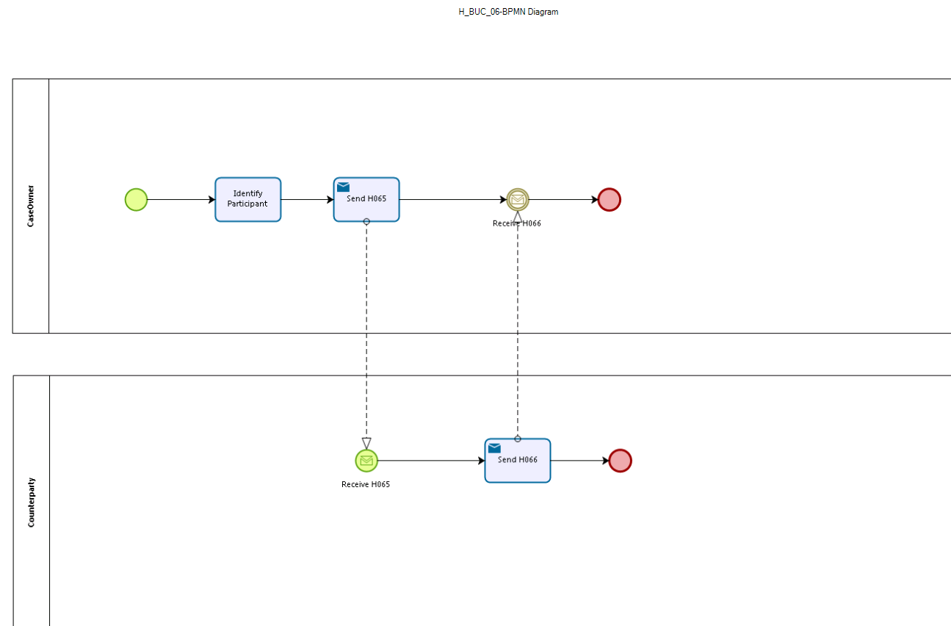

Figure 1: depicts the use case end-to-end, from a high level, using the BPMN 2.0 collaboration diagram

Sub Processes

Not Applicable

Appendices

Issues
The issues listed below need to be added to the issue log and discussed at the proper communication level.
# | Issue date | Description | Solution | Close date

