

EESSI Business Use Case

APPROVED

H_BUC_07 –
Notification of Death



Table of Contents

Table of Contents 2
1. Introduction 6
1.1. Purpose 6
1.2. Scope 6
1.3. Definitions, Acronyms and Abbreviations 6
1.4. References 7
1.5. Overview 7
2. Description 8
2.1. Business Scenario 8
2.2. Legal Base 8
3. Actors & Roles 9
4. Use Case 10
4.1. RUP Table Representation 10
4.2. Request – Reply SEDs 13
4.3. Attachments Allowed 13
4.4. Artefacts used 14
5. Business Processes 15
5.1. Case Owner and Counterpart(y)(ies) 15
5.2. Sub Processes 16
6. Appendices 17
6.1. Issues 17

Document Control Information
Settings | Value
Document Title: | Business Use Case  H_BUC_07 - Notification of Death
Project Title: | EESSI (Electronic Exchange of Social Security Information) Project
Document Author: | European Commission, DG EMPL F5
System Owner: | European Commission, DG EMPL D2
Doc. Version: | v4.1.0
Sensitivity: | Public
Date: | 31/08/2018

Document history:
The Document Author is authorized to make the following types of changes to the document without requiring that the document be re-approved:
- Editorial, formatting, and spelling
- Clarification
To request a change to this document, contact the Document Author or Owner.
Revision | Date | Created by | Short Description of Changes
v0.10 | 24/03/2014 | Reginald Amade | Initial draft
v0.20 | 28/03/2014 | Reginald Amade | Rework after internal review
v0.3 | 12/02/2015 | Eric Briffoz | Updates after review P. Cummings.
v0.4 | 03/03/2015 | Eric Briffoz | Adaptations after review from the AHG.
v0.5 | 30/03/2015 | Eric Briffoz | Minor corrections (flow replace by case).
v0.6 | 08/04/2015 | Eric Briffoz | Update following review meeting with AHG on 07/04/2015 and 08/04/2015
v0.99.0 | 31/03/2016 | Anda Mirita | Candidate for AHG Approval  Inclusion of Request-Reply Table  Inclusion of Attachment Allowed Table  Inclusion of SED & Sub-process Versioning Information
v0.99.1 | 06/06/2016 | Anda Mirita | Correction made following comments received from AC
v1.0.0 | 06/07/2016 | Anda Mirita | AC Approved Version
v1.0.1 | 29/06/2017 | Dragos Gorjan | Updated Section 5.1 Case Owner – Counterparty – added new diagram H_BUC_07_Diagram v1.0.0.3  Deleted Sub-process section content  Added Not Applicable  -Replaced the reference to the BUC on Confluence.
v1.0.2 | 08/12/2017 | Heidi Warson | Alignment to the standard description and layout of the BUC:  - Section 2.1 changed title to 'Business Scenario' instead of 'Detailed description;  - Section 2.2 changed title to 'Legal base' and rephrased introduction text;  - Updated section 4.1 RUP Table Representation:  branches 2 and 3 to align forward and invalidate wording to the standard wording and updated special requirement for branch 3 to allow multiple invoking of the branch;  - Removed Section 4.4 RUP UC Diagram Representation.  - Included H_BUC_04 and H_BUC_10 (as not used for this BUC) in table "Sub processes' Table.
v4.1.0 | 31/08/2018 | Novella Bacelli | - Section 4.4 merged 2 tables (for SED & for Subprocesses) into 1 BUC Artefact table."  - Version adaptations to release 4.1.0

Introduction

Purpose
The purpose of this document is to construct an external view of, part of, the 'EESSI business system' as described in EC Regulations 883/2004 and 987/2009. The ‘EESSI Business System’ describes the business and expected business processes without any consideration as to which part(s) may be realized by an IT System (i.e. the proposed EESSI IT System).
The external view comprises of models and descriptions of business use cases, the services of a business system offered to business actors: customers, business partners, or other business systems, and business processes.
A business use case is described from an actor's perspective; it describes the interaction between an actor and the business system, meaning it describes the behaviors of the business system that the actor utilizes. The Business Use Case includes Use Case Diagrams and Business Process Models.
Use case diagrams show actors, business use cases, and their relationships. Use case diagrams do not describe procedures. Alternative scenarios also remain hidden. These diagrams give a good overview of the behaviors of the EESSI business system which will direct and govern part of the expected behaviors and functionality delivered by the EESSI IT System.
The business process models describe procedures of the EESSI business system. The subjects of these descriptions are interactions between actors and the business system, meaning the goods and services that are offered to customers and business partners. On the basis of business process models, outsiders can identify how to interact with the business system. They are especially useful to illustrate sequences, alternatives, and parallel events.

Scope
This document is limited to the external view on the horizontal sector process Notification of Death. The different elements like use case description, actors, and business process as well as supporting UML diagrams and BPMN models pertaining to Notification of Death.

Definitions, Acronyms and Abbreviations
Please see the EESSI Project Glossary.

References
# | Description
1 | EC Regulation 883/2004 | Regulation EC No 883- 2004.pdf
2 | EC Regulation 987/2009 | Regulation EC No 987-2009.pdf
3 | UML 2.x | http://www.omg.org/spec/UML/
4 | BPMN 2.0 | http://www.omg.org/spec/BPMN/index.htm
5 | UML 2.0 In Action | Henriette Baumann, Patrick Grassle & Philippe Baumann, 2005, ISBN 1904811558
6 | RUP@EC standard 5.0 | http://www.cc.cec/RUPatEC_Standard/
7 | RUP op maat | http://www.rupopmaat.nl/

Overview
Chapter 1 introduces the external view on the business system under review and lists the elements of this specification.
Chapter 2 introduces us to the Notification of Death business process. The chapter gives a short and detailed description as well as a reference to business process´ legal base.
Chapter 3 lists the actors involved in the Notification of Death business process.
Chapter 4 describes in detail the Notification of Death business process based on the RUP use case template, as well as the relationship to other use cases.
Chapter 5 describes the Notification of Death business process using business process modelling notation (BPMN).

Description

Business Scenario
The Competent Institutions of Member States, having the duty of mutual information and cooperation, notify the death of an insured person.

Legal Base
This Business Use Case document's legal base is described in the following Regulations
- Basic Regulation (EC) No 883/2004
The following matrix specifies the SEDs that are used in this Business Use Case and documents the articles that provide the legal basis for each SED.

Base Reg. (883/2004)
76
H070
Table 1: SED – Legal base relationship matrix

Actors & Roles
This chapter captures details of the actors which are important to understanding the different types of system users. An actor is anyone or anything that exchanges data with the business system. An actor can be a user, external hardware, or another system.
The overarching description of each actor described in this Business Use Case can be found in the Glossary. Below you will find a short description which provides further clarity of this actor within the context of this Business Use Case.

Actor name | Description
Case Owner | In this BUC the Case Owner is the sender of Notification of Death to the Counterparty. In most cases this is an institution in the Country of residence.
Counterparty | In this BUC the Counterparty is the Competent Institution/Liaison body in the (other) Member State that receives the Notification of Death.  In exceptional cases the country of residence may receive the information from another party  Depending on the situation, the communication may run between 2 or more Member states.

Use Case

RUP Table Representation
Use Case ID: | H_BUC_07
Use Case Name: | H_BUC_ 07 - Notification of Death
Created By: | Reginald Amade |  | Last Updated By: | Novella Bacelli
Date Created: | 24/03/2014 |  | Last Revision Date: | 31/08/2018
Actors: |  | Case Owner  Counterparty(ies)
Description: |  | The Competent Institutions of Member States, having the duty of mutual information and cooperation, notify the death of an insured person.
Trigger: |  | The Case Owner sends the Notification of Death to the Counterparty(ies).
Preconditions: |  | A person died and the institution has knowledge this person was also insured in another MS
Post conditions: |  | The Counterparty(ies) received the Notification of Death.
Main Scenario: |  | Identify Participant  - The Case Owner identifies the EU Member State(s) where the person concerned was previously insured based on the information(documents) provided by the insured/deceased person or by the person who declares the death.  - The Case Owner identifies the Competent Institution/ Liaison body (the Counterparty) in each Member State where they were previously insured;  Send Notification of Death  - The Case Owner fills in a Notification of Death (H070) by entering all the required Information;  - The Case Owner sends the H070, attaching, if necessary, any other document , to the Counterparty(ies) proving the death of person concerned ;  Process Claim  - The Counterparty(ies) receive(s) and views H070, and attachments;  - The Counterparty(ies) process(es) the H070;  - The use case ends here.
Alternative Scenarios: |  | The Following Branches Determine the use of Horizontal Processes within this Business Process
Branch 1: at any stage after [step 5] the Counterparty identifies that more information is needed to process the Notification

1. The Counterparty starts H_BUC_01 – Adhoc Exchange of Information;
2. This Use Case resumes at [step 6].

 |  | The Following Branches Determine the use of Administrative Processes within this Business Process
Branch 2: at any stage after [step 5] the Counterparty may choose to Forward Business Process to a new Participant within their MS who assumes responsibility for handling it

- The Counterparty executes business use case AD_BUC_05_Forward Case;
- [This Branch] Ends

Branch 3: at any stage after [step 4] the Case Owner may choose to advice all recipients of their H070 that it is invalid under Art 5 of 987/09

- The Case Owner executes business use case AD_BUC_06_Invalidate SED;
- Optionally, the Case Owner fills in a Notification of Death (H070) by entering all the required data;
- Optionally, the Case Owner sends the H070, including any attachments, to all Counterparties;
- [This Branch] Ends

Branch 4: at any stage after [step 4] the Case Owner may choose to send an updated version of H070

- The Case Owner executes business use case AD_BUC_010 - Update_SED;
- [This Branch] Ends

Branch 5: at any stage after [step 5], any participant may choose to add a new participant

- The triggering participant executes business use case AD_BUC_03_Add_Participant;
- [This Branch] Ends

Branch 6: at any stage after [step 4], the case owner may choose to remove a participant

- 1. The triggering participant executes business use case AD_BUC_04_Remove_Participant ;
- [This Branch] Ends

Includes: |  | See section 4.4
Special Requirements: |  | SR1: H070 can be sent more than once.  SR2: Rules about the invoking of Branches:  Administrative  [Branch 1] – May only be invoked when there is a valid H070 (not possible to start H_BUC_01 if there's no valid H070).  [Branch 2] – May be invoked more than once  [Branch 3] – May be invoked more than once  [Branch 4] – May be invoked more than once  [Branch 5] – May be invoked more than once  [Branch 6] – May be invoked more than once  SR3: Rules about the destination for each SED Type:  H070 – Must be sent to all Counterparties  SR4: H070 may have multiple destination recipients  SR5: When Update_SED is used (AD_BUC_010-Subprocess), the recipient of updated SED can see both version of SEDs
Assumptions:
Notes and Issues: |  | [List any additional comments about this use case or any remaining open issues or TBDs (To Be Determined) that must be resolved.

Request – Reply SEDs
The following table specifies and SED that have a logical pairing to one another, usually this is known as a request-reply pair.
Not applicable.

Attachments Allowed
The following table specifies whether attachments are permitted to be included when sending a SED type.
SED | Attachments
H070 | Allowed

Artefacts used
The following table specifies the artefacts that are used in this Business Use Case.
Artefact name | Artefact type
H070 | SED
H_BUC_01_Subprocess | BUC spec
AD_BUC_03_Subprocess – Add Participant | BUC spec
AD_BUC_04_Subprocess – Remove Participant | BUC spec
AD_BUC_05_Subprocess – Forward Case | BUC spec
AD_BUC_06_Subprocess – Invalidate SED | BUC spec
AD_BUC_10_Subprocess – Update SED | BUC spec
AD_BUC_11_Subprocess – Business Exception | BUC spec
AD_BUC_12_Subprocess – Change of participant | BUC spec

Business Processes
The following paragraphs describe the Business Use Case Notification of Death using BPMN 2.0.

Case Owner and Counterpart(y)(ies)

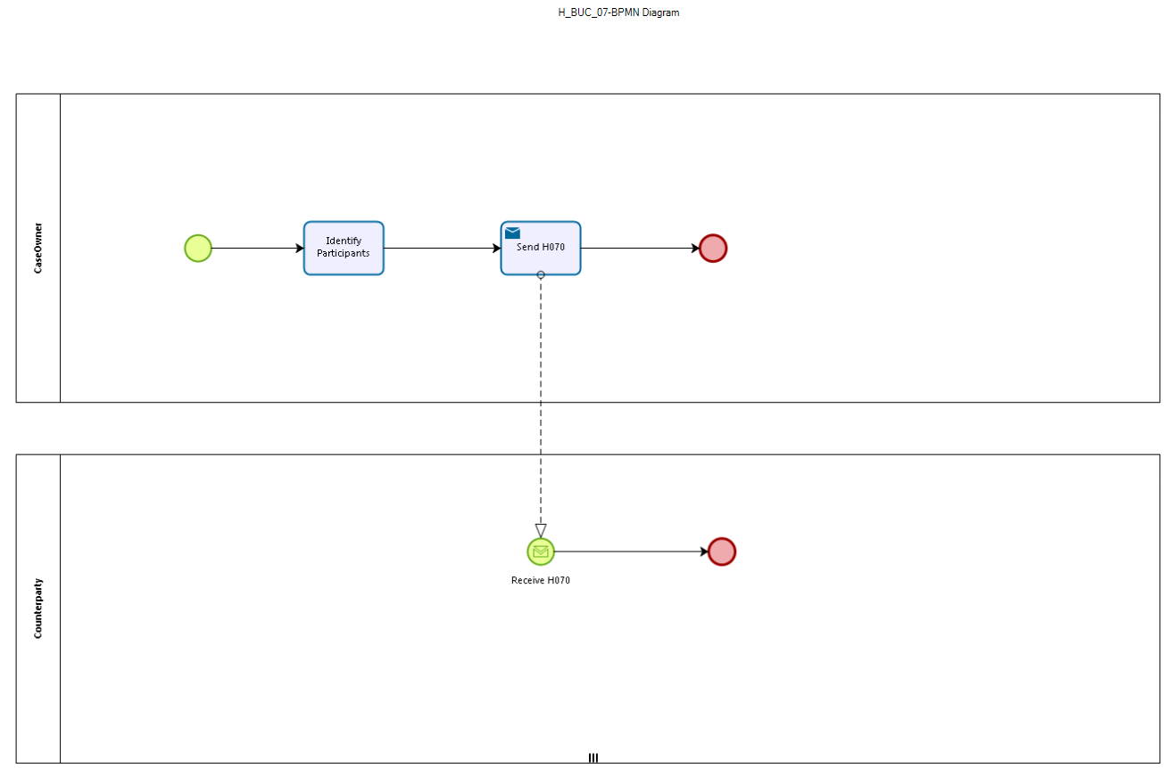

Figure 1: depicts the use case end-to-end, from a high level, using the BPMN 2.0 collaboration diagram

Sub Processes
Not Applicable.

Appendices

Issues
The issues listed below need to be added to the issue log and discussed at the proper communication level.
# | Issue date | Description | Solution | Close date

