

EESSI Business Use Case


APPROVED

H_BUC_08 - Medical Information



Table of Contents

Table of Contents 2
1 Introduction 6
1.1. Purpose 6
1.2. Scope 6
1.3. Definitions, Acronyms and Abbreviations 6
1.4. References 7
1.5. Overview 7
2. Description 8
2.1. Business Scenario 8
2.2. Legal Base 8
3. Actors & Roles 9
4. Use Case 10
4.1. RUP Table Representation 10
4.2. Request – Reply SEDS 14
4.3. Attachments Allowed 14
4.4. Artefacts used 14
5. Business Processes 15
5.1. Case Owner – Counterparty 15
5.2. Sub Processes 16
6. Appendices 17
6.1. Issues 17

Document Control Information
Settings | Value
Document Title: | Business Use Case  H_BUC_08 - Medical Information
Project Title: | EESSI (Electronic Exchange of Social Security Information) Project
Document Author: | European Commission, DG EMPL F5
System Owner: | European Commission, DG EMPL D2
Doc. Version: | v4.1.0
Sensitivity: | Public
Date: | 13/07/2018

Document history:
The Document Author is authorized to make the following types of changes to the document without requiring that the document be re-approved:
- Editorial, formatting, and spelling
- Clarification

To request a change to this document, contact the Document Author or Owner.

Revision | Date | Created by | Short Description of Changes
v0.1.0 | 21/04/2015 | Phil Cummings | Initial Draft
v0.2.0 | 04/01/2016 | Eric Briffoz | Adaptations following remarks received by J-I Samuelsson Apelgren.
v0.3.0 | 18/03/2016 | Eric Briffoz | - Updated the BPMN process model  - Added Description of the BUC.  - Added Branches related to Costs Estimations.  - Added paragraphs 4.2, 4.3 and 4.5
v0.4.0 | 21/04/2016 | Eric Briffoz | Following Horizontal AHG Meeting 19-20 april 2016  - Adaptation on the name of the BUC  - Adaptation of Legal References
v0.5.0 | 25/07/2016 | Anda Mirita | Alignment to the standard description and layout of the BUC.
v0.6.0 | 14/09/2016 | Anda Mirita | Typos and corrections made after comments received from AC  Small Re-wording for Branch 1 with no impact on the process
v0.7.0 | 26/09/2016 | Anda Mirita | Updated following comments received from AHG  Branch 4 and Branch 5 modified to include 2 options.  Branch 6 removed
v0.99.0 | 06/10/2016 | Anda Mirita | Candidate for AC Approval  The following changes have been implemented following agreement with AHG group:  Name of the BUC: Medical Information  Add Branch 3 to enable the Counterparty [after step 3] to ask for additional information by using H_BUC_01-SubProcess-Ad hoc Exchange of Information.  As new branch has been added, renumbering of the following branches has been done accordingly.  Branch 3 – became Branch 4  Branch 4 – became Branch 5  Branch 5 – became Branch 6  Branch 6 – became Branch 7  Branch 7 – became Branch 8  Branch 8 – became Branch 9  Branch 9 – became Branch 10  Branch 10 - AD-BUC-09 Sub process Reject removed  SR have been updated accordingly  Section 4.5 table with Sub processes has been updated accordingly to include H_BUC_01_Subprocess
v0.99.1 | 07/10/2016 | Anda Mirita | Submitted for AC Approval
v1.0.0 | 21/10/2016 | Anda Mirita | AC Approved Version
v1.0.1 | 29/06/2017 | Dragos Gorjan | Updated Section 5.1 Case Owner – Counterparty – added new diagram H_BUC_08_Diagram v1.0.0.5  Deleted Sub-process section content  Added Not Applicable  -Replaced the reference to the BUC on Confluence.
v1.0.2 | 21/11/2017 | Heidi Warson | - Updated section 4.1 RUP Table Representation: branches 5 and 6 to align invalidate wording to the standard wording;  - Removed Section 4.4 RUP UC Diagram Representation.
v4.1.0 | 13/07/2018 | Novella Bacelli | - Added missing step in main scenario and clarification in branch 1  - Managed H_BUC_04 subprocess in "artefacts used" table as "Not used", until CR for adding corresponding branch is approved  - Deleted text in BUC's description that mentions the possibility to invoke H_BUC_04_Subprocess  - Section 4.4 merged 2 tables (for SED & for Subprocesses) into 1 BUC Artefact table."  - Version adaptations to release 4.1.0

Introduction

Purpose
The purpose of this document is to construct an external view of the 'EESSI business system' as described in EC Regulations 883/2004 and 987/2009. The ‘EESSI Business System’ describes the business and expected business processes without consideration as to which part(s) may be realised by an IT System (i.e. the proposed EESSI IT System).

The external view comprises of models and descriptions of business use cases, the services of a business system offered to business actors: customers, business partners, or other business systems.

A business use case is described from an actor's perspective; it describes the interaction between an actor and the business system, meaning it describes the behaviours of the business system that the actor utilises. The Business Use Case includes Use Case Diagrams and Business Process Models.

Use case diagrams show actors, business use cases, and their relationships. Use case diagrams do not describe procedures. Alternative scenarios also remain hidden. These diagrams give a good overview of the behaviours of the EESSI business system which will direct and govern part of the expected behaviours and functionality delivered by the EESSI IT System.

Scope
This document is limited to the external view of Horizontal Sector process Medical Information.

The different elements like use case description, business actors, and business process as well as supporting UML diagrams and BPMN models pertaining to Medical Information.

Definitions, Acronyms and Abbreviations
Please see the EESSI Project Glossary here.

References
# | Description
1 | EC Regulation 883/2004 | Regulation EC No 883- 2004.pdf
2 | EC Regulation 987/2009 | Regulation EC No 987-2009.pdf
3 | UML 2.x | http://www.omg.org/spec/UML/
4 | BPMN 2.0 | http://www.omg.org/spec/BPMN/index.htm
5 | UML 2.0 In Action | Henriette Baumann, Patrick Grassle & Philippe Baumann, 2005, ISBN 1904811558
6 | RUP@EC standard 5.0 | http://www.cc.cec/RUPatEC_Standard/
7 | RUP op maat | http://www.rupopmaat.nl/

Overview
Chapter 1 introduces the external view on the business system under review and lists the elements of this specification.
Chapter 2 introduces the Medical Information business process. This chapter gives a short and detailed description as well as a reference to the business process´ legal base.
Chapter 3 lists the actors involved in the Medical Information business process.
Chapter 4 describes in detail the Medical Information business process based on the RUP use case template, as well as the relationship to other use cases.
Chapter 5 describes the Medical Information business process using business process modelling notation (BPMN).

Description

Business Scenario
This Business Use Case is initiated by the Competent Institution to request the institution of the place of residence/stay to carry out a Medical Examination of the insure person in accordance with the procedures laid down by the legislation of the Member State of residence/stay. The institution of the latter Member State provides the competent institution with its conclusions (report
of the institution's doctor) on the requested Medical Examination.
In this BUC the Case Owner is a competent institution who requires a medical evidence or examination of an insured person (claimant/beneficiary) for the purposes of assessing or checking a right/entitlement to benefits due under the legislation applicable, including specific sectorial provisions of the Regulations. When relevant, the prior request for information about the estimated costs of medical evidence/examination is possible.

Legal Base
This Business Use Case document's legal base is described in the following Regulations
- Basic Regulation (EC) No 883/2004.
- implementing Regulation (EC) No 987/2009.
The following matrix specifies the SEDs that are used in this Business Use Case and documents the articles that provide the legal basis for each SED.

SED | Implementing Reg (987/09) |  |  |  |  |  | Basic Reg
SED | 2(2) | 27(5)(6)(10) | 28(3)(5) | 33(1) | 34(4) | 87(1)(2)(4) | 21 | 34 | 36(3) | 82
H120
H121
Table 1: SED – Legal base relationship matrix

Actors & Roles
This chapter captures details of the actors which are important to understand the different types of system users. An actor is anyone or anything that exchanges data with the business system. An actor can be a user, external hardware or another system.
The overarching description of each actor described in this Business Use Case can be found in the Glossary. Below you will find a short description which provides further clarity of this actor within the context of this Business Use Case.
Actor name | Description
Case Owner | The Case Owner is a competent Institution who requires: a Medical Evidence/Examination (or also in advance the information on estimated costs of Medical Evidence/Examination) for the purposes of checking a right/entitlement under the provision of the Regulations
Counterparty | In this BUC the Counterparty is an institution (usually the MS of residence/stay or another MS’s competent institution(s) involved) that is requested to provide medical evidence or to carry out a medical examination, and when relevant, is formerly requested for information about the estimated costs of medical evidence/examination.  The Counterparty provides the required medical evidence or informs about the outcomes of the requested medical examination and, when relevant, issues a requested medical report to be attached to the main reply.  When relevant, at the request of the Case Owner the Counterparty provides in advance information on estimated costs of medical evidence/ examination.  The SEDs concern more than one sector, therefore for each sector the Counterparty is defined on basis of specific provisions of the Regulations.
Table 2: Actors and Roles

Use Case

RUP Table Representation
Use Case ID: | H_BUC_08
Use Case Name: | Medical Information
Created By: | Phil Cummings |  | Last Updated By: | Novella bacelli
Date Created: | 21/04/2015 |  | Last Revision Date: | 13/07/2018
Actors: |  | Case Owner  Counterparty
Description: |  | This BUC is initiated by the competent institution to request the institution of the place of residence/stay or another MS’s competent institution(s) involved to provide medical evidence or to carry out a medical examination of the person concerned for the purposes of assessing or checking a right/entitlement to benefits due under the legislation applicable, including specific sectoral provisions of the Regulations. When relevant, the prior exchange of information about the estimated costs of medical evidence/ examination is possible.  In the reply the Counterparty provides the required medical evidence or informs about the outcomes of the requested medical examination and, when relevant, issue/s a requested medical report to be attached to the reply.  In case of the exchange of information on estimated costs of medical evidence/ examination, the information is provided by the counterparty at the former request of the Case Owner.  For that purpose, the following pair of SED's will be used :  - The H120 SED - Request for Medical Information  - The H121 SED - Reply to Request for Medical Information / Reply to Request for Information on Estimated Costs  The SEDs concern more than one sector, therefore specific sections need to be filled in accordingly.  When relevant, after this BUC the H_BUC_04 will be used to reimburse the costs of the medical examination.
Trigger: |  | The competent institution finds it is necessary to request the institution of the place of residence/stay or another MS’s competent institution(s) involved to provide a medical evidence or to carry out a medical examination of the person concerned for the purposes of assessing or checking a right/entitlement to benefits due under the legislation applicable, including specific sectoral provisions of the Regulations.  Prior the exchange of information about the estimated costs of medical evidence/examination is possible, when relevant.
Preconditions: |  | The Case Owner requires a Medical Evidence / Report / Examination.
Post conditions: |  | The Case Owner receives the reply to the request with the required documents, if relevant.
Main Scenario: |  | Identify Participants  - The Case Owner identifies the Member State where the Counterparty is located;  - The Case Owner then identifies the correct institution in that Member State;  Send Request  - The Case Owner fills in a SED H120 by entering all the required information about the request;  - The Case Owner sends the SED H120, including any attachments to the Counterparty.  Provide Reply  - The Counterparty receives the SED H120 and any attachment;  - The Counterparty fills in SED H121 with all the relevant information and attaches all required documents;  - The Counterparty sends the SED H121 with any attachment to the Case Owner;  7.1 The Case Owner receives the SED H121;  - The use case ends here.
Alternative Scenarios: |  | - At [Step 3], the Case Owner may request an estimation of the costs by filling the relevant fields of H120 SED  - The Case Owner fills in a H120 SED to request for estimation of the costs;  - The Case Owner sends the H120 SED to the Counterparty;  - The Counterparty receives H120 SED from the Case Owner;  - The Counterparty fills in a SED H121 and fills in the estimated costs (the amount of the estimated costs will be given in the currency of the member state of residence or stay);  - The Counterparty sends the H121 SED back to the Case Owner;  - If the Case Owner agrees to cover the costs then fills in a new instance of H120 SED to request Medical Report by specifying acceptance in Section relevant section of the H120 SED;  - The Case Owner sends H120 SED to the Counterparty, including any attachments;  [This Branch Ends] and Reverts to Step 5 of the Main Scenario.
- At [Step 6] of Branch 1, If the Case Owner does not agree on the costs and decides not to request for medical evidence/ examination, then he closes the BUC

- The Case Owner executes the business use case AD_BUC_01_SubProcess – Close;
- [This Branch] Ends.
 |  | The Following Branches determine the use of Horizontally Defined Processes within this Business Process
Branch 3: at any step after [step 3], any participant may choose to Request AdHoc Information from the other participant

- The participant executes business use case H_BUC_01_Subprocess – AdHoc Exchange of Information;
- [This Branch] Ends.

 |  | The Following Branches Determine the use of Administrative Processes within this Business Process
Branch 4: at any step between [step 3] and [step 8] the Counterparty may choose to Forward this Business Use Case to another Competent Institution within their MS who assumes responsibility for handling it

- The participant executes business use case AD_BUC_05 – Forward Case;
- [This Branch] Ends.
Branch 5: at any step after [step 4] the Case Owner may choose to advise the Counterparty of their H120 that it is invalid under Art 5 of 987/09 .

- The Case Owner executes business use case AD_BUC_06-SubProcess - Invalidate_SED;
- Optionally, the Case owner fills in "Request for Medical Information" (H120) by entering all required data;
- Optionally, the Case Owner sends the H120 to the Counterparty;
- [This Branch] Ends.

Branch 6: at any step after [step 7] the Counterparty may choose to advice the Case Owner of their H121 that it is invalid under Art 5 of 987/09

- The Counterparty executes business use case AD_BUC_06 -SubProcess Invalidate_SED;
- Optionally, the Case Owner fills in " Reply to Request for Medical Information / Reply to Request for Information on Estimated Costs " (H121) by entering all required data;
- Optionally, the Case Owner sends the H121 to the Counterparty.
- [This Branch] Ends.

 |  | Branch 7: [Removed]
Branch 8: at any step after [step 3] the Counterparty may choose to send an updated version of the H121 SED

- The Case Owner executes business use case AD_BUC_010 - Update_SED;
- [This Branch] Ends.
Branch 9: at any step after [step 4] any Participant may optionally choose to send a Reminder to the other participant for the return of information they were expecting from that participant but did not receive.

- The participant who invokes this branch executes business use case AD_BUC_07 -_Reminder;
- [This Branch] Ends.

 |  | Branch 10: [Removed]
Exceptions: |  | None
Includes: |  | See section part 4.4
Special Requirements: |  | SR1: Rules about the invoking of Branches:  [Branch 1] – May be invoked once  [Branch 2] – May be invoked once  [Branch 3] – May be invoked once  [Branch 4] – May be invoked more than once  [Branch 5] – May be invoked more than once (provided a new SED H120 has been created after invalidation)  [Branch 6] – May be invoked more than once (provided a new SED H121 has been created after invalidation)  [Branch 8] – May be invoked more than once  [Branch 9] – May be invoked more than once  SR2: Alternative Branches 1 – 9 are non-interrupting Branches;
Assumptions:
Notes and Issues:

Request – Reply SEDS
The following table specifies the SEDs that have a logical pairing to one another, usually this is known as a request-reply pair.
REQUEST SED | REPLY SED(s)
H120 | H121

Attachments Allowed
The following table specifies whether attachments are permitted to be included when sending a SED type.
SED | Attachments
H120 | Allowed
H121 | Allowed

Artefacts used
The following table specifies the artefacts that are used in this Business Use Case.
Artefact name | Artefact type
H120 | SED
H121 | SED
H_BUC_01_Subprocess | BUC spec
AD_BUC_01_Subprocess – Close Case | BUC spec
AD_BUC_05_Subprocess – Forward Case | BUC spec
AD_BUC_06_Subprocess – Invalidate SED | BUC spec
AD_BUC_07_Subprocess – Reminder | BUC spec
AD_BUC_10_Subprocess – Update SED | BUC spec
AD_BUC_11_Subprocess – Business Exception | BUC spec
AD_BUC_12_Subprocess – Change of Participant | BUC spec

Business Processes
This chapter describes the Business Use Case Medical Information using BPMN 2.0.

Case Owner – Counterparty
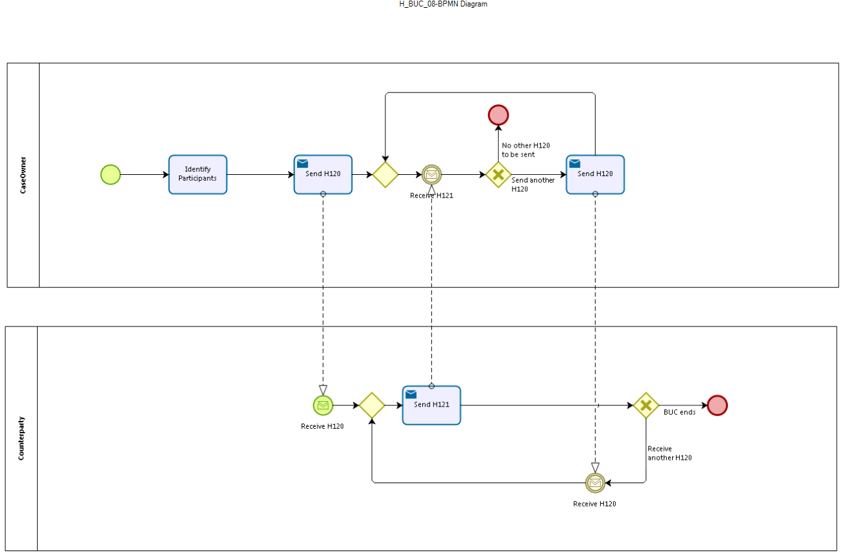

Sub Processes
Not Applicable.

Appendices

Issues
# | Issue date | Description | Replies | Action/Resolution | Close date
1 | 04/01/2016 | Comment received from J-I.S.A: When the counterparty receives the first H120 they start the arrangement with the doctor/hospital. The doctor/hospital book an appointment with the person concerned and makes the necessary preparations. If an updated request arrives it would probably mean that all arrangements have to be redone meaning that the update is to be considered a new request. You need to think about that. |  | To be discussed with all interested sectorial AHGs
2 | 21/04/2016 | In case of pensions there may be more than one counterparty so we need to take it into account even if in S and DA sectors there will be always one Counterparty. |  | we agree that there is only one counterparty and if more institutions are involved like in P sector a new BUC should be opened in regard to each P institution involved.
3 | 21/04/2016 | A very important comment. Need to be discussed also with other sectoral AHGs to decide if we really want update.If a sent SED covers information on basis of which money will be paid/recovered/ reimbursed or the right will be established or some other time consuming procedures will be run, it should be limited in my opinion to situations regarding a basic mistake but not a change in crucial info or a nature/ scope of the request. For me it is safer to invalidate the whole SED and send a new one here. This logic was used in some AHGs in regard for sure to reimbursement SEDs.  But maybe update can be justified when there will be a clear information (now we have it) that updated SEDs are versioned (the latter does not replace the former) and how should we act when we have received updated version but have already acted based on the “original one” – should it depend purely on the knowledge and expertise of the clerk or should there be a possibility to first answer to the original SED and in addition to an updated one? In case of bared costs of such actions, will the versioning of updated SEDs be enough as a proof / basis we acted in good faith on basis of a request/information valid at time we performed actions? |  | We need some intersectoral agreements to have common understanding and therefore rules in all BUCs
4 | 24/06/2016 | Conversion of BPMN model to split between Case Owner and Counterparty |  | Scheduled for Update
5. | 27/09/2016 | Usage of AD-BUC-09 Subprocess Reject |  | The usage of AD-BUC-09 Subprocess Reject has been discussed with AHG members. It was decided this will not be used in this BUC but SED will be updated accordingly.

