
EESSI Business Use Case

APPROVED


H_BUC_09
Notification of Medical Information



Table of Contents

Table of Contents 2
1. Introduction 6
1.1. Purpose 6
1.2. Scope 6
1.3. Definitions, Acronyms and Abbreviations 6
1.4. References 7
1.5. Overview 7
2. Description 8
2.1. Business Scenario 8
2.2. Legal Basis 8
3. Actors & Roles 8
4. Use Case 9
4.1. RUP Table Representation 9
4.2. Request – Reply SEDs 11
4.3. Attachments Allowed 11
4.4. Artefacts used 11
5. Business Processes 12
5.1. Case Owner - Counterparty 12
5.2. Sub Processes 12
6. Appendices 12
6.1. Issues 12

Document Control Information
Settings | Value
Document Title: | Business Use Case  H_BUC_09 - Notification of Medical Information
Project Title: | EESSI (Electronic Exchange of Social Security Information) Project
Document Author: | European Commission, DG EMPL F5
System Owner: | European Commission, DG EMPL D2
Doc. Version: | v4.1.0
Sensitivity: | Public
Date: | 31/08/2018

Document history:
The Document Author is authorized to make the following types of changes to the document without requiring that the document be re-approved:
- Editorial, formatting, and spelling
- Clarification
To request a change to this document, contact the Document Author or Owner.

Revision | Date | Created by | Short Description of Changes
v0.1.0 | 05/12/2016 | Anda Mirita | Initial draft
v0.2.0 | 12/12/2016 | Anda Mirita | Updated following comments received during AHG Horizontal meeting
v0.3.0 | 06/01/2017 | Anda Mirita | Alignment to the standard description and layout of the BUC.
v0.4.0 | 21/02/2017 | Anda Mirita | Updates following comments received from AC and agreed with AHG  Update Point 1 of Main Scenario to: 1. The Case Owner identifies the EU Member State where the notification of Medical Information (A Medical Report) has to be sent by the doctors of the MS where the person resides or stays.  Branch 1 updated  Legal Base updated  Branch 5 added – Admin BUC Reminder
v0.99.0 | 27/02/2017 | Anda Mirita | Candidate for AC Approval
v1.0.0 | 16/03/2017 | Anda Mirita | AC Approved version
v1.0.1 | 29/06/2017 | Gelu Mitu | Updated 5.1 chapter's name to 5.1 – Business Processes – Case Owner – Counterparty and updated its content with the new BPMN diagram: H_BUC_09_Diagram v0.99.0.3.  Removed chapter 5.2 Case Counterparty.  -Replaced the reference to the BUC on Confluence.
v1.1.0 | 01/12/2017 | Heidi Warson | - Updated section 4.1 RUP Table Representation with following clarifications:  branches 2 and 3 to align forward and invalidate wording to the standard wording;  - Removed Section 4.4 RUP UC Diagram Representation.  - Included H_BUC_04 and H_BUC_10 (as not used for this BUC) in table "Sub processes' Table.  - Section 5: rephrase introduction text for this section to the standard text.  Updated following Change Request for "H_BUC_09 – Forward Case is missing for the Counterparty ", see JIRA EESSI-2195"  - Updated branch 2 + updated the Special Requirement 1 for branch 2.
v4.1.0 | 31/08/2018 | Novella Bacelli | - Section 4.4 merged 2 tables (for SED & for Subprocesses) into 1 BUC Artefact table."  - Version adaptations to release 4.1.0

Introduction

Purpose
The purpose of this document is to construct an external view of, part of, the 'EESSI business system' as described in EC Regulations 883/2004 and 987/2009. The ‘EESSI Business System’ describes the business and expected business processes without consideration as to which part(s) may be realized by an IT System (i.e. the proposed EESSI IT System).

The external view comprises of models and descriptions of business use cases, the services of a business system offered to business actors: customers, business partners, or other business systems.

A business use case is described from an actor's perspective; it describes the interaction between an actor and the business system, meaning it describes the behaviours of the business system that the actor utilizes. The Business Use Case includes Use Case Diagrams and Business Process Models.

Use case diagrams show actors, business use cases, and their relationships. Use case diagrams do not describe procedures. Alternative scenarios also remain hidden. These diagrams give a good overview of the behaviours of the EESSI business system which will direct and govern part of the expected behaviours and functionality delivered by the EESSI IT System.

Scope
This document is limited to the external view on the horizontal sector process of Notification of Medical Information. The different elements like use case description, business actors, and business process as well as supporting UML diagrams and BPMN models pertaining to Notification of Medical Information.

Definitions, Acronyms and Abbreviations
Please see the EESSI Project Glossary.

References
# | Description
1 | EC Regulation 883/2004 | Regulation EC No 883- 2004.pdf
2 | EC Regulation 987/2009 | Regulation EC No 987-2009.pdf
3 | UML 2.x | http://www.omg.org/spec/UML/
4 | BPMN 2.0 | http://www.omg.org/spec/BPMN/index.htm
5 | UML 2.0 In Action | Henriette Baumann, Patrick Grassle & Philippe Baumann, 2005, ISBN 1904811558
6 | RUP@EC standard 5.0 | http://www.cc.cec/RUPatEC_Standard/
7 | RUP op maat | http://www.rupopmaat.nl/

Overview
Chapter1 introduces the external view on the business system under review and lists the elements of this specification.
Chapter 2 introduces the Notification of Medical Information business process. The chapter gives a short and detailed description as well as a reference to business process´ legal base.
Chapter 3 lists the actors involved in the Notification of Medical Information business process.
Chapter 4 describes in detail the Notification of Medical Information business process based on the RUP use case template, as well as the relationship to other use cases.
Chapter 5 describes the Notification of Medical Information business process using business process modelling notation (BPMN).

Description

Business Scenario
H_BUC_09 is a business process that allows institutions to send Notification of Medical Information (A Medical Report) usually prepared by the doctors of the MS where the person resides.

Legal Basis
This Business Use Case document's legal base is described in the following Regulations
- basic Regulation (EC) No 883/2004
- implementing Regulation (EC) No 987/2009
The following matrix specifies the SEDs that are used in this Business Use Case and documents the articles that provide the legal basis for each SED.

SED | Basic Reg. (883/04) | Implementing Reg. (987/09)
SED | 82 | 87 | 34(2)(4) | 26
H121
Table 1: SED – Legal base relationship matrix

Actors & Roles
This chapter captures details of the actors which are important to understanding the different types of system users. An actor is anyone or anything that exchanges data with the business system. An actor can be a user, external hardware, or another system.
The overarching description of each actor described in this Business Use Case can be found in the Glossary. Below you will find a short description which provides further clarity of this actor within the context of this Business Use Case.
Actor name | Description
Case Owner | In this BUC the Case Owner is an Institution who sends Medical Information for the purposes of checking and assessing a right/entitlement under the provision of the Regulations
Counterparty | In this BUC the Counterparty is an Institution who receives the medical information.

Use Case

RUP Table Representation
Use Case ID: | H_BUC_09
Use Case Name: | Notification of Medical Information
Created By: | Anda Mirita |  | Last Updated By: | Novella Bacelli
Date Created: | 05/12/2016 |  | Last Revision Date: | 31/08/2018
Actors: |  | Case Owner  Counterparty
Description: |  | H_BUC_09 is a business process that allows for Notification of Medical Information (A Medical Report) prepared by the doctors of the (institutions of the) MS where the person resides or stays.
Trigger: |  | An Institution wishes to provide another / other Institution(s) with Medical Information.
Preconditions: |  | A change of circumstances has occurred in the medical condition of the person.
Post conditions: |  | The Institution received the Medical Information.
Main Scenario: |  | Identify Participants  - The Case Owner identifies the EU Member State where the notification of Medical Information (A Medical Report) has to be sent by the doctors of the MS where the person resides or stays.  - The Case Owner then identifies the correct institution (the Counterparty) or institutions who receive the medical information.  - The Case Owner fills out a Notification of Medical Information / Reply to request for Medical Information (SED H121) by entering all the required information;  - The Case Owner sends the H121, including any attachments, to the Counterparty (s);  - The Counterparty (s) receives the Notification of Medical Information / Reply to request for Medical Information (H121), including any attachments.  The use case ends here.
Alternative Scenarios: |  | Following Branches Determine the use of Horizontal Processes within this Business Process
- After [step 5] Counterparty may optionally choose to request Ad Hoc Information from Case Owner

- The Counterparty executes business use case H_BUC_01 – Ad Hoc Exchange of Info;
- [This Branch] Ends.

 |  | Following Branches Determine the use of Administrative Processes within this Business Process
- At any step after step [5], the Counterparty may choose to Forward this Business Process to another Competent Institution within their MS who assumes responsibility for handling it.
1. The Counterparty executes Business Use Case AD_BUC_05_Forward Case;
2. [This Branch] Ends.

Branch 3: At any step after [step 4] the Case Owner may choose to advise all recipients of their H121 that it is invalid under Art 5 of 987/09

- The Case Owner executes business use case AD_BUC_06_ subProcess Invalidate SED;
- Optionally, the Case Owner fills in Notification of Medical Information / Reply to request for Medical Information (SED H121) by entering all the required data;
- Optionally, the Case Owner sends the H121, including any attachments, to the Counterparty (s);
- [This Branch] Ends.

Branch 4: at any step after [step 4] the Case Owner may choose to send an updated version of H121

- The Case Owner executes business use case AD_BUC_010 - subProcess Update_SED;
- [This Branch] Ends.

Branch 5: at any step after any Participant may optionally choose to send a Reminder to the other Participant for the return of information they were expecting from that participant but did not receive.

- The participant who invokes this branch executes business use case AD_BUC_07_Subprocess _Reminder;
- [This Branch] Ends.
Exceptions: |  | None
Includes: |  | See section 4.4
Special Requirements:: |  | SR1: Rules about the invoking of Branches:  [Branch 1] – May be invoked more than once  [Branch 2] – May be invoked more than once  [Branch 3] – May be invoked more than once (provided a new SED H121 has been created after invalidation)  [Branch 4] – May be invoked more than once  [Branch 5] – May be invoked more than once  SR2: Rules about the destination for each SED Type:  H121 – Defines and is sent to all Active Participants  SR3: The term "Send/Sent to All Active Participants" does not include sending it himself (i.e. to the senders institution)
Assumptions:
Notes and Issues:

Request – Reply SEDs
The following table specifies and SED that have a logical pairing to one another, usually this is known as a request-reply pair.
REQUEST SED | REPLY SED(s)

Attachments Allowed
The following table specifies whether attachments are permitted to be included when sending a SED type.
SED | Attachments
H121 | Allowed

Artefacts used
The following table specifies the artefacts that are used in this Business Use Case.
Artefact name | Artefact type
H121 | SED
H_BUC_01_Subprocess | BUC spec
AD_BUC_05_Subprocess – Forward Case | BUC spec
AD_BUC_06_Subprocess – Invalidate SED | BUC spec
AD_BUC_07_Subprocess – Reminder | BUC spec
AD_BUC_10_Subprocess – Update SED | BUC spec
AD_BUC_11_Subprocess – Business Exception | BUC spec
AD_BUC_12_Subprocess – Change of Participant | BUC spec

Business Processes
This chapter describes the Business Use Case Notification of Medical Information using BPMN 2.0.

Case Owner - Counterparty

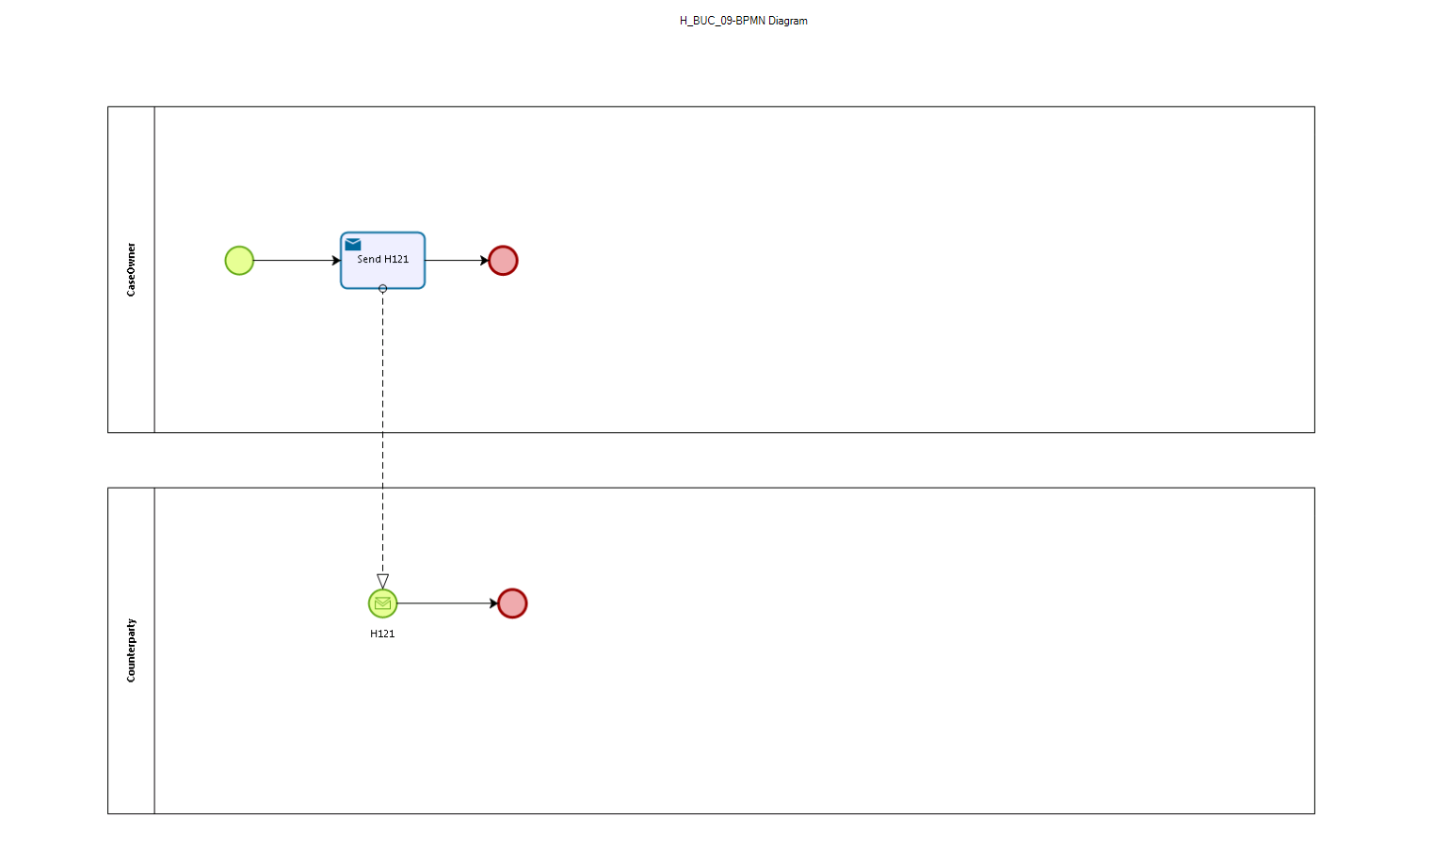

Sub Processes

Not applicable

Appendices

Issues
The issues listed below need to be added to the issue log and discussed at the proper communication level.
# | Issue date | Description | Solution | Close date
1

