
EESSI Business Use Case


LA_BUC_02
Determination of legislation applicable



Table of Contents

Table of Contents 2
1. Introduction 6
1.1. Purpose 6
1.2. Scope 6
1.3. Definitions, Acronyms and Abbreviations 6
1.4. References 7
1.5. Overview 7
2. Description 8
2.1. Business Scenario 8
2.2. Legal Base 8
3. Actors & Roles 9
4. Use Case 10
4.1. RUP Table Representation 10
4.2. Request – Reply SED 20
4.3. Attachments Allowed 20
4.4. Artefacts used 21
6. Business Processes 21
6.1. Case Owner 22
6.2. Counterparty 23
6.3. Sub Processes 24
7. Appendices 25
7.1. Issues 25

Document Control Information
Settings | Value
Document Title: | Business Use Case  LA_BUC_02 - Determination of legislation applicable
Project Title: | EESSI (Electronic Exchange of Social Security Information) Project
Document Author: | European Commission, DG EMPL F5
System Owner: | European Commission, DG EMPL D2
Doc. Version: | v4.1.0
Sensitivity: | Public
Date: | 20/08/2018

Document history:
The Document Author is authorized to make the following types of changes to the document without requiring that the document be re-approved:
- Editorial, formatting, and spelling
- Clarification

To request a change to this document, contact the Document Author or Owner.
Revision | Date | Created by | Short Description of Changes
v0.01 | 15/03/2015 | Mihai Dinca | First draft
v0.02 | 05/06/2015 | Mihai Dinca | AHG comments accepted  Diagrams get more details
v0.03 | 24/07/2015 | Mihai Dinca | Update on the Use Case diagram  Minor corrections within branches
v0.04.0 | 20/01/2016 | Violeta Popescu | Inclusion of Invalidate SED  Removal of LA_BUC_03 as a SubProcess  Inclusion of A008 SED by CO and CP  Update to align with business architecture principles
v0.5.0 | 24/06/2016 | Violeta Popescu | Alignment to the standard description and layout of the BUC  Corrected minor errors found in the document
v0.5.1 | 30/06/2016 | Violeta Popescu | Small changes following the comments received from the Deputy Rapporteur of the AHG
v0.5.2 | 15/07/2016 | Violeta Popescu | Integrated the comments received from the AHG members (typos)
v0.6.0 | 25/07/2016 | Carine Molle | Alignment to the standard description and layout of the BUC
v0.6.1 | 27/07/2016 | Violeta Popescu | Changed "Rapporteur" and "Deputy Rapporteur" instead of "Members of the AHG" at section "Document Approver(s) and Reviewer(s)"
v0.6.2 | 16/08/2016 | Violeta Popescu | Corrected Branch 11: The Counterparty can invalidate the A005, not the Case Owner
v0.99.0 | 14/09/2016 | Violeta Popescu | Integrated the comments received from the AC (typos)  Corrected the Request-Reply A005/A006 (the Request can be sent to one or more Participants and that the reply/replies are sent to the same Participants that received the Request)
v0.99.1 | 16/09/2016 | Violeta Popescu | Submitted for AC approval  Integrated the comments received from the AC
v1.0.0 | 24/10/2016 | Violeta Popescu | AC APPROVED version
v1.0.1 | 3/07/2017 | Calin Niculescu | -Added the BPMN diagrams (version 1.0.1.0).  -Correction in the Sub-process table in section 4.5.  - Inserted reference to BUC confluence page in Configuration Management  - removed Use Case diagram
v1.0.2 | 14/12/2017 | Calin Niculescu | - Updated the BPMN diagrams to clarify the fact that the issuing a portable document A1 is out of the scope of EESSI.  - Patched the Invalidate-SED and Forward-Case BUC branches in order to align them for all sectors.
v4.1.0 | 20/08/2018 | Calin Niculescu | - Changes in section 4.4: the two tables were merged into one, containing all the used artefacts;  - Small patch changes to fit release 4.1.0

Introduction

Purpose
The purpose of this document is to construct an external view of, part of, the 'EESSI business system' as described in EC Regulations 883/2004 and 987/2009. The ‘EESSI Business System’ describes the business and expected business processes without consideration as to which part(s) may be realised by an IT System (i.e. the proposed EESSI IT System).

The external view comprises of models and descriptions of business use cases, the services of a business system offered to business actors: customers, business partners, or other business systems.
A business use case is described from an actor's perspective; it describes the interaction between an actor and the business system, meaning it describes the behaviors of the business system that the actor uses. The Business Use Case includes Use Case Diagrams and Business Process Models.
Use case diagrams show actors, business use cases, and their relationships. Use case diagrams do not describe procedures. Alternative scenarios also remain hidden. These diagrams give a good overview of the behaviors of the EESSI business system which will direct and govern part of the expected behaviors and functionality delivered by the EESSI IT System.

Scope
This document is limited to the external view on the Legislation Applicable sector process of Determination of legislation applicable.

Definitions, Acronyms and Abbreviations
Please see the EESSI Project Glossary here.

References
# | Description
1 | EC Regulation 883/2004 | Regulation EC No 883- 2004.pdf
2 | EC Regulation 987/2009 | Regulation EC No 987-2009.pdf
3 | UML 2.x | http://www.omg.org/spec/UML/
4 | BPMN 2.0 | http://www.omg.org/spec/BPMN/index.htm
5 | UML 2.0 In Action | Henriette Baumann, Patrick Grassle & Philippe Baumann, 2005, ISBN 1904811558
6 | RUP@EC standard 5.0 | http://www.cc.cec/RUPatEC_Standard/
7 | RUP op maat | http://www.rupopmaat.nl/

Overview
Chapter 1 introduces the external view on the business system under review and lists the elements of this specification.
Chapter 2 introduces the Determination of legislation applicable business process. The chapter gives a short and detailed description as well as a reference to business process legal base.
Chapter 3 lists the actors involved in the Determination of legislation applicable business process.
Chapter 4 describes in detail the Determination of legislation applicable business process based on the RUP use case template, as well as the relationship to other use cases.
Chapter 5 describes the Determination of legislation applicable business process using business process modelling notation (BPMN).

Description

Business Scenario
The business process of Determination of legislation applicable in the Legislation Applicable sector describes how situations involving a need to determine the proper legislation to apply in a given case are handled according to article 13 of Regulation (EC) No 883/2004.
According to the guidelines, the process is started when a person or his legal representatives are contacting a competent institution in the Member State where that is person is resident, asking to determine the legislation applicable.
The case can also be triggered by changes in the existing circumstances, signalled through the BUC_LA_03 – Notification of relevant information.

Legal Base
This Business Use Case document's legal base is described in the following Regulations:
- Basic Regulation (EC) No 883/2004
- Implementing Regulation (EC) No 987/2009
The following matrix specifies the SEDs that are used in this Business Use Case and documents the articles that provide the legal basis for each SED.

- SED | Basic Reg (883/04) |  | Implementing Reg (987/09)
- SED | Article 13 | Title II | Article 6 | Article 16 | Article 14
A003
A004
A005
A006
A007
A012
A008
Table 1: SED – Legal base relationship matrix

Actors & Roles
This chapter captures details of the actors that are important to understand the business. An actor is anyone or anything that exchanges data with the business system. An actor can be a user, external hardware, or another system.
The overarching description of each actor described in this Business Use Case can be found in the Glossary. Below you will find a short description which provides further clarity of the actor within the context of this Business Use Case.

Actor name | Description
Case Owner | In this BUC the Case Owner is an institution of a Member State that is being petitioned by a self-employed person or an employee or by its employer in order to determine the Legislation Applicable in a situation where a person works or has worked/receives or has received certain benefits in two or more Member States. It is entitled to contact institutions from other Member States in order to acquire the needed information.
Counterparty | In this BUC, the Counterparty is an institution of a Member State requested to agree or disagree (agree but with changed parameters) on the proposed legislation applicable.  The Case Owner and the Counterparty(ies) are herein collectively referred to as the Participants.
Petitioner | In this BUC, the Petitioner is a person covered by social security legislation (self-employed or employee) that is working/has worked or is receiving/has received certain benefits in at least two member States, or its employer.
Table 2: Actors & Roles

Use Case

RUP Table Representation
Use Case ID: | LA_BUC_02
Use Case Name: | Determination of legislation applicable
Created By: | Mihai Dinca |  | Last Updated By: | Violeta Popescu
Date Created: | 20/01/2015 |  | Last Revision Date: | 24/10/2016
Actors: |  | Case Owner  Counterparty  Petitioner
Description: |  | A Competent Institution from a Member State informs a Counterparty Institution in a different Member State(s) about its (provisional) Determination of legislation applicable.
Trigger: |  | The person concerned and/or his/her employer contacts the designated institution of the person’s Member State of residence.  or  A change of circumstances is signalled through BUC_LA_03 - Notification of relevant information.
Preconditions: |  | A person is working/has worked in two or more Member States and/or the person receives/has received certain benefits based on previous employment from another Member State.  Examples of these situations would be:  - the person works in two or more Member States;  - the person works in one Member State and receives certain benefits from another Member State.
Post conditions: |  | A (provisional) decision has been made regarding the Legislation Applicable. The institution from the Member State whose legislation is applicable may issue the Portable Document A1.
Main Scenario: |  | Identify Participants  - The Case Owner identifies the EU Member State(s) where the person works or has worked or where the person receives or has received certain benefits from;  - The Case Owner then identifies the correct institution/s (the Counterparty(ies) in each Member State involved in the decision making process related to determining whose legislation is applicable. There will be one Counterparty or more (in case more Member States are involved). The Case Owner and the Counterparty(ies) are herein collectively referred to as the Participants. There can be only one institution per Member State.  Send decision  - The Case Owner fills in an A003 SED, in order to determine the legislation applicable;  - The Case Owner sends the A003 SED to the Counterparty(ies).  Receive decision  - Each Counterparty receives and reviews the A003 SED.  Time triggered event  - After two months, if no reply is received, the A003 SED is implicitly approved by all institutions concerned; the competent institution according to the concrete situation may issue the PD A1 (a provisional PD A1 can be issued before the two months have passed);  - The Case Owner executes the business use case AD_BUC_01 - Close;  - This use case ends here.
Alternative Scenario: |  | - after [step 5] and before [step 6] any Counterparty may choose to approve explicitly the decision of legislation applicable expressed in A003  - The Counterparty fills in the A012 SED – Acceptance of Decision on Applicable Legislation to all Participants;  - The Counterparty sends the A012 SED – Acceptance of Decision on Applicable Legislation to the Case Owner (and to all other Participants involved);  - The Case Owner reviews the received A012 SED;  - [This Branch] Ends;  - The case resumes at [step7].
- after [step 5] and before [step 6] any Counterparty may optionally choose to request AdHoc Information from the Case Owner and any other Participant

- The Counterparty fills in the A005 SED, requesting for more information from the Case Owner and any other Participant that received the A003 SED;
- The Counterparty sends the A005 SED to the Case Owner and the Participants that received the A003 SED;
- The Participants receive and review the A005 SED - Request for more information;
- The Participant that wants to reply with A006 SED selects the same Participants that have received the A005 SED (and the sender of A005 SED);
- The Participant fills in a A006 SED by providing the requested information;
- The Participant sends the A006 SED – Reply to Request for more information to the Participants selected at step 4 of the current branch;
- The Participants receive and review the content of A006;
- [This Branch] Ends;
- The case resumes at [step6].
- after [step 5] and before [step6] any Counterparty may choose to reject the decision of legislation applicable expressed in A003

- The Counterparty fills in the A004 SED, rejecting the Determination of legislation applicable ;
- The Counterparty sends the A004 SED – Rejection of Determination of legislation applicable (to all Participants);
- The Participants receive and review the A004 SED – Rejection of Determination of legislation applicable;
- The Case Owner fills in a new A003 SED – Determination of legislation applicable to all Participants;
- The Case Owner sends the A003 SED – Determination of legislation applicable to all Participants;
- The Counterparty receives and reviews the content of A003 SED;
- [This Branch] Ends;
- The case resumes at [step6].
- Providing that [branch 3] has been executed, after [branch 3 step 3] and before [branch 3 step4] any Participant may issue a SED that provisionally determines the legislation applicable

- The Participant fills in the A007 SED – Provisional Determination of Applicable Legislation ;
- The Participant sends the A007 SED – Provisional Determination of Applicable Legislation (to all other Participants);
- The other Participants receive and review the A007 SED – Provisional Determination of Applicable Legislation;
- [This Branch] Ends;
- The case resumes at [branch 3 step4].
- Providing the [branch 3] has been executed after [branch 3 step 3] and before [step7] any Participant may optionally choose to request AdHoc Information from the Participant that started the [Branch 3] and any other Participant

- The Participant fills in the A005 SED, in order to request for more information;
- The Participant sends the A005 SED - Request for more information to the Participant that started the [Branch 3] and any other Participant;
- The Participants receive and review the A005 SED - Request for more information;
- The Participant that wants to reply to A005 SED fills in a A006 SED, by providing the requested information (there must be the same Participants that received the A005 SED, including the sender of the A005 SED);
- The Participant sends the A006 SED – Reply to Request for more information to the Participants selected at step 4 of the current branch;
- The other Participants receive and review the content of A006 SED;
- [This branch] Ends;
- The case resumes at the step where it was before this branch was triggered.
- Providing the [branch 4] has been executed, after [branch 4 step 3] and before [step7] any Participant may optionally choose to request AdHoc Information from the Participant that started the [Branch 4] and any other Participant

- The Participant fills in the A005 SED in order to request for more information;
- The Participant sends the A005 SED - Request for more information to the Participant that started the [Branch 4] and any other Participant;
- The Participants receive and review the A005 SED - Request for more information;
- The Participant that wants to reply to A005 SED fills in a A006 SED – Reply to Request for more information (there must be the same Participants that received the A005 SED, including the sender of the A005 SED);
- The Participant sends the A006 SED by providing the requested information to the Participants selected at step 4 of the current BUC;
- The Participant that started the [Branch 6] and any other Participant receive and review the content of A006 SED;
- [This branch] Ends;
8. The case resumes at the step where it was before this branch was triggered.
- at any step after [step 5] the Case Owner may choose to notify the Counterparties of Relevant Information

- The Case Owner fills in the A008 - Notification of Relevant Information;
- The Case Owner sends the A008 to all Participants;
- Each Participant receives and reviews the content of the A008;
- [This branch] Ends.

- at any step after [step 5] a Counterparty may choose to notify the other Participants of Relevant Information

- The Counterparty fills in the A008 – Notification of Relevant Information;
- The Counterparty sends the A008 to the other Participants;
- Each Participant receives and reviews the content of the A008;
- [This branch] Ends.

 |  | The Following Branches Determine the use of other Legislation Applicable Processes within this Business Process
- at any step between [step 3] and [step 7] the Case Owner may choose to advise all recipients of their A003 that it is invalid under Art 5 of 987/09

- The Case Owner executes business use case AD_BUC_06_SubProcess – Invalidate SED;
- Optionally, the Case Owner fills in an A003 – Determination of Applicable Legislation, by entering all the required data;
- Optionally, the Case Owner sends the A003, including any attachments, to all the recipients;
- [This Branch] Ends.
- at any step between [Branch 1 Step2] and [step 7] the Counterparty may choose to advise all recipients of their A012 that it is Invalid under Art 5 of 987/09

- The Counterparty executes business use case AD_BUC_06_SubProcess-Invalidate SED;
- Optionally, the Counterparty fills in an A012 – Acceptance of Decision on Applicable Legislation, by entering all the required data;
- Optionally, the Counterparty sends the A012, including any attachments, to all the recipients;
- [This Branch] Ends.
- at any step between [Branch 2 Step2] and [step 7] the Counterparty may choose to advise all recipients of their A005that it is Invalid under Art 5 of 987/09

- The Counterparty executes business use case AD_BUC_06_SubProcess-Invalidate SED;
- Optionally, the Counterparty fills in an A005 – Request for more information, by entering all the required data;
- Optionally, the Counterparty sends the A005, including any attachments, to all the recipients;
- [This Branch] Ends.
- at any step between [Branch 2 Step5] and [step 7] the Case Owner may choose to advise all recipients of their A006 that it is Invalid under Art 5 of 987/09

- The Case Owner executes business use case AD_BUC_06_SubProcess-Invalidate SED;
- Optionally, the Case Owner fills in an A006 – Reply to request for more information, by entering all the required data;
- Optionally, the Case Owner sends the A006, including any attachments, to all the recipients;
- [This Branch] Ends.
- at any step between [Branch 3 Step 2] and [step 7] the Counterparty may choose to advise all recipients of their A004 that it is Invalid under Art 5 of 987/09

- The Counterparty executes business use case AD_BUC_06_SubProcess-Invalidate SED;
- Optionally, the Counterparty fills in an A004 – Rejection of Determination on Applicable Legislation, by entering all the required data;
- Optionally, the Counterparty sends the A004, including any attachments, to all the recipients;
- [This Branch] Ends.
- at any step between [Branch 4 Step 2] and [step 7] any Participant may choose to advise all recipients of their A007that it is Invalid under Art 5 of 987/09

- The Participant executes business use case AD_BUC_06_SubProcess-Invalidate SED;
- Optionally, the Participant fills in an A007 – Provisional Determination of Applicable Legislation, by entering all the required data;
- Optionally, the Participant sends the A007, including any attachments, to all the recipients;
- [This branch] Ends.
 |  | The Following Branches Determine the use of Horizontally Defined Processes within this Business Process
- at any step between [step 5] and [step 7] any Participant may optionally choose to request AdHoc Information from another Participant

- The Participant executes business use case H_BUC_01 – AdHoc Exchange of Info;
- [This Branch] Ends.
- at any step between [step 5] and [step 7] any Participant may optionally choose to determine the residence of the Person with another Participant

- The Participant executes business use case H_BUC_02 – Determine Residence;
- [This Branch] Ends.
- at any step between [step 5] and [step 7] any Participant may optionally choose to Transfer of Claim document with another Participant

- The Participant executes business use case H_BUC_06 – Transfer of Claim;
- [This Branch] Ends.
- at any step between [step 5] and [step 7] any Participant may optionally choose to notify another Participant of a Death of a Person

- The Participant executes business use case H_BUC_07 – Notification of Death;
- [This Branch] Ends.
 |  | The Following Branches Determine the use of Administrative Processes within this Business Process
- at any step between [step 5] and [step 7] the Case Owner may choose to Forward this Business Process to another Competent Institution within their Member State who assumes responsibility for handling it

- The Case Owner executes business use case AD_BUC_05 – Forward Case;
- [This Branch] Ends.
- at any step between [step 5] and [step 7] the Counterparty may choose to Forward this Business Process to another Competent Institution within their Member State who assumes responsibility for handling it

- The Counterparty executes business use case AD_BUC_05 – Forward Case;
- [This Branch] Ends.
 |  | - REMOVED
- at any step between [step 4] and [step 7] the Case Owner may choose to send an updated version of A003

- The Case Owner executes business use case AD_BUC_010 - Update_SED;
- [This Branch] Ends.
- at any step between [Branch 1 step 2] and [step 7] the Counterparty may choose to send an updated version of A012

- The Counterparty executes business use case AD_BUC_010 - Update_SED;
- [This Branch] Ends.
- at any step between [Branch 3 step 2] and [step 7] the Counterparty may choose to send an updated version of A004

- The Counterparty executes business use case AD_BUC_010 - Update_SED;
- [This Branch] Ends.
- at any step between [Branch 3 step 5] and [step 7] the Case Owner may choose to send an updated version of A003

- The Case Owner executes business use case AD_BUC_010 - Update_SED;
- [This Branch] Ends.
- at any step between [Branch 4 step 2] and [step 7] the Counterparty may choose to send an updated version of A007

- The Counterparty executes business use case AD_BUC_010 - Update_SED;
- This Branch] Ends.
- at any step between completion of [Branch 2/5/6] and [step 7] the Participant that invoked the branches may choose to send an updated version of A005

- The Participant executes business use case AD_BUC_010 - Update_SED;
- [This Branch] Ends.
- at any step between the completion of [Branch 2/5/6] and [step 7] the Participant may choose to send an updated version of A006

- The Participant executes business use case AD_BUC_010 - Update_SED;
- [This Branch] Ends.
- at any step between [step 4] and [step 7] any Participant may optionally choose to send a Reminder in order to receive the answer to information expected but not received

- The Participant who invokes this branch executes business use case AD_BUC_07 - Reminder;
- [This Branch] Ends.
- at any step between [step 4] and [step 7] any Participant may optionally choose to request to another Participant clarification of the previously sent data

- The Participant executes business use case AD_BUC_08 - Clarify Content;
- [This Branch] Ends.
- at any step between [step 4] and [step 7] any Participant may optionally choose to Reject a previously received SED

- The Participant who invokes this branch executes business use case AD_BUC_09 - Reject_SED;
- [This Branch] Ends.
- at any step between [step 5] and [step 7] the Case Owner may choose to Add a Counterparty to this Business Process

- The Case Owner executes business use case AD_BUC_03 – Add Participant;
- [This Branch] Ends.

- at any step between [step 4] and [step 7] the Case Owner may choose to Remove a Counterparty from this Business Process (providing that at least one Counterparty will remain into the case)

- The Case Owner executes business use case AD_BUC_04 – Remove Participant;
- [This Branch] Ends.
- at any step after [Branch 7 Step 2] a Case Owner may choose to advise all recipients of their A008 that it is Invalid under Art 5 of 987/09

- The Case Owner executes business use case AD_BUC_06_SubProcess – Invalidate SED;
- Optionally, the Case Owner fills in an A008 – Notification of Relevant Information, by entering all the required data;
- Optionally, the Case Owner sends the A008, including any attachments, to all the recipients;
- [This Branch] Ends.

- at any step after [Branch 8 Step 2] a Counterparty may choose to advise all recipients of their A008 that it is Invalid under Art 5 of 987/09

- The Counterparty executes business use case AD_BUC_06_SubProcess – Invalidate SED;
- Optionally, the Counterparty fills in an A008 – Notification of Relevant Information, by entering all the required data;
- Optionally, the Counterparty sends the A008, including any attachments, to all the recipients;
- [This Branch] Ends.

- at any step after [Branch 7 Step 2] the Case Owner may choose to send an updated version of A008
- The Case Owner executes business use case AD_BUC_10_SubProcess - Update_SED;
- [This Branch] Ends.
- at any step after [Branch 8 Step 2] a Counterparty may choose to send an updated version of A008
1. The Counterparty executes business use case AD_BUC_10_SubProcess - Update_SED;
2. [This Branch] Ends.
Exceptions: |  | Exception 1: at any step between [step 4] and [step 7] the Case Owner may optionally choose to end the process due to unexpected information becoming known during the course of the investigations  - The Case Owner executes the business use case AD_BUC_01 - Close;  - This BUC Ends.
Includes: |  | See diagram at part 4.4.
Special Requirements: |  | SR1: Rules about the invoking of Branches:  Business  [Branch 2] to [Branch 6] - May be invoked more than once, per Participant  Other LA cases  [Branch 7] to [Branch 12] - May be invoked more than once, per Participant  Horizontals  [Branch 13] to [Branch 17] - May be invoked more than once, per Participant  Administrative  [Branch 18] to [Branch 31] – May be invoked more than once  SR2: Rules about the destination for each SED Type:  A003 – Must be Sent to all Active Participants  A012 – Must be Sent to all Active Participants  A004 – Must be Sent to all Active Participants  A005 – Must be Sent to one or more active Participants  A006 – Must be Sent to all active Participants that received the A005  A008 - Must be Sent only to all active Participants  SR3: The term "Send/Sent to All Active Participants" does not include sending it himself (i.e. to the sender's institution)  SR4: Active Participants are defined as those Participants identified at [Step 2] and those Participants added through the execution of [Branch 30] and not removed through the execution [Branch 31]  SR5: Alternative Branches 1 – 31 are non-interrupting Branches; Exception 1 is an Interrupting Exception.
Assumptions:
Notes and Issues:

Request – Reply SED
The following table specifies the SEDs that have a logical pairing to one another, usually this is known as a request-reply pair.
REQUEST SED | REPLY SED(s)
A003 | A004, A012
A005 | A006

Attachments Allowed
The following table specifies whether attachments are permitted to be included when sending a SED type.
SED | Attachments
A003 | Allowed
A004 | Allowed
A005 | Allowed
A006 | Allowed
A007 | Allowed
A008 | Allowed
A012 | Allowed

Artefacts used
- The following table specifies the artefacts that are used in this Business Use Case:
Artefact name | Artefact type
A003 | SED
A004 | SED
A005 | SED
A006 | SED
A007 | SED
A008 | SED
A012 | SED
H_BUC_01_Subprocess | BUC
H_BUC_02_Subprocess | BUC
H_BUC_06_Subprocess | BUC
H_BUC_07_Subprocess | BUC
AD_BUC_01_Subprocess – Close Case | BUC
AD_BUC_03_Subprocess – Add Participant | BUC
AD_BUC_04_Subprocess – Remove Participant | BUC
AD_BUC_05_Subprocess – Forward Case | BUC
AD_BUC_06_Subprocess – Invalidate SED | BUC
AD_BUC_07_Subprocess – Reminder | BUC
AD_BUC_08_Subprocess – Clarify Content | BUC
AD_BUC_09_Subprocess – Reject SED | BUC
AD_BUC_10_Subprocess – Update SED | BUC
AD_BUC_11_Subprocess – Business Exception | BUC
AD_BUC_12_Subprocess – Change of Participant | BUC

Business Processes
This chapter describes the Business Use Case Determination of legislation applicable using BPMN 2.0. Based on BPMN Diagram version 1.0.1.3.

Case Owner
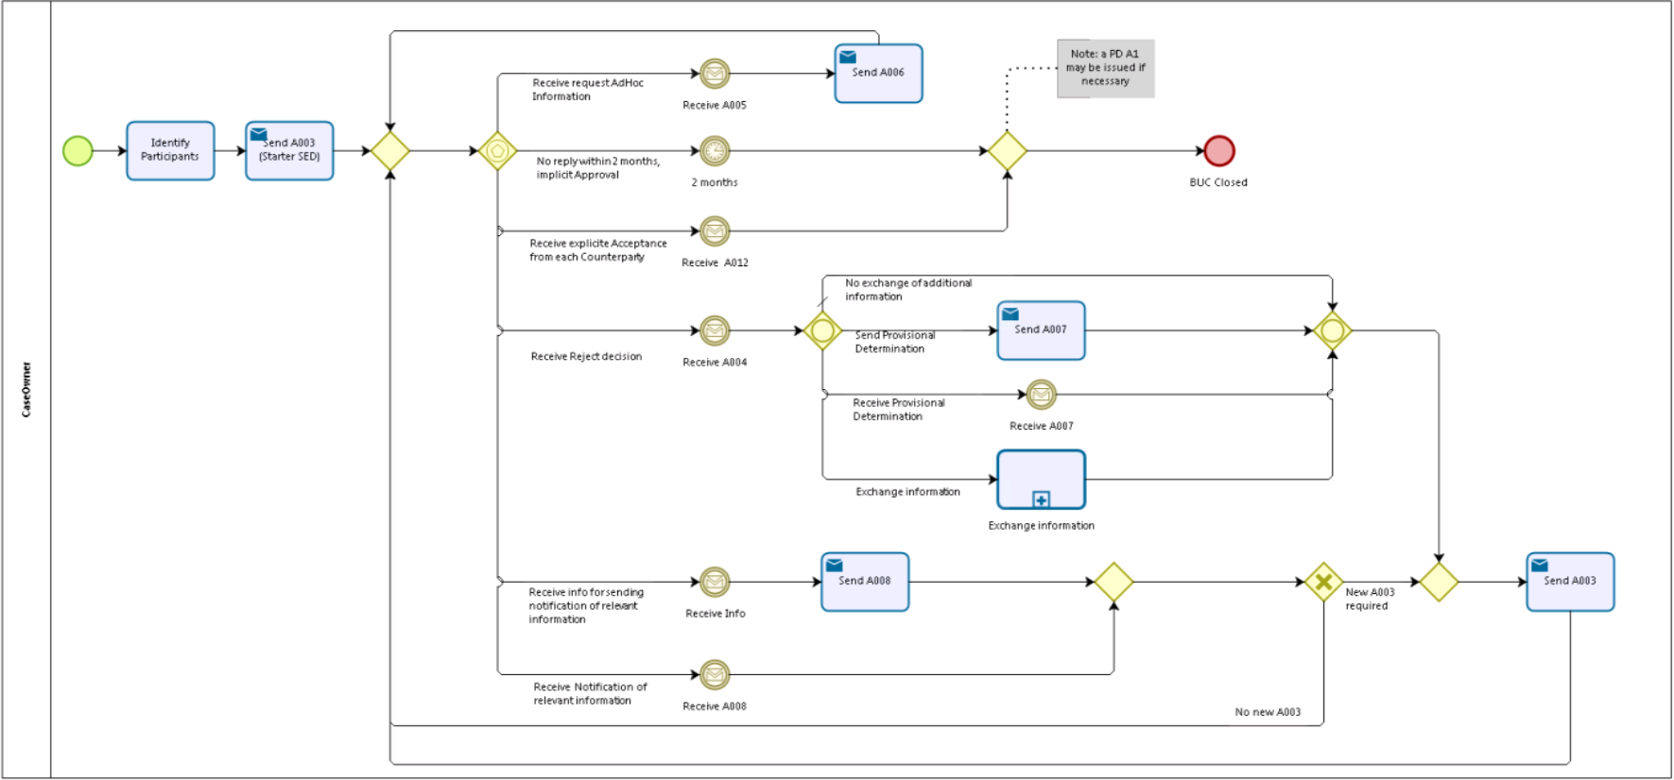

Counterparty
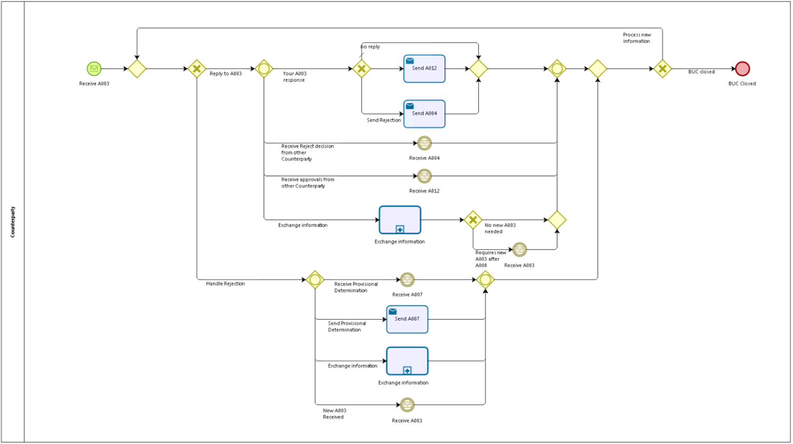

Sub Processes
Exchange Information
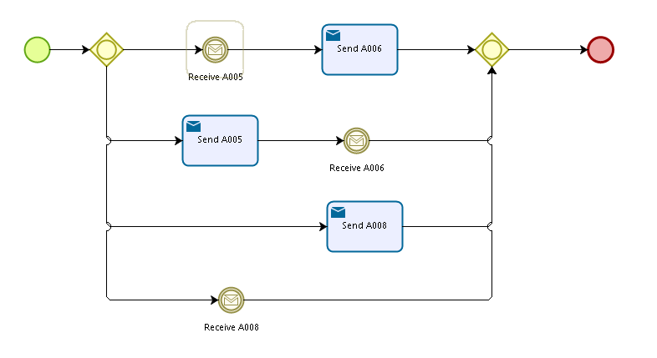

Appendices

Issues

# | Issue date | Description | Solution | Close date

