
EESSI Business Use Case


LA_BUC_03
Notification of relevant information



Table of Contents

Table of Contents 2
1. Introduction 6
1.1. Purpose 6
1.2. Scope 6
1.3. Definitions, Acronyms and Abbreviations 6
1.4. References 7
1.5. Overview 7
2. Description 8
2.1. Business Scenario 8
2.2. Legal Base 8
3. Actors & Roles 9
4. Use Case 10
4.1. RUP Table Representation 10
4.2. Request – Reply SED 13
4.3. Attachments 13
4.4. Artefacts used 14
5. Business Processes 15
5.1. Case Owner and Counterparty 15
5.2. Called sub-processes 15
6. Appendices 16
6.1. Issues 16

Document Control Information
Settings | Value
Document Title: | Business Use Case  LA_BUC_03 - Notification of relevant information
Project Title: | EESSI (Electronic Exchange of Social Security Information) Project
Document Author: | European Commission, DG EMPL F5
System Owner: | European Commission, DG EMPL D2
Doc. Version: | v4.1.0
Sensitivity: | Public
Date: | 20/08/2018

Document history:
The Document Author is authorized to make the following types of changes to the document without requiring that the document be re-approved:
- Editorial, formatting, and spelling
- Clarification

To request a change to this document, contact the Document Author or Owner.

Revision | Date |  | Created by | Short Description of Changes
v0.1 | 13/01/2015 |  | Mihai Dinca | First Draft
v0.2 | 21/01/2015 |  | Mihai Dinca | Citizen actor added, BPMN changed accordingly
v0.3 | 28/04/2015 |  | Mihai Dinca | Change version system  Remove former flow reference  Add Forward Case Branch
v0.4.0 | 27/01/2016 |  | Violeta Popescu | Add the Request – Reply SED  Add the Attachments Allowed section  Add SED and Sub-process versioning  Add Close Exception  Update to align with the business architecture principles
v0.4.1 | 12/02/2016 |  | Violeta Popescu | Integration of the changes made following the AHG meeting:  - added the note saying that A008 could be the trigger of LA_BUC_02  - changed "Title II" at Implementing Regulation (instead of "Art 16")  - added the "Update", "Invalidate" and "Add Participant" branches
v0.4.2 | 31/03/2016 |  | Violeta Popescu | Integrated further comments received from the AHG
v0.5.0 | 26/06/2016 |  | Violeta Popescu | Add the Reopen branch  Add steps 7 and 8 (Close)  Alignment to the standard description and layout of the BUC
v0.5.1 | 29/06/2016 |  | Violeta Popescu | Rephrased the Description, Trigger, Post Conditions in the Main Scenario, following the comments received from the Deputy Rapporteur of the AHG
v0.6.0 | 25/07/2016 |  | Carine Molle | Alignment to the standard description and layout of the BUC.
v0.99.0 | 14/09/2016 |  | Violeta Popescu | Integrated the comments received from the AC (typos)
v0.99.1 | 15/09/2016 |  | Violeta Popescu | Submitted for AC approval  Integrated more comments received from  the AC
v1.0.0 | 24/10/2016 |  | Violeta Popescu | AC Approved version
v1.0.1 | 3/07/2017 |  | Calin Niculescu | Added BPMN diagram (version 1.0.0.5)
v1.1.0 |  | 11/12/2017 | Calin Niculescu | Approval of change request for " LA_BUC_03 - Add Administrative Sub-processes Clarify and Reject ", see JIRA EESSI-1780.": The participants receiving SEDs need to clarify or reject them.  - Added BPMN version of the diagram in section 5.  - Correction in the sub-process table in section 4.5.
v1.1.1 |  | 19/12/2017 | Calin Niculescu | - Updated the BPMN diagrams to clarify the fact that the issuing a portable document A1 is out of the scope of EESSI.  - Patched the Invalidate-SED and Forward-Case BUC branches in order to align them for all sectors.
v4.1.0 |  | 20/08/2018 | Calin Niculescu | - Changes in section 4.4: the two tables were merged into one, containing all the used artefacts;  - Small patch changes to fit release 4.1.0

Introduction

Purpose
The purpose of this document is to construct an external view of, part of, the 'EESSI business system' as described in EC Regulations 883/2004 and 987/2009. The ‘EESSI Business System’ describes the business and expected business processes without consideration as to which part(s) may be realised by an IT System (i.e. the proposed EESSI IT System).

The external view comprises of models and descriptions of business use cases, the services of a business system offered to business actors: customers, business partners, or other business systems.
A business use case is described from an actor's perspective; it describes the interaction between an actor and the business system, meaning it describes the behaviors of the business system that the actor utilises. The Business Use Case includes Use Case Diagrams and Business Process Models.
Use case diagrams show actors, business use cases, and their relationships. Use case diagrams do not describe procedures. Alternative scenarios also remain hidden. These diagrams give a good overview of the behaviors of the EESSI business system which will direct and govern part of the expected behaviors and functionality delivered by the EESSI IT System.

Scope
This document is limited to the external view on the Legislation Applicable sector process of Notification of relevant Information.
The different elements like use case description, actors, and business process as well as supporting UML diagrams and BPMN models pertaining to the Notification of relevant Information.

Definitions, Acronyms and Abbreviations
Please see the EESSI Project Glossary here.

References
# | Description
1 | EC Regulation 883/2004 | Regulation EC No 883- 2004.pdf
2 | EC Regulation 987/2009 | Regulation EC No 987-2009.pdf
3 | UML 2.x | http://www.omg.org/spec/UML/
4 | BPMN 2.0 | http://www.omg.org/spec/BPMN/index.htm
5 | UML 2.0 In Action | Henriette Baumann, Patrick Grassle & Philippe Baumann, 2005, ISBN 1904811558
6 | RUP@EC standard 5.0 | http://www.cc.cec/RUPatEC_Standard/
7 | RUP op maat | http://www.rupopmaat.nl/

Overview
Chapter1 introduces the external view on the business system under review and lists the elements of this specification.
Chapter 2 introduces the Notification of relevant information business process. The chapter gives a short and detailed description as well as a reference to business process' legal base.
Chapter 3 lists the actors involved in the Notification of relevant information business process.
Chapter 4 describes in detail the Notification of relevant information business process based on the RUP use case template, as well as the relationship to other use cases.
Chapter 5 describes the Notification of relevant information business process using business process modelling notation (BPMN).

Description

Business Scenario
The "Notification of relevant information" business process in the Legislation Applicable sector describes how situations involving a need to revise a previous decision are handled according to Title II of Regulation (EC) No 883/2004.
If one of the institutions that participated in determining the legislation applicable notices that relevant changes have occurred (affecting the situation that lead to the mentioned decision), it can notify the other institution concerned about the changes. This may lead to issuing a new PD A1.
The BUC also covers the situations when there is a need to inform the institution in the state of residence of an employee or self-employed person about him/her pursuing an activity in two or more Member States. This will allow the institution in the state of residence to make a provisional assessment as described in article 16 Reg. 987/2009.

Legal Base
This Business Use Case document's legal base is described in the following Regulations
- Basic Regulation (EC) No 883/2004
- Implementing Regulation (EC) No 987/2009
The following matrix specifies the SEDs that are used in this Business Use Case and documents the articles that provide the legal basis for each SED.

- SED | Basic Reg (883/04) | Implementing Reg (987/09)
- SED | Title II | Title II
A008
Table 1: SED – Legal base relationship matrix

Actors & Roles
This chapter captures details of the actors which are important to understand the different types of system users. An actor is anyone or anything that exchanges data with the business system. An actor can be a user, external hardware, or another system.
The overarching description of each actor described in this Business Use Case can be found in the Glossary. Below you will find a short description which provides further clarity of this actor within the context of this Business Use Case.

Actor name | Description
Case Owner | Institution that notices the relevant changes  or  Institution that wants to inform other Member States about the activities of one of their residents in two or more Member States.
Counterparty | Institution that is being notified about:  Relevant changes  or  The activity in two or more Member States.  The Case Owner and the Counterparty(ies) are herein collectively referred to as the Participants.
Citizen | The beneficiary of the PD A1.
Table 2: Actors & Roles

Use Case

RUP Table Representation
Use Case ID: | LA_BUC_03
Use Case Name: | Notification of Relevant Information
Created By: | Mihai Dinca |  | Last Updated By: | Violeta Popescu
Date Created: | 13/01/2015 |  | Last Revision Date: | 24/10/2016
Actors: |  | Case Owner  Counterparty  Citizen
Description: |  | A Competent Institution from a Member State finds out that relevant changes have occurred and notifies the other(s) concerned institution(s) about it. It can also be used to inform the Competent Institution of the country of residence of a worker/self employed working in 2 or more countries.
Trigger: |  | Relevant changes occurred or a Competent Institution of a Member State learns about the situation of a worker/self-employed, residing in another Member State, working in 2 or more countries (Member States)
Preconditions: |  | A decision has already been taken  or  A SED has been exchanged  or  A Competent Institution of a Member State learns about the situation of a worker/self-employed, residing in another Member State, working in 2 or more countries (Member States)
Post conditions: |  | All institutions concerned are notified about:  Relevant changes  or  The activity of a worker/self-employed in 2 or more Member States  After LA_BUC_03 is finished, LA_BUC_02 can be used, in order to continue the business process and determine the legislation applicable.
Main Scenario: |  | Identify Participants  - The Case Owner identifies the EU Member State(s) which is (are) concerned with the changes or which is the country of residence of the (self) employed person working in 2 or more Member States;  - The Case Owner then identifies the correct institution(s) (the Counterparty(ies)) in the concerned Member State(s). The Case Owner and the Counterparty(ies) are herein collectively referred to as the Participants.  Send the notification of relevant changes  - The Case Owner fills in an A008 SED – Notification of relevant information;  - The Case Owner sends the A008 SED – Notification of relevant information to the Counterparty(ies).  Receive the notification  - The Counterparty receives and reviews the A008 SED.  Issue the new PD A1 (if needed)  - The Case Owner or the Counterparty may issue a new PD A1 to the citizen, if needed, depending on the circumstances;  - The Case Owner waits for a period of 30 calendar days;  - The Case Owner executes use case AD_BUC_01 – Close Case;  - The use case ends here.
Alternative branches: |  | The Following Branches Determine the use of Administrative Processes within this Business Process
- at any step between [step 4] and [step 7] the Case Owner may choose to forward this Business Process to another Competent Institution within their Member State who assumes responsibility for handling it.

- The Case Owner executes business use case AD_BUC_05 – Forward Case;
- [This Branch] Ends.

- at any step between [step 5] and [step 7] the Counterparty may choose to forward this Business Process to another Competent Institution within their Member State who assumes responsibility for handling it.

- The Counterparty executes business use case AD_BUC_05 – Forward Case;
- [This Branch] Ends.
- at any step between [step 4] and [step 7] the Case Owner may choose to add a Participant to this Business Process.

1. The Case Owner executes business use case AD_BUC_03 – Add Participant;
2. [This Branch] Ends.
- at any step between [step 5] and [step 7] the Counterparty may choose to add a Participant to this Business Process.

1. The Counterparty or any Participant executes business use case AD_BUC_03 – Add Participant;
2. [This Branch] Ends.
- at any step between [step 4] and [step 7] the Case Owner may choose to advise all recipients of their A008 that it is invalid under Art 5 of 987/09.

- The Case Owner executes business use case AD_BUC_06_SubProcess – Invalidate SED;
- Optionally, the Case Owner fills in an A008 – Notification of Relevant Information, by entering all the required data;
- Optionally, the Case Owner sends the A008, including any attachments, to the recipients;
- [This Branch] Ends

- at any step between [step 4] and [step 7] the Case Owner may choose to send an updated version of A008.

- The Case Owner executes business use case AD_BUC_10 - Update_SED;
- [This Branch] Ends.
- After Step [8] any Participant may choose to Reopen the Business Process.

- Any Participant may execute business use case AD_BUC_02 – Reopen Case;
- [This Branch] Ends.
- At any step after [Step 5] and before [Step 8] any Counterparty may request to another Participant (who previously sent them an A008 SED – Notification of relevant information) provide clarifications of the information they sent.

- The Participant executes business use case AD_BUC_08_SubProcess - Clarify Content;
- [This Branch] Ends.
- At any step after [Step 5] and before [Step 8] any Participant may choose to Reject the previously received SED.

- The Participant executes business use case
AD_BUC_09 - Reject_SED;
- [This Branch] Ends.
Includes: |  | See diagram at part 4.4.
Special Requirements:
Assumptions:
Notes and Issues:

Request – Reply SED
The following table specifies the SEDs that have a logical pairing to one another, usually this is known as a request-reply pair.

REQUEST SED | REPLY SED(s)
NONE

Attachments
The following table specifies whether attachments are permitted to be included when sending a SED type.

SED | Attachments
A008 | Allowed

Artefacts used
The following table specifies the artefacts that are used in this Business Use Case:

Artefact name | Artefact type
A008 | SED
AD_BUC_01_Subprocess – Close Case | BUC
AD_BUC_02_Subprocess – Reopen Case | BUC
AD_BUC_03_Subprocess – Add Participant | BUC
AD_BUC_05_Subprocess – Forward Case | BUC
AD_BUC_06_Subprocess – Invalidate SED | BUC
AD_BUC_08_Subprocess – Clarify Content | BUC
AD_BUC_09_Subprocess – Reject SED | BUC
AD_BUC_10_Subprocess – Update SED | BUC
AD_BUC_11_Subprocess – Business Exception | BUC
AD_BUC_12_Subprocess – Change of Participant | BUC

Business Processes
This chapter describes the Business Use case Notification of Applicable legislation using BPMN 2.0.Based on the BPMN diagram version 1.1.0.11.

Case Owner and Counterparty
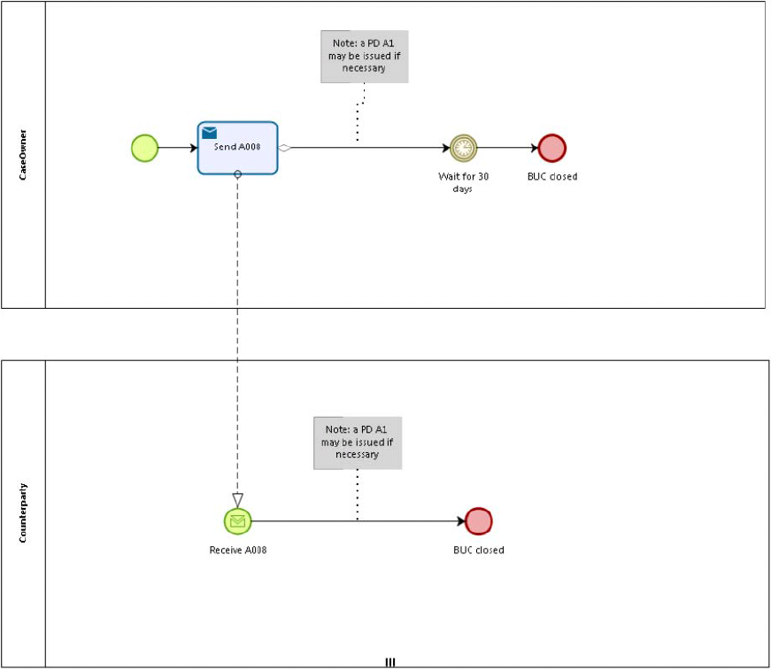

Called sub-processes
N/A.

Appendices

Issues
# | Issue date | Description | Solution | Close date

