

EESSI Business Use Case



LA_BUC_04
Notification of posting



Table of Contents

Table of Contents 2
1. Introduction 6
1.1. Purpose 6
1.2. Scope 6
1.3. Definitions, Acronyms and Abbreviations 6
1.4. References 7
1.5. Overview 7
2. Description 8
2.1. Business Scenario 8
2.2. Legal Base 8
3. Actors & Roles 9
4. Use Case 10
4.1. RUP Table Representation 10
4.2. Request – Reply SEDs 12
4.3. Attachments 12
4.4. Artefacts used 12
5. Business Processes 13
5.1. Case Owner and Counterparty 14
5.2. Called sub processes 15
6. Appendices 15
6.1. Issues 15

Document Control Information
Settings | Value
Document Title: | Business Use Case  LA_BUC_04 - Notification of posting
Project Title: | EESSI (Electronic Exchange of Social Security Information) Project
Document Author: | European Commission, DG EMPL F5
System Owner: | European Commission, DG EMPL D2
Doc. Version: | v4.1.0
Sensitivity: | Public
Date: | 20/08/2018

Document history:
The Document Author is authorized to make the following types of changes to the document without requiring that the document be re-approved:
- Editorial, formatting, and spelling
- Clarification

To request a change to this document, contact the Document Author or Owner.
Revision | Date | Created by | Short Description of Changes
v0.1.0 | 29/07/2015 | Mihai Dinca | First Draft of the document
v0.2.0 | 11/11/2015 | Violeta Popescu | Add the Request – Reply SED  Add the Attachments Allowed section  Add SED and Sub-process versioning  Add Close Exception  Update to align with the business architecture principles
v0.2.1 | 05/02/2016 | Violeta Popescu | Changes in the description of the "Trigger", "Post condition", "Main scenario" AHG meeting  Added the "Update", "Forward" and "Invalidate" as Administrative Processes
v0.2.2 | 02/03/2016 | Violeta Popescu | Integrated the comments received from the AHG members  Added branch 4 "Add Participant"
v0.3.0 | 21/06/2016 | Violeta Popescu | Alignment to the standard description and layout of the BUC
v0.4.0 | 23/06/2016 | Violeta Popescu | Add the Reopen branch  Add steps 7 and 8 (Close)
v0.4.1 | 27/06/2016 | Violeta Popescu | Integrated the comments received from the Rapporteur and Deputy Rapporteur:  - steps 3,4 and 5 in the Main Scenario can be repeated by the Case Owner  - reworded the text under "Post conditions"  - the waiting period for the Case Owner to close the case (in Main Scenario) was changed from 60 to 30 days
v0.4.2 | 27/07/2016 | Violeta Popescu | Changed "Rapporteur" and "Deputy Rapporteur" instead of "Members of the AHG" at section Document Approver(s) and Reviewer(s)
v0.5.0 | 19/08/2016 | Violeta Popescu | Update the BUC, in order to reflect that there can be more Counterparties
v0.99.0 | 15/09/2016 | Violeta Popescu | Submitted for AC approval
v0.99.1 | 06/10/2016 | Violeta Popescu | Submitted for AC approval  Created two branches for Forward and Add Participant (one for the CO, one for the CP)
v1.0.0 | 24/10/2016 | Violeta Popescu | AC Approved version
v1.0.1 | 30/06/2017 | Calin Niculescu | Added the BPMN diagram (version 1.0.0.10).
v1.1.0 | 11/07/2017 | Calin Niculescu | Approval of change request for "LA_BUC_04 - remove the branch "Add Participant" and make it bilateral", see JIRA EESSI-1788: Make the BUC bilateral and not multilateral.  - Added the BPMN version of the diagram in section 5.  - Correction in the list of sub-processes in section 4.5.  - Inserted reference to BUC confluence page in Configuration Management
v1.1.1 | 19/12/2017 | Calin Niculescu | - Updated the BPMN diagrams to clarify the fact that the issuing a portable document A1 is out of the scope of EESSI.  - Patched the Invalidate-SED and Forward-Case BUC branches in order to align them for all sectors.
v4.1.0 | 20/08/2018 | Calin Niculescu | - Changes in section 4.4: the two tables were merged into one, containing all the used artefacts;  - Small patch changes to fit release 4.1.0

Introduction

Purpose
The purpose of this document is to construct an external view of, part of, the 'EESSI business system' as described in EC Regulations 883/2004 and 987/2009. The ‘EESSI Business System’ describes the business and expected business processes without consideration as to which part(s) may be realised by an IT System (i.e. the proposed EESSI IT System).

The external view comprises of models and descriptions of business use cases, the services of a business system offered to business actors: customers, business partners, or other business systems.

A business use case is described from an actor's perspective; it describes the interaction between an actor and the business system, meaning it describes the behaviours of the business system that the actor utilises. The Business Use Case includes Use Case Diagrams and Business Process Models.
Use case diagrams show actors, business use cases, and their relationships. Use case diagrams do not describe procedures. Alternative scenarios also remain hidden. These diagrams give a good overview of the behaviours of the EESSI business system which will direct and govern part of the expected behaviours and functionality delivered by the EESSI IT System.

Scope
This document is limited to the external view on the Legislation Applicable´ sector process of the Notification of Posting.

The different elements like use case description, actors, and business process as well as supporting UML diagrams and BPMN models pertaining to the Notification of Posting.

Definitions, Acronyms and Abbreviations
Please see the EESSI Project Glossary here.

References
# | Description
1 | EC Regulation 883/2004 | Regulation EC No 883- 2004.pdf
2 | EC Regulation 987/2009 | Regulation EC No 987-2009.pdf
3 | UML 2.x | http://www.omg.org/spec/UML/
4 | BPMN 2.0 | http://www.omg.org/spec/BPMN/index.htm
5 | UML 2.0 In Action | Henriette Baumann, Patrick Grassle & Philippe Baumann, 2005, ISBN 1904811558
6 | RUP@EC standard 5.0 | http://www.cc.cec/RUPatEC_Standard/
7 | RUP op maat | http://www.rupopmaat.nl/

Overview
Chapter 1 introduces the external view on the business system under review and lists the elements of this specification.
Chapter 2 introduces the Notification of Posting business process. The chapter gives a short and detailed description as well as a reference to business process' legal base.
Chapter 3 lists the actors involved in the Notification of Posting business process.
Chapter 4 describes in detail the Notification of Posting business process based on the RUP use case template, as well as the relationship to other use cases.
Chapter 5 describes the Notification of Posting business process using business process modelling notation (BPMN).

Description

Business Scenario
The "Notification of posting" business process in the Legislation Applicable sector describes how another state can be informed that a person was posted to its territory or that a self-employed person is pursuing an activity there according to art. 12 of Regulation (EC) No 883/2004.

Legal Base
This Business Use Case document's legal base is described in the following Regulations:

- Basic Regulation (EC) No 883/2004
- Implementing Regulation (EC) No 987/2009
The following matrix specifies the SEDs that are used in this Business Use Case and documents the articles that provide the legal basis for each SED.

- SED | Basic Reg (883/04) | Implementing Reg (987/09)
- SED | 12 | 15
A009
Table 1: SED – Legal base relationship matrix

Actors & Roles
This chapter captures details of the actors which are important to understand the different types of system users. An actor is anyone or anything that exchanges data with the business system. An actor can be a user, external hardware, or another system.
The overarching description of each actor described in this Business Use Case can be found in the Glossary. Below you will find a short description which provides further clarity of this actor within the context of this Business Use Case.

Actor name | Description
Case Owner | In this BUC the Case Owner is a Competent Institution who notifies about the posting.
Counterparty | In this BUC the Counterparty is a Competent Institution who is being notified about the posting.
Citizen | In this BUC the Citizen is the beneficiary of the PD A1.
Table 2: Actors & Roles

Use Case

RUP Table Representation
Use Case ID: | LA_BUC_04
Use Case Name: | Notification of posting
Created By: | Mihai Dinca |  | Last Updated By: | Calin Niculescu
Date Created: | 29/07/2015 |  | Last Revision Date: | 11/07/2017
Actors: |  | Case Owner  Counterparty  Citizen
Description: |  | A Competent Institution from a Member State notifies the corresponding institution in another Member State that a worker / self-employed is carrying out activities on the territory of the second Member State.
Trigger: |  | A worker / self-employed is posted in a different Member State or the period of posting is changed.
Preconditions: |  | The Competent Institution is requested to decide on the posting situation.
Post conditions: |  | The institution concerned is notified about the new posting or about the changes in a period of posting.
Main Scenario: |  | Identify Participants  - The Case Owner identifies the Member State to whom the worker of self-employed person is posted;  - The Case Owner then identifies the correct institution (the Counterparty) in the concerned Member State. The Case Owner and the Counterparty are herein collectively referred to as the Participants.  Send the notification of posting  - The Case Owner fills in an A009 SED – Notification of posting;  - The Case Owner sends the A009 SED to the Counterparty.  - The Case Owner may issue a PD A1 to the citizen. Steps 3, 4 and 5 can be repeated by the Case Owner.  Receive the notification  - The Counterparty receives and reviews the A009 SED;  - The Case Owner waits for a period of 30 calendar days before closing this use case;  - The Case Owner closes this use case by executing the use case AD_BUC_01 – Close Case;  - The use case ends here.
Alternative branches |  | The Following Branches Determine the use of Administrative Processes within this Business Process
- At any step between [step 4] and [step 8] the Case Owner may choose to Forward this Business Process to another Competent Institution
- The Case Owner executes AD_BUC_05_Subprocess – Forward Case;
- [This Branch] Ends.

- At any step between [step 6] and [step 8] the Counterparty may choose to Forward this Business Process to another Competent Institution within their Member State who assumes responsibility for handling it.
- The Counterparty executes AD_BUC_05_Subprocess – Forward Case;
- [This Branch] Ends.

- At any step between [step 4] and [step 8] the Case Owner may choose to advise the recipient of its A009 that it is Invalid under Art 5 of 987/2009

- The Case Owner executes business use case AD_BUC_06 - Invalidate_SED;
- Optionally, the Case Owner fills in an A009 – Notification of Posting, by entering all the required data;
- Optionally, the Case Owner sends the A009, including any attachments, to the recipient;
- [This Branch] Ends.

- At any step between [step 4] and [step 8] the Case Owner may choose to send an updated version of A009 regarding the period of posting

- The Case Owner executes business use case AD_BUC_10 - Update_SED;
- [This Branch] Ends.

- After [Step 8] any Participant may choose to Reopen the Business Process

- Any Participant may execute business use case AD_BUC_02 – Reopen;
- [This Branch] Ends.

Includes: |  | See diagram at part 4.4.
Special Requirements:
Assumptions:
Notes and Issues:

Request – Reply SEDs
The following table specifies the SED that have a logical pairing to one another, usually this is known as a request-reply pair.

REQUEST SED | REPLY SED(s)
none

Attachments
The following table specifies whether attachments are permitted to be included when sending a SED type.

SED | Attachments
A009 | Allowed

Artefacts used
The following table specifies the artefacts that are used in this Business Use Case:

Artefact name | Artefact type
A009 | SED
AD_BUC_01_Subprocess – Close Case | BUC
AD_BUC_02_Subprocess – Reopen Case | BUC
AD_BUC_05_Subprocess – Forward Case | BUC
AD_BUC_06_Subprocess – Invalidate SED | BUC
AD_BUC_10_Subprocess – Update SED | BUC
AD_BUC_11_Subprocess – Business Exception | BUC
AD_BUC_12_Subprocess – Change of Participant | BUC

Business Processes
This describes the Business Use Case Notification of Posting using BPMN 2.0. Based on BPMN diagram version 1.1.0.18

Case Owner and Counterparty
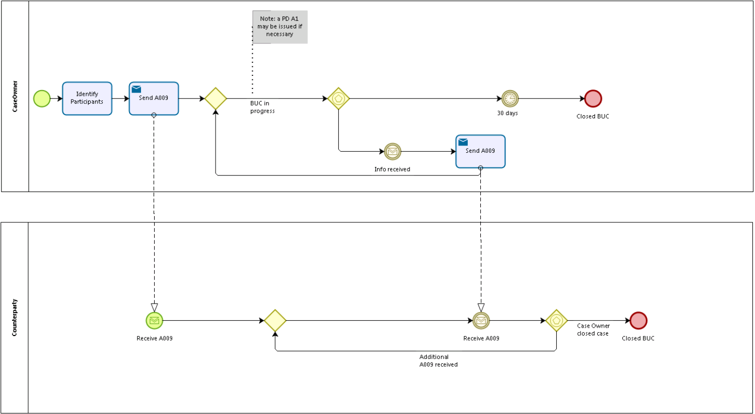

Called sub processes
N/A.

Appendices

Issues

# | Issue date | Description | Solution | Close date
1 | 21/06/2016 | Conversion of the BPMN model to split between Case Owner and Counterparty | Scheduled for Update

