
EESSI Business Use Case



LA_BUC_05
Notification of applicable legislation



Table of Contents

Table of Contents 2
1. Introduction 6
1.1. Purpose 6
1.2. Scope 6
1.3. Definitions, Acronyms and Abbreviations 6
1.4. References 7
1.5. Overview 7
2. Description 8
2.1. Business Scenario 8
2.2. Legal Base 8
3. Actors & Roles 9
4. Use Case 10
4.1. RUP Table Representation 10
4.2. Request – Reply SED 13
4.3. Attachments Allowed 13
4.4. Artefacts used 13
6. Business Processes 14
6.1. Case Owner and Counterparty 15
6.2. Called sub-processes 16
7. Appendices 16
6.1 Issues 16

Document Control Information
Settings | Value
Document Title: | Business Use Case  LA_BUC_05 - Notification of applicable legislation
Project Title: | EESSI (Electronic Exchange of Social Security Information) Project
Document Author: | European Commission, DG EMPL F5
System Owner: | European Commission, DG EMPL D2
Doc. Version: | v4.1.0
Sensitivity: | Public
Date: | 20/08/2018

Document history:
The Document Author is authorized to make the following types of changes to the document without requiring that the document be re-approved:
- Editorial, formatting, and spelling
- Clarification

To request a change to this document, contact the Document Author or Owner.

Revision | Date | Created by | Short Description of Changes
v0.1.0 | 30/07/2015 | Mihai Dinca | First draft of the document
v0.2.0 | 01/12/2015 | Violeta Popescu | Add the Request – Reply SED section  Add the Attachments Allowed section  Add the SED and Sub-process versioning section  Add Close Exception  Update to align with the business architecture principles
v0.2.1 | 12/02/2016 | Violeta Popescu | Integrate the changes made following the AHG meeting, eg:  - there can be more Counterparties  - the option to send the PD A1 only after the BUC ends  - added the Admin Processes: Add Participant, Forward, Update and Invalidate
v0.3.0 | 21/06/2016 | Violeta Popescu | Alignment to the standard description and layout of the BUC
v0.4.0 | 23/06/2016 | Violeta Popescu | Add the Reopen branch  Add steps 7 and 8 (Close)
v0.4.1 | 27/06/2016 | Violeta Popescu | Integrate the comments received from the Rapporteur and Deputy Rapporteur:  - steps 3,4 and 5 from Main Scenario can be repeated by the Case Owner  - the waiting period for the Case Owner to close the case (in Main Scenario) was changed from 60 to 30 days
v0.4.2 | 15/07/2016 | Violeta Popescu | Integrated the comments received from the AHG members (typos)
v0.4.3 | 27/07/2016 | Violeta Popescu | Changed "Rapporteur" and "Deputy Rapporteur" instead of "Members of the AHG" at section Document Approver(s) and Reviewer(s)
v0.4.4 | 30/07/2016 | Violeta Popescu | Removed the first issue at point 6.1
v0.4.5 | 17/08/2016 | Violeta Popescu | Incorporated the comments received following the AC review (small mistakes)
v0.99.0 | 14/09/2016 | Violeta Popescu | Submitted for AC approval
v1.0.0 | 24/10/2016 | Violeta Popescu | AC Approved version
v1.0.1 | 3/07/2017 | Calin Niculescu | - Added the BPMN diagram (version 1.0.1.0).  - Added the BPMN diagram version in section 5.  - Correction in the list of Sub-processes in section 4.5.  - Inserted reference to BUC confluence page in Configuration Management  - removed Use Case diagram
v1.0.2 | 19/12/2017 | Calin Niculescu | - Updated the BPMN diagrams to clarify the fact that the issuing a portable document A1 is out of the scope of EESSI.  - Patched the Invalidate-SED and Forward-Case BUC branches in order to align them for all sectors.
v4.1.0 | 20/08/2018 | Calin Niculescu | - Changes in section 4.4: the two tables were merged into one, containing all the used artefacts;  - Small patch changes to fit release 4.1.0

Introduction

Purpose
The purpose of this document is to construct an external view of, part of, the 'EESSI business system' as described in EC Regulations 883/2004 and 987/2009. The ‘EESSI Business System’ describes the business and expected business processes without consideration as to which part(s) may be realised by an IT System (i.e. the proposed EESSI IT System).

The external view comprises of models and descriptions of business use cases, the services of a business system offered to business actors: customers, business partners, or other business systems.
A business use case is described from an actor's perspective; it describes the interaction between an actor and the business system, meaning it describes the behaviors of the business system that the actor utilises. The Business Use Case includes Use Case Diagrams and Business Process Models.
Use case diagrams show actors, business use cases, and their relationships. Use case diagrams do not describe procedures. Alternative scenarios also remain hidden. These diagrams give a good overview of the behaviors of the EESSI business system which will direct and govern part of the expected behaviors and functionality delivered by the EESSI IT System.

Scope
This document is limited to the external view on the Legislation Applicable sector process of Notification of applicable legislation.
The different elements like use case description, actors, and business process as well as supporting UML diagrams and BPMN models pertaining to the Notification of applicable legislation.

Definitions, Acronyms and Abbreviations
Please see the EESSI Project Glossary here.

References
# | Description
1 | EC Regulation 883/2004 | Regulation EC No 883- 2004.pdf
2 | EC Regulation 987/2009 | Regulation EC No 987-2009.pdf
3 | UML 2.x | http://www.omg.org/spec/UML/
4 | BPMN 2.0 | http://www.omg.org/spec/BPMN/index.htm
5 | UML 2.0 In Action | Henriette Baumann, Patrick Grassle & Philippe Baumann, 2005, ISBN 1904811558
6 | RUP@EC standard 5.0 | http://www.cc.cec/RUPatEC_Standard/
7 | RUP op maat | http://www.rupopmaat.nl/

Overview
Chapter 1 introduces the external view on the business system under review and lists the elements of this specification.
Chapter 2 introduces the Notification of applicable legislation process. The chapter gives a short and detailed description as well as a reference to business process' legal base.
Chapter 3 lists the actors involved in the Notification of applicable legislation business process.
Chapter 4 describes in detail the Notification of applicable legislation business process based on the RUP use case template, as well as the relationship to other use cases.
Chapter 5 describes the Notification of applicable legislation business process using business process modelling notation (BPMN).

Description

Business Scenario
The "Notification of applicable legislation" business process in the Legislation Applicable sector describes how the state whose legislation is applicable can inform the state where a person is pursuing an activity about the legislation applicable. The case is used for situation not covered by art. 12, 13 and 16 of Regulation (EC) No 883/2004 (LA guidelines – chapter 6).

Legal Base
This Business Use Case document's legal base is described in the following Regulations
- Basic Regulation (EC) No 883/2004
- Implementing Regulation (EC) No 987/2009
The following matrix specifies the SEDs that are used in this Business Use Case and documents the articles that provide the legal basis for each SED.

 | Basic Reg (883/04) |  |  |  | Implementing Reg (987/09)
SED | Art. 11 (3)(b)(c)(d) | Art. 11 (4) | Art. 11 (5) | Art. 15 | Art.15 | Art.17
A010
Table 1: SED – Legal base relationship matrix

Actors & Roles
This chapter captures details of the actors which are important to understand the different types of system users. An actor is anyone or anything that exchanges data with the business system. An actor can be a user, external hardware, or another system.
The overarching description of each actor described in this Business Use Case can be found in the Glossary. Below you will find a short description which provides further clarity of this actor within the context of this Business Use Case.

Actor name | Description
Case Owner | In this BUC the Case Owner is a Competent Institution that informs the other state involved about the legislation applicable
Counterparty | In this BUC the Counterparty is a Competent Institution that is being notified about the legislation applicable
Citizen | In this BUC the Citizen is the beneficiary of the PD A1
Table 2: Actors & Roles

Use Case

RUP Table Representation
Use Case ID: | LA_BUC_05
Use Case Name: | Notification of applicable legislation
Created By: | Mihai Dinca |  | Last Updated By: | Violeta Popescu
Date Created: | 30/07/2015 |  | Last Revision Date: | 24/10/2016
Actors: |  | Case Owner  Counterparty  Citizen
Description: |  | A Competent Institution from a Member State notifies the institution in the other Member State about the legislation applicable.
Trigger: |  | The flow is initiated when the Competent Institution of the state whose legislation applies informs the other state involved.
Preconditions: |  | A citizen is performing work related activities in a different Member State than the one whose legislation applies, or receives unemployment benefits in the State of Residence.
Post conditions: |  | The institution in the other Member State is notified about the legislation applicable.
Main Scenario: |  | Identify Participants  - The Case Owner identifies the EU Member State where the person is pursuing an activity;  - The Case Owner then identifies the correct institution (s) (the Counterparty(ies)) in the concerned Member State. The Case Owner and the Counterparty (ies) are herein collectively referred to as the Participants.  Send the notification of legislation applicable  - The Case Owner fills in an A010 – Notification of applicable legislation;  - The Case Owner sends the A010 – Notification of applicable legislation to the Counterparty;  - The Case Owner may issue a PD A1 to the citizen. Steps 3, 4 and 5 can be repeated by the Case Owner.  Receive the notification  - The Counterparty(ies) receive(s) and review(s) the A010 SED;  - The Case Owner waits for a period of 30 calendar days;  - The Case Owner executes use case AD_BUC_01 – Close Case;  - The use case ends here.
Alternative branches |  | The Following Branches Determine the use of Administrative Processes within this Business Process
- at any step between [step 4] and [step 8] the Case Owner may choose to Forward this Business Process to another Competent Institution

- The Case Owner executes business use case AD_BUC_05 - Forward;
- [This Branch] Ends.
- at any step between [step 6] and [step 8] the Counterparty may choose to Forward this Business Process to another Competent Institution within the Member State who assumes responsibility for handling it

- The Counterparty executes business use case AD_BUC_05 – Forward Case;
- [This Branch] Ends.

- at any step between [step 4] and [step 8] the Case Owner may choose to Add a Participant to this Business Process

1. The Case Owner executes business use case AD_BUC_03 – Add Participant;
2. [This Branch] Ends.

- at any step between [step 6] and [step 8] the Counterparty may choose to Add a Participant to this Business Process

1. The Counterparty executes business use case AD_BUC_03 – Add Participant;
2. [This Branch] Ends.

- at any step between [step 4] and [step 8] the Case Owner may choose to advise all recipients of their A010 that it is invalid under Art 5 of 987/09

- The Case Owner executes business use case AD_BUC_06_SubProcess – Invalidate SED;
- Optionally, the Case Owner fills in an A010 – Notification of Applicable Legislation, by entering all the required data;
- Optionally, the Case Owner sends the A010, including any attachments, to the recipients;
- [This Branch] Ends

- at any step between [step 4] and [step 8] the Case Owner may choose to send an updated version of A010

- The Case Owner executes business use case AD_BUC_10 - Update_SED;
- [This Branch] Ends.

- After Step [8] any Participant may choose to Reopen the Business Process

- Any Participant may execute business use case AD_BUC_02 – Reopen;
- [This Branch] Ends.
Includes |  | See diagram at part 4.4.
Special Requirements: |  | none
Assumptions:
Notes and Issues:

Request – Reply SED
The following table specifies the SED that have a logical pairing to one another, usually this is known as a request-reply pair.
REQUEST SED | REPLY SED(s)
none

Attachments Allowed
The following table specifies whether attachments are permitted to be included when sending a SED type.
SED | Attachments
A010 | Allowed

Artefacts used
- The following table specifies the artefacts that are used in this Business Use Case:

SED | Version
A010 | SED
AD_BUC_01_Subprocess – Close Case | BUC
AD_BUC_02_Subprocess – Reopen Case | BUC
AD_BUC_03_Subprocess – Add Participant | BUC
AD_BUC_05_Subprocess – Forward Case | BUC
AD_BUC_06_Subprocess – Invalidate SED | BUC
AD_BUC_10_Subprocess – Update SED | BUC
AD_BUC_11_Subprocess – Business Exception | BUC
AD_BUC_12_Subprocess – Change of Participant | BUC

Business Processes
This chapter describes the Business Use case Notification of Applicable legislation using BPMN 2.0. Based on the BPMN Diagram version 1.0.1.3.

Case Owner and Counterparty
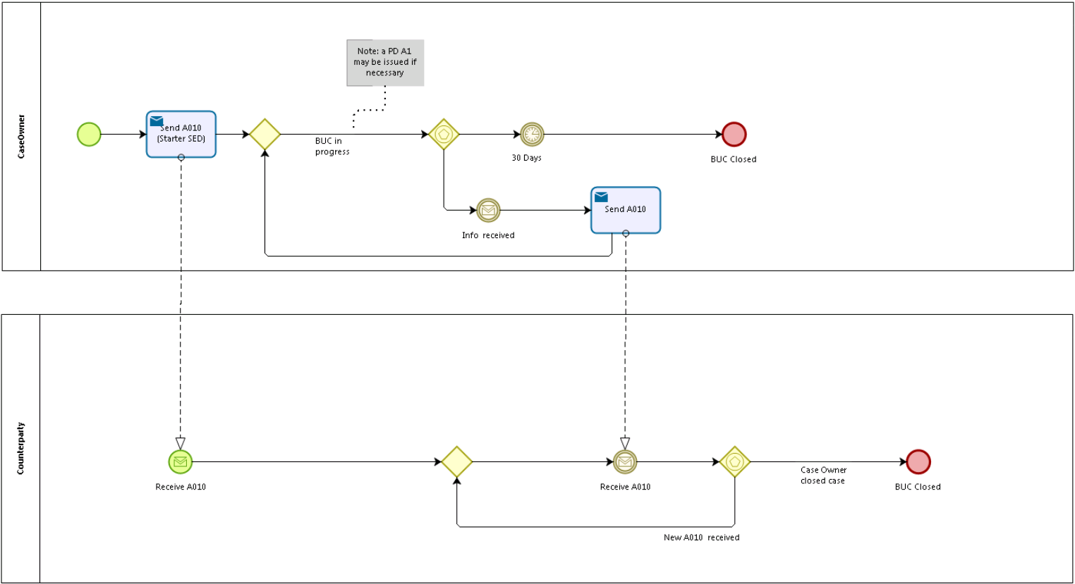

Called sub-processes
N/A

Appendices

6.1 Issues

# | Issue date | Description | Solution | Close date
1 |  | Does the AHG see a business need to use a forward admin BUC for the Case owner and/or for the counterparty? | Yes

