
EESSI Business Use Case



LA_BUC_06
Request for more information



Table of Contents

Table of Contents 2
1. Introduction 5
1.1. Purpose 5
1.2. Scope 5
1.3. Definitions, Acronyms and Abbreviations 5
1.4. References 6
1.5. Overview 6
2. Description 7
2.1. Business Scenario 7
2.2. Legal Base 7
3. Actors & Roles 8
4. Use Case 9
4.1. RUP Table Representation 9
4.2. Request – Reply SED 12
4.3. Attachments Allowed 12
4.4. Artefacts used 12
5. Business Processes 12
5.1. Case Owner and Counterparty 13
5.2. Sub-processes 14
6. Appendices 14
6.1 Issues 14

Document Control Information
Settings | Value
Document Title: | Business Use Case  LA_BUC_06 - Request for more information
Project Title: | EESSI (Electronic Exchange of Social Security Information) Project
Document Author: | European Commission, DG EMPL F5
System Owner: | European Commission, DG EMPL D2
Doc. Version: | v4.1.0
Sensitivity: | Public
Date: | 20/08/2018

Document history:
The Document Author is authorized to make the following types of changes to the document without requiring that the document be re-approved:
- Editorial, formatting, and spelling
- Clarification

To request a change to this document, contact the Document Author or Owner.

Revision | Date | Created by | Short Description of Changes
v0.1.0 | 07/07/2016 | Violeta Popescu | First draft of the document
v0.2.0 | 12/07/2016 | Violeta Popescu | Integrated the comments received from the Rapporteur and Deputy Rapporteur of the LA AHG (sections: Trigger, Precondition, Postcondition)
v0.2.1 | 22/07/2016 | Violeta Popescu | Integrated the comments received from the AHG
v0.99.0 | 17/11/2016 | Violeta Popescu | Changes made following the AC review (sections Trigger, Postconditions, Preconditions, etc.). Inclusion of AD_BUC_07 – Reminder and AD_BUC_04 – Remove Participant
v1.0.0 | 15/12/2016 | Violeta Popescu | AC Approved version
v1.0.1 | 3/07/2017 | Calin Niculescu | - Added the BPMN diagram (version 1.0.1.0).  - Added the BPMN version of the diagram in section 5.  - Correction in the list of sub-processes in section 4.5.  - Adapted reference to BUC confluence page in Configuration Management  - removed Use Case diagram
v1.0.2 | 19/12/2017 | Calin Niculescu | - Patched the Invalidate-SED and Forward-Case BUC branches in order to align them for all sectors.
v4.1.0 | 20/08/2018 | Calin Niculescu | - Changes in section 4.4: the two tables were merged into one, containing all the used artefacts;  - Small patch changes to fit release 4.1.0

Introduction

Purpose
The purpose of this document is to construct an external view of, part of, the 'EESSI business system' as described in EC Regulations 883/2004 and 987/2009. The ‘EESSI Business System’ describes the business and expected business processes without consideration as to which part(s) may be realised by an IT System (i.e. the proposed EESSI IT System).

The external view comprises of models and descriptions of business use cases, the services of a business system offered to business actors: customers, business partners, or other business systems.
A business use case is described from an actor's perspective; it describes the interaction between an actor and the business system, meaning it describes the behaviors of the business system that the actor utilises. The Business Use Case includes Use Case Diagrams and Business Process Models.
Use case diagrams show actors, business use cases, and their relationships. Use case diagrams do not describe procedures. Alternative scenarios also remain hidden. These diagrams give a good overview of the behaviors of the EESSI business system which will direct and govern part of the expected behaviors and functionality delivered by the EESSI IT System.

Scope
This document is limited to the external view on the Legislation Applicable sector process of Request for more information.
The different elements like use case description, actors, and business process as well as supporting UML diagrams and BPMN models pertaining to the Request for more information.

Definitions, Acronyms and Abbreviations
Please see the EESSI Project Glossary here.

References
# | Description
1 | EC Regulation 883/2004 | Regulation EC No 883- 2004.pdf
2 | EC Regulation 987/2009 | Regulation EC No 987-2009.pdf
3 | UML 2.x | http://www.omg.org/spec/UML/
4 | BPMN 2.0 | http://www.omg.org/spec/BPMN/index.htm
5 | UML 2.0 In Action | Henriette Baumann, Patrick Grassle & Philippe Baumann, 2005, ISBN 1904811558
6 | RUP@EC standard 5.0 | http://www.cc.cec/RUPatEC_Standard/
7 | RUP op maat | http://www.rupopmaat.nl/

Overview
Chapter 1 introduces the external view on the business system under review and lists the elements of this specification.
Chapter 2 introduces the Request for more information business process. The chapter gives a short and detailed description as well as a reference to business process' legal base.
Chapter 3 lists the actors involved in the Request for more information business process.
Chapter 4 describes in detail the Request for more information business process based on the RUP use case template, as well as the relationship to other use cases.
Chapter 5 describes the Request for more information business process using business process modelling notation (BPMN).

Description

Business Scenario
The "Request for more information" business process in the Legislation Applicable sector describes how a Member State can ask for more information from another Member State, in order to determine the legislation applicable.

The process involves a simple request-reply exchange of messages between a competent institution, competent authority or the designated body of a Member State to another competent authority(ies) or designated body(ies) from a different Member State. The responding institution(s) may provide the requested information or may forward the request to another competent institution(s), competent authority(ies) or designated body(ies), who take(s) the responsibility for providing the requested information.

Legal Base
This Business Use Case document's legal base is described in the following Regulations
- Basic Regulation (EC) No 883/2004
- Implementing Regulation (EC) No 987/2009
The following matrix specifies the SEDs that are used in this Business Use Case and documents the articles that provide the legal basis for each SED.

 | Basic Reg (883/04) | Implementing Reg (987/09)
SED | Title II | Title II | Art 2.2
A005
A006
Table 1: SED – Legal base relationship matrix

Actors & Roles
This chapter captures details of the actors which are important to understand the different types of system users. An actor is anyone or anything that exchanges data with the business system. An actor can be a user, external hardware, or another system.
The overarching description of each actor described in this Business Use Case can be found in the Glossary. Below you will find a short description which provides further clarity of this actor within the context of this Business Use Case.

Actor name | Description
Case Owner | In this BUC the Case Owner is a Competent Institution, Competent Authority or Designated Body (further referred as “Competent Institution”) that requests for more information from another Competent Institution(s)
Counterparty | In this BUC the Counterparty is a Competent Institution(s) that is requested to provide more information
Citizen | In this BUC the Citizen is the person who works or used to work in at least one other Member States and/or the person receiving/having been receiving certain benefits based on previous employment from another Member State
Table 2: Actors & Roles

Use Case

RUP Table Representation
Use Case ID: | LA_BUC_06
Use Case Name: | Request for more information
Created By: | Violeta Popescu |  | Last Updated By: | Violeta Popescu
Date Created: | 07/07/2016 |  | Last Revision Date: | 15/12/2016
Actors: |  | Case Owner  Counterparty  Citizen
Description: |  | A Competent Institution from a Member State requests for more information from another Competent Institution(s) in the other Member State, in order to determine the legislation applicable or to clarify the situation of the person concerned.
Trigger: |  | One institution requires information from one or more institutions in order to make an assessment regarding which legislation applies to a person.
Preconditions: |  | A person is working/has worked/will be working in at least one other Member States and/or the person receives/has received/will be receiving certain benefits based on previous employment from another Member State.
Post conditions: |  | A decision (provisional or definitive) has been made regarding the Legislation Applicable.
Main Scenario: |  | Identify Participants  - The Case Owner identifies the EU Member State where the person is pursuing an activity;  - The Case Owner then identifies the correct institution (the Counterparty) in the concerned Member State. The Case Owner and the Counterparty are herein collectively referred to as the Participants.  Send the request for more information  - The Case Owner fills in an A005 – Request for more information;  - The Case Owner sends the A005 – Request for more information to the Counterparty.  Receive the request for more information  - The Counterparty receives and reviews the A005 SED;  - The Counterparty fills in an A006 SED, by providing the requested information in order to determine the Legislation Applicable;  - The Counterparty sends the A006 SED. Steps 3 to 7 can be repeated;  - The Case Owner waits for a period of 30 calendar days;  - The Case Owner executes use case AD_BUC_01 – Close Case;  - The BUC Ends.
Alternative branches |  | The Following Branches Determine the use of Administrative Processes within this Business Process
- at any step between [step 4] and [step 8] the Case Owner may choose to Forward this Business Process to another Competent Institution within their Member State who assumes responsibility for handling it

- The Case Owner executes business use case AD_BUC_05 – Forward Case;
- [This Branch] Ends.

- at any step between [step 5] and [step 8] the Counterparty may choose to Forward this Business Process to another Competent Institution within their Member State who assumes responsibility for handling it

- The Counterparty executes business use case AD_BUC_05 – Forward Case;
- [This Branch] Ends.

- at any step between [step 4] and [step 8] the Case Owner may choose to Add a Participant to this Business Process

1. The Case Owner executes business use case AD_BUC_03 – Add Participant;
2. [This Branch] Ends.

- at any step between [step 5] and [step 8] the Counterparty may choose to Add a Participant to this Business Process

1. The Counterparty executes business use case AD_BUC_03 – Add Participant;
2. [This Branch] Ends.

- at any step between [step 4] and [step 8] the Case Owner may choose to advise all recipients of their A005 that it is invalid

- The Case Owner executes business use case AD_BUC_06 – Invalidate SED;
- Optionally, the Case Owner fills in an A005 – Request for more information, by entering all the required data;
- Optionally, the Case Owner sends the A005, including any attachments, to all the recipients;
- [This Branch] Ends.

- at any step between [step 7] and [step 8] the Counterparty may choose to advise all recipients of their A006 that it is invalid

- The Counterparty executes business use case AD_BUC_06 – Invalidate SED;
- Optionally, the Counterparty fills in an A005 – Request for more information, by entering all the required data;
- Optionally, the Counterparty sends the A005, including any attachments, to all the recipients;
- [This Branch] Ends.

- at any step between [step 4] and [step 8] the Case Owner may choose to send an updated version of A005

- The Case Owner executes business use case AD_BUC_10 - Update_SED;
- [This Branch] Ends.

- at any step between [step 7] and [step 8] the Counterparty may choose to send an updated version of A006

- The Counterparty executes business use case AD_BUC_10 - Update_SED;
- [This Branch] Ends.

- at any step between [step 4] and [step 8] the Case Owner may choose to remove a Counterparty from this Business Process (providing that at least one Counterparty will remain into the case)

- The Case Owner executes business use case AD_BUC_04 – Remove Participant;
- [This Branch] Ends.
- at any step between [step 5] and [step 8] the Counterparty may choose to remove another Counterparty from this Business Process (providing that at least one Counterparty will remain into the case)

- The Counterparty executes business use case AD_BUC_04 – Remove Participant;
- [This Branch] Ends.
- at any step between [step 4] and [step 8] the Case Owner may optionally choose to send a reminder in order to receive the answer to information expected but not received

- The Case Owner executes business use case AD_BUC_07 - Reminder;
- [This Branch] Ends.
Includes |  | See diagram at part 4.4.
Special Requirements: |  | none
Assumptions:
Notes and Issues:
Table 3: BUC Description

Request – Reply SED
The following table specifies the SED that have a logical pairing to one another, usually this is known as a request-reply pair.
REQUEST SED | REPLY SED(s)
A005 | A006

Attachments Allowed
The following table specifies whether attachments are permitted to be included when sending a SED type.
SED | Attachments
A005 | Allowed
A006 | Allowed

Artefacts used
The following table specifies the artefacts that are used in this Business Use Case:
Artefact name | Artefact type
A005 | SED
A006 | SED
AD_BUC_01_Subprocess – Close Case | BUC
AD_BUC_03_Subprocess – Add Participant | BUC
AD_BUC_04_Subprocess – Remove Participant | BUC
AD_BUC_05_Subprocess – Forward Case | BUC
AD_BUC_06_Subprocess – Invalidate SED | BUC
AD_BUC_07_Subprocess – Reminder | BUC
AD_BUC_10_Subprocess – Update SED | BUC
AD_BUC_11_Subprocess – Business Exception | BUC
AD_BUC_12_Subprocess – Change of Participant | BUC

Business Processes
This chapter describes the Business Use case Notification of Applicable legislation using BPMN2.0. Based on the BPMN diagram version 1.0.1.0.

Case Owner and Counterparty
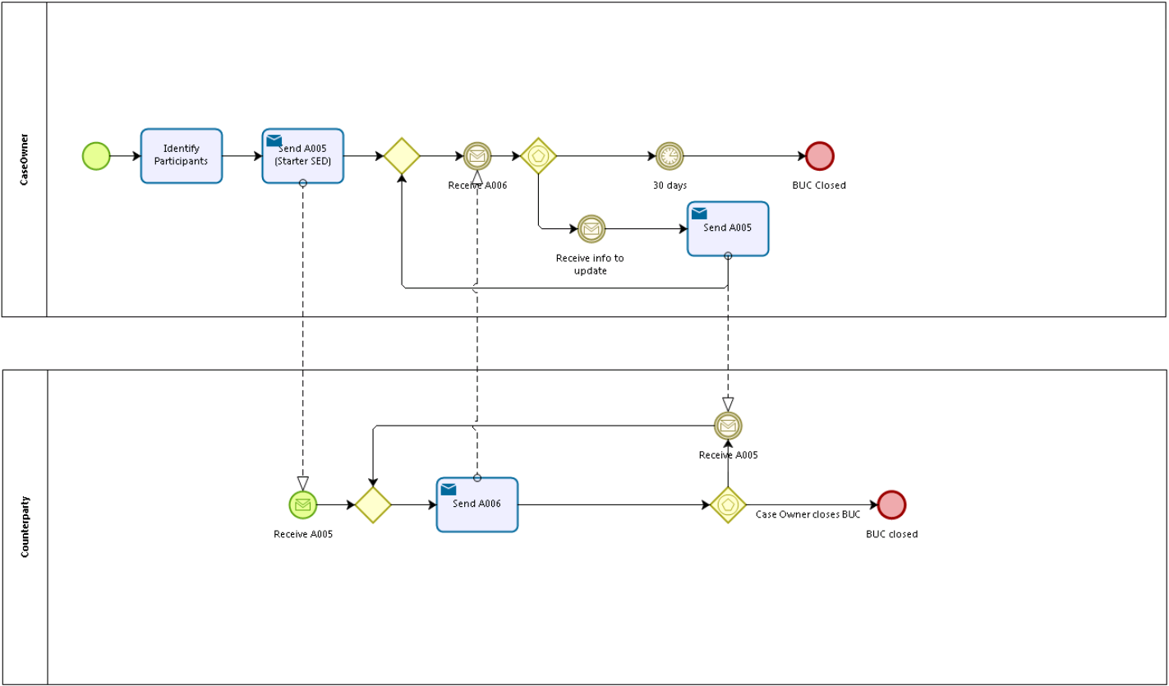

Sub-processes
N/A

Appendices

6.1 Issues

# | Issue date | Description | Solution | Close date
1
2

