

Annex Nr.8 to the note AC 370/16rev

EESSI Business Use Case



P_BUC_03
Invalidity Pension Claim



Table of Contents

Table of Contents 2
1. Introduction 6
1.1. Purpose 6
1.2. Scope 6
1.3 Definitions, Acronyms and Abbreviations 6
1.4 References 7
1.5 Overview 7
2. Description 8
2.1. Business Scenario 8
2.2. Legal Basis 8
3. Actors & Roles 9
4. Use Case 10
4.1. RUP Table Representation 10
4.2 Request – Reply SEDs 19
4.3. Attachments Allowed 19
4.4. BUC Artefacts used 20
5. Business Processes 22
5.1 Case Owner and Counterparty 22
5.2 Sub Processes 23
6. Appendices 24
6.1. Issues 24

Document Control Information
Settings | Value
Document Title: | Business Use Case  P_BUC_03 - Invalidity Pension Claim
Project Title: | EESSI (Electronic Exchange of Social Security Information) Project
Document Author: | European Commission, DG EMPL F5
System Owner: | European Commission, DG EMPL D2
Doc. Version: | v4.1.0
Sensitivity: | Public
Date: | 03/08/2018

Document history:
The Document Author is authorized to make the following types of changes to the document without requiring that the document be re-approved:
- Editorial, formatting, and spelling
- Clarification
To request a change to this document, contact the Document Author or Owner.
Revision | Date | Created by | Short Description of Changes
v0.01 | 19/12/2014 | Phil Cummings | First Draft
v0.02 | 07/04/2015 | Phil Cummings | Updated version to include comments provided by AHG members and to align with the changes made to P_BUC_01.
v0.03 | 12/05/2015 | Phil Cummings | Minor corrections to description text following workshop with AHG.
v0.4.0 | 25/04/2016 | Cristina Ezaru | Minor corrections/updates in Document Control Information and Purpose.  Update the document template with new subchapters 4.2; 4.3; 4.4; 4.5
v0.5.0 | 16/05/2016 | Cristina Ezaru | Incorporated feedback received from AHG, key alteration made:  1. removed legal basis art1 for P3000  2. rewording in step 15."One valid P6000 or other equivalent information" is written instead of the current text  3. Branch14 updated: adding participants should be able to any participant (within their own MS)  4. Branch17 step 1 updated to allow the participant to do it.  5. Branches 9,11,12 added to SR2.  6. new SR8 added.  7. updated Request-Replay SEDs table:only P8000-P9000 are request-reply pairs.  8. updated Attachments Allowed table  9. updated Sub-process table: AD_BUC_11 is used
v0.6.0 | 20/05/2016 | Cristina Ezaru | Incorporated review received from AHG:  1. Branch 14 updated: Case owner can add participants in any MS, Counterparties can add participants in their own MS.  2. rewording in step 15
v0.99.0 | 23/05/2016 | Cristina Ezaru | Candidate for AC Approval as agreed by the Pension rapporteur.
v0.99.1 | 30/05/2016 | Cristina Ezaru | Minor formatting, date, version and grammar changes  Updated Use Case diagram.
v0.99.2 | 13/06/2016 | Cristina Ezaru | Correction to SED version: to 4.0.x  Correction to numbering of Branches 26 and 37  Added BPMN
v1.0.0 | 14/07/2016 | Phil Cummings | AC Approved Version
v1.0.1 | 26/06/2017 | Madalina Alecsandrescu | Last version BPMN section 5
v1.0.2 | 11/08/2017 | Eric Briffoz | - Included the BPMN version of the diagram in section 5.  - Correction in the sub process table in section 4.5.  -Removed Use Case diagram
 |  | Madalina Alecsandrescu | Align wording for Invalidate SED and Forward participant
v4.1.0 | 03/08/2018 | Madalina Alecsandrescu | - Section 4.4 merged 2 tables (for SED & for Subprocesses) into 1 BUC Artefact table."  - Version adaptations to release 4.1.0.  - Clarification regarding using of the right term as Case Owner to [Branch 11], [Branch 12]  - Add SR for [Branch 10]  - Correction in wording [Branch 15]

Introduction

Purpose
The purpose of this document is to construct an external view of, part of, the 'EESSI business system' as described in EC Regulations 883/2004 and 987/2009. The ‘EESSI Business System’ describes the business and expected business processes without any consideration as to which part(s) may be realized by an IT System (i.e. the proposed EESSI IT System).
The external view comprises of models and descriptions of business use cases, the services of a business system offered to business actors: customers, business partners, or other business systems.
A business use case is described from an actor's perspective; it describes the interaction between an actor and the business system, meaning it describes the behaviors of the business system that the actor utilizes. The Business Use Case includes Use Case Diagrams and Business Process Models.
Use case diagrams show actors, business use cases, and their relationships. Use case diagrams do not describe procedures. Alternative scenarios also remain hidden. These diagrams give a good overview of the behaviors of the EESSI business system which will direct and govern part of the expected behaviors and functionality delivered by the EESSI IT System.

Scope
This document is limited to the external view on the pensions´ sector process of the Invalidity Pension Claim. The different elements like use case description, actors, and business process as well as supporting UML diagrams and BPMN models pertaining to the Invalidity Pension Claim.

1.3 Definitions, Acronyms and Abbreviations
Please see the EESSI Project Glossary

1.4 References
# | Description
1 | EC Regulation 883/2004 | Regulation EC No 883- 2004.pdf
2 | EC Regulation 987/2009 | Regulation EC No 987-2009.pdf
3 | UML 2.x | http://www.omg.org/spec/UML/
4 | BPMN 2.0 | http://www.omg.org/spec/BPMN/index.htm
5 | UML 2.0 In Action | Henriette Baumann, Patrick Grassle & Philippe Baumann, 2005, ISBN 1904811558
6 | RUP@EC standard 5.0 | http://www.cc.cec/RUPatEC_Standard/
7 | RUP op maat | http://www.rupopmaat.nl/

1.5 Overview
Chapter 1 introduces the external view on the business system under review and lists the elements of this specification.
Chapter 2 introduces us to the Invalidity Pension Claim business process. The chapter gives a short and detailed description as well as a reference to business process´ legal base.
Chapter 3 lists the actors involved in the Invalidity Pension Claim business process.
Chapter 4 describes in detail the Invalidity Pension Claim business process based on the RUP use case template, as well as the relationship to other use cases.
Chapter 5 describes the Invalidity Pension Claim business process using business process modelling notation (BPMN).

2. Description

2.1. Business Scenario
In a situation where a citizen is or becomes incapacitated for work leading to invalidity they will claim an Invalidity Pension (the citizen becomes a claimant). Where the claimant has been subject to the legislation of two or more Member States of which at least one is a Type B scheme and the Member State to which the claimant applied assumes responsibility for coordinating the Invalidity Pension claim under all the legislations of the Member States to which the claimant has been subject (Exceptions apply as per EU Regulation 883/04). This institution assumes the role of the Contact Institution and is responsible for starting and coordinating a process which assures that the Claimant receives the Invalidity Pension they are entitled to and are not disadvantaged by their decision to exercise their right to free movement and work or live in more than one EU Member State (a fundamental pillar of the EU).

2.2. Legal Base
This Business Use Case document's legal base, according to the agreed version 3 Pensions Guidelines, documented by the expert AHGs, is described in the

- Basic Regulation (EC) No 883/2004
- Implementing Regulation (EC) No 987/2009
The following matrix derived from the applicable version 3 SEDs, documented by the expert AHGs, lists the SEDs used in this Business Use Case and their relation with the articles mentioned above.

 | Basic Reg (883/04) |  |  |  |  |  |  |  | Implementing Reg (987/09)
 | 1 | 6 | 45 | 49 | 51 | 52 | 57 | 60 | 12(1) | 45(4) | 46(1) | 46(3) | 47(1) | 47(4) | 47(5) | 47(6) | 48 | 48(1) | 48(2) | 50(1) | 51(2) | 52(1)b
P2200
P3000
P4000
P5000
P6000
P7000
P8000
P9000
P10000
Table 1: SED – Legal base relationship matrix

3. Actors & Roles
This chapter captures details of the actors which are important to understanding the different types of system users. An actor is anyone or anything that exchanges data with the business system. An actor can be a user, external hardware, or another system.
The overarching description of each actor described in this Business Use Case can be found in the Glossary. Below you will find a short description which provides further clarity of this actor within the context of this Business Use Case.

Actor name | Description
Case Owner | In this BUC the Case Owner is a Competent Institution who performed the role of the Contact Institution as described by the Regulations
Counterparty | In this BUC the Counterparty(ies) are Competent Institutions who perform the role of Institutions Concerned as described by the Regulations
Claimant | In this BUC the Claimant is the Citizen who wishes to claim the Invalidity Pension
Table 2: Actors & Roles

4. Use Case

4.1. RUP Table Representation
Use Case ID: | P_BUC_03
Use Case Name: | Claim for Invalidity Pension
Created By: | Phil Cummings |  | Last Updated By: | Cristina Ezaru
Date Created: | 19/12/2014 |  | Last Revision Date: | 30/05/2016
Actors: |  | Claimant  Case Owner  Counterparty
Description: |  | In a situation where a citizen is or becomes incapacitated for work leading to invalidity they will claim an Invalidity Pension (the citizen becomes a claimant). Where the claimant has been subject to the legislation of two or more Member States of which at least one is a Type B scheme and the Member State to which the claimant applied assumes responsibility for coordinating the Invalidity Pension claim under all the legislations of the Member States to which the claimant has been subject (Exceptions apply as per EU Regulation 883/04 Article). This institution assumes the role of the Contact Institution and is responsible for starting and coordinating a process which assures that the Claimant receives the Invalidity Pension they are entitled to and are not disadvantaged by their decision to exercise their right to free movement and work or live in more than one EU Member State (a fundamental pillar of the EU).
Trigger: |  | A citizen claims an Invalidity Pension from an EU Member State
Preconditions: |  | The Claimant claims an Invalidity Pension
Post conditions: |  | The Claimant is informed of the decisions made in respect to their Invalidity Pension Claim from each Member State
Main Scenario: |  | Identify Participants  - The Case Owner identifies the Member States where the person has lived or worked previously and wishes to claim an Invalidity pension;  - The Case Owner then identifies the correct institution or institutions (the Counterparty(ies)) in each Member State that are responsible for making a decision on the claim for Invalidity pension. There will be one counterparty or more. The Case Owner and the Counterparty(ies) are herein collectively referred to as the Participants;  Send Invalidity Pension Claim  - The Case Owner fills out an Invalidity Pension Claim (P2200) by entering all the required Invalidity Pension data;  - The Case Owner sends the P2200, including any attachments, to all Counterparties;  Process Claim & Send Decision  - Each Counterparty will receive an Invalidity Pension Claim (P2200) with the fitting personal ID dataset and any and all attachments, after which their Claim investigation will start;  - The Case Owner then optionally fills in a Report on Insurance and Residence Periods (P5000) which provides detailed insurance information to assist the Invalidity pension processing;  - The Case Owner sends the P5000 to all other Participants; [Steps 6 and 7] collectively may optionally be repeated by the Case Owner many times after this step  - The Case Owner fills in an Pension Decision (P6000) by entering all the required information about the Pension decision they have made;  - The Case Owner sends the P6000 to all counterparties; [Steps 8 and 9] collectively may optionally be repeated by the Case Owner many times after this step  - Each Counterparty then optionally fills in a Report on Insurance and Residence Periods (P5000) which provides detailed insurance information to assist the Invalidity pension processing;  - Each Counterparty then sends the P5000 to all other Participants; [Steps 10 and 11] collectively may optionally be repeated by each Counterparty many times after this step  - Each Counterparty fills in a Pension Decision (P6000) by entering all the required information about the Pension decision they have made;  - Each Counterparty then sends their P6000 to the Case Owner and any other Counterparties; [Steps 12 and 13] collectively may optionally be repeated by each Counterparty many times after this step  - [Steps 6 and 7] collectively, [Steps 8 and 9] collectively, [Steps 10 and 11] collectively and [Steps 12 and 13] collectively may occur in any order  Receive & Process Pension Decisions  - Each time the Case Owner receives a Pension Decision (P6000) from a Counterparty, or it sends a P6000, it checks if:  - There is at least one valid P6000 or other equivalent information from each participant involved, that P7000 can be issued.  If this is true, the Case Owner OR at the discretion of the Case Owner from each Member State involved continues to the [Next Step] if not it repeats [This Step];  Finalize Claim for Invalidity Pension  - The Case Owner fills in a Portable Document (P1) by entering specific data provided in the Pension Decisions (P6000) exchanged by all participants. The completed P1 is then sent to the claimant to inform them of the Pensions decisions taken by all participants and their right to review;  - The Case Owner fills in a Summary of Pension Decisions (P7000) by entering specific data provided in the Pension Decisions (P6000) exchanged by all participants;  - The Case Owner sends the P7000 to all Counterparties  - Upon the sending of the P7000 the Invalidity Pension Claim is complete  - This use case ends here.
Alternative Scenarios: |  | - at any step after [step 5] the Case Owner may optionally choose to fill in and send Country Specific Information  - The Case Owner fills in Country Specific Information (P3000_XX) which provides supplementary information to assist the Invalidity pension processing in the Member State it was designed for;  - The Case Owner sends the P3000_xx to specific counterparties (see Special Requirements)  - [This Branch] Ends
- at any step after [step 5] the Case Owner may optionally choose to fill in and send a Report on Insurance History
- The Case Owner fills in Report on Insurance History (P4000) which provides supplementary information to assist the Invalidity pension processing;
- The Case Owner sends the P4000 to all Counterparties
- [This Branch] Ends

 |  | - [Removed]
- at any step after [step 5] any Participant may optionally choose to fill in a Request for Additional Information
- The participant who invokes this branch fills in a Request for Additional Information (P8000) which details the additional information they need;
- The participant who wishes to request additional information sends the P8000 to one or more participants (the receiving participants are at the discretion of the sending participant)
- Each participant who received a P8000 may optionally gather the requested information and fill in a Reply to Request for Additional Information (P9000) provided the P8000 is not declared to be invalid at [step 25];
- Where [Branch 4 Step 3] was completed each participant who filled out the P9000 sends the P9000, including any attachments, to the sender of the P8000 and all other participants who received the P8000.
- Upon receipt of a P9000 the participant may optionally choose to send another P8000 provided the P9000 is not declared to be invalid at [step 26]; [go to Branch 4 Step 1]
- [This Branch] Ends

- at any step after [step 5] any Participant may optionally choose to fill in a Transfer of Additional Information
- The participant who invokes this branch fills in a Transfer of Additional Information (P10000) which details the additional information they wish to transfer;
- The participant who wishes transfer the additional information sends the P10000, with any attachments, to one or more participants (the receiving participants are at the discretion of the sending participant)
- [This Branch] Ends

 |  | The Following Branches determine the use of Horizontally Defined Processes within this Business Process
 |  | - - Removed -
 |  | - - Removed -
 |  | - - Removed -
- at any step after [step 5] any Participant may optionally choose to request the Reimbursement of Admin Costs or Medical Costs from another Participant

- The Participant executes business use case H_BUC_04 – Reimbursement of Admin or Medical Costs;
- [This Branch] Ends

- at any step after [step 5] any Participant may optionally choose notify another Participant of the Death of a Person

- The Participant executes business use case H_BUC_07_Subprocess – Notification of Death;
- [This Branch] Ends
- - at any step after [step 5] a Case Owner may optionally choose to provide a Detailed Medical Report to the Counterpart(ies)

- The Case Owner executes business use case H_BUC_08 – Exchange of Medical Data;
- [This Branch] Ends

- at any step after [step 5] the Case Owner may optionally choose to provide the Counterparty(ies) with a detailed Medical Examination

- The Case Owner executes business use case H_BUC_09 – Notification of a Medical Report;
- [This Branch] Ends

 |  | The Following Branches Determine the use of Administrative Processes within this Business Process
- at any step after [step 5] the Case Owner may choose to Remove a Counterparty from this Business Process

- The Case Owner executes business use case AD_BUC_04 – Remove Participant;
- [This Branch] Ends

- at any step after [step 5] any Participant may choose to Add new participants to this Business Process. Case owner should be able to add participants in any MS, Counterparties should be able to add participants in their own MS.

- The Participant executes business use case AD_BUC_03 – Add Participant;
- [This Branch] Ends

- at any step after [step 5] any Participant may choose to Forward this Business Process to another Competent Institution within their MS who assumes responsibility for handling it

- The Participant executes business use case AD_BUC_05 – Forward Case;
- [This Branch] Ends

- at any step after [step 5] the Case Owner may choose to advise all recipients of their P2200 that it is Invalid under Art 5 of 987/09

- The Participant executes business use case AD_BUC_06 - Invalidate_SED;
- Optionally, the Case Owner fills out an Invalidity Pension Claim (P2200) by entering all the required Invalidity Pension data;
- Optionally, the Case Owner sends the P2200, including any attachments, to all Counterparties;
- [This Branch] Ends

- at any step after [step 7] the Case Owner may choose to advise all recipients of their P5000 that it is Invalid under Art 5 of 987/09

- The Participant executes business use case AD_BUC_06 - Invalidate_SED;
- Optionally, the Case Owner fills out an P5000, by entering all the required data;
- Optionally, the Case Owner sends P5000, including any attachments, to all Counterparties;
- [This Branch] Ends

- at any step after [step 11] a Counterparty may choose to advise all recipients of their P5000 that it is Invalid under Art 5 of 987/09

- The Participant executes business use case AD_BUC_06 - Invalidate_SED;
- Optionally, the Counterparty fills out an P5000, by entering all the required data;
- Optionally, the Counterparty sends P5000, including any attachments, to all Counterparties;
- [This Branch] Ends

- at any step after [step 9] the Case Owner may choose to advise all recipients of their P6000 that it is Invalid under Art 5 of 987/09

- The Case Owner executes business use case AD_BUC_06 - Invalidate_SED;
- If no other Valid P6000 exists from the Case Owner then the Main Scenario reverts to [step 6].
- [This Branch] Ends

- at any step after [step 13] a Counterparty may choose to advise all recipients of their P6000 that it is Invalid under Art 5 of 987/09

- The Counterparty executes business use case AD_BUC_06 - Invalidate_SED;
- If no other Valid P6000 exists for this Counterparty then the Main Scenario reverts to [step 8].
- [This Branch] Ends

- at any step after [step 18] , the Case Owner may choose to advise all recipients of their P7000 that it is Invalid under Art 5 of 987/09

- The Case Owner executes business use case AD_BUC_06 - Invalidate_SED;
- The Main Scenario reverts to [step 16].
- [This Branch] Ends.

- where [Branch 1 Step 2] has been executed then at any step after [Branch 1 Step 2] the Case Owner may choose to advise all recipients of their P3000_xx that it is Invalid under Art 5 of 987/09

- The Case Owner executes business use case AD_BUC_06 - Invalidate_SED;
- Optionally, the Case Owner fills out P3000_xx, by entering all the required data;
- Optionally, the Case Owner sends P3000_xx, including any attachments, to all Counterparties;
- [This Branch] Ends

- where [Branch 2 Step 2] has been executed then at any step after [Branch 2 Step 2] the Case Owner may choose to advise all recipients of their P4000 that it is Invalid under Art 5 of 987/09

- The Case Owner executes business use case AD_BUC_06 - Invalidate_SED;
- Optionally, the Case Owner fills in P4000, by entering all the required data;
- Optionally, the Case Owner sends P4000,including any attachments, to all Counterparties;
- [This Branch] Ends

- where [Branch 4 Step 2] has been executed then at any step after [Branch 4 Step 2] the participant who sent the P8000 may choose to advise all recipients of their P8000 that it is Invalid under Art 5 of 987/09

- The Participant executes business use case AD_BUC_06 - Invalidate_SED;
- Optionally, the participant fills out P8000, by entering all the required data;
- Optionally, the participant sends P8000, including any attachments, to all participants;
- [This Branch] Ends

- where [Branch 4 Step 4] has been executed then at any step after [Branch 4 Step 4] the participant who sent the P9000 may choose to advise all recipients of their P9000 that it is Invalid under Art 5 of 987/09

- The Participant executes business use case AD_BUC_06 - Invalidate_SED;
- Optionally, the participant fills out P9000, by entering all the required data;
- Optionally, the participant sends P9000, including any attachments, to all participants;
- [This Branch] Ends
- where [Branch 5 Step 2] has been executed then at any step after [Branch 5 Step 2] the participant who sent the P10000 may choose to advise all recipients of their P10000 that it is Invalid under Art 5 of 987/09

- The Participant executes business use case AD_BUC_06 - Invalidate_SED;
- Optionally, the participant fills out P10000, by entering all the required data;
- Optionally, the participant sends P10000, including any attachments, to all participants;
- [This Branch] Ends
- at any step after [step 5] the Case Owner may choose to send an updated version of P2200

- The Case Owner executes business use case AD_BUC_10 - Update_SED;
- [This Branch] Ends

- at any step after [step 7] the Case Owner may choose to send an updated version of their P5000
- The Case Owner executes business use case AD_BUC_10 - Update_SED;
- [This Branch] Ends

- at any step after [step 11] a counterparty may choose to send an updated version of their P5000
- The Counterparty executes business use case AD_BUC_10 - Update_SED;
- [This Branch] Ends

- at any step after [step 9] the Case Owner may choose to send an updated version of their P6000
- The Case Owner executes business use case AD_BUC_10 - Update_SED;
- [This Branch] Ends

- at any step after [step 13] a Counterparty may choose to send an updated version of their P6000
- The Counterparty executes business use case AD_BUC_10 - Update_SED;
- [This Branch] Ends

- at any step after [step 18] the Case Owner may choose to send an updated version of their P7000
- The Case Owner executes business use case AD_BUC_10 - Update_SED;
- [This Branch] Ends

- where [Branch 1 Step 2] has been executed then at any step after [Branch 1 Step 2] the Case Owner may choose to send an updated version of their P3000_xx

- The Case Owner executes business use case AD_BUC_10 - Update_SED:
- [This Branch] Ends

- where [Branch 2 Step 2] has been executed then at any step after [Branch 2 Step 2] the Case Owner may choose to send an updated version of their P4000

- The Case Owner executes business use case AD_BUC_10 - Update_SED;
- [This Branch] Ends
- where [Branch 4 Step 2] has been executed then at any step after [Branch 4 Step 2] the Participant who sent the P8000 may choose to send an updated version of their P8000

- The Participant executes business use case AD_BUC_10 - Update_SED;
- [This Branch] Ends

- where [Branch 4 Step 4] has been executed then at any step after [Branch 4 Step 4] the participant who sent the P9000 may choose to send an updated version of their P9000

- The Participant executes business use case AD_BUC_10 - Update_SED;
- [This Branch] Ends

- where [Branch 5 Step 2] has been executed then at any step after [Branch 5 Step 2] the participant who sent the P10000 may choose to send an updated version of their P10000

- The Participant executes business use case AD_BUC_10 - Update_SED;
- [This Branch] Ends

- at any step after [step 5] and any Participant may optionally choose to send a Reminder to another Participant for the return of information they were expecting from that participant but did not receive.

- The Participant who invokes this branch executes business use case AD_BUC_07 -_Reminder;
- [This Branch] Ends

Exceptions: |  | Exception 1: [Removed]
Includes: |  | See diagram at part 4.2
Special Requirements: |  | SR1: When Alternative [Branch 1] is invoked the Country Specific Information (P3000_XX) can only be sent to institutions in the MS it was designed for. This is identifiable by the last two characters of the P3000_XX – represented here as "XX" for example:  P3000_UK can only be sent to institutions in the UK  P3000_DE can only be sent to institutions in the Germany  SR2: Rules about the invoking of Branches:  [Branch 1] – May only be invoked per Destination Member State (see SR1) when there is no valid P3000_xx  [Branch 2] – May only be invoked once, per Participant  [Branch 4] – May be invoked more than once, per Participant  [Branch 5] – May be invoked more than once, per Participant  Horizontals  [Branch 9] – May be invoked more than once, per Participant  [Branch 10] – May be invoked only once, per Participant.  [Branch11] – May be invoked more than once, per Participant  [Branch 12] – May be invoked more than once, per Participant  Administrative  [Branch 13] to [Branch 38] – May be invoked more than once, per Participant, exception [Branch 15] – May be invoked only once, per Participant.  SR3: Rules about the destination for each SED Type when the SED is sent:  P2200 – Defines and is sent to all Active Participants  P3000_xx – Must be Sent to All Active Participants of the MS designed for (See SR1)  P4000 – Must be Sent to all Active Participants  P5000 - Must be Sent to all Active Participants  P6000 - Must be Sent to all Active Participants  P7000 - Must be Sent to all Active Participants  P8000 – Can be sent to one or more Active Participants  P9000 – Must be sent to all Active Participants that received the P8000  P10000 - Can be sent to one or more Active Participants  SR4: The term "Send/Sent to All Active Participants" does not include sending it himself (i.e. to the senders institution)  SR5: Active Participants are defined as those participants identified at [Step 2] and those participants added through the execution of [Branch 15] and/or [Branch 16] and not removed through the execution of [Branch 14] and/or [Branch 16]  SR6: Alternative Branches 1 – 38 are non-interrupting Branches;  SR7: Clarification: where two or more institutions from the same MS are involved in the case only one P6000 needs to be exchanged from that MS to satisfy this rule.  SR8: "at the discretion of the Case Owner" – allows under exceptional circumstances for the Case Owner to progress to the next Steps without all P6000 information.
Assumptions:
Notes and Issues:

4.2 Request – Reply SEDs
The following table specifies the SED that have a logical pairing to one another, usually this is known as a request-reply pair.
REQUEST SED | REPLY SED(s)
P8000 | P9000

Attachments Allowed
The following table specifies whether attachments are permitted to be included when sending a SED type.
SED | Attachments
P2200 | Allowed
P3000_XX | Allowed
P4000 | Allowed
P5000 | Not Allowed
P6000 | Allowed
P7000 | Not Allowed
P8000 | Allowed
P9000 | Allowed
P10000 | Allowed

  - Artefacts used
The following table specifies the artefacts that are used in this Business Use Case.
Artefact name | Artefact type
P2200 | SED
P3000_XX | SED
P4000 | SED
P5000 | SED
P6000 | SED
P7000 | SED
P8000 | SED
P9000 | SED
P10000 | SED
H_BUC_07_Subprocess | BUC
H_BUC_08_Subprocess | BUC
H_BUC_09_Subprocess | BUC
AD_BUC_03_Subprocess – Add Participant | BUC
AD_BUC_04_Subprocess – Remove Participant | BUC
AD_BUC_05_Subprocess – Forward Case | BUC
AD_BUC_06_Subprocess – Invalidate SED | BUC
AD_BUC_07_Subprocess – Reminder | BUC
AD_BUC_10_Subprocess – Update SED | BUC
AD_BUC_11_Subprocess – Business Exception | BUC
AD_BUC_12_Subprocess – Change of Participant | BUC

Business Processes
The following paragraphs describe the Business Use Case Invalidity Pension Claim.

5.1 Case Owner and Counterparty

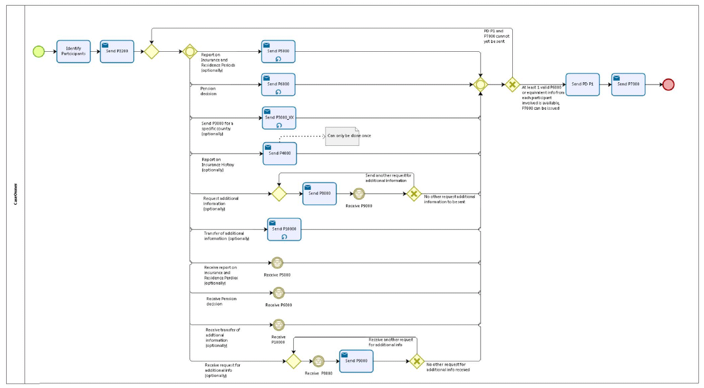

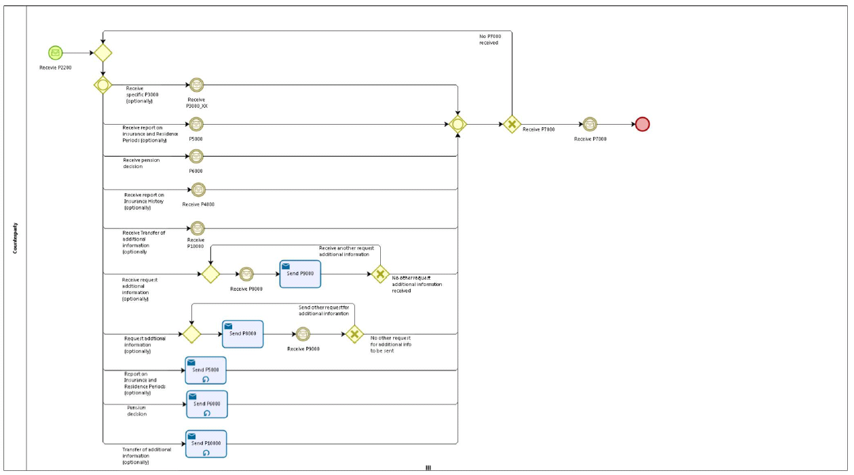

5.2 Sub Processes

n/a

Appendices

Issues
# | Issue date | Description | Replies | Action/Resolution | Close date
1
2
3
4

