
EESSI Business Use Case

Annex Nr.12 to the note AC 370/16rev

Approved

R_BUC_07
Request for recovery


EESSI Business Use Case

Table of Contents

Table of Contents 2
1. Introduction 9
1.1. Purpose 9
1.2. Scope 9
1.3. Definitions, Acronyms and Abbreviations 9
1.4. References 10
1.5. Overview 10
2. Description 11
2.1. Business Scenario 11
2.2. Legal Base 11
3. Actors & Roles 13
4. Use Case 14
4.1. RUP Table Representation 14
4.2. Request – Reply SEDs 30
4.3. Attachments Allowed 30
4.4. Artefacts used 30
5. Business Processes 32
5.1. Case Owner 33
5.2. Counterparty 34
5.3. Sub Processes 35
5.3.1. Case Owner's sub process: 'Contestation initiated by the Case Owner' 35
5.3.2. Case Owner's sub process: 'Receive Contestation from Counterparty' 35
5.3.3. Case Owner's sub process: 'Receive Reimbursement Request' 36
5.3.4. Counterparty's sub process: 'Receive Contestation from Case Owner' 36
5.3.5. Counterparty's sub process: 'Contestation initiated by Counterparty' 37
5.3.6. Counterparty's sub process: 'Reimbursement of costs' 37
6. Appendices 38
6.1. Issues 38

Document Control Information
Settings | Value
Document Title: | Business Use Case  R_BUC_07 – Request for recovery
Project Title: | EESSI (Electronic Exchange of Social Security Information) Project
Document Author: | European Commission, DG EMPL F5
System Owner: | European Commission, DG EMPL D2
Doc. Version: | v4.1.0
Sensitivity: | Public
Date: | 03/08/2018

Document history:
The Document Author is authorized to make the following types of changes to the document without requiring that the document be re-approved:
- Editorial, formatting, and spelling
- Clarification
To request a change to this document, contact the Document Author or Owner.

Revision | Date | Created by | Short Description of Changes
v0.1 | 03/10/2014 | Eric Briffoz | Initial draft
v0.2 | 05/05/2015 | Eric Briffoz | Adaptations following AHG Reviews received from DE, AT, PL, UK.
v0.3 | 11/05/2015 | Eric Briffoz | - Adaptation 2.2 Matrix.  - Branch 5 adapted to add condition used.  - Added condition used in branch 4 (Section Item of the SED)  - Adapted Branches Ids.  - Adaptation of Condition in Main Scenario Step 13.
v0.4 | 05/06/2015 | Eric Briffoz | - Corrections following review by UK: adaptations in Branch 4.  - Adaptation of rule concerning usage of R018 : Branch 2.
v0.5 | 02/09/2015 | Eric Briffoz | Corrections following review of the testing team
v0.6 | 10/09/2015 | Eric Briffoz | - Adaptations concerning the usage of the invalidate administrative SED: the behaviour of invalidate on the process is that it becomes possible to resend the same document type.  - Branch 4, Step 4: Adding "Clerk decision", ie it's not the system which will verify this selection in the SED.  - Main Scenario – Step 13:  It must be possible to send additional R004 even though a Final R004 has been sent.
v0.7 | 16/09/2015 | Eric Briffoz | Correction following review by the testing team:  - Branch 10a: Case owner does not agree to reimburse the estimated costs (option for provisional R028). However, Case owner also has dropdown-box selection: does not agree to reimburse the actual costs (option for final R028).  - Clarification in Branches 10 and 11: possible creation of multiple R004's, in case of multiple payments.  - Correction Branch 38 (reference to Branches 7 and 8)
v0.99.0 | 03/02/2016 | Eric Briffoz | Candidate for AHG Approval  Inclusion of Request-Reply Table  Inclusion of Attachment Allowed Table  Inclusion of SED & Sub-process Versioning Information
v0.99.1 | 23/02/2016 | Eric Briffoz | Adaptations following comments received by AHG on version 0.99.0.  - Branch 4: struck through text has been deleted  - Correction of numbering on Branches 20, 24 and 27.  - exception 1: removed reference to issues 6.1 which is no longer necessary.  - Adaptations to BPMN (counterparty side): labels corrections.  - Other minor textual corrections.
v0.99.2 | 13/04/2016 | Heidi Warson | Adaptations following comments received from UK:  - added "of contestation" to the name of SED R033 in paragraph 2.1;  - deleted the word "have" in paragraph 3 – Actor;  - Branches 6, 7, 9, 10 and 11 – changed the positioning of the text "including any attachments". This wording is attached to the steps "sending", not to the steps – "fills in";  - Branch 10a – referred to step 6 in Branch 11;  - Branch 15 – referred to steps in Branches 2, 4 and 5;  - Branch 17 – referred to steps in Branch 3b;  - Branch 19 – deleted the word "Branch"  - Branch 30 to 45 – instead of referring to the related branch, it is changed to "provided the SED has not been invalidated" to accommodate that when a new SED has been filled in, it is also allowed to update this one again  - Branch 31 – referred to steps in Branches 2 and 5  - Branch 33 – referred to steps in Branch 3b  - Branch 38 – deleted references to steps in Branches 6 and 7 (already included in branch 37)  - a number of minor format changes
v0.99.3 | 28/04/2016 | Heidi Warson | Candidate for AC Approval as agreed by the Recovery rapporteur.  Minor formatting, date, version and grammar changes.
v0.99.4 | 13/06/2016 | Heidi Warson | Updated following AC review comments from NL and align this BUC with R_BUC_02:  - Section 4.1 – RUP Table Representation: Used at first time use, 'Instrument Permitting Enforcement ('IPE')'. Next throughout the document 'IPE' is used.  - Section 4.1 – RUP Table Representation – branch 3a step 3, branch 3b step 3, branch 4 step 4 + 6, branch 5 step 3, branch 6 step 3 + 6 + 9, branch 7 step 3 + 4 + 6 + 9, branch 8 step 3 + 5 + 6 + 9, branch 9 step 3 + 6 + 9, branch 10 step 3 + 6 + 9 + 12 + 15, branch 11 step 3 + 6 + 9: updated steps related to attachments for sending: 'including any attachments, if provided' after 'SED', or for receiving: 'any attachments (if provided) after 'document'.  - Section 4.1 – RUP Table Representation – branches 14 to 29: included 'Optionally' before steps 2 and 3, to keep the document aligned with R_BUC_02.  - Section 5.3 – Called Sub Processes: removed 'Section 5.3.1 – Identify Participants' and 'Section 5.3.2 – Fill in & Send SED' to align the R_BUC_07 with R_BUC_02.
v1.0.0 | 08/07/2016 | Heidi Warson | AC Approved.
v1.1.0 | 11/07/2016 | Heidi Warson | Approval of change request for "R_BUC_07 – Include Admin Subprocess Reopen", see JIRA EESSI-1738.  Alignment to the standard description and layout of the BUC:  - Throughout the document updated with grammatical changes and formatting.  - Rephrased section 2.1 Business Scenario: to remove references to the SEDs.  - Renamed section 2.2 from 'Legal Regulations / Policy Issues / Other' to 'Legal Base' & aligned the text and table to the standard BUC.  - Section 3 Actors & Roles: replaced for the 'Case Onwer' the word 'institution' with 'applicant party' and 'requested party' and for role 'Counter Party' with 'requested party'. Deleted actor 'Debtor', as this is not an active actor in the BUC. The information should be included in the guideline, when required.  - Section 4.5 SED and Sub-process Versioning: added subprocess AD_BUC_12_Subprocess – Change of Participant in the table 'SUB PROCESS'  - Section 5 Business Processes: rephrased first paragraph.  Updated following AC review comment from PL as agreed by the AHG members:  - Section 2.1 Business Scenario: rephrased "Optionally situations can occur where a claim occurs from the debtor" to "Optionally situations can occur where the debtor starts a dispute."  Updated following feedback received at recovery AHG June 2016 meeting:  - Updated section 4.1 RUP Table Representation: added new Branch 48 for Sub process UC reopen.  - Updated section 4.4 RUP UC Diagram Representation: included UC Reopen in the diagram.  - Updated section 4.5 SED and SUB-process Versioning - table SUB PROCESS: indicated the use of AD_BUC_02_Subprocess – Reopen Case.
v1.1.1 | 22/11/2016 | Heidi Warson | Added the reference in the history table to V1.1.0 as follows "Approval of change request for "R_BUC_07 – Include Admin Subprocess Reopen", see JIRA EESSI-1738."  Updated section 4.1 RUP Table Representation to be aligned with R_BUC_03/04/05/06:  - Branch 3b, step 4 a): replaced "section 7" with "(section "Action required"/ item "Receiving institution is asked to" of R025)";  - Branch 3b, step 4 b): replaced "(item 7.1 first tick box)" with "(item "Receiving institution is asked to" = "Cease recovery measures" in R025)";  - Branch 4, step 4: rephrased "second bullet at 10.1 has not ben ticked" to "item "Agreement to accept the following proposal" = "Has been given" has not been selected";  - Branch 4, step 5: added ", including any attachments,";  - Branch 5: removed reference to the SED " Section 6.1 of R018";  - Branch 7 and 8 and 9, step 1: replaced 6.3 with " Contestation concerns" and 6.2 with " Contestation received by";  - Branch 10, step 1: replaced 8 with "Estimated costs and/or losses";  - Branch 10, step 7 and branch 11, step 1: replaced 7 with "Actual costs and/or losses";  – Exception branch: removed step 2, as branch 12 is already available in the BUC;  - Special requirements: added "[Branch 48] - May be invoked more than once (provided a new close was requested following the re-open)" and "[Exception 1] May be invoked more than once (provided branch 48 has been invoked);" for SR1.  And in addition, performed some reformatting throughout the document.
v1.1.2 | 19/04/2017 | Heidi Warson | Corrected section 4.1 RUP Table Representation – Special Requirement 5 to the following:  "- Alternative Branches 1, 2, 3b step 4a), 4, and 6 to 47 are non-interrupting Branches;  - Branches 3a, 3b step 4b), 5, and Exception 1 are Interrupting Branches/Exception."
v1.1.3 | 03/07/2017 | Heidi Warson | Included new Business Process picture, including all sub processes.
v1.1.4 | 17/08/2017 | Eric Briffoz | Added BPMN version of the diagram in section 5. Correction in sub-process table in section 4.5.
v1.2.0 | 25/07/2017 | Heidi Warson | Change Request for "Update alternative scenario's to include branch 1 Precautionary request", see JIRA EESSI-1991.  Updated section 4.1 RUP Table Representation to include branch 1 (for type = Precautionary Measures') also for branches 3a, 3b, 4, 7, 8 and 11.  Corrected some spelling mistakes.
v1.2.1 | 11/08/2017 | Eric Briffoz | - removed Use Case diagram.
v1.2.2 | 22/09/2017 | Heidi Warson | CMB Approval of change request for "R_BUC_07 – Update alternative scenario's to include branch 1 Precautionary request", see JIRA EESSI-1991.
v1.2.3 | 15/12/2017 | Heidi Warson | Aligned Invalidate branches to standard text to include reference to Art 5.
v4.1.0 | 03/08/2018 | Heidi Warson | - Section 4.4: merged 2 tables (for SED & for Subprocesses) into 1 Artefact table.  - Version adaptations to release 4.1.0.

Introduction

Purpose
The purpose of this document is to construct an external view of, part of, the 'EESSI business system' as described in EC Regulations 883/2004 and 987/2009. The ‘EESSI Business System’ describes the business and expected business processes without consideration as to which part(s) may be realised by an IT System (i.e. the proposed EESSI IT System).
The external view comprises of models and descriptions of business use cases, the services of a business system offered to business actors: customers, business partners, or other business systems.
A business use case is described from an actor's perspective; it describes the interaction between an actor and the business system, meaning it describes the behaviours of the business system that the actor utilises. The Business Use Case includes Use Case Diagrams and Business Process Models.
Use case diagrams show actors, business use cases, and their relationships. Use case diagrams do not describe procedures. Alternative scenarios also remain hidden. These diagrams give a good overview of the behaviours of the EESSI business system which will direct and govern part of the expected behaviours and functionality delivered by the EESSI IT System.

Scope
This document is limited to the external view on the recovery sector process Request for recovery. The different elements like use case description, actors, and business process as well as supporting UML diagrams and BPMN models pertaining to the Request for recovery.

Definitions, Acronyms and Abbreviations
Please see the EESSI Project Glossary here.

References
# | Description
1 | EC Regulation 883/2004 | Regulation EC No 883- 2004.pdf
2 | EC Regulation 987/2009 | Regulation EC No 987-2009.pdf
3 | UML 2.x | http://www.omg.org/spec/UML/
4 | BPMN 2.0 | http://www.omg.org/spec/BPMN/index.htm
5 | UML 2.0 In Action | Henriette Baumann, Patrick Grassle & Philippe Baumann, 2005, ISBN 1904811558
6 | RUP@EC standard 5.0 | http://www.cc.cec/RUPatEC_Standard/
7 | RUP op maat | http://www.rupopmaat.nl/

Overview
Chapter 1 introduces the external view on the business system under review and lists the elements of this specification.
Chapter 2 introduces us to the Request for recovery business process. The chapter gives a short and detailed description as well as a reference to business process´ legal base.
Chapter 3 lists the actors involved in the Request for recovery business process.
Chapter 4 describes in detail the Request for recovery business process based on the RUP use case template, as well as the relationship to other use cases.
Chapter 5 describes the Request for recovery business process using business process modelling notation (BPMN).

Description

Business Scenario
In a situation where an institution in a Member State wants to recover a debt from a debtor and if the regulation permits (in respect of the application of the reimbursement chapters of Regulations (EC) No. 883/2004 of 987/2009); this Member State is allowed to request the institution of another Member State to recover this debt on its behalf.
Various scenarios can occur in this BUC:
1) The Institution of the Member State makes a request to recover a debt on its behalf. This is the main scenario.
2) The Institution of the Member State requests a precautionary measure to protect a claim.
3) The Institution of the Member State makes a request to recover a debt and decides to reduce or withdraw the debt.
4) The Institution of the Member State requests a precautionary measure to protect a claim, and decides to reduce or to withdraw the debt.
5) The institution of the Member State makes a request to recover a debt on its behalf but the requested Institution needs additional information to be able to execute the request.
Optionally situations can occur where the debtor starts a dispute.
Finally, situations can occur where the requested institution (Counterparty) may ask the Case Owner for reimbursement of costs.

Legal Base
This Business Use Case document's legal base is described in the following Regulations
- implementing Regulation (EC) No 987/2009

The following matrix specifies the SEDs that are used in this Business Use Case and the articles that provide the legal basis for each SED.

- SED | Implementing Reg (987/09)
- SED | 75 | 78 | 79 | 80 | 81 | 82 | 83 | 84 | 85 | 90
R017
R018
R025
R036
R004
R019
R033
R034
R028
R029
Table 1: SED – Legal base relationship matrix

Actors & Roles
This chapter captures details of the actors which are important to understand the different types of system users. An actor is anyone or anything that exchanges data with the business system. An actor can be a user, external hardware, or another system.
The overarching description of each actor described in this Business Use Case can be found in the Glossary. Below you will find a short description which provides further clarity of this actor within the context of this Business Use Case.

Actor name | Description
Case Owner | The Case Owner is the applicant party in one member state which asks the requested party in another member state to recover a debt on his behalf, or to take precautionary measures to protect the claim.
Counterparty | The Counterparty is the requested party in the other Member State (where the person concerned resides or has assets) that handles the request to recover a debt, or the request to take precautionary measures.
Table 2: Actors & Roles

Use Case

RUP Table Representation
Use Case ID: | R_BUC_07
Use Case Name: | Request for recovery
Created By: | Eric Briffoz |  | Last Updated By: | Heidi Warson
Date Created: | 03/10/2014 |  | Last Revision Date: | 13/11/2017
Actors: |  | Case Owner  Counterparty
Description: |  | This business Use Case occurs in a situation where an institution in a member state wants to ask another institution to recover a debt on its behalf, or to take precautionary measures to protect the claim.  - Optionally, the Case Owner may decide to withdraw or to reduce the debt to recover.  - Optionally, the debtor may dispute (contestation) the claim either to the Case Owner, or to the Counterparty.  - Optionally, the requested institution (the counterparty) may ask the Case Owner for reimbursement of costs.
Trigger: |  | A Member State identifies a debt which is not paid in due time. The debtor lives in or has assets in another Member State and no further national recovery measures are possible. There is also no (efficient) possibility for offsetting according to articles 72 or 73 of Regulation (EC) No. 987/2009. So a request for recovery should be sent to the competent institution in another Member State in accordance with article 78 of Regulation (EC) No. 987/2009.
Preconditions: |  | An institution in one member state would like to recover a debt under articles of the specified Regulation or would like to request precautionary measures to be taken.
Post conditions: |  | - The debt is fully recovered or  - The debt is partially recovered (following a reduction of claim)  - Precautionary measures were taken to protect the claim or  - The debt was not recovered at all or partially, following a decision after a contestation of the debtor or because no recovery/further recovery options are possible.
Main Scenario:  (= when Recovery is possible) |  | Identify Participant  - The Case Owner identifies the EU Member State where the person concerned lives or has assets;  - The Case Owner identifies the Competent Institution (the Counterparty) in that Member State from the Database.  Send Request for Recovery  - The Case Owner fills in a Request for recovery of a debt (SED R017) by entering all the required Information about the debt that ought to be recovered;  The Instrument Permitting Enforcement ('IPE') needs to be added as attachment. (it is an obligation to attach the 'IPE' [article 78(1) of regulation (EC) No. 987/2009]);  - The Case Owner sends their SED R017, including any attachments, to the Counterparty.  Process Request & Send Reply  - The Counterparty receives SED R017, and the attachments provided in the request;  - The Counterparty checks what is possible :  - Recovery measures are possible to apply: debtor's assets were found;  - Recovery by instalment;  - No (further) recovery action is possible at all (instalment agreement hasn't been reached or debtor has no available assets – See [Branch 5]);  - Further information is needed [Branch 4];  - The Counterparty fills in a 'Reply to Request for recovery' (SED R018) by entering all required information;  - The Counterparty sends their SED R018, including any attachments, to the Case Owner;  - The Case Owner receives and views SED R018, including any attachments. [If No recovery action is possible the use case ends here: See [Branch 5].  Process Decision & Send Payment Notification  - The Counterparty fills in a Notification of Payment (SED R004) indicating whether the payment is "Payment in Full", " Partial payment", "Instalment" or "Final Instalment";  - The Counterparty sends their SED R004, including any attachments, to the Case Owner;  - The Case Owner receives the R004;  - The main scenario reverts to [Step 10] or [Step 7] (both options are still possible);  - The use case ends here.
Alternative Scenarios: |  | Branch 1: (Precautionary request) at [Step 3] the Case Owner wants to ask an institution of another Member State to take precautionary measures  - The Case Owner fills in a Request for precautionary measures (SED R017) by entering all the required information about the requested precautionary measures. The 'IPE' should also be added as attachment;  - The Case Owner sends their SED R017, including any attachments to the Counterparty;  - The Counterparty receives the SED R017, and attachments (if provided);  - The Counterparty fills in a 'Reply to Request for recovery/precautionary measures (SED R018) by entering all required information;  - The Counterparty sends SED R018, including any attachments, to the Case Owner;  - The Case Owner receives the R018, and attachments (if provided);  - [This Use Case] Ends.
Branch 2 : at any Step after an R018 has been sent, a new R018 may be created by the Counterparty
- The Counterparty creates a new R018 SED;
- The Counterparty sends the R018 SED to the Case Owner;
- The Case Owner receives the R018 SED;
- [This Branch] Ends.
Branch 3a; at any Step between [Step 4] and [Step 14] or in [Branch 1] between [Step 2] and [Step 6], the Case Owner (after sending the request) decides to withdraw the debt (for any reason other than contestation)
- The Case Owner fills a 'Notification of withdrawal or reduction of claim' (SED R025) by entering all required information; and specifies that it wishes to withdraw the debt;
- The Case Owner sends their SED R025, including any attachments, to the Counterparty;
- The Counterparty receives and views R025, including attachments (if provided);
- [The Use Case] Ends.

Branch 3b: at any Step between [Step 4] and [Step 14] or in [Branch 1] between [Step 2] and [Step 6], the Case Owner (after sending the request) decides to reduce the debt (for any reason other than contestation)
- The Case Owner fills a 'Notification of withdrawal or reduction of claim' (SED R025) by entering all required information; and specifies that it wishes to reduce the debt;
- The Case Owner sends their SED R025, including any attachments, to the Counterparty;
- The Counterparty receives and views R025, including attachments (if provided);
4. a) If further action is required (section "Action required", item "Receiving institution is asked to" of R025) then revert to Main Scenario at [step 6];
b) If further recovery action should be ceased (item "Receiving institution is asked to" = "Cease recovery measures" of R025) then [This Use Case] Ends.

Branch 4: at [Step 6] or in [Branch 1] at [Step 3]; while responding by using the R018, the Counterparty (Requested Institution) may ask for further information (in order to assist the recovery or the precautionary procedures), or to make a proposal of payment by installment. The Case Owner will reply to it by using SED R036
- The Counterparty fills in a 'Reply to request for recovery /precautionary measures' (R018), and defines that further information would be needed in order to assist recovery or asks for, or confirms a decision on the proposal of payment by installment;
- The Counterparty sends their R018 document to the Case Owner;
- The Case Owner receives and views R018;
- If R018 item "Agreement to accept the following proposal" = "Has been given" has not been selected, (Clerk Decision) then the Case Owner fills in a 'Provision of additional information' R036 document, including any attachments, containing the requested information asked by the counterparty (or the decision on the proposal of payment by installment);
- The Case Owner sends the R036 document, including any attachments, to the counterparty;
- The counterparty receives and views the 'Provision of additional information' (SED R036) document, including attachments (if provided);
- The BUC continues at [Step 6] of the main scenario.

Branch 5: at [Step 6], the counterparty decides that no (further) recovery actions are possible at all (instalment agreement has not been reached or debtor has no available assets, or debtor has assets but the requested institution is not able to recover the debt from these assets in accordance with their own procedure)
- The Counterparty fills in a 'Reply to Request for recovery' (SED R018) by entering all required information;
- The Counterparty sends their SED R018, including any attachments, to the Case Owner;
- The Case Owner receives and views SED R018, including any attachments (if provided);
- No recovery action is possible so
[The use case] ends here.

Branch 6: at any Step between [Step 4] and [Step 13], or in [Branch 1] between [Step 2] and [Step 6] the Case Owner (Applicant institution) receives a contestation from the debtor (third party) and it concerns the claim and/or 'IPE' issued by the Case Owner
- The Case Owner fills in a 'Notification of contestation' SED R019;
- The Case Owner sends the R019 document, including any attachments, to the counterparty;
- The Counterparty receives and views R019, including any attachments (if provided);
- The Counterparty fills in a 'Reply to notification of contestation' SED R033;
- The Counterparty sends SED R033 document, including any attachments, to the Case Owner;
- The Case Owner receives and views R033, including any attachments (if provided);
- The Case Owner fills in a 'Decision on contestation' SED R034;
- The Case Owner sends the R034 document, including any attachments, to the counterparty;
- The Counterparty receives and views the R034 document, including any attachments (if provided);
- [This Branch] Ends.

Branch 7: at any Step between [Step 6] and [Step 13] or in [Branch 1] between [Step 2] and [Step 6], the Case Owner (Applicant institution) receives a Contestation from the debtor (third party) and it concerns Recovery Measure, Precautionary Measure and/or 'IPE' issued by the Counterparty
- The Case Owner fills in a 'Notification of contestation' SED R019 including any attachments;
For this Branch 7, the Case Owner Selects the following
(a) Section: "Contestation concerns", choices are:
Precautionary measures taken by the requested institution
Enforcement action taken by the requested institution
'IPE' issued by the requested institution
(b) Section: "Contestation received by" should contain the following:
Received by the Applicant Institution;
- The Case Owner sends the R019 document, including any attachments, to the counterparty;
- The Counterparty receives and views R019, including any attachments (if provided);
- The Counterparty fills in a 'Reply to notification of contestation' SED R033, including any attachments;
- The Counterparty sends SED R033 document to the Case Owner;
- The Case Owner receives and views R033, including any attachments (if provided);
- The Counterparty fills in a 'Decision on contestation' SED R034, including any attachments;
- The Counterparty sends the R034 document to the Case Owner;
- The Case Owner receives and views the R034 document, including any attachments (if provided);
- [This Branch] Ends.

Branch 8: at any Step between [Step 6] and [Step 13] or in [Branch 1] between [Step 3] and [Step 6], the counterparty (requested institution) receives a contestation from the debtor and it concerns a Recovery Measure, Precautionary Measure and/or 'IPE' issued by the Counterparty
- The Counterparty fills in a 'Notification of contestation' SED R019 including any attachments;
For this Branch 8, the following :
(a) Section "Contestation concerns", should be filled-in by the Counterparty:
Precautionary measures taken by the requested institution
Enforcement action taken by the requested institution
'IPE' issued by the requested institution
(b) Section "Contestation received by" should contain the following:
"Received by Requested institution";
- The Counterparty sends the R019 document to the Case Owner;
- The Case Owner receives and views R019, including any attachments (if provided);
- The Case Owner can optionally fill in a 'Reply to notification of contestation' SED R033, including any attachments;
If R033 should not be created this Branch continues at Step 7;
- The Case Owner sends SED R033 document, including any attachments, to the Counterparty;
- The Counterparty receives and views R033 SED document, including any attachments (if provided);
- The Counterparty fills in a 'Decision of contestation' SED R034, including any attachments;
- The Counterparty sends R034 document to the Case Owner.
- The Case Owner receives and views the R034 document, including any attachments (if provided);
- [This Branch] Ends.

Branch 9: At any Step between [Step 5] and [Step 13] or in [Branch 1] between [Step 3] and [Step 6], the Counterparty (requested institution) receives a contestation from the debtor and it concerns the claim and/or the 'IPE' issued by the Case Owner
- The Counterparty fills in a 'Notification of contestation' SED R019;
For this Branch 9, the following Section needs to be filled in:
"Contestation received by": Received by the Requested Institution;
"Contestation concerns": Claim/'IPE' issued by the Applicant Institution;
- The Counterparty sends the R019 document, including any attachments, to the Case Owner;
- The Case Owner receives and views R019, including any attachments (if provided);
- The Case Owner fills in a 'Reply to notification of contestation' SED R033;
- The Case Owner sends SED R033 document, including any attachments, to the Counterparty;
- The Counterparty receives and views R033 SED document, including any attachments (if provided);
- The Case Owner fills in a 'Decision on contestation' SED R034;
- The Case Owner sends R034 document, including any attachments, to the counterparty;
- The Counterparty receives and views the R034 document, including any attachments (if provided);
- [This Branch] Ends.

Branch 10: (Claim for reimbursement): at any Step between [Step 6] and [Step 13], or in [Branch 1] at any Step between [Step 3] and [Step 6], the requested institution may optionally ask for a reimbursement of costs, including a provisional request
- The Counterparty fills in a R028 SED document. It is stated that the request is provisional (in Section "Estimated costs and/or losses");
- The Counterparty sends the R028 document, including any attachments, to the case owner;
- The Case Owner receives and views R028, including any attachments (if provided);
- The Case Owner fills in a R029 SED document;
- The Case Owner sends the R029 SED document, including any attachments, to the Counterparty;
- The Counterparty receives and views R029 SED, including any attachments (if provided);
- If the Case Owner has agreed to reimburse the estimated costs; the Counterparty fills in a R028 SED document. It is stated that the request is final (Section "Actual costs and/or losses");
- The Counterparty sends the R028 document, including any attachment, to the Case Owner;
- The Case Owner receives and views R028, including any attachments (if provided);
- The Case Owner fills in a R029 SED document;
- The Case Owner sends the R029 SED document, including any attachments, to the Counterparty;
- The Counterparty receives and views R029 SED, including any attachments (if provided);
- If Payments can be made, the case owner fills in a R004 document for each payment to be processed;
- The Case Owner sends the R004 document, including any attachments, to the counterparty;
- The Counterparty receives and views the R004 document, including any attachments (if provided);
- If additional payments need to be made, this branch reverts to [Step 13]; else
- [This Branch] Ends.

Branch 10a: in Branch [10] at [Step 7], or at Branch [10] at [Step 12] or in Branch 11 [Step 6] the Case owner does not agree to reimburse the (estimated) costs
1. [This Branch] Ends and Reverts to Main Scenario [Step 6].

Branch 11: at any Step between [Step 6] and [Step 13] or in [Branch 1] between [Step 2] and [Step 6], the requested institution may optionally request for a reimbursement of costs, without provisional request
- The Counterparty fills in a R028 SED document, including any attachments. It is stated that the request is final (Section "Actual costs and/or losses");
- The Counterparty sends the R028 document, including any attachments, to the case owner;
- The Case Owner receives and views R028, including any attachments (if provided);
- The Case Owner fills in a R029 SED document;
- The Case Owner sends the R029 SED document¸ including any attachments, to the Counterparty;
- The Counterparty receives and views R029 SED, including any attachments (if provided);
- If Payments can be made, the case owner fills in a R004 document for each payment to be processed;
- The Case Owner sends the R004 document, including any attachments, to the counterparty;
- The Counterparty receives and views the R004 document, including any attachments (if provided);
- If additional payments need to be made, the system reverts to [Step 7]; else
- [This Branch] Ends.

 |  | The Following Branches determine the use of Horizontally Defined Processes within this Business Process
Branch 12: at any Step between [Step 5] and [Step 13] or in [Branch 1] between [Step 3] and [Step 6], any Participant may optionally choose to request AdHoc Information from another participant
- The participant executes business use case H_BUC_01 – Adhoc Exchange of Info;
- [This Branch] Ends.

 |  | The Following Branches Determine the use of Administrative Processes within this Business Process
Branch 13: at any Step between [Step 5] and [Step 13] or in [Branch 1] at any Step between [Step 3] and [Step 6] any participant may choose to Forward this Business Process to another Competent Institution within their Member State who assumes responsibility for handling it
- Any Participant executes business use case AD_BUC_05_Subprocess Forward Case;
- [This Branch] Ends.

Branch 14: at any Step between [Step 4] and [Step 13] or in [Branch 1] at any Step between [Step 2] and [Step 6], the Case Owner may choose to advise the counterparty that their R017 is Invalid under Art 5 of Regulation (EC) no 987/09
- The Case Owner executes business use case AD_BUC_06_Subprocess Invalidate_SED;
- Optionally, the Case owner fills in a Request for recovery/precautionary measures (R017) by entering all the required recovery / precautionary measures;
- Optionally, the Case owner sends the R017, including any attachments, to the counterparty;
- [This Branch] Ends.

Branch 15: at any Step between [Step 8] and [Step 13] or in [Branch 1] between [Step 5] and [Step 6], or in Branch 2 between [Step 2] and [Step 4] or in Branch 4 between [Step 2] and [Step 7], or in Branch 5 between [Step 2] and [Step 4] the Counterparty may choose to advise the Case Owner that their R018 is Invalid under Art 5 of Regulation (EC) no 987/09
- The Counterparty executes business use case AD_BUC_06_Subprocess Invalidate_SED;
- Optionally, the Counterparty fills in a Reply to request for recovery/precautionary measures (R018) by entering all required field from that SED;
- Optionally, the Counterparty sends R018, including optional attachments to the Case Owner;
- [This Branch] Ends.

Branch 16: at any Step between [Step 11] and [Step 13] the Counterparty may choose to advise the Case Owner that their R004 is Invalid under Art 5 of Regulation (EC) no 987/09
- The Counterparty executes business use case AD_BUC_06_Subprocess Invalidate_SED;
- Optionally, the Counterparty fills in a Notification of Payment (R004) by providing the required fields of the notification;
- Optionally, the Counterparty sends the notification of payment to the Case Owner;
- [This Branch] Ends.

Branch 17: in [Branch 3a] at any step between [Step 2] and [Step 4] or in [Branch 3b] between [Step 2] and [Step 4], the Case Owner may choose to advise the Counterparty that their R025 is Invalid under Art 5 of Regulation (EC) no 987/09
- The Case Owner executes business use case AD_BUC_06_Subprocess Invalidate_SED;
- Optionally, the Case owner fills in a Notification of withdrawal or reduction of claim (R025) SED by entering all necessary information about the withdrawal / reduction of the claim;
- Optionally, the Case Owner sends the R025 SED to the Counterparty;
- [This Branch] Ends.

Branch 18: in [Branch 4 ], at any Step between [Step 5] and [Step 7], the Case Owner may choose to advise the Counterparty that their R036 is Invalid under Art 5 of Regulation (EC) no 987/09
- The Case Owner executes business use case AD_BUC_06_Subprocess Invalidate_SED;
- Optionally, the Case Owner fills in a provision of additional information (R036) SED by entering the needed information from the additional information SED;
- Optionally, the Case Owner sends R036 to the Counterparty.
- [This Branch] Ends.

Branch 19: in [Branch 6], at any Step between [Step 2] and [Step 6] or in [Branch 7] at any Step between [Step 2] and [Step 6], the Case Owner may choose to advise the Counterparty that their R019 is Invalid under Art 5 of Regulation (EC) no 987/09
- The Case Owner executes business use case AD_BUC_06_Subprocess Invalidate_SED;
- Optionally, the Case Owner fills in a notification of contestation (R019) SED by entering the required information about the contestation;
- Optionally, the Case Owner sends the notification of contestation to the Counterparty, including any optional attachment;
- [This Branch] Ends.

Branch 20: in [Branch 8] at any Step between [Step 2] and [Step 6] or in [Branch 9] at any Step between [Step 2] and [Step 6] the Counterparty may choose to advise the Case Owner that their R019 is Invalid under Art 5 of Regulation (EC) no 987/09
- The Counterparty executes business use case AD_BUC_06_Subprocess Invalidate_SED;
- Optionally, the counterparty fills in a notification of contestation (R019) SED by entering the required information about the contestation;
- Optionally, the counterparty sends the notification of contestation to the Case Owner, including any optional attachment;
- [This Branch] Ends.

Branch 21: in [Branch 6] at any Step between [Step 5] and [Step 6] or in [Branch 7] at any Step between [Step 5] and [Step 6], the Counterparty may choose to advise the Case Owner that their R033 is Invalid under Art 5 of Regulation (EC) no 987/09
- The Counterparty executes business use case AD_BUC_06_Subprocess Invalidate_SED;
- Optionally, the Counterparty fills in a reply to notification of contestation (R033) by filling in the necessary fields of the reply;
- Optionally, the Counterparty sends the reply to notification of contestation to the case owner, including any optional attachment;
- [This Branch] Ends.

Branch 22: in [Branch 8] at any step between [Step 5] and [Step 6] or in [Branch 9] at any step between [Step 5] and [Step 6], the Case Owner may choose to advise the Counterparty that their R033 is Invalid under Art 5 of Regulation (EC) no 987/09
- The Case Owner executes business use case AD_BUC_06_Subprocess Invalidate_SED;
- Optionally, the Case Owner fills in a reply to notification of contestation (R033) by filling in the necessary fields of the reply;
- Optionally, the Case Owner sends the reply to notification of contestation to the Counterparty, including any optional attachment;
- [This Branch] Ends.

Branch 23: in [Branch 6] at any Step between [Step 8] and [Step 9] or in [Branch 9] at any Step between [Step 8] and [Step 9] the Case Owner may choose to advise the Counterparty that their R034 is Invalid under Art 5 of Regulation (EC) no 987/09
- The Case Owner executes business use case AD_BUC_06_Subprocess Invalidate_SED;
- Optionally, the Case Owner fills in a decision on contestation (R034) by entering the requested fields of the decision on contestation;
- Optionally, the Case Owner sends the decision on contestation to the Counterparty;
- [This Branch] Ends.

Branch 24: in [Branch 7] at any Step between [Step 8] and [Step 9] or in [Branch 8] at any Step between [Step 8] and [Step 9], the Counterparty may choose to advise the Case Owner that their R034 is Invalid under Art 5 of Regulation (EC) no 987/09
- The Counterparty executes business use case AD_BUC_06_Subprocess Invalidate_SED;
- Optionally, the Counterparty fills in a decision on contestation (R034) by entering the requested fields of the decision on contestation;
- Optionally, the Counterparty sends the decision on contestation to the Case Owner;
- [This Branch] Ends.

Branch 25: in [Branch 10] at any Step between [Step 2] and [Step 6], the Counterparty may choose to advise the Case Owner that their provisional R028 is Invalid under Art 5 of Regulation (EC) no 987/09
- The Counterparty executes business use case AD_BUC_06_Subprocess Invalidate_SED;
- Optionally, the counterparty fills in a Request for reimbursement of costs (R028) SED by filling the necessary information from the request of reimbursement;
- Optionally, the Counterparty sends the Request for reimbursement of costs to the case owner, including any optional attachment;
- [This Branch] Ends.

Branch 26: in [Branch 10] at any Step between [Step 5] and [Step 6], the Case Owner may choose to advise the Counterparty that their provisional R029 is Invalid under Art 5 of Regulation (EC) no 987/09
- The Case Owner executes business use case AD_BUC_06_Subprocess Invalidate_SED;
- Optionally, the Case Owner fills in a Reply to request for reimbursement of costs SED (R029) by entering the necessary information about the reply of reimbursement;
- Optionally, the Case Owner sends the Reply to request for reimbursement of costs to the Counterparty including any optional attachment;

- [This Branch] Ends.

Branch 27: in [Branch 10] at any Step between [Step 8] and [step 15] or in [Branch 11] at any Step between [Step 2] and [Step 10], the Counterparty may choose to advise the Case Owner that their final R028 is Invalid under Art 5 of Regulation (EC) no 987/09
- The Counterparty executes business use case AD_BUC_06_Subprocess Invalidate_SED;
- Optionally, the Counterparty fills in a Request for reimbursement of costs (R028) SED by filling the necessary information from the request of reimbursement;
- Optionally, the Counterparty sends the Request for reimbursement of costs to the case owner, including any optional attachment;
- [This Branch] Ends.

Branch 28: in [Branch 10] at any Step between [Step 11] and [Step 15] or in [Branch 11] at any Step between [Step 5] and [Step 10], the Case Owner may choose to advise the Counterparty that their final R029 is Invalid under Art 5 of Regulation (EC) no 987/09
- The Case Owner executes business use case AD_BUC_06_Subprocess Invalidate_SED;
- Optionally, the Case Owner fills in a Reply to request for reimbursement of costs SED (R029) by entering the necessary information about the reply of reimbursement;
- Optionally, the Case Owner sends the Reply to request for reimbursement of costs to the Counterparty, including any optional attachment;
- [This Branch] Ends.

Branch 29: in [Branch 10] at any Step between [Step 14] and [Step 15] or in [Branch 11] at any Step between [Step 8] and [Step 10], the Case Owner may choose to advise the Counterparty that their R004 is Invalid under Art 5 of Regulation (EC) no 987/09
- The Case Owner executes business use case AD_BUC_06_Subprocess Invalidate_SED;
- Optionally, the Case Owner fills in a notification of payment (R004) by filling the necessary information from the notification of payment;
- Optionally, the Case owner sends the notification of payment to the Counterparty;
- [This Branch] Ends.

Branch 30: at any Step between Step 4] and [Step 13] or in [Branch 1] at any Step between [Step 2] and [Step 6], the Case Owner may choose to send an updated version of their R017 provided the SED has not been invalidated
- The Case Owner executes business use case AD_BUC_10_Subprocess Update_SED;
- [This Branch] Ends.

Branch 31: at any Step between [Step 8] and [Step 13] or in [Branch 1] at any Step between [Step 5] and [Step 6], or in [Branch 2] between [Step 2] and [Step 4] or in [Branch 4] at any Step between [Step 2] and [Step 6], or in [Branch 5] between [Step 2] and [Step 4] the Counterparty may choose to send an updated version of their R018 provided the SED has not been invalidated
- The Counterparty executes business use case AD_BUC_10_Subprocess Update_SED;
- [This Branch] Ends.

Branch 32: at any Step between [step 11] and [step 13] the Counterparty may choose to send an updated version of their R004 provided the SED has not been invalidated
- The Counterparty executes business use case AD_BUC_10_Subprocess Update_SED;
- [This Branch] Ends.

Branch 33: in [Branch 3a] at any Step between [Step 2] and [Step 4] or in Branch 3b between [Step 2] and [Step 4], the Case Owner may choose to send an updated version of their R025 provided the SED has not been invalidated
- The Case Owner executes business use case AD_BUC_10_Subprocess Update_SED;
- [This Branch] Ends.

Branch 34: in [Branch 4] at any Step between [Step 5] and [Step 6], the Case Owner may choose to send an updated version of their R036 provided the SED has not been invalidated
- The Case Owner executes business use case AD_BUC_10_Subprocess Update_SED;
- [This Branch] Ends.

Branch 35: in [Branch 6] at any Step between [Step 2] and [Step 6] or in [Branch 7] at any Step between [Step 2] and [Step 6] the Case Owner may choose to send an updated version of their R019 provided the SED has not been invalidated
- The Case Owner executes business use case AD_BUC_10_Subprocess Update_SED;
- [This Branch] Ends.

Branch 36: in [Branch 8] at any step between [Step 2] and [Step 6] or in [Branch 9] at any step between [Step 2] and [Step 6] the Counterparty may choose to send an updated version of their R019 provided the SED has not been invalidated
- The Counterparty executes business use case AD_BUC_10_ Subprocess Update_SED;
- [This Branch] Ends.
Branch 37: in [Branch 6] at any Step between [Step 5] and [Step 6] or in [Branch 7] at any Step between [Step 5] and [Step 6] the Counterparty may choose to send an updated version of their R033 provided the SED has not been invalidated
1. The Counterparty executes business use case AD_BUC_10_Subprocess Update_SED;
2. [This Branch] Ends.

Branch 38: in [Branch 8] at any Step between [Step 5] and [Step 6] or in [Branch 9] at any Step between [Step 5] and [Step 6], the Case Owner may choose to send an updated version of their R033 provided the SED has not been invalidated
1. The Case Owner executes business use case AD_BUC_10_Subprocess Update_SED;
2. [This Branch] Ends.

Branch 39: in [Branch 6] at any Step between [Step 8] and [Step 10] or in [Branch 9] at any Step between [Step 8] and [Step 10], the Case Owner may choose to send an updated version of their R034 provided the SED has not been invalidated
1. The Case Owner executes business use case AD_BUC_10_Subprocess Update_SED:
2. [This Branch] Ends

Branch 40: in [Branch 7] at any step between [step 8] and [step 10] or in [Branch 8] at any step between [step 8] and [step 10], the Counterparty may choose to send an updated version of their R034 provided the SED has not been invalidated
1. The Counterparty executes business use case AD_BUC_10_Subprocess Update_SED;
2. [This Branch] Ends.

Branch 41: in [Branch 10] at any Step between [Step 2] and [Step 6] the Counterparty may choose to send an updated version of their provisional R028 provided the SED has not been invalidated
1. The Counterparty executes business use case AD_BUC_10_Subprocess Update_SED;
2. [This Branch] Ends.

Branch 42: in [Branch 10] at any Step between [Step 5] and [Step 6], the Case Owner may choose to send an updated version of their provisional R029 provided the SED has not been invalidated
1. The Case Owner executes business use case AD_BUC_10_Subprocess Update_SED;
2. [This Branch] Ends.

Branch 43: in [Branch 10] at any Step between [Step 8] and [Step 15] or in [Branch 11] at any Step between [Step 2] and [Step 10]; the Counterparty may choose to send an updated version of their final R028 provided the SED has not been invalidated
1. The Counterparty executes business use case AD_BUC_10_Subprocess Update_SED;
2. [This Branch] Ends.

Branch 44: in [Branch 10] at any Step between [Step 11] and [Step 15] or in [Branch 11] at any Step between [Step 5] and [Step 10] the Case Owner may choose to send an updated version of their final R029 provided the SED has not been invalidated
1. The Case Owner executes business use case AD_BUC_10_Subprocess Update_SED;
2. [This Branch] Ends.

Branch 45: in [Branch 10] at any Step between [Step 14] and [Step 15] or in [Branch 11] at any Step between [Step 8] and [Step 10]; the Case Owner may choose to send an updated version of their R004 provided the SED has not been invalidated
1. The Case Owner executes business use case AD_BUC_10_Subprocess Update_SED;
2. [This Branch] Ends.

Branch 46: at any Step where a participant is expecting to receive a SED from the other participant, that participant may optionally choose to send a reminder to the other participant for the return of information they were expecting from that participant but did not receive
- The participant who invokes this branch executes business use case AD_BUC_07_Subprocess Reminder;
- [This Branch] Ends.

Branch 47: at any Step where a participant has received a SED, that participant may optionally choose to Request the other participant who previously sent them Information to provide clarification of the data that they have sent
- The participant executes business use case AD_BUC_08_Subprocess Clarify Content;
- [This Branch] Ends.

Branch 48: when the BUC has ended, any participant may choose to exchange information despite the formal finishing of the Process

- Any participant executes business use case AD_BUC_02_SubProcess ReOpen Process;
- [This Branch] Ends.

Exceptions: |  | Exception 1: at any Step after at least one SED has been exchanged in the Case, the Case Owner or the Counterparty may optionally choose to end the process due to unexpected information becoming known to them during the course of their investigations  - The Case Owner or the Counterparty executes the business use case AD_BUC_01_Subprocess Close;  - The Use Case ends here
Includes: |  | See diagram at part 4.4.
Special Requirements: |  | SR1: Rules about the invoking of Branches:  [Branch 1] – May be invoked only once.  [Branch 2] – May be invoked multiple times.  [Branch 3a] – May be invoked only once.  [Branch 3b] – May be invoked multiple times.  [Branch 4] – May be invoked multiple times.  [Branch 5] – May be invoked only once.  [Branch 6] – May be invoked multiple times  [Branch 7] – May be invoked multiple times  [Branch 8] – May be invoked multiple times  [Branch 9] – May be invoked multiple times  [Branch 10] – May be invoked multiple times.  [Branch 10a] – May be invoked multiple times.  [Branch 11] – May be invoked multiple times.  Horizontal  [Branch 12] - May be invoked more than once  Administrative  - [Branch 13]: May be invoked more than once  - [Branch 14] – [Branch 29]: May be invoked more than once (provided a new SED has been created following the invalidation)  - [Branch 30] – [Branch 45]: May be invoked more than once  - [Branch 46] – [Branch 47]: May be invoked more than once  - [Branch 48] - May be invoked more than once (provided a new close was requested following the re-open)  - [Exception 1]: May be invoked more than once (provided branch 48 has been invoked).  SR2: Rules about the destination for each SED Type:  R004 – Must be sent to the Case Owner in Main Scenario.  R004 – Must be sent to the Counterparty in Branches 10 and 11  R028 – Must be sent to the Case Owner  R029 – Must be sent to the Counterparty  R017 – Must be sent to the Counterparty  R018 – Must be sent to the Case Owner  R019 – May be sent to the Case Owner or to Counterparty  R033 – May be sent to the Case Owner or to Counterparty  R034 – May be sent to the Case Owner or to Counterparty  R025 – Must be sent to the Counterparty  R036 – Must be sent to the Counterparty  SR3: The term "Send/Sent to All Active Participants" does not include sending it to himself (i.e. to the senders institution)  SR4: Active Participants are defined as those participants identified at [step 2] and those participants added and removed through the execution of the Forward [Branch 13]  SR5:  - Alternative Branches 1, 2, 3b step 4a), 4, and 6 to 47 are non-interrupting Branches;  - Branches 3a, 3b step 4b), 5, and Exception 1 are Interrupting Branches/Exception.
Assumptions:
Notes and Issues:

Request – Reply SEDs
The following table specifies any SED that have a logical pairing to one another, usually this is known as a request-reply pair.
REQUEST SED | REPLY SED(s)
R017 | R018
R019 | R033
R028 | R029

Attachments Allowed
The following table specifies whether attachments are permitted to be included when sending a SED type.
SED | Attachments
R028 | Allowed
R029 | Allowed
R017 | Allowed
R018 | Allowed
R019 | Allowed
R033 | Allowed
R034 | Allowed
R025 | Allowed
R036 | Allowed
R004 | Allowed

Artefacts used
The following table specifies the artefacts that are used in this Business Use Case.
Artefact name | Artefact type
R004 | SED
R017 | SED
R018 | SED
R019 | SED
R025 | SED
R028 | SED
R029 | SED
R033 | SED
R034 | SED
R036 | SED
H_BUC_01_Subprocess | BUC
AD_BUC_01_Subprocess – Close Case | BUC
AD_BUC_02_Subprocess – Reopen Case | BUC
AD_BUC_05_Subprocess – Forward Case | BUC
AD_BUC_06_Subprocess – Invalidate SED | BUC
AD_BUC_07_Subprocess – Reminder | BUC
AD_BUC_08_Subprocess – Clarify Content | BUC
AD_BUC_10_Subprocess – Update SED | BUC
AD_BUC_11_Subprocess – Business Exception | BUC
AD_BUC_12_Subprocess – Change of Participant | BUC

Business Processes
This chapter describes the Business Use Case Request for recovery using BPMN 2.0.

Case Owner
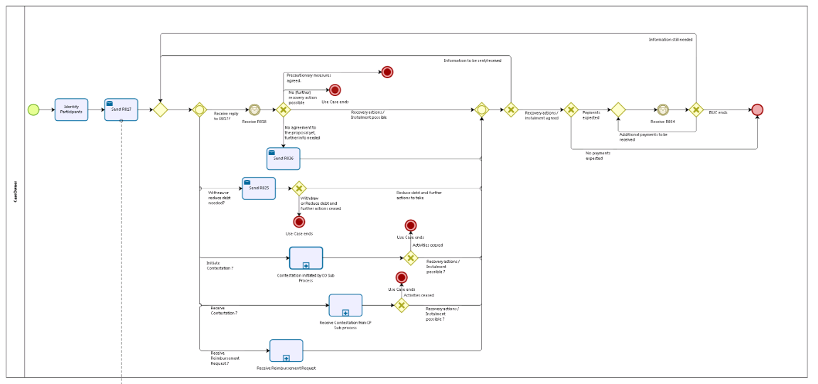
Figure 2: depicts the use case end-to-end, from the Case Owner Perspective

Counterparty
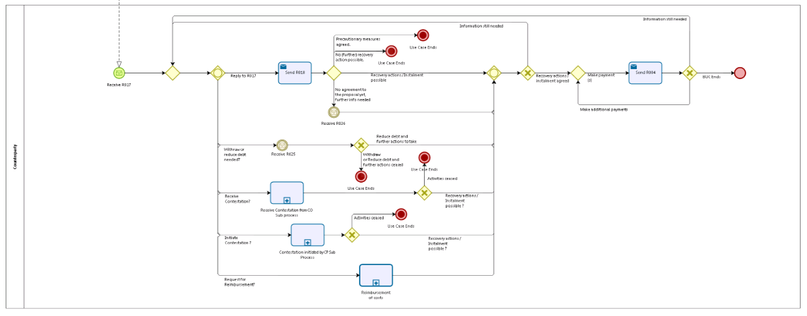
Figure 3: depicts the use case end-to-end, from the Counterparty Perspective

Sub Processes

Case Owner's sub process: 'Contestation initiated by the Case Owner'
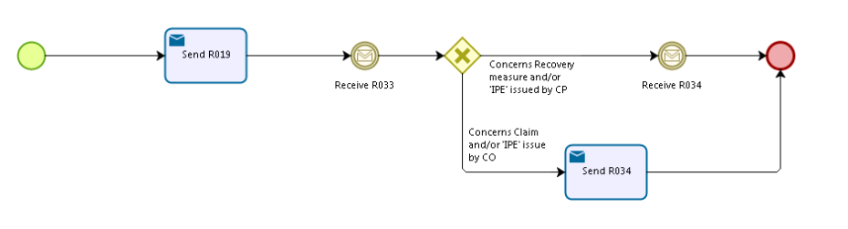
Figure 4: depicts the sub process 'Contestation initiated by the Case Owner'

Case Owner's sub process: 'Receive Contestation from Counterparty'
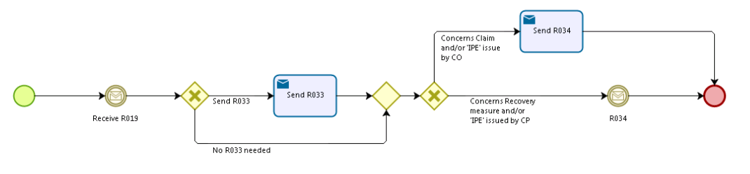
Figure 5: depicts the sub process 'Receive Contestation from Counterparty'

Case Owner's sub process: 'Receive Reimbursement Request'
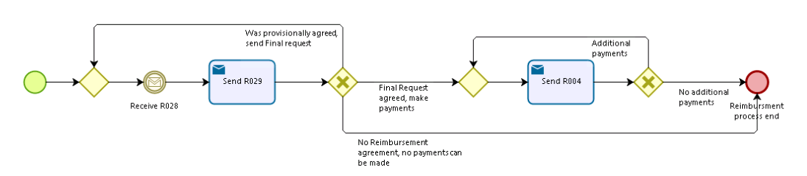
Figure 6: depicts the sub process 'Receive Reimbursement Request'

Counterparty's sub process: 'Receive Contestation from Case Owner'
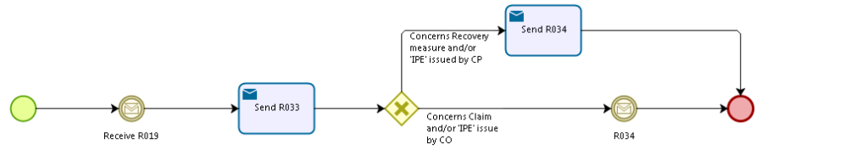

Figure 7: depicts the sub process: 'Receive Contestation from Case Owner'

Counterparty's sub process: 'Contestation initiated by Counterparty'
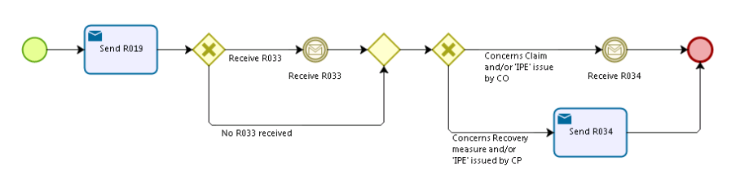

Figure 8: depicts the sub process: 'Receive Contestation from Case Owner'

Counterparty's sub process: 'Reimbursement of costs'
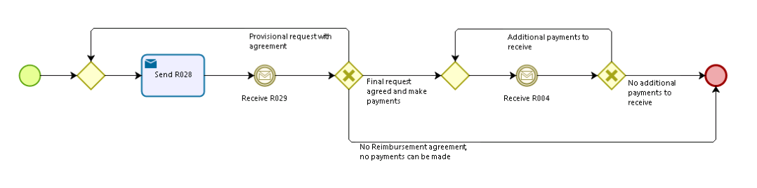
Figure 9: depicts the sub process: 'Reimbursement Request'

Appendices

Issues

# | Issue date | Description | Solution | Close date
1 | 04/05/2015 | Concerning the usage of invalidate SED:  Is this what we want? Should they not just send an updated (valid) R017 to replace the original or a R025 to withdraw the request altogether?  If we agree that the invalid request should be updated with a valid request, then this principle will probably apply equally to branches 18 to 32 below. | It is true that an updated valid SED could be sent in order to replace the original invalid request.  However, as the institution might perhaps not always have immediately the correct information in order to send back the corrected SED, we might still have the choice to immediately send an invalidate SED to inform the other party that the SED should not be considered as valid anymore, which then should leave enough time to provide the corrected information in the new updated SED. | 08/07/2016
2 | 04/05/2015 | Do we need the notification of death sub-process? | The requested authority would do this via an R018. The applicant authority could do it by an amended R017. So, this sub-process H_BUC_07 has not been included in this BUC. | 08/07/2016

