TECHNICAL SPECIFICATION FOR PRODUCTS AND SERVICES

DESCRIPTION OF THE SUBJECT OF THE CONTRACT

DEFINITIONS
Client means LTG Infra AB.
Supplier means an economic entity, including a natural person, private legal person, public legal person, other organisations and their subdivisions or a group of such persons, with whom the Client concludes the Contract.
Products means the Locomotive Safety System (LSS).
Services means LSS design, installation and training services.
Contract means the Contract concluded between the Supplier and the Client on the Subject of the Contract.

SUBJECT OF THE CONTRACT
  - Road machinery Acquisition of the Locomotive Safety System (the Subject of the Contract).
  - The Subject of the Contract is not subdivided into lots.
  - The groups of products to be purchased are listed in the table below:
Item No | NAME OF THE PRODUCT GROUP / SUBGROUP | Amount
1. | Locomotive Safety System with design installation and training services | 1 set

REQUIREMENTS FOR THE SUBJECT OF THE CONTRACT

  - LSS functional characteristics:
    - Determination of the rolling stock speed and coordinates based on information from satellite navigation systems, speed and track sensors;
    - Generation of the speed limit and speed value using Automatic Locomotive Signalling (ALS), electronic map;
    - Provision of visual and/or audible information in real time to the on-board crew (driver and/or driver's assistant) to ensure traffic safety;
    - Assurance of automatic braking of the rolling stock movement when the instantaneous actual speed is higher than the permissible speed on the current section;
    - Elimination of the possibility of passing a prohibited traffic light or other signalling device;
    - Elimination of unauthorised rolling stock movement (derailment);
    - Monitoring driver vigilance;
    - Recording of vehicle movement parameters on a removable data logger;
    - Assurance of the safe operation of the rolling stock from cabs A and B in the travel direction (two-cab configuration);
    - Reliable operation of the LSS on lines with ALS equipment installed with signal coding frequencies of 25 Hz, 50 Hz and 75 Hz;
    - ALS signal current strength limits on rails:
1.4 A – 25 A AC on electrified sections;
1.2 A – 25 A AC on non-electrified sections.
    - The parameters of the ALS signals shall be as specified in Table 2 of this Technical Specification;
    - The values of the harmonics of the traction current shall be as given in Table 3 of this Technical Specification.

- Table.
ALS signal parameters
Light (code being sent) | Pulse and interval duration, s
KPTŠ-5  Green  Yellow  Red and yellow | 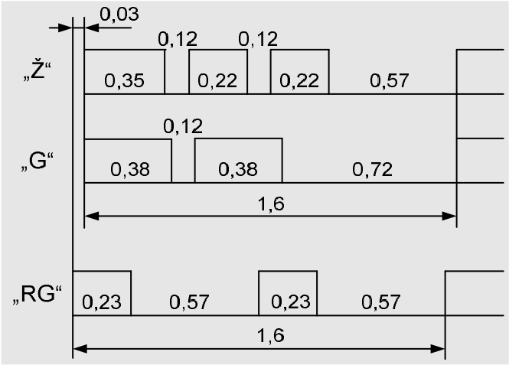
KPTŠ-7  Green  Yellow  Red and yellow | 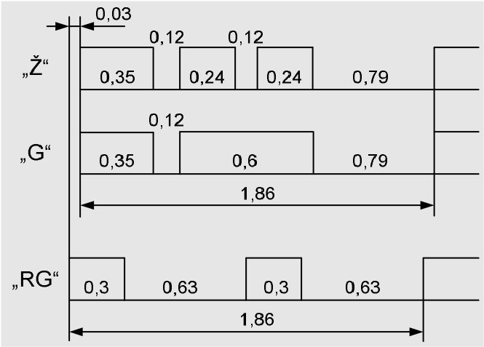
Protection (ARG) | 1  .  2  0  .  4  1  .  6

- Table.
Harmonic values of the traction current
Electrical power supply system | Signal current average frequency, Hz | Frequency band, Hz | Effective value of the current harmonic at continuous impact (more than 0.3 s), A, not more than
25 kV, 50 Hz | 25 | 21-29  15-21 29-35 | 1.0  4.1 4.1
25 kV, 50 Hz | 75 | 65-85 | 1.0

  - The LSS must ensure:
    - Recognition of at least two out of three consecutive code signals of the same code;
    - Automatic or manual selection of the ALS signal frequency;
    - Functioning on both coded and non-coded lines. The transition from coded to non-coded sections may be automatic or manual, while the transition from non-coded to coded sections (in the case of ALS signals) is automatic only;
    - Activation of the on-board traffic light signal corresponding to the code signal being received;
    - Activation of the white light on the locomotive's traffic lights in the event of the loss of code signals or an unrecognisable signal if a Green or Yellow code signal has been received before;
    - Activation of the locomotive's red light in the event of the loss of code signals or an unrecognisable signal if a Red and Yellow code signal has been received before;
    - Activation of a momentary acoustic signal when the locomotive's traffic lights change;
    - Continuous control of speeding above 20 km/h when the red light of the locomotive's traffic light is on;
    - Continuous control of speeding when the red and yellow lights on the locomotive are on;
    - Change of the corresponding on-board traffic light display after a delay of three periods of the code signal sequence (5 to 6 seconds) when the incoming code signal changes or disappears;
    - Control of speeding of the rolling stock based on the ALS code signals received. If the vehicle exceeds the permissible speed according to the corresponding ALS code signal and no action is taken to reduce the vehicle speed to the permissible speed within 7 seconds, the vehicle brakes shall be applied;
    - Setting the permissible speed, taking into account the design speed and the permissible running speed set by the railway infrastructure manager for station and inter-station tracks;
    - Setting the permissible speed according to the values of the on-board traffic lights:
      - Green light (Green code signal) on coded sections/white light on non-coded sections – maximum speed set by the railway infrastructure manager on station and inter-station tracks for the relevant type of vehicles;
      - White light on coded sections – speed not more than 60 km/h;
      - Yellow light (Yellow code signal) – speed set by the railway infrastructure manager, taking into account the characteristics of the track, e.g. the speed set for crossing the turnouts;
      - Red and Yellow lights (Red and Yellow code signal) – speed to be determined by the railway infrastructure manager, taking into account the characteristics of the track and rolling stock, but not exceeding 80 km/h;
      - Red light – speed not more than 20 km/h;
    - Possibility for the driver to change the value of the locomotive's traffic lights from Red Light to White Light, and in the event of the loss of a code signal or an unrecognisable signal, the white light shall be switched on automatically;
    - Activation of the audible alarm when the vehicle exceeds the permissible speed and the vehicle's brakes must be applied if no action is taken to reduce the vehicle's speed to the permissible speed within 7 seconds;
    - Automatic braking of an unauthorised vehicle that is moving (has started moving);
    - Early warning to the driver when the vehicle reaches a speed close to the maximum permissible speed;
    - Ability to enter the data of the railway lines to be used (track number, traffic lights, speed limits, etc.). Based on the data stored in the LSS memory, the braking curves of the rolling stock shall be created and the brakes of the rolling stock shall be applied when the rolling stock exceeds the set permissible speed or the speed allowed in the braking curves;
    - Continuous monitoring of driver vigilance at certain intervals according to the ALS code signals (locomotive traffic light readings) received at vehicle speeds of 10 km/h and above;
    - If the rolling stock is not equipped with an automatic driver vigilance control function, a green check of driver vigilance at regular intervals:
      - Light on coded sections/white light on non-coded sections or white light on coded sections in the event of loss of coded signals or an unrecognisable signal – at least 60-90 seconds;
      - Yellow light for at least 60 to 90 seconds at speeds up to 80 km/h and at least 30 to 40 seconds at higher speeds;
      - Red and yellow lights for at least 30-40 seconds;
      - Red and yellow lights on station tracks for at least 15-20 seconds;
    - Recording and preserving key information;
    - Driver identification data;
    - Dates (year, month, day);
    - Actual time;
    - Train number;
    - Rolling stock number;
    - Type of vehicle;
    - Length of the trainset (number of axles);
    - Length of the trainset (in conventional wagons);
    - Weight of the trainset (tonnes);
    - Ordinates of the location of the rolling stock;
    - Track number;
    - Direction of travel;
    - Distance travelled;
    - Permissible speed limit;
    - Actual speed;
    - Locomotive's traffic light readings;
    - Mode of operation (train/manoeuvre/dual traction);
    - Air pressure in the brake line (brake cylinders);
    - Availability of EAV power supply;
    - EAV key position;
    - State of the driver's control;
    - Activation of the telemechanical driver vigilance monitoring system;
    - Frequency of driver vigilance checks;
    - Driver's actions and ordinates for changes in the status of the LSS equipment (change of the locomotive's traffic lights, use of audible warning devices, etc.);
    - LSS interface language: Lithuanian, English;
    - Possibility of future expansion of the system for secure data reception and transmission over the GSM-R radio channel.
  - The following maintenance equipment shall be provided with the LSS to ensure the performance of the functions:
    - Equipment for reading and decrypting information from the data logger (1 pc.);
    - Software for analysing rolling stock control data (1 workstation);
    - Emergency back-up set for restoring equipment operation (1 set).
  - Technical requirements
Item No | Technical and functional requirements | Size, condition
- LSS set
1.1. | Driver's display | LCD anti-vandal display with touch control (one display in each driver’s cab).
1.2. | Registration block | Must ensure the recording of vehicle movement parameters, driver actions and diagnostic data in a removable data logger and in an internal non-volatile memory (one logging unit in each driver's cab).
1.3. | Movement Parameter Data Logger | For recording driver actions and diagnostic data.
1.4. | Vigilance buttons | Two buttons in each cab.
1.5. | Power units | For changing the input voltage of the on-board mains to the output voltage supplying the LSS components, electrical pneumatic equipment, discrete signal reception circuits.
1.6. | Pressure sensors | For measuring pressure in brake cylinders (one sensor), brake bus (one sensor), power bus (one sensor).
1.7. | Track and speed sensor or turning angle sensor | For determining speed and distance, mounted on the vehicle's axle box, installed 2 pcs.
1.8. | ALS signal receiving coils | For the reception of ALS code signals (two coils are installed at each end of the vehicle under the body, above the rail head).
1.9. | EAV – Electric Air Valve | For ensuring the automatic braking function.

  - LSS design, installation and staff training:
    - The Supplier must be the producer and manager of the LLS software code and the code must be developed in accordance with secure programming principles.
    - The LLS must be able to update the software.
    - Protection of enclosures and equipment housings not lower than IP54 inside the driver's cab and not lower than IP56 outside.
    - Protection of safety-critical items from unauthorised access (sealing);
    - Vibration protection shall comply with EN 50155 or equivalent standards.
    - Electromagnetic emission level and immunity to interference of the LSS according to EN 50121-4AC or equivalent standards.
    - Electromagnetic compatibility of the LSS when operating on rolling stock in accordance with the requirements of EN 50121-3-1:2006 or equivalent standards.
    - The LSS or its components shall be robust, durable, functional, reusable and/or easily repairable and/or replaceable.

DOCUMENTS SUBMITTED TOGETHER WITH THE TENDER

  - Name and full address of the manufacturer and/or its authorised representative (to be indicated on the Tender Form).
  - If the Contract does not require the submission of documents proving the conformity of the Products with the requirements, the Buyer shall have the right to require the submission of documents proving the conformity of the Products at any time during the execution of the Contract.
  - Supplier's declarations of compliance with national security requirements (Annexes V and VI to the Tender). When verifying the compliance of the Tender with the requirements of the Procurement Conditions, including the confirmations declared by the Supplier, the LTG shall be entitled to request from the Supplier other documents and data to substantiate the compliance with the requirements of the Procurement Conditions and the confirmations referred to in its declaration. To be submitted in electronic form.
  - The Supplier shall submit, together with the tender, a test report or certificate from a conformity assessment body established in the Republic of Lithuania, as an appropriate means of demonstrating how the equivalent products offered by the Supplier comply with the requirements or criteria set out in the Technical Specification, the criteria for evaluating tenders, or the terms and conditions of the Contract, and shall also recognise certificates issued by equivalent conformity assessment bodies established in other countries. If the Supplier is unable to obtain the certificates or test reports referred to above, or is unable to obtain them within the time limit due to circumstances beyond the Supplier's control, and proves by objective, written evidence that the Products comply with the requirements or criteria set out in the Technical Specification, with the criteria for evaluating tenders, or with the conditions for the performance of the Contract, the Buyer shall accept other appropriate means. However, self-declarations by the Supplier, where the Supplier is not the manufacturer of the Products, without specific, technical evidence are not considered to be adequate means (all evidence, certificates and other documents must be submitted with the tender).
  - Documents required to be submitted with the products, when handing over the services or works performed:
  - User manual for the proposed equipment (in English and Lithuanian).
  - Product passport / form with the technical description of the LSS, with the exact name and serial numbers indicated on the components of the LSS (in English and Lithuanian, if the document submitted is in another language, a translation into Lithuanian must be provided).
  - Instructions, operating descriptions, drawings, diagrams, characteristics and other explanations necessary to operate, maintain, repair and verify the proper functioning of the LSS (including the Data Logger Decryptor) (in English and Lithuanian).
  - LSS installation instructions (English and Lithuanian).
  - Staff training programme.
  - Test programme and methodology.
  - Valid initial verification certificates for the LSS equipment subject to metrological verification.
  - LSS electromagnetic compatibility certificate.
  - Document certifying that the LSS has been tested and is suitable for use on an electrified railway (TNN, Annex 24, point 11).
  - Certificates of compliance issued to trained staff.
  - Software on a digital storage medium.
  - Product / Service Handover and Acceptance Certificates.

FULFILMENT OF OBLIGATIONS

PROCEDURES FOR THE DELIVERY OF PRODUCTS / SERVICES
  - The self-propelled special rolling stock (SSGR) design for the installation of the LSS shall be carried out by the Supplier within 15 calendar days of the entry into force of the Contract, after the necessary technical parameters and solutions have been agreed with the Client, who shall provide all available technical documentation for SSGR and unrestricted access to SSGR in order to allow a proper assessment of the scope of the future works.
  - The LSS and its maintenance equipment shall be delivered to Vilkpėdės g. 2B, Vilnius (check before delivery) for installation in SSGR no later than 30 calendar days after the entry into force of the Contract.
  - The installation, training and static and dynamic testing of the LSS in SSGR shall be carried out by the Supplier in accordance with a service schedule mutually agreed between the Supplier and the Client, but no later than within 45 calendar days after the entry into force of the Contract.
  - The installation of the LSS in SSGR shall be carried out by the Supplier at the Client's technical base (Vilkpėdės str. 2B, Vilnius).
  - The Supplier shall provide the Client with a training programme for technical and operational staff no later than within 15 calendar days after the entry into force of the Contract.
  - The Supplier shall train the Client's personnel (SSGR drivers and service personnel) to operate, service and repair the LSS independently, and issue certificates of compliance to the trained personnel, in accordance with a schedule mutually agreed between the Supplier and the Client, but no later than within 15 calendar days after the installation of the LSS in SSGR.
  - The Supplier shall not be entitled during the performance of the Contract to supply products or services which do not comply with the requirements of the Procurement Documents and/or the supply of which is restricted due to international sanctions (as defined in the Law on International Sanctions of the Republic of Lithuania) and/or due to their threat to the national security, as defined in the Procurement Documents and in the Republic of Lithuania Law on Public Procurement/ the Republic of Lithuania Law on Procurement by Contracting Entities in the Water Management, Energy, Transport and Postal Services Sectors.
  - The Supplier must inform the Buyer in writing (by e-mail) of the country of origin of the Products ordered and the manufacturer of the Products (name, legal entity code, country of registration) no later than within 1 (one) working day after receipt of the order, before the order is fulfilled. The provision of this information is included in the lead time.
  - The Supplier shall deliver a test programme and methodology, agreed in advance with the Client, no later than within 15 calendar days after the entry into force of the Contract.
  - After the installation of the LSS in each SSGR unit, static and dynamic tests of the LSS shall be carried out on the Lithuanian railway infrastructure within a maximum of 15 calendar days.
  - The test drives shall be carried out in accordance with a test drive programme drawn up by the Supplier and agreed in advance with the Client.

PROCEDURE AND DEADLINES FOR RECTIFYING DEFECTS
  - Defects in the Products shall be rectified no later than within 10 (ten) calendar days from the date of the Buyer's e-mail notification.
  - A minimum 24-month warranty period for the VMS with a valid metrological verification of the complex. The guarantee period shall start from the end of the installation phase of the specific LSS upon signing of the service acceptance certificate.
  - If the last day of the period for delivery of the Products or rectification of defects in the Products falls on a day other than a working day or an official holiday, the end of the period shall be deemed to be the following working day. Public holidays and non-working days (Saturdays and Sundays) shall be counted as part of the time limit for delivery of the Products or rectification of defects in the Products.
  - During the test runs, all technical and system deficiencies in the LSS shall be addressed by the Supplier.
  - If thelast day of the period for the provision of the Services or a phase thereof (if applicable) or for the rectification of defects in the Services or a phase thereof (if applicable) falls on a day which is not a working day or an official holiday, then the end of the period shall be deemed to be the next working day. Public holidays and non-working days (Saturdays and Sundays) shall be counted towards the time limit for the provision of the Services or a phase thereof (as applicable) or the rectification of defects in the Services or a phase thereof.
- ANNEXES
Annex 1. - Environmental (green) criteria

Annex 1 - Environmental (green) criteria

ENVIRONMENTAL (GREEN) CRITERIA

No. | Requirement | Documents
1. | Where the object to be procured is not included in the list of products for which minimum environmental criteria have been set (4.4.4. of the Descriptions), the environmental criteria may be determined independently according to one of the environmental principles:  * less consumption of natural resources in the production and/or supply of the good, service or work.
1. | During the performance of the Contract, no paper forms will be used, all documents will be submitted electronically, and communication between the Customer and the Service Provider will be carried out electronically (by telephone, e-mail, etc.); | Not applicable

