KU5 Annex to the Competition Brief

INTERNATIONAL OPEN ARCHITECTURAL COMPETITION FOR THE VILNIUS CONGRESS CENTRE
INTEGRATION OF THE ARCHITECTURAL CONCEPT INTO PHOTO PANORAMAS
The competition participants must insert their proposed design solutions into the required photo panoramas. Participants may, at their discretion, crop the size of each photo insignificantly only for layout purposes in the exposition boards. The mandatory photo panoramas are provided in the Annex KU4 folder.
Visualizations of Photo Panoramas No.2, No.5, No.4 and No.6 must be prepared at a high level of detail.
Visualizations of Photo Panoramas No. 1, No. 3, must be prepared at a lower level of detail, showing non-detailed (conceptual) design shapes (clay models).
Please use the photo panoramas as it is provided, without modifying them (do not change proportions or resolution or use other forms of visual manipulation). Only insignificant cropping is allowed.
Extra photo panoramas and pictures taken by the participant may also be used in addition to mandatory. Participants are allowed to select other photos at their own discretion.

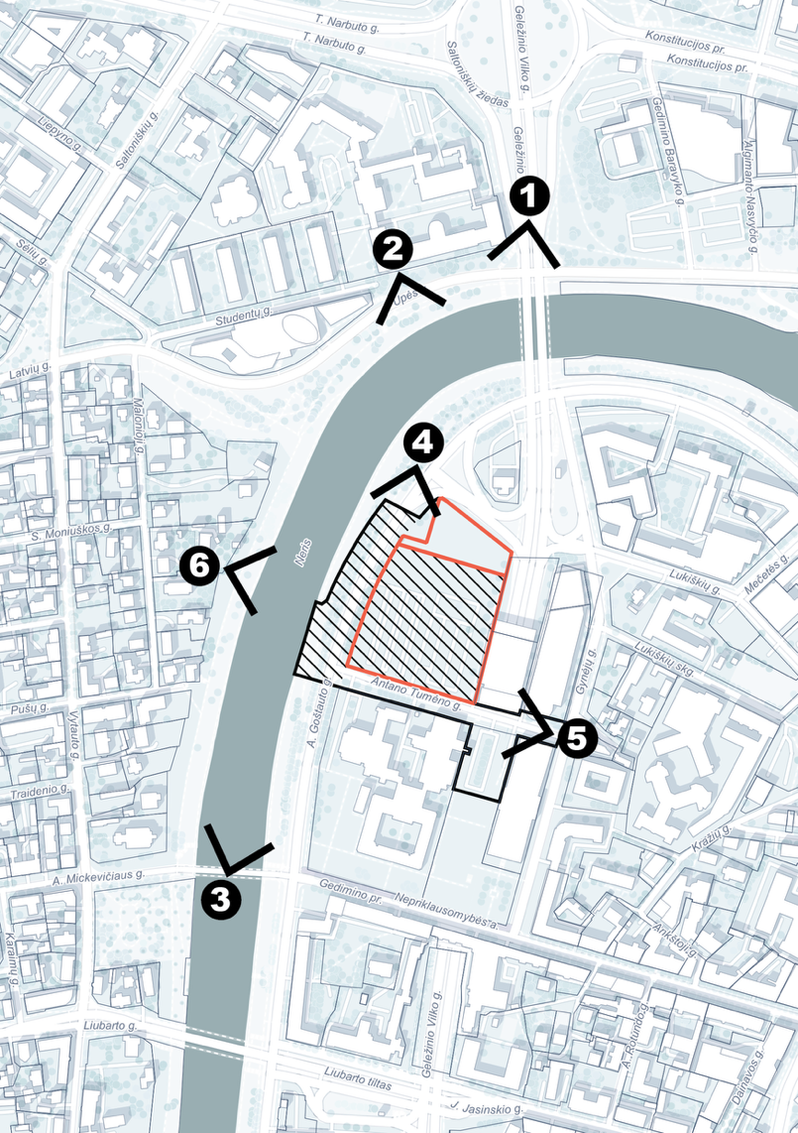
Diagram of mandatory photopanorama points.

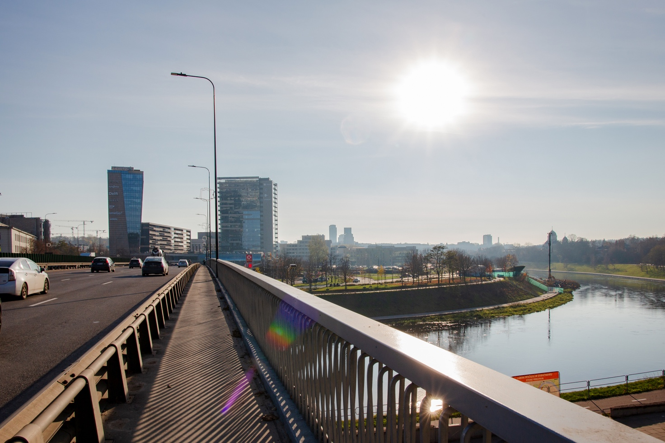
Mandatory photo panorama No. 1 (Visualization of low level of detail)

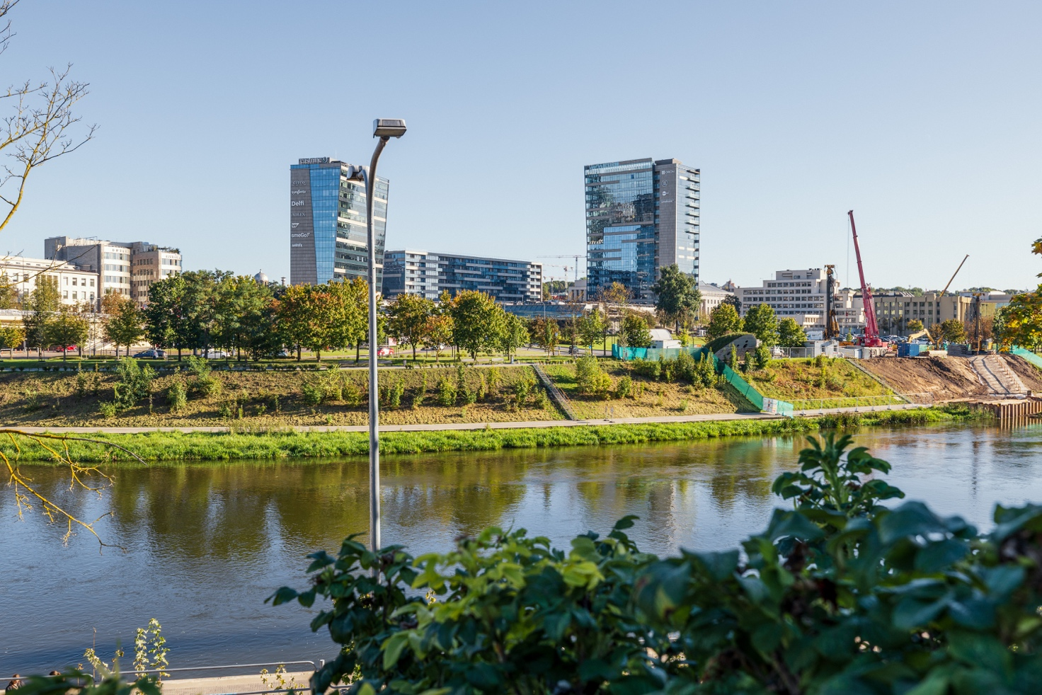
Mandatory photo panorama No. 2 (Visualization of high level of detail)

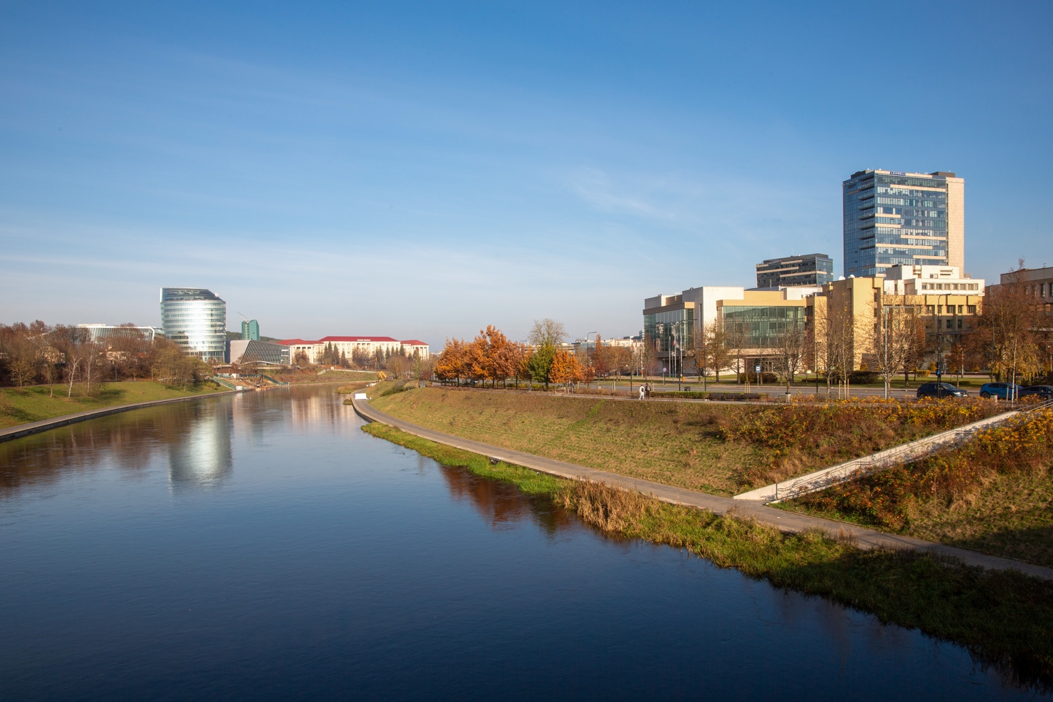
Mandatory photo panorama No. 3 (Visualization of low level of detail)

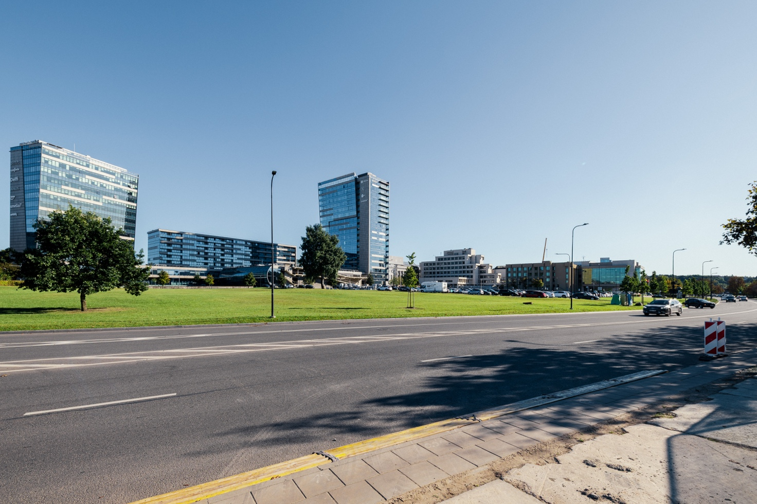
Mandatory photo panorama No. 4 (Visualization of high level of detail)

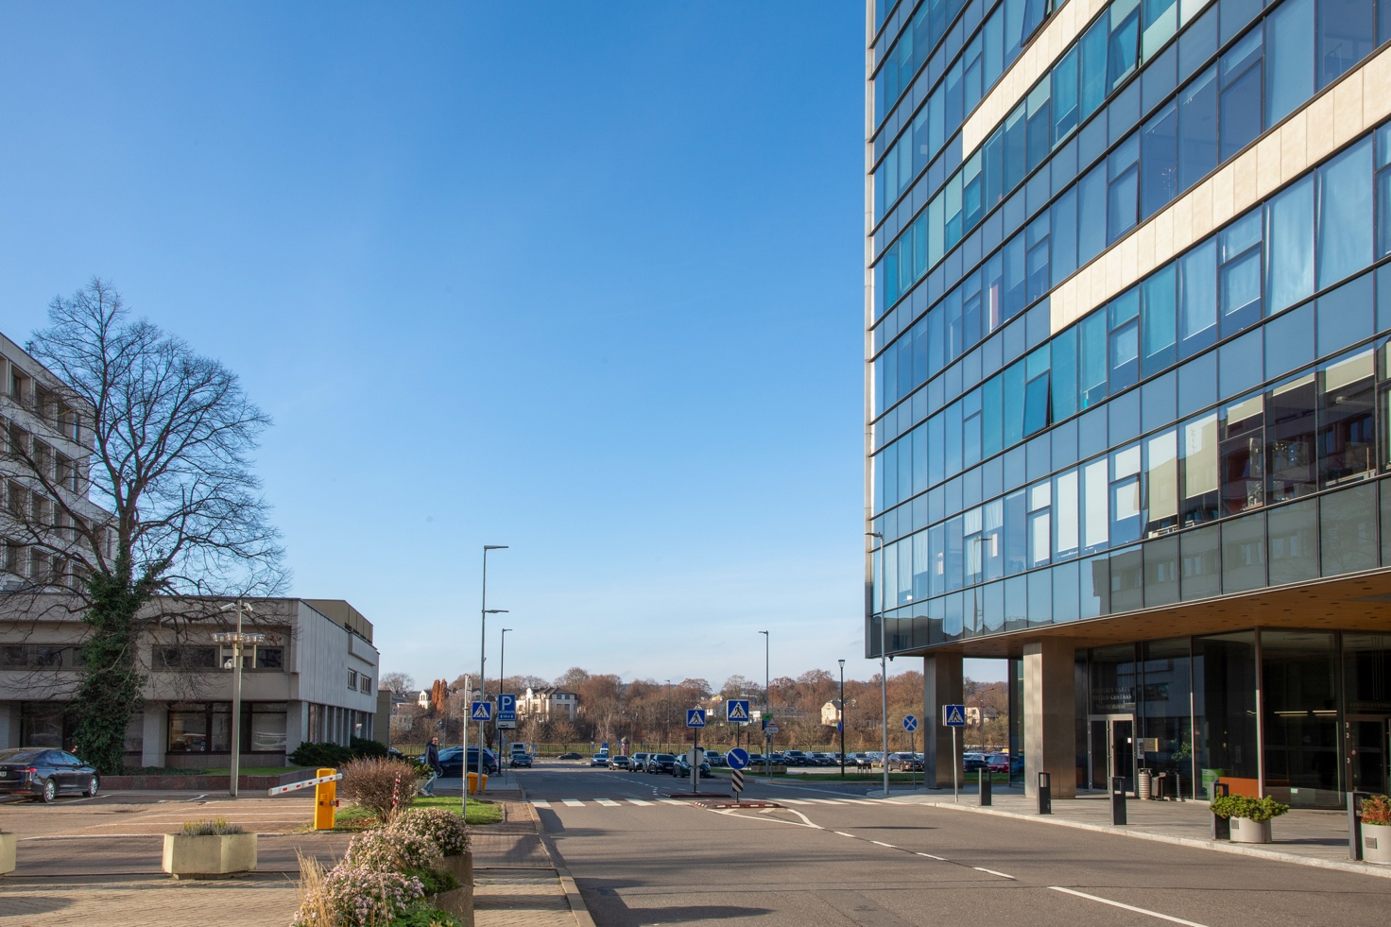
Mandatory photo panorama No. 5 (Visualization of high level of detail)

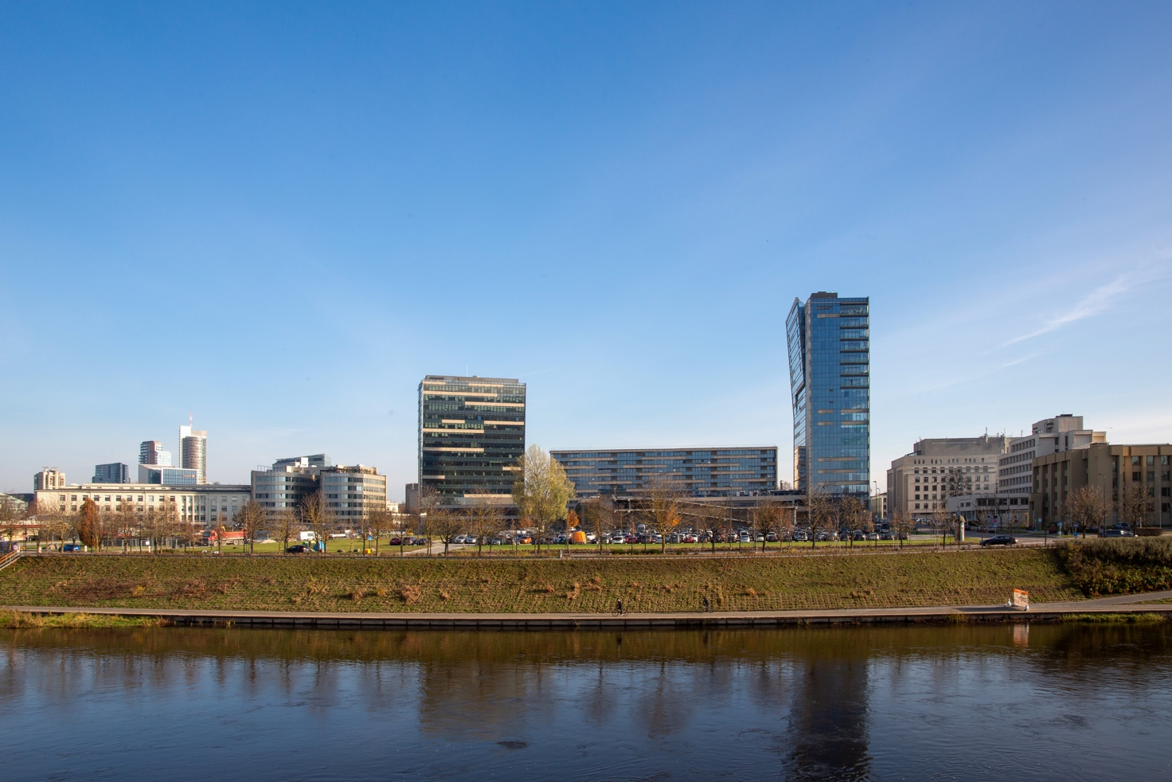
Mandatory photo panorama No. 6 (Visualization of high level of detail)

