Annex 2 to the Procurement Conditions

ARCHITECTURAL DESIGN COMPETITION FOR THE VILNIUS CONGRESS CENTRE

PRICE OFFER
(to be submitted in the first CVP IS Envelope 1)

(Date)

Participant identifier

We confirm our acceptance of all conditions of the competition documents and offer to provide the following services:

Objects of the procurement:

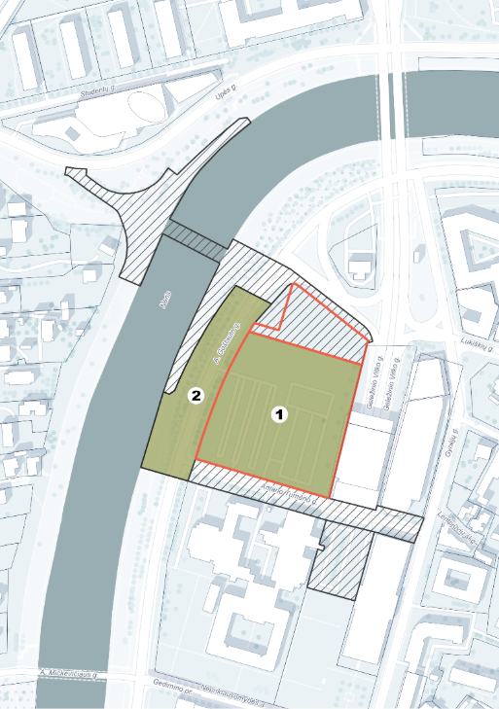

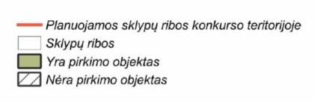

- Part 1 of the Price Offer: The Price Offer for the design of the Vilnius Congress Centre building for administrative use with access routes on A. Goštauto Street, Vilnius:

Service Delivery Stage | We recommend that the cost of the components of the Service Delivery Stage does not exceed the specified percentage of the total cost of this stage (Price Offer, Section A)* | Price excl. VAT, EUR | VAT, EUR | Price incl.  VAT, EUR
Preparation of design proposals  BIM (LOD200), obtaining a building permit or other legally required document authorising the works | 20–30 % | [sum] | [sum] | [sum]
Preparation of the technical working design BIM (LOD350–400) | 60–70 % | [sum] | [sum] | [sum]
Project implementation supervision | 15 % | [sum] | [sum] | [sum]
Total service cost for Section A of the Price Offer:

- Part 2 of the Price Offer: The Price for the design of the redevelopment of the Neris waterfront adjacent to the Vilnius Congress Centre and site improvement:

Service Delivery Stage | It is recommended that the cost of the components of the Service Delivery Stage does not exceed the specified percentage of the total cost of this stage (Price Offer, Section B).* | Price excl. VAT, EUR | VAT, EUR | Price incl.  VAT, EUR
Preparation of design proposals  BIM (LOD200), obtaining a building permit | 20–30 % | [sum] | [sum] | [sum]
Preparation of the technical working design BIM (LOD350–400) | 60–70 % | [sum] | [sum] | [sum]
Project implementation supervision | 15 % | [sum] | [sum] | [sum]
Total service cost for Section B of the Price Offer:

*Payments for services will be made according to the schedule and terms stipulated in the contract; therefore, when submitting the stage costs, due consideration must be given to this, and significant deviations from the recommended percentages should be avoided.

TOTAL PRICE OF THE PROPOSAL
(Included as Criterion C of the evaluation under the Procurement Conditions)
Service Delivery Stage | Recommended percentage of the total price of the proposal: | Price excl. VAT, EUR | VAT, EUR | Price incl.  VAT, EUR
Section A of the Price Offer | Approx. 90–95 % | [sum] | [sum] | [sum]
Section B of the Price Offer | Approx. 5–10 % | [sum] | [sum] | [sum]
1) Total service price excluding VAT, EUR (in numbers and words)
(Evaluation Criterion C)
2) VAT on the total service price, EUR (in numbers and words)
3) Total service price including VAT, EUR (in numbers and words)

The proposal price (including all cost components and surcharges, if any) must be stated with the accuracy of no more than two decimal places.

The proposed price must include all taxes payable by the Supplier and all expenses incurred by the Supplier related to the performance of the procurement contract, including submission of payment documents via SABIS.

- General comments: The 1st place winner will, during confidential negotiations, provide written justification for their proposed service prices, based on analogous projects or other means.
- The proposed services fully comply with the requirements specified in the Procurement Conditions.
- The total estimated value of services to be provided by the Supplier, partners of the group of suppliers and subcontractors must encompass the total proposal price in EUR including VAT.
- In cases where, under applicable legislation, the Supplier is not required to pay VAT, the Supplier shall state prices excluding VAT, leave the corresponding rows in the table blank, and indicate the reasons for not paying VAT.
- The proposal shall remain valid until the end of the deadline specified in the Competition Conditions.
- When submitting the proposal, the Supplier must assess all necessary parts of the project and all surveys required for project preparation, including, but not limited to, traffic flow studies and traffic flow modelling required for the preparation of transport solutions falling within the building footprint and required according to the Supplier’s architectural concept. Where necessary, the Supplier may, at its own discretion (if, having assessed the additional information available from the Contracting Authority during the Procurement or during the design process, it considers that such information is insufficient), conduct additional surveys: geodetic, topographic, preparation and coordination of topographic image, geological, geotechnical, audit of existing utility systems, and other mandatory investigations required by the nature of the services, as well as all other mandatory investigations required by legislation for the preparation of the design. The Supplier shall not be required to self-assess studies and investigations the necessity of which could not reasonably have been anticipated at the time of submission of the proposals, such as archaeological investigations, servitude registration, or eco-geological surveys.
- When submitting the proposal, the Supplier must ensure that the technical working design documentation shall comprehensively define the quality parameters of the construction materials and/or works intended for project implementation, without restricting competition among potential suppliers and/or contractors; i.e. an option to choose from no fewer than 3 (three) suppliers/contractors must be ensured. These services must also include, if required by the Contracting Authority, preparation of responses to questions submitted by suppliers concerning design services, for future contractors during the procurement of construction works.
- The requirements for the level of detail of the BIM for each project stage and for each part of the project may be coordinated separately during the design process.
- Along with this Price Offer, the documents submitted electronically are specified in Section 4.8 of the Special Procurement Conditions.

The Supplier, when submitting their proposal, must ensure that the technical design comprehensively defines the quality parameters of the construction materials and/or works intended for project implementation, but without restricting competition among potential suppliers and/or contractors; i.e. the option to choose from no fewer than 3 (three) suppliers/contractors must be ensured. These services also include, if required, preparing responses to questions submitted by suppliers concerning design services, for future contractors during the procurement of construction works.

