Document templates and forms
Note. All annexes will be provided at the time of signature of the contract.

ROUTE SCHEDULE FORM

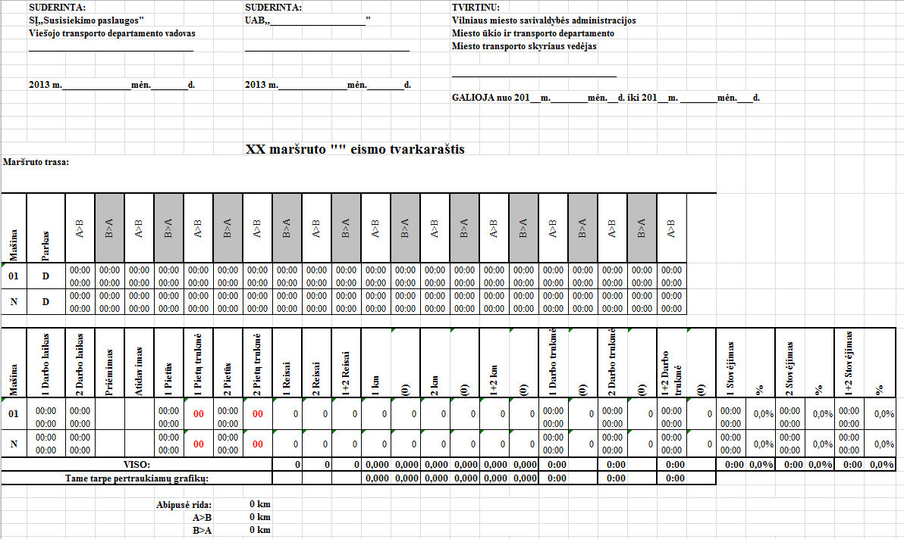
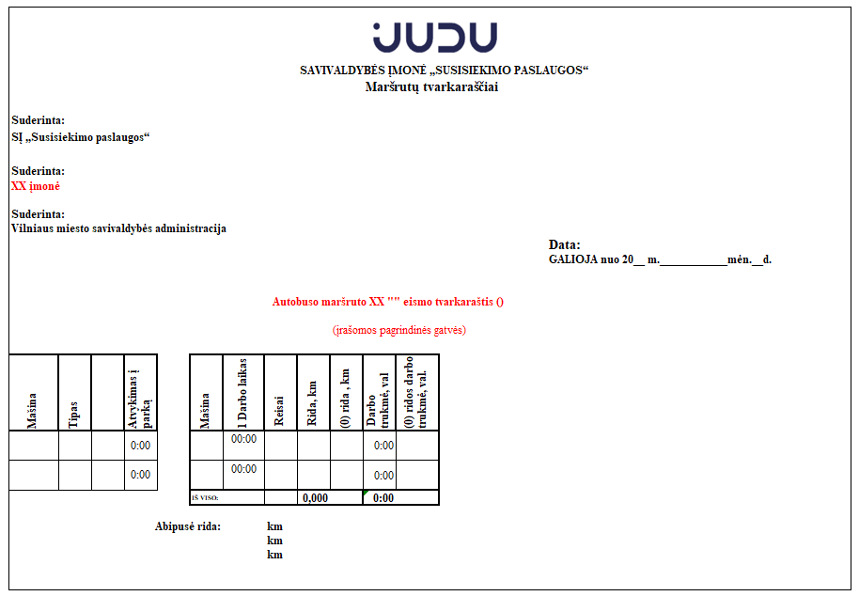

FORM FOR MEASUREMENT REPORTING

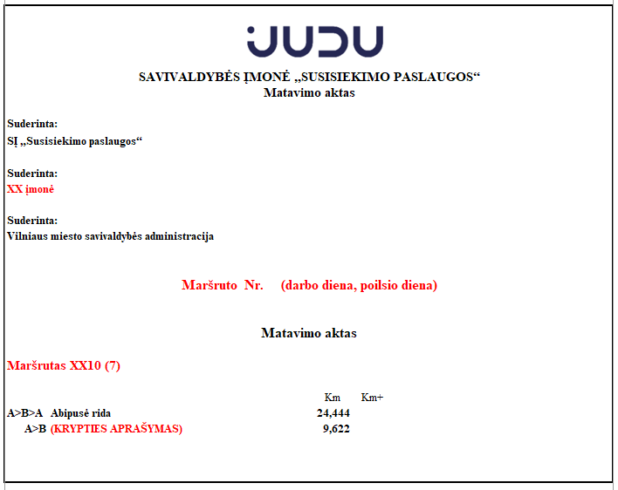

BOOKING PUBLIC TRANSPORT TICKETS

__/________/201___ ..............
 | (date of booking)
No. | Ticket type | Ticket price | Quantity | Amount
Total: |  |  | 0 | 0.00
 |  | (full name, position, signature)

Carrier's breach report. Penalty deed

Agreed | Agreed
"Susisiekimo paslaugos” SĮ | " “ UAB

CARRIER'S BREACH REPORT. PENALTY DEED

Reporting period Month 20XX

No. | Breaches | Penalty, EUR | No of breaches | Total penalties, EUR
1 |  |  | 0 | 0
 |  | Total: | 0 | 0

Authorized Body’s specialist in charge:

Carrier's specialist in charge:

Municipality Authorized body Carrier

_______________________ _______________________ _______________________

