Communication of the TRAFFIC MANAGEMENT CENTRE of the Authorized Body with the carriers and drivers working in the public transport system

  - The Traffic Management Centre of the Authorized Body (hereinafter ‘the TCC’) coordinates public transport traffic in the territories of the city of Vilnius and neighbouring municipalities.
  - In carrying out its functions, the TCC closely cooperates with dispatchers of carriers, drivers of public transport vehicles, technical services and other special services responsible for traffic safety and public order.
  - Functions of the Traffic Management Centre:
  - To monitor and coordinate the traffic of public vehicles and control the provision of services by carriers in the city's public transport system, i.e. control how the carrier complies with the schedules and routes provided by the Authorized Body and other provisions of the Contract related to the functions of the Traffic Management Centre.
  - To coordinate public transport traffic by giving instructions to the Carrier's drivers regarding route changes during atypical situations.
  - Control the departures of vehicles from the terminal points/stops and the further progress of the routes and give instructions to the Carrier's drivers on these issues
  - To coordinate public transport traffic according to the information received from the responsible persons and drivers of carriers in the city's public transport system.
  - To coordinate and carry out route changes of public transport routes during atypical situations.
  - To respond promptly to changing actual traffic conditions for public transport traffic (e.g.: deteriorating weather conditions, obstacles on the road) and inform thereof the relevant services and, if necessary, the driver(s) of the Carrier.
  - If it is necessary to call special, etc. services in case of traffic accidents.
- The TCC communicates with the Carrier's drivers by means of communication.
- The Carrier must ensure that all vehicles have mobile phones and hands-free equipment, and the Carrier's drivers must be connected to the E-Ticketing system of the Authorized Body during working hours.
- The Carrier’s persons in charge must provide information on the release of public transport vehicles to the routes every day. The information must be provided indicating whether the routes are served by the number and type of vehicles predetermined by the Authorized Body. In cases where the Carrier releases a smaller number of vehicles on the routes and a different type of vehicles than specified by the Authorized Body, the Carrier shall inform the representatives of the Authorized Body (see Figure 1) about the reasons for not ensuring the release of sufficient number of PT vehicles and indicates when the reasons will be removed.
- Every day, the Carrier’s persons in charge enter in the system administered by the Authorized Body or in another alternative system the data on the assignment of PT vehicles to routes for each day (when planning a day ahead) and other relevant information specified by the Authorized Body.
- TCC communication procedure with the Carrier's drivers:
  - Communication between the Authorized Body and the driver(s) of the Carrier takes place via means of communication and/or the system administered by the Authorized Body.
  - TCC shall immediately notify the Carrier's drivers of the following information:
    - About an atypical situation on the route that affects public transport traffic (e.g. traffic accident, blocked road and no way to pass, etc.) and give instructions to the driver regarding the execution of the route.
    - About temporary changes to the route and to give instructions to the driver(s) regarding the change of the route and its implementation.
    - About additional stops at public transport stops when travelling along the route of the changed route.
    - Other information related to changes in public transport work organization or information transfer to the Carrier's driver.
  - The drivers of the Carrier must report information to the TCC on:
    - atypical situation(s) on the route that affects public transport traffic (traffic accident, blocked road, no way for public transport to pass, etc.);
    - cases of changes in the vehicle's technical condition and breakdowns;
    - cases of an accident or hooligan attack in a vehicle;
    - cases of impaired health of the driver or passenger;
    - in other cases, when the driver has questions about the execution of the route;
    - cases of damage to the stop or other PT infrastructure (e.g. broken stop road sign, broken pavilion glass, torn schedule, etc.).
    - about the condition of the road surface of the route (e.g. dirty, dusty road surface, damage to the surface, obstacles on the road.
    - And in other cases related to public transport traffic.

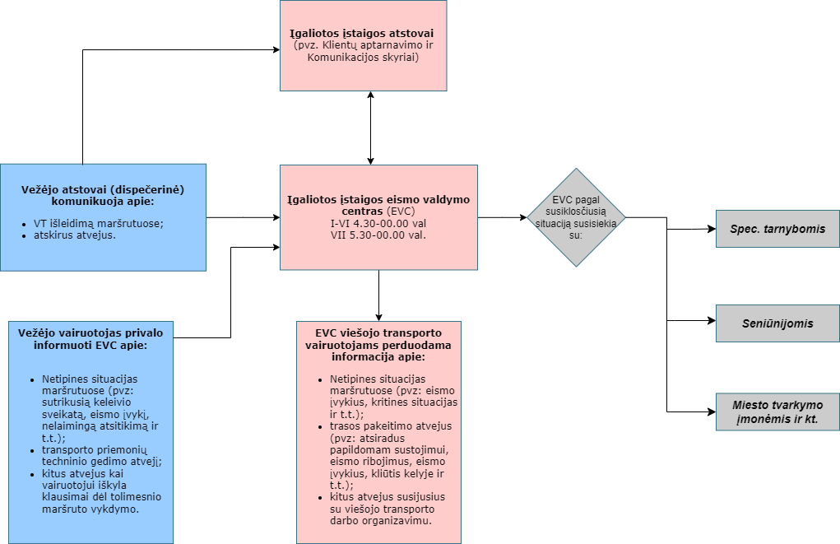
Figure 1. TCC communication procedure with the Carrier's drivers:

Municipality Authorized body Carrier

_______________________ _______________________ _______________________

