Requirements for the provision and quality of passenger transportation services

Public passenger transportation services must be provided and public transport activities must be organised in accordance with European Union, national and local legislation defining the requirements for passenger transportation services and quality. In the event of a change in any legal act, the current version of the legal act shall prevail during the performance of the Contract.
- Requirements for vehicles used for passenger transportation services
  - General requirements for vehicles:
    - The Carrier must use vehicles insured against civil liability during the period of validity of the Contract.
    - Vehicles used for passenger transportation services must be registered in the Republic of Lithuania.
    - Vehicles used for passenger transportation services must be issued with state registration certificates, copies of licences and compulsory road worthiness test reports, and other documents required by law.
    - The requirements for the cleanliness, appearance, road worthiness and presentation of the vehicles during the performance of the Contract shall be in accordance with the requirements laid down in this Annex and in the technical specification for vehicles.
  - Requirements for the cleanliness of the exterior and interior of vehicles. Vehicles shall leave for the first stewarding trip of the route clean inside and out. Cleanliness inside the vehicle must be maintained throughout the entire working route, i.e. from the first to the last trip. Vehicles must undergo daily, periodic and general cleaning.
    - Daily cleaning of vehicle:
              - Daily cleaning of vehicles must be carried out every day after the vehicles have finished working on the routes. Daily cleaning must include a wet wash of the vehicle bodywork.
              - Daily cleaning must include cleaning of the vehicle interior: all passenger seats, window panes, frames, all passenger touch surfaces (e.g. composters, handles, grab rails, handrails, armrests, etc.), wiping and cleaning of the floor, and removal of dust and other dirt from all elements of the vehicle interior. All passenger touch surfaces (e.g. composters, handrails, handholds, handrails, handrails, armrests, etc.) must be disinfected.
              - All stickers not provided for in this Annex shall be removed from the interior of the vehicle. At the end of the daily cleaning, the condition of the vehicle interior (interior) and exterior stickers specified as mandatory in this Annex shall be checked.
              - In case of peeling of the internal and external stickers, the Carrier must replace them with new stickers during the same cleaning, provided that the Authorized Body has supplied the necessary number of stickers. Otherwise, upon receipt of the sticker refill from the Authorized Body, no later than within 3 (three) working days.
              - The fact of daily cleaning of the vehicle shall be recorded in a logbook or equivalent document (electronic or hard copy) and shall be made available to the Authorized Body within 1 (one) working day upon request.
    - Periodic cleaning of vehicles:
- Periodic cleaning of vehicles must be carried out at least 2 (two) times per calendar month. At least 10 (ten) calendar days must have elapsed since the last periodic cleaning of the vehicle.
- Periodic cleaning shall include all the daily cleaning procedures specified in 1.2.1. In addition, this cleaning shall include the use of cleaning agents to remove soiling of the passenger compartment elements not removed by routine cleaning procedures, cleaning of soiled passenger compartment floors, passenger seats, smudged windows, chewing gum etc.
- Graffiti or other visual contamination shall be removed from the surfaces of the passenger compartment elements (e.g. seat backs, handles, walls, etc.).
- Disinfection of the entire vehicle compartment must be carried out.
- The fact of periodic cleaning of vehicles shall be recorded in a logbook or equivalent document (electronic or paper) and shall be made available to the Authorized Body within 1 (one) working day upon request.
    - General vehicle cleaning:
- General cleaning of vehicles must be carried out every 60-65 calendar days. During the general cleaning, the daily and periodic cleaning procedures must be carried out first.
- This shall be followed by an additional wash of the vehicle ceiling and, if the vehicle structure contains a bus trailer coupling, the coupling and the elements of this coupling shall be cleaned.
- All passenger seats and other fabric surfaces in the cabin shall be dry-cleaned.
- The fact of general cleaning of vehicles shall be recorded in a logbook or equivalent document (electronic or paper) and, upon request, shall be made available within 1 (one) working day to the Authorized Body.
    - Keeping the vehicle clean between journeys. At the last stop of the route, the interior of the vehicle must always be searched for rubbish and passengers' belongings. This does not apply if the Carrier's driver is late in leaving the departure/end stop of the route, but even in this case the driver has to make sure that there are no persons or passengers' belongings in the vehicle.
    - The interior fittings (e.g. handrails, seats, fixings for disinfectant containers, backrests, etc.) in vehicles must be in good working order and must not endanger the safety of passengers. All interior and exterior surfaces must be visually clean, painted and free from corrosion. The windows of the vehicle must not be scratched, marked, etc. Scratched glass is defined as glass with a scratched area of 20 (twenty) per cent or more of the total area of the glass, or with drawings/symbols engraved on the glass, irrespective of the scratched area, which are contrary to public order or good morals.
    - The following figures give examples of proper and improper cleaning of the vehicle.
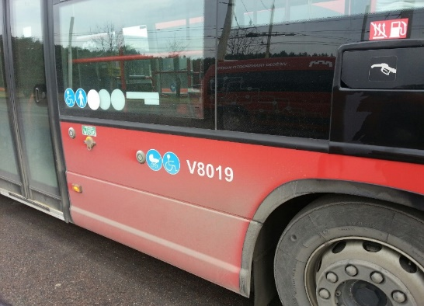 |  | 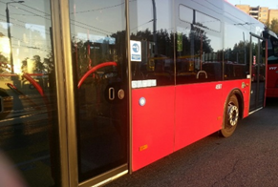
Figure 1. Dirty vehicle bodywork. There are obvious signs of dirt above the wheel arches and the passenger entry/exit doors. |  | Figure 2. Clean vehicle bodywork.
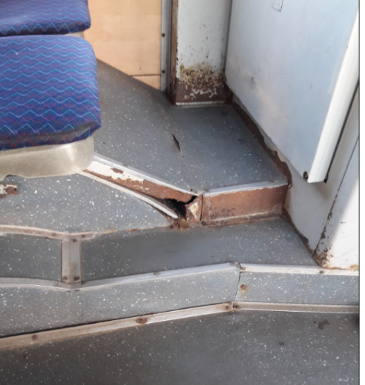 | 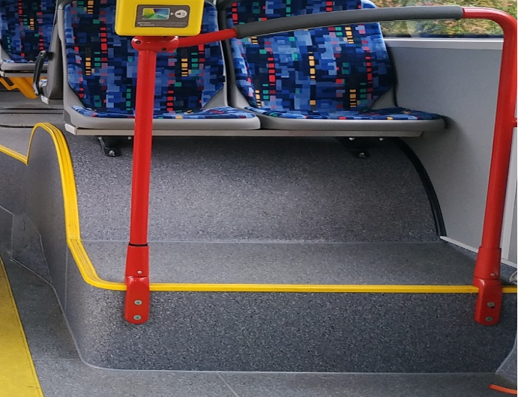
Figure 3. Corroded, untidy and aesthetically unpleasant elements of the vehicle interior | Figure 4. The interior of the vehicle is in good order.
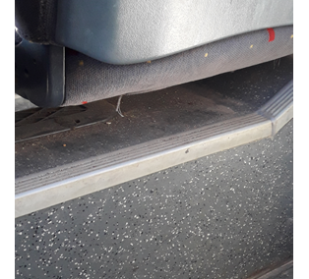 | 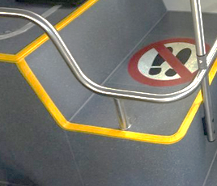
Figure 5. Dust in the vehicle interior. Dust must also be cleaned in hard-to-reach areas of the vehicle interior. | Figure 6. The cabin is clean, the floor has been swept and there is no dust on the passenger compartment.
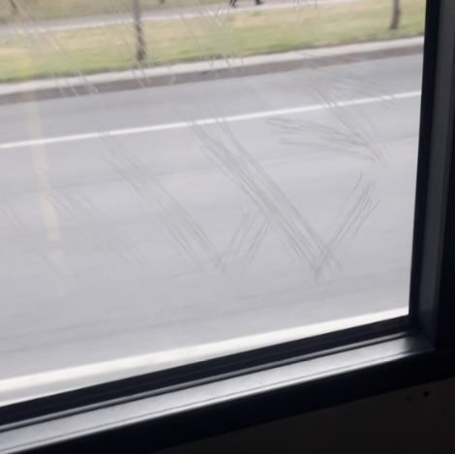 | 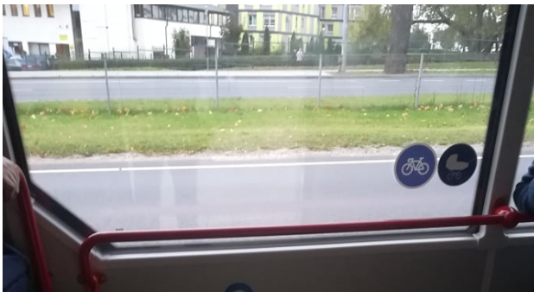
Figure 7. Scratched passenger compartment windowpane. | Figure 8. Passenger compartment windowpane is clean and not damaged.

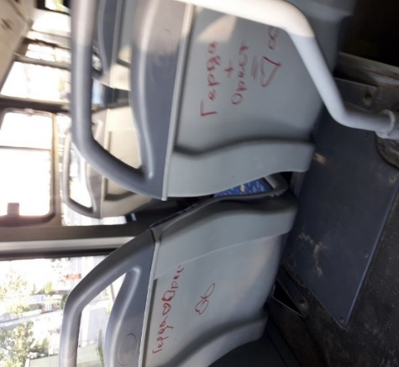 | 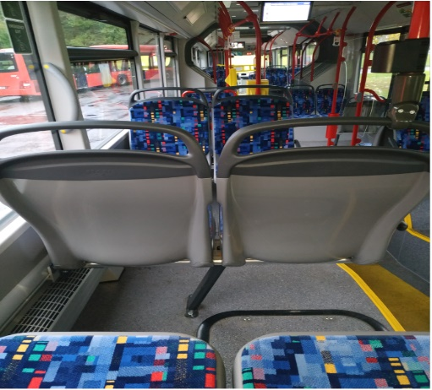
Figure 9. The passenger compartment of the vehicle is stained with graffiti and other visual contamination. | Figure 10. The interior of the vehicle shall be clean and free from any stickers, graffiti or other soiling of the surfaces of the passenger compartment not covered by this Annex.

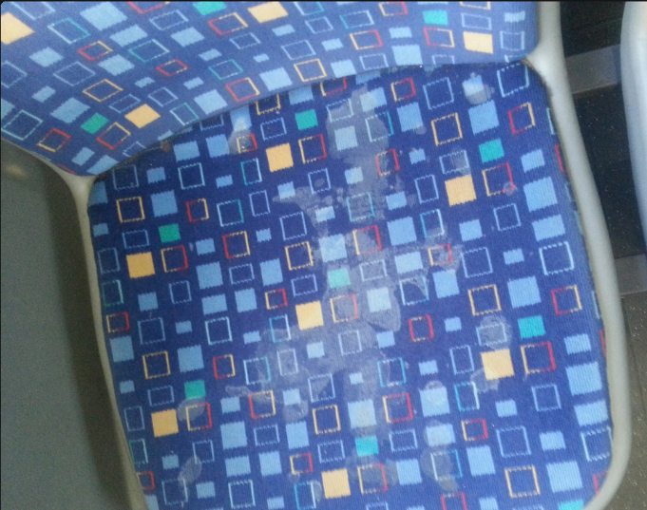 | 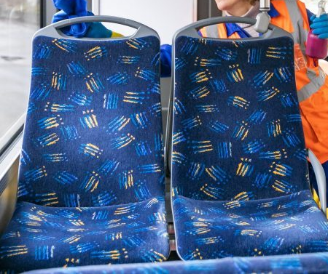
Figure 11. Soiled passenger compartment seat. | Figure 12. Passenger seats are clean and free from surface contamination.
    - Vehicle interior disinfection:
      - Disinfection of vehicles is mandatory. The compulsory disinfection of vehicle handrails, handholds, grab rails and other passenger gripping surfaces shall be carried out once at the end of each working day (see 1.2.1). Disinfection of vehicles must be carried out using special disinfectants complying with the quality requirements/recommendations for such products established in the Republic of Lithuania. The frequency of compulsory disinfection of the interior of vehicles may be specified by the Authorized Body or by legislation. The fact of daily disinfection of the vehicle shall be recorded in a logbook or equivalent document (electronic or paper) and shall be made available to the Authorized Body within 1 (one) working day upon request.
      - Disinfection of vehicles is mandatory. More intensive disinfection of the vehicle (more frequent than once per working day) shall performed in case of a threat of spread of a virus or infection, during pandemics, epidemics.
      - Bacteriological and micro-organism tests. The Carrier shall, at least once a quarter, carry out random bacteriological and micro-organism tests on the washings of the interior of the passenger compartment of at least half of the vehicles serving the routes and shall inform the Authorized Body of the results of the tests no later than 3 working days after receipt of the test results. These tests shall be paid for by the Carrier. In the event of bacteriological and micro-organism contamination of vehicles, the Carrier shall inform the Authorized Body and submit a plan to remedy the situation and comply with it.
      - Passenger hand sanitiser:
- All vehicles shall be equipped with disinfectant containers with a dispenser and disinfectant liquid at each passenger entry/exit door.
- The composition of the disinfectant liquid used in the vehicles must comply with the recommendations/instructions of the Lithuanian authorities.
- The Carrier must ensure that the vehicle leaves on each journey with a full container of disinfectant liquid and a properly functioning dispenser. The dispenser shall be reusable and refillable.
- The disinfectant liquid must be kept in the dispensers for the entire duration of the service. The disinfectant dispenser shall bear the information in Lithuanian and in English “Rankų dezinfekcinis skystis” and “Hand disinfection liquid”.

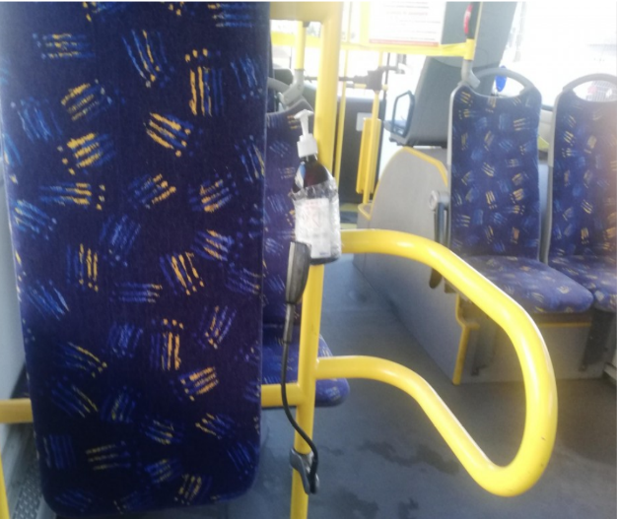 | 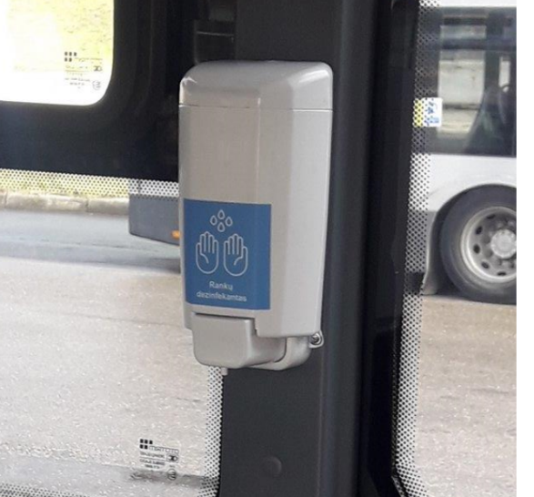
Figure 13. Improperly installed and inadequate disinfectant liquid container | Figure 14. Proper container of disinfectant liquid
  - Passenger compartment ventilation/heating requirements
    - Vehicles shall be equipped with air-conditioning systems for the driver's workstation and the passenger compartment, with separate controls for the driver's workstation area and the passenger compartment area. The air-conditioning system must have the functionality to both heat and ventilate the cabin of the vehicle.
    - Vehicles must be equipped with hardware to monitor in real time the temperature of the passenger compartment of the vehicles on the routes and to see the status of the installed heating/air-conditioning equipment, i.e. turned on/turned off in real time and on the relevant date (data must be stored and must be updated at least every 1 minute). The data must be sent to the software to which the Carrier must provide remote access to the Authorized Body. It shall be made possible for the responsible staff of both the Carrier and the Authorized Body to access the system remotely.
    - The passenger compartment of the vehicle shall be permanently ventilated or heated.
    - Vehicles shall meet the following requirements for passenger compartment air temperature:
- During the period from 1 November to 31 March, the temperature in the passenger compartment of vehicles on routes must be maintained between 10 º and 15 ºC, and when the outside temperature is below 0 ºC, the maintained temperature must be at least 5 °C.
- Between 1 April and 31 October, the temperature in the passenger compartment of the vehicles shall be maintained between 18 º and 23 ºC during the operation of the routes, except for cases when the outside temperature exceeds 28° degrees - in such case, the temperature in the passenger compartment of the vehicle must be 5-8ׄ° C lower than the outside temperature.
- In the event of abnormal outside temperatures or above-normal deviations from the national average temperature for many years, the temperature in the passenger compartment of the vehicle must comply with the requirements laid down in the Rules for Transportation of Passengers and Luggage. If the Rules for the Transportation of Passengers and Luggage do not specify temperature requirements for the passenger compartment of the vehicle, the temperature must be agreed in advance with the Authorised Body.
  - Measuring the air temperature in the passenger compartment
    - The air temperature in the passenger compartment is measured by the Authorized Body's responsible persons during public transport inspections. Temperature measurements may only be carried out by an Authorized Body with metrologically verified instruments.
    - The final result of the measurement of the air temperature in the passenger compartment shall be recorded and the information shall be uploaded to the Vehicle Inspection Information System (VIS) of the Authorized Body.

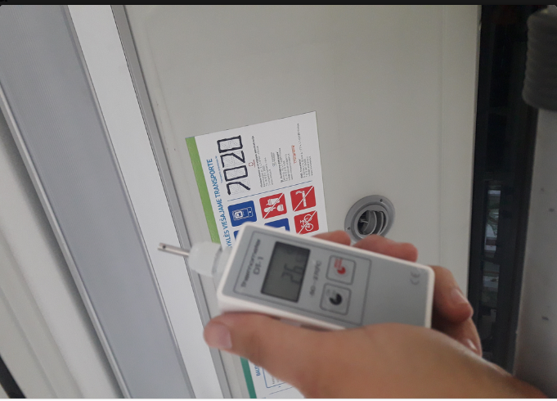
Figure 15. Recording the temperature in the vehicle. One photo must show the garage number of the vehicle and the measured temperature.

  - Requirements for passenger compartment handrails, handholds and other passenger holding devices
    - The passenger compartment of the vehicle shall be fitted with tubular handrails, handholds or equivalent holding devices which shall be so arranged that they can be easily grasped and do not obstruct the entrance/exit to/from the passenger compartment. All vehicle handrails, handholds or equivalent passenger holding devices must be in good aesthetic condition and in good working order.
    - The passenger compartment shall be fitted with tubular handrails in a bright colour contrasting with the colour of the vehicle interior trim. When the Carrier acquires new vehicles, the colour of the tubular handrails must be agreed in advance with the Authorized Body.
    - In addition, horizontal handrails shall be fitted with loops hanging along the handrail for passengers to hold on to.
    - At least 2 "STOP" buttons shall be provided on the vertical handrails of each passenger service door. The buttons must be red, with inscription "STOP" in Braille.

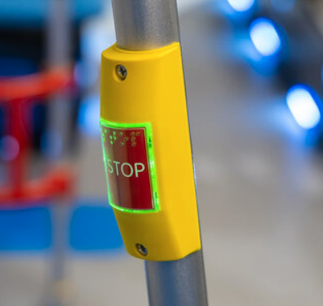
Figure 16. An example of a "STOP" button with a light

    - An information light must illuminate when one of the "STOP" buttons is activated.
    - The cabin of the vehicle must be free of any protruding, broken or fragile elements that could endanger the safety of passengers or their belongings.
  - Requirements for equipment for the safe carriage of bicycles and luggage:
    - Buses of two-axle type and above shall be equipped with bicycle locking equipment (e.g. straps and/or rack, etc.) to securely fasten and carry bicycles.

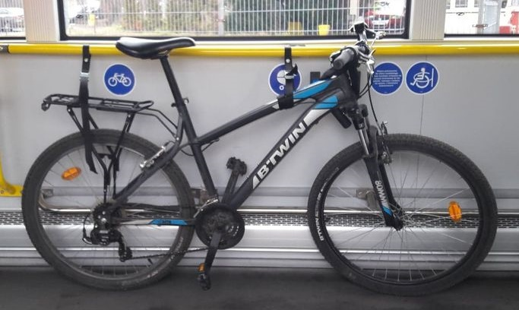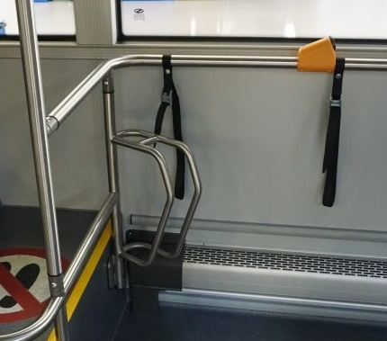
Figures 17, 18: Example of equipment for transporting bicycles

    - Buses on routes to the Airport must be equipped (see Figure 19 below) to carry passengers' luggage safely and comfortably. The Carrier shall agree with the Authorized Body on the type and location on the new bus of luggage transportation solution during the performance of the Contract.
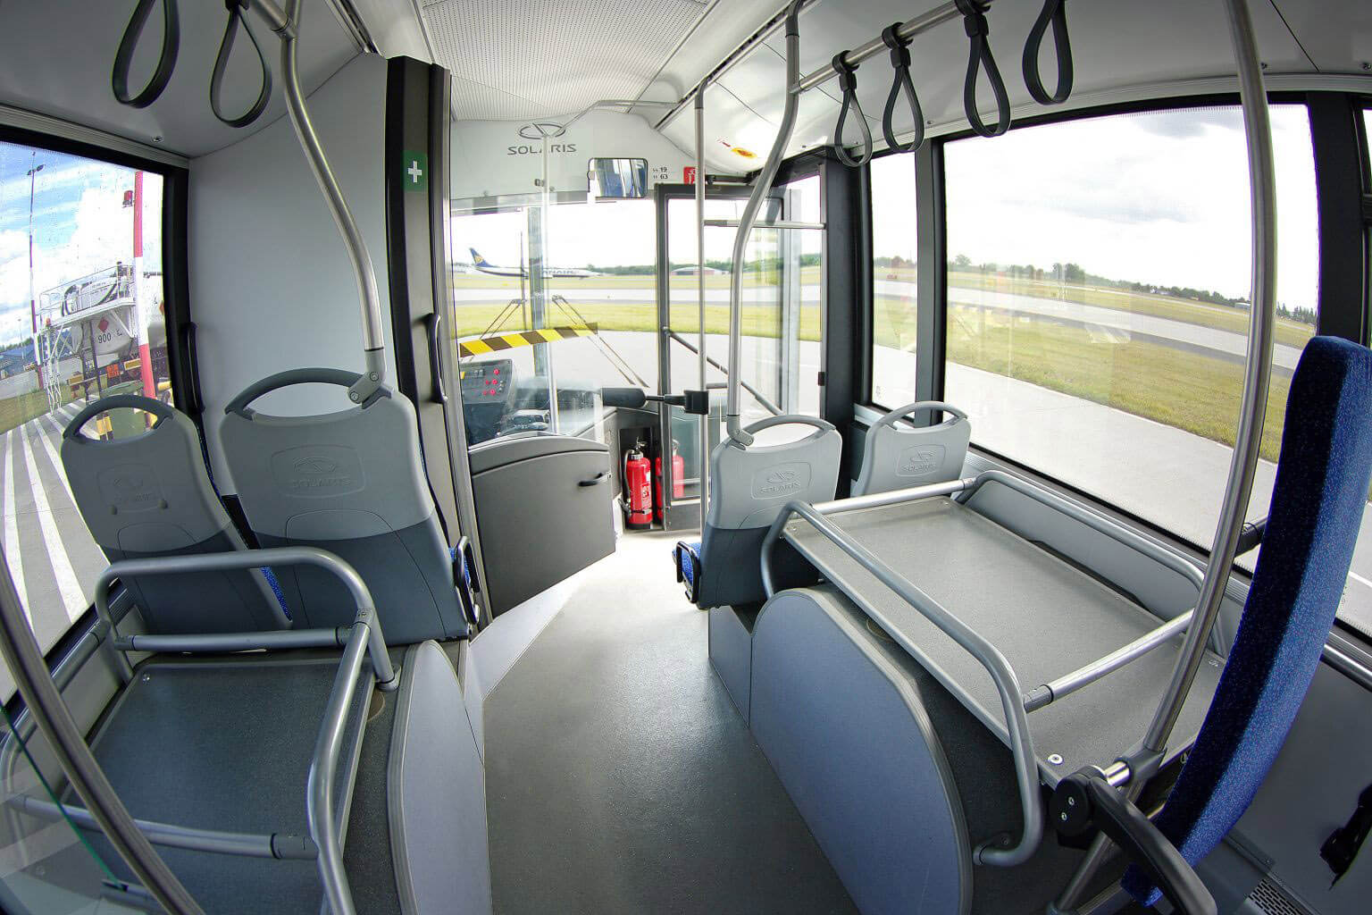
Figure 19. Example of equipment for passenger luggage

  - Requirements for vehicle door mechanisms
    - The passenger service door mechanisms must be in good working condition and order at all times during the service.
    - Passenger service door mechanisms must be equipped with an anti-pinch device. When closing the door, the door must open if there is an obstruction between the doors.
    - Vehicles shall have an external emergency opening mechanism for passenger service doors.
    - The passenger service doors shall be controlled in two ways:
      - from the driver’s workstation;
      - system of independent opening of doors for passengers: using buttons in the passenger compartment and outside the vehicle, with which passengers can independently open specific doors by themselves; these buttons can only be activated (turned on) by the driver from his workstation. The requirement does not apply to low capacity buses.
    - As a door closes, the audible and light signals at that door (in the passenger compartment) must be activated.
    - Two or more axle vehicles shall have at least one (1) passenger grab bar on the inside of each door, except when the door opens outwards. When a vehicle door is opened, the vehicle's brake or other system must be activated to ensure that the vehicle cannot move when the door is open. The door opening must be blocked automatically when the vehicle is moving.
    - Drivers are encouraged to open the doors using the passenger independent opening system to ensure the most stable temperature in the vehicle cabin. In case of an overcrowded vehicle, a large number of passengers boarding, or a long delay time, the driver can also open the door from his workstation. Upon spotting a blind passenger or a passenger with any other disability that would prevent the passenger from opening the door independently, the driver must open the door for such a passenger from his workstation.
    - One independent door opening button for passengers must be installed at the front door, both inside and outside the vehicle. Two independent door opening buttons must be installed at all other doors, both inside and outside the vehicle. An alternative solution is also possible, which is coordinated with the Authorized Body before the Carrier commences servicing of the routes.
    - Independent opening buttons in the passenger compartment must contrast with colours of vehicle’s interior finish and handrails. Buttons on the outside of the vehicle must also contrast with the exterior of the vehicle. Buttons must be adapted for the blind (embossed or with braille). The door opening buttons must have a "memory" function (when a button is pushed inside the vehicle while the vehicle is still in motion, the system must register the pressing and that door must open when the driver activates the door buttons). In this case, the door opening button must also act as a STOP button.

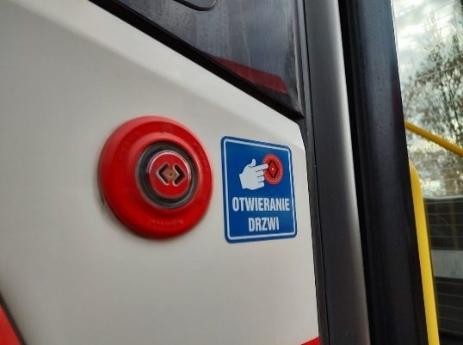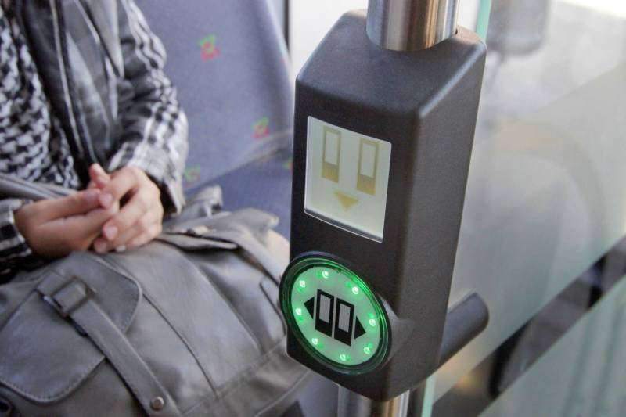
Figure 20 and Figure 21
Examples of independent opening buttons on the outside and the inside

    - Buttons shall be provided on the exterior of the vehicle at the passenger service door to announce the entry or exit of a wheelchair or infant/child, and inside the cabin at the wheelchair or infant/child space. When one of the buttons is activated, the passenger shall be informed by a light signal.

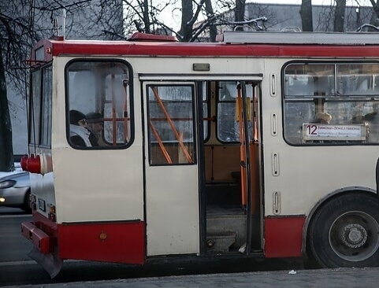 | 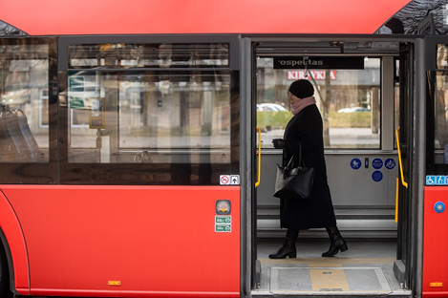
Figure 22. Vehicle door not properly opened. | Figure 23. Passenger service doors properly opened. The doors of the vehicle shall open synchronously, both door leaves together.
  - Requirements for vehicle floors
    - The floor of the passenger compartment shall be coated with a continuous, non-slip, easy-to-clean, abrasion-, fire-, chemical- and weather-resistant PVC or equivalent coating for public transport.
    - Colour fastness to wear (according to EN ISO 105 BO2 or equivalent): at least 6.
    - The surface roughness (slipperiness) of the flooring shall not be less than R10 (EN 13845 or equivalent).
    - It must comply with the fire safety requirements of EU Directive 95/28 CEE (as amended and supplemented or equivalent).
    - The colour and pattern of the PVC flooring must be practical to keep the vehicle floor looking neat and aesthetic throughout the working life. The floor covering must be agreed with the Authorized Body (for the purchase of vehicles or for the replacement of vehicle floor coverings).
    - The edges of the PVC covering shall be laid down (raised) on the cabin walls or an alternative solution.
    - The junctions of the difference in floor surface heights are marked with a bright contrasting marking.
    - The floor of the vehicle's cabin shall be equipped with warning and guidance surfaces for the blind. When new vehicles are purchased or the floor of the vehicle is replaced, the floor of the vehicle compartment must be fitted with blind warning and guidance surfaces. These surfaces shall guide the blind person from the door to the nearest e-ticketing system ticket scanner (validator and seats).
  - Requirements for technological equipment of vehicles
  - Electronic ticketing system equipment
    - All vehicles serving the routes must be equipped with an Electronic Ticketing System.
    - The Carrier may only operate routes on vehicles with properly functioning ticket readers (validators). If more than one ticket scanner (validator) on the vehicle is not working or is not working properly, the Carrier cannot operate the route on that vehicle. At least one ticket scanner must be in operation on low-capacity buses (LCB), otherwise the Carrier cannot operate the route without a functioning ticket scanner (validator) in the vehicle.
    - The implementation of the new e-ticketing software is the responsibility of the Authorized Body, and implementation of the hardware is the responsibility of the Carrier (requirements are specified in Annex No. 3 to the specification).
    - If a driver detects a malfunction of the electronic ticketing system during the route, he/she must immediately notify the Traffic Management Centre of the Authorized Body or transmit the information via the e-ticketing system.
    - Details of the e-ticketing system and a description of the system are set out in Annex 4 to the Contract.
  - Requirements for automatic passenger counting system equipment
    - Automatic Passenger Counting System equipment must be fitted to all vehicles on the routes.
    - The automatic passenger counting system shall be installed at all passenger service doors of the vehicle.
    - The automatic passenger counting system shall provide data on the number of boardings and alightings at each stop.
    - The accuracy of the automatic passenger counting system equipment must be at least 95%.
    - The automatic passenger counting system must include sensors for measuring passengers (e.g. People Counting Unit (PCU)) and on-board computers;
      - The automatic passenger flow measurement equipment of the passenger counting system shall:
        - Capture public transport passenger flow (raw data), linking them to a specific location (coordinates), time, PT vehicle and PT vehicle door;
        - Have a global positioning system (GPS, Galileo or equivalent) function installed to detect and record the coordinates of the vehicle's position and the time at which they are recorded;
        - Link the recorded coordinates of the vehicle to specific public transport stops;
        - Ensure the safety of the data collected.
      - The Automatic Passenger Counting Equipment (APCE) shall be able to function reliably and continuously during the operation of the service.
      - In the APCE, all connections and cables must be suitable for public transport. This means they must be resistant to vibration, environmental influences (dust, water, humidity and temperature).
      - Requirements for occupant measurement sensors (hereinafter referred to as "IR sensors"):
        - IR sensors shall be infrared (or equivalent) and shall be capable of triangulation detection of objects and direction of movement of objects. Infrared rays that are invisible and harmless to the human eye must be used.
        - IRs shall be mounted in the vehicle in openings in the vehicle structure above the passenger service doors and shall perform well at the mounting height in the PT vehicles in use.
        - The number of IR sensors at each passenger service door shall be such as to ensure the accuracy specified in clause 1.11.4 (the Operator should plan for two passenger service door leaves per door in most cases, with the exception of the first door, where a single leaf is usually used for boarding and alighting passengers).
        - The IR sensors shall be powered by the on-board computer of the APCE and shall not use batteries.
    - Each vehicle shall be equipped with the number of APCE required to cover the number of corresponding passenger service doors. If more than one on-board computer is deployed, they must operate in a master-slave principle.
      - Vehicles with an APCE shall have to:
        - Generate a file of estimated passenger flows and other data (position, door closures, etc.) and transmit this data via GSM to an application server equipped with the Dilax Citisense software, which allows the viewing and analysis of the statistical data obtained. Files must be in dlx, csv or xml format. The Carrier shall be fully responsible for the submission of the data and the compatibility with the Dilax Citisense software. The structure of the files must be agreed with the Authorized Body. The APCE shall be able to retain at least 2 days of data in the event of communication failures.
        - Send data on the status and errors and failures of the components of the APCE. The APCE shall be able to install firmware updates from a central system.
        - Have an integrated positioning system (GPS or Galileo or equivalent). The antenna of the positioning system unit shall be provided with the APCE.
        - Have a data communication device for mobile GSM networks (4G or higher), which must be equipped with a standard SIM card. The antenna of the positioning system unit shall be provided with the APCE.
        - Ability to operate in Ethernet. It shall be possible to configure the on-board computer via a computer network (either connected to the network on-board the vehicle or remotely via a GSM data link) using a web-based user interface.
        - The APCE shall be installed and ready for operation, i.e. all necessary wiring, cables and connectors to connect all components shall be supplied and installed. All connections must be such that they cannot be connected incorrectly. Connectors and cables must comply with the environmental (dust, water, vibration) requirements for the equipment.
    - Requirements for the transmission of passenger flow (raw) data
      - The data on the flow of PT passengers must be transmitted to the service stations installed in the premises of the Authorized Body, which are equipped with the APC IS, which allows viewing and analysing the statistics obtained.
      - Data shall be transmitted from the APCE to the APC IS over a wireless IP network, e.g. GPRS or equivalent. Separate Local Area Networks (LANs) must be created for data transmission if the data is transmitted over a closed data network, and separate APNs Access Point Nodes (APNs) or individual VPNs if the data is transmitted over public data networks.
    - Requirements for the APCE:
      - Must be suitable for use in ambient temperatures ranging from -25° to +40° C.
      - Passenger measuring sensors shall have an environmental protection rating of not less than IP65 according to IEC 60529 or equivalent standard.
      - Passenger measuring sensors shall have at least an IK08 vandalism protection class according to IEC 62262, EN 50102 or equivalent.
      - It shall comply with the requirements for shock and vibration resistance category 1, class B in accordance with EN 61373 or equivalent.
      - Passenger counting data must be at least 95% accurate.
      - The data recorded by the APCE shall be transmitted automatically at least every 24 hours.
      - It must be made possible (if necessary) to access data in real time (at least every 30 seconds). The data and data formats that contain the passenger flow calculation information and are passed for the calculations must be open.
  - Requirements for in-vehicle and exterior camera equipment
    - Cameras mounted on the exterior of the vehicle and in the interior of the vehicle shall be equipped with a sensor with a maximum image resolution of at least 6 megapixels, shall be designed to operate in a temperature range of -20 °C to +45 °C; shall be resistant to dust, vibration and extreme temperature changes; shall have a resistance class of at least IP65 or equivalent, and shall comply with EN 55024, EN 61000-6-1, or equivalent standards.
    - The camera system must meet at least one of the following cyber security certifications: SySS, NDAA, Secure by Default, CNPP trust passport.
    - The lenses of the cameras shall be chosen to ensure a clear and high-quality image from all the cameras in the vehicle (external and internal).
    - The CCTV system shall be capable of recording video from all cameras, shall provide for automatic start of recording when the vehicle engine is started and shutdown of the system at a set time after the engine has been switched off, and shall be capable of storing a minimum of 200 hours of video footage on the storage medium of the device, with a resolution of not less than 1920x1080 and a minimum resolution of not less than 24 unique Frames Per Second (fps). The video material must be recorded on a medium without mechanical parts.
    - The Authorized Body must be able to view/export the video for viewing with at least Windows Media Player or VLC media player or equivalent video viewer. The Carrier shall provide access to the cameras in the Carrier's vehicles upon request by an Authorised B.
    - The video recorder shall be free of moving parts, have a minimum of 200 hours of video recording memory, and use MxPEG or MJPEG or an equivalent code for encoding the video (so that the moving object is not lost and is clear when the recording is stopped).
    - The Authorised Body shall be able to connect to a system of front CCTV cameras that capture images of the front/exterior of the vehicle via the software Digifort used by the contracting authority. The Carrier shall be responsible for providing the necessary licences to display the CCTV footage in Digifort.
    - The transmission of CCTV footage or video with audio (if permitted by legal regulations) to the Authorized Body on request must be ensured within 1 day of the request by the Authorized Body.
    - Vehicle cabin video camera system
    - The video camera equipment system for the cabin of the vehicle shall consist of one camera at the driver's workstation and additional camera(s) to ensure that all passengers entering/exiting the vehicle are filmed. Each video camera in the passenger compartment shall have a minimum 360° lens or an equivalent solution to provide surveillance of the whole area of the vehicle compartment without a blind spot (obstruction of the passenger seats or handrails is not considered a blind spot), and shall have a viewing angle overlay to ensure the safety of the passengers, the other cameras, and the cabin of the vehicle against vandalism. The installation locations of the video cameras must be agreed with the Authorized Body.
    - A video camera capable of recording video with sound shall be installed in the cabin of the vehicles at each passenger service door. The driver-facing camera shall have the functionality to mute the sound. The positioning of the cameras shall ensure that the display at the driver's workstation shows the passenger standing areas at all doors. The positioning of the cameras shall also provide video surveillance at each passenger door in the passenger compartment.
    - Vehicle exterior camera system
    - One camera recording the view in front of the vehicle (outside) shall have a lens of at least 90° in order to provide a view of the traffic in the carriageway.
    - One camera capturing the image at the rear (outside) of the vehicle.
    - One camera on the right side of the vehicle (outside), providing video surveillance at each passenger service door.
    - When the driver presses a button (e.g. SOS, "A lane"), a part of the video from all the cameras in the vehicle would be flagged for automatic transmission according to the parameters set in the software (time interval in seconds before the button is pressed, and the time interval in seconds after the button is pressed), and the possibility to send to the software an alarm with a video of the event of at least 10 seconds duration.
  - Loudspeakers inside and outside the vehicle:
    - The vehicle must be equipped with external and internal loudspeakers.
    - In the passenger compartment, the audible information system shall have a volume of not less than 85 dB in proportion to the size of the vehicle.
    - The loudspeakers must be able to work in coordination with the Authorized Body's e-ticketing system and/or the on-board passenger information system.
    - An external loudspeaker shall be installed at the passenger service door. The external loudspeaker must be suitable for operation in outdoor conditions (resistance class at least IP53 or alternative). The external loudspeaker must be able to play a different audio recording than the internal loudspeaker in the passenger compartment at the same time (connected separately from the internal loudspeakers).
    - The vehicle must be equipped with a microphone, which must work in conjunction with the loudspeakers in the cabin, and messages from the microphone must take precedence over other messages.
    - Audible reversing and door-closing alarms shall be provided.
    - Audio announcements in the vehicle must be made clearly and at a volume that is understandable to passengers. The audio file format must be MP3 at 320kbps/mono/44.1kHz
    - The in-cabin public address system shall be able to play audible announcements and adjust their volume.
    - The audible announcement of stop names must be synchronised with the stop information provided by the internal displays (internal passenger information displays) in the cabin.
  - Requirements for external and internal passenger information displays in vehicles
    - The on-board passenger information system, consisting of external and internal passenger information boards (displays), shall be able to input information (routes, etc.) in the following ways:
              - GTFS format. GTFS format files shall be provided by the Authorized Body or its authorised persons and partner(s). The passenger information system of the bus operator shall automatically process the information provided (scan the file provided at the start of the bus shift and generate the correct route number, direction, stop list and other information below for the specific vehicle assigned to the route) and automatically display the correct information on the external and internal boards (displays). The passenger information system shall have to (automatically) track the changes of the files provided in GTFS format and other files and, where needed, shall have to instantly update the information displayed during the entire shift of the bus driver. The driver must be able to manually select the route number and direction.
              - Routes and other information shall be programmed manually by the Carrier on the basis of route information provided by the Authorized Body. The Carrier is responsible for programming the passenger information system in this way and for acquiring and maintaining the necessary software (licences). This method should be used as a fall-back when, due to technical difficulties, GTFS files or other data are not available for the automatic processing and submission of information for a longer period of time, and upon notification and confirmation of the use of this method by the Authorized Body no earlier than 5 working days in advance.
    - During the operation of the routes, the communication related to passenger information (route number and name, direction, stops, interchanges, etc.) shall be properly displayed on all external vehicle displays and internal displays in the passenger compartment, with the correct information, in accordance with the design template provided by the Authorized Body. The Authorized Body shall provide a template for the design of the route mapping no later than 30 working days before the start of the service.
    - The front exterior display of the vehicle shall display the route number, the direction of the route, the nature of the journey (abbreviated, modified, detour, park, etc.) and, in certain directions, the symbol (e.g. for airport journeys, the airplane symbol), in accordance with the design template provided by the Authorized Body. The route number shall be displayed in colour, according to the GTFS file or colour codes provided by the Authorized Body. The direction of the route must be displayed in monochromatic white or an alternative solution must be provided.
    - The external display on the right-hand side of the vehicle shall contain information on the route number, name and direction, the nature of the journey (abbreviated, modified, detour, fleet, etc.) in accordance with the design template provided by the Authorized Body. The route number shall be displayed in colour according to the GTFS file or colour codes provided by the Authorized Body. The direction of the route must be displayed in monochromatic white.
    - The outer rear display of the vehicle shall display the route number and, in the case of a larger panel, the direction, the type of journey (shortened, modified, detour, going to the bus park, etc.) in accordance with the design template provided by the Authorized Body. The route number shall be displayed in colour according to the GTFS file or colour codes provided by the Authorized Body. The direction of the route shall be displayed in monochromatic white or an alternative solution.
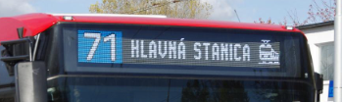
Figure 24. Example of colour route number display on external displays

    - External passenger information displays must be able to display other information unrelated to the route number and direction, including ideograms (icons) such as "Happy Holidays" or "Happy Birthday, Vilnius ♥". The information shall be displayed as it changes with direction and shall be agreed on with the Authorized Body.
    - At the starting stop or end point, external displays showing both the route number and direction must alternately display the time remaining until the vehicle departs in minutes, for example: “1 STATION” -> “1 departs in 3 min”.
    - All vehicles must be equipped with internal passenger information displays.
    - The in-cabin information displays shall provide accurate and non-misleading information to passengers in real time, based on the geographical position of the bus.
    - The Authorized Body shall provide the Carrier with a template for the design of the display of information on the internal displays, which the Carrier shall follow.
    - The following information shall be displayed on the cabin displays in the passenger compartment of the vehicle:
      - Vehicle route number;
      - The direction of the vehicle route;
      - The technical possibility of displaying the preceding stop must be provided;'
      - Nearest stop (highlighted in larger font);
      - Next stop;
      - Arrow showing the sequence of stops;
      - Clock showing the real time;
      - Static (pre-recorded or from a GTFS file) information about possible changes at the next stop;
      - Real-time information (obtained from the GTFS-RT file) about the departures of other routes from the next stop;
      - Real-time information (derived from the GTFS-RT file) on the time it will take a vehicle to approach certain stops;
      - Real-time information (from a file provided by the Authorized Body or its partners) on traffic disruptions, reported b the Traffic Management Centre of the Authorized Body.
      - Configuration of transfer points before certain stops provided by the Authorized Body (provided by the Authorized Body in png or equivalent format).
      - After pressing the STOP button, the inscription “STOP” should appear next to the name of the nearest stop (the inscription and its location can be further specified upon submission of the final design template).
    - Larger diagonal displays (29" and above) shall be able to display both two images simultaneously (e.g. a small vertical route layout and the nearest departures from a stop, information provided by an Authorized Body, or an advertisement of the Carrier) and one single image (e.g. a horizontal route layout of a large format).

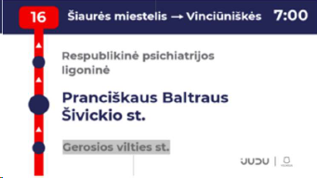
Figure 23. Example of the design of the passenger information display on the indoor passenger information display

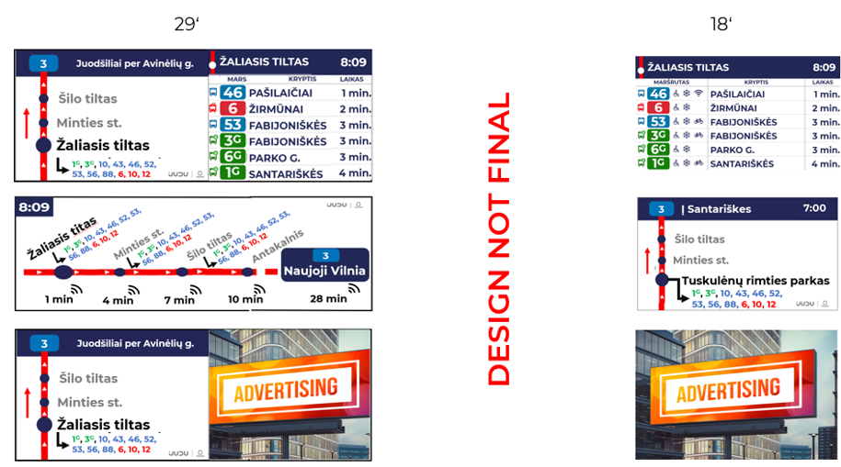

Figure 24. Example of the display image and information broadcast on the indoor passenger information board

    - The Carrier shall broadcast on the internal displays (screens) in the passenger compartment, in accordance with the procedure laid down by the Authorized Body, at least fifty (50) per cent of the time information for passengers relating to the organisation of public transport routes (as referred to in clause 1.14.10 and its sub-clauses, and in clause 1.14.11), and for the announcement of other information (e.g. on changes in the legislation governing the carriage of passengers, safety requirements etc.). The Carrier may use the remaining display time (i.e. the time not allocated for the publication of the Authorized Body’s information) at its discretion in accordance with the advertising requirements set out in this Annex to the Contract and the legislation.
    - The Carrier shall broadcast other information relevant to the passengers provided by the Authorized Body to the Carrier free of charge (e.g. video material on the methods and prices of purchasing public transport tickets, changes in routes, educational videos on passenger culture in public transport, information about ongoing events in Vilnius, etc.) on the internal boards (screens) in the passenger cabin. It must be made possible to assign to the video material certain rules according to which the video material must be displayed, i.e. by date, time, only on a certain route, in a certain defined area ("geofence" function by circling the area on the map), only at or approaching a certain terminal stop.
    - The Carrier shall provide the Authorized Body with the possibility to upload video material independently and free of charge via the CMS (Content Management System) or equivalent systems, and to provide login information to the Carrier's Passenger Information System (PIS) software for uploading content. The display video management system shall be able to report on the number of views of a specific video material on a specific vehicle over a specific period of time. The Carrier must upload the information provided by the Authorized Body to the internal displays of the vehicles immediately if requested by the Authorized Body or within 1 working day of receipt of the information at the latest. If the date and/or time is specified by the Authorized Body, the Carrier must upload the information at the time specified and publish it by the date and/or time specified by the Authorized Body.
    - The software provided by the Carrier shall be compatible with Mobitec (Luminator Technology group) or other alternative passenger information system software used in Vilnius City public transport, which may be installed in the future by the Authorized Body.The data exchange protocols are available free of charge by registering on the manufacturer's website at:.
    - The size of the number(s) of the route number displayed on the external displays shall be at least 100 mm, the size of the letters and numbers of the names of the first and last stops shall be at least 60 mm, and the size of the letters and numbers of the intermediate stops shall be 35 mm. The signs on the route arrows must be in the national language. If the route number is made up of a combination of number(s) and letter(s), the size of the letter(s) shall be at least 1/2 the size of the number.
    - The Authorized Body may also provide for additional functionalities in the passenger information system during the performance of the Contract, taking into account the technical capabilities of the passenger information system. The Carrier is responsible for the installation of additional functionalities.
The Carrier is responsible for the technical and software maintenance of the display system, the acquisition of all necessary licenses and the proper scanning of the GTFS file in accordance with the rules agreed with the Authorized Body. These rules must be coordinated with the Authorized Body before the start of passenger transport services.
  - Wireless (Wi-Fi) technology equipment
    - All Carrier's vehicles must be equipped with Wi-Fi connection.
    - The name of the WiFi connection (visible to passengers when connecting to WiFi) is specified by the Authorized Body.
    - The Carrier must coordinate the WiFi settings and configuration with the Authorized Body.
    - The Wi-Fi service must be free for passengers. The Carrier is fully responsible for the cost of the communication service.
    - Internet access in the vehicle cabin must be available to all devices with a WiFi interface.
    - The in-vehicle Wi-Fi internet connection device must:
      - ensure a minimum upload speed of 100 Mbps and a minimum download speed of 50 Mbps;
      - Support 802.11b/g/standard n or equivalent;
      - The Authorized Body has the right to control the operation of the Wi-Fi connection and the transmission of information.
  - Universal connectors (USB Type-C) in the passenger compartment
    - All Carrier vehicles must have USB Type-C connectors for charging mobile phones for the shared use of passengers.
    - USB Type-C connectors must be positioned in proportion to the size of the vehicle. There cannot be more than two USB Type-C connectors per USB Type-C node.
    - The number of USB Type-C connections for passenger sharing in the vehicle shall be no less than 6 USB Type-C nodes, the location and number of USB nodes to be agreed with the Authorized Body.
  - Vehicle decoration
    - Advertising requirements. The Carrier must ensure that advertising inside and outside the vehicles complies with the principles and general requirements for advertising laid down in the Law on Advertising of the Republic of Lithuania and does not conflict with the objectives of sustainable mobility. Advertisements inside vehicles should not include advertising that encourages the non-use of public transport, or that promotes modes of mobility that are contrary to the objectives of sustainable mobility and/or that do not comply with the advertising principles and general requirements for advertising set out in the Law on Advertising of the Republic of Lithuania. If the Authorized Body finds that the advertising on the vehicles does not comply with the requirements set out in this clause, the Carrier shall immediately take lawful measures to remove such advertising.
    - The exterior of the vehicles shall be decorated in accordance with the decoration procedure specified in paragraph 1.18 of this Annex.
  - Requirement for other mandatory information inside and outside the vehicle
    - Mandatory external and internal vehicle decoration/labelling, which is the responsibility of the Carrier:
      - The Carrier shall be responsible for the exterior design and marking of the vehicles used to provide passenger transport services, which shall be in accordance with the vision agreed/approved by the Vilnius City Municipality and the Authorized Body, as well as for the production of vehicle markings related to the operation of the Carrier's vehicle, the drivers' performance, safety, functionality for different social groups of passengers, etc., and for the quality of the markings (pasting/painting/posting) on the inside and the outside of the public vehicles in accordance with the requirements of the law and the requirements of the Authorized Body.
      - Before marking vehicles in accordance with the examples given in Table 1 of this Annex, the Carrier shall agree the design and method of marking in writing with the Approved Body and obtain its approval.
      - If new types of marking/decoration are introduced in the legislation regulating passenger transport activities, or if new marking is related to the technical parameters of the vehicle, or if the procedure for the external decoration of public transport vehicles agreed upon by the Vilnius City Municipality and/or the Authorized Body is changed, this document shall be amended accordingly.
      - The Carrier shall continuously monitor the technical condition and quantity of the external and internal decoration/labelling of the vehicle on all its vehicles and, in the event of any defects or damage to the decoration/labelling of the vehicle, shall ensure that it is replaced within 3 days at its own expense. If a longer period of time is required for the changes to be made, the Carrier must agree in writing with the Authorized Body a new time limit, which may not exceed 30 days.
      - The Carrier may only operate passenger services in vehicles equipped in accordance with these procedures.
      - If the Authorized Body directs a change in the decoration/markings on certain vehicles of the Carrier, the Carrier must do it at its own expense within no longer than 30 calendar days.
      - If the Authorized Body directs a change in the decoration/markings on all the Carrier's vehicles, the Carrier must agree in writing with the Authorized Body the timing of the markings/decoration.
      - The compulsory external and internal markings and decoration of the vehicle, which are the responsibility of the Carrier, are set out in Tables 1 and 2 of this Annex. The following tables give possible examples of external and internal vehicle markings, the final design of which must be agreed by the Carrier with the Authorized Body.
      - The Authorized Body may change the exterior decoration/labelling of the vehicle during the performance of the Contract.

Table 1. Requirements for mandatory external and internal vehicle decoration/labelling:
The requirement applies to the exterior decoration of the vehicle | Example of exterior vehicle decoration
- The colour of the vehicle must be agreed with the Authorized Body. | 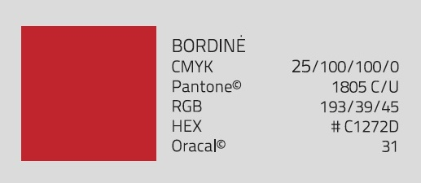
- At the rear of the vehicle (as shown in the example), through the centre of the rear part, on the sides (the end of the logo to the centre of the front tyre, the garage number to the edge of the part), the name of the Carrier or the logo and the garage number of the vehicle must appear. | 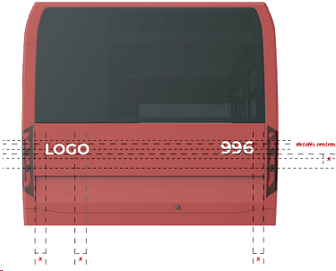  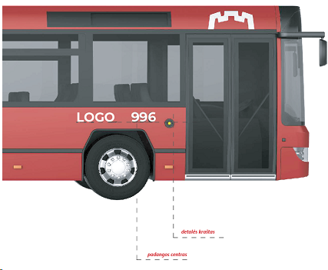
- The Vilnius City logo must be above the first (driver's) door. The centre of the castle in the logo shall be aligned with the centre of the front door and the top of the castle shall be aligned with the top edge of the screen. | 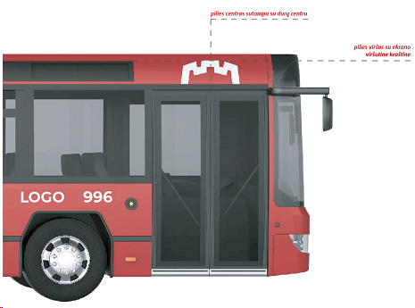
- Vilnius City logo (VILNIUS). The end of the lettering of this logo shall be the same as the end of the vehicle part. | 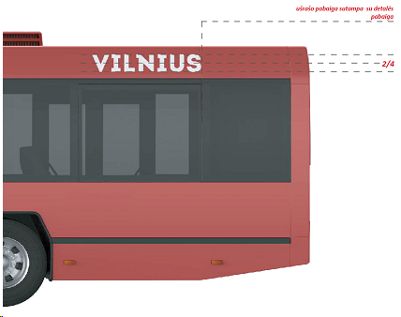
- The emergency opening mechanism shall bear a sticker "Emergency door opening".  - Sticker dimensions, e.g. 65x130mm  - Stickers shall be attached on the outside of the vehicle to each door fitted with an emergency door release.  - The information on the sticker must be in both Lithuanian and English. | 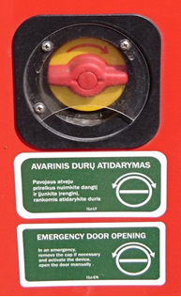
- Important information on the vehicle's accessibility for all passengers and passengers with disabilities shall be displayed at the middle door on the outside or, where there is a ramp, on the right hand side of the door. E.g., one sticker shall measure at least 75x75 mm. Mandatory stickers depending on vehicle specification:  - Passenger with a child;  - Disabled;  - Old people;  - Wi-Fi;  - Bicycles;  - Air-conditioner; | 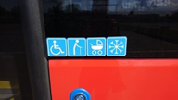
- Stickers marking the service door of the vehicle (e.g. 75x75 mm).  - 1 pc. at the front door;  - 1 pc. at the middle door (on the left side of the door);  - 2 pcs. at the back door (on both sides of the door). | 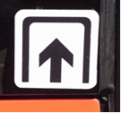
- Stickers indicating the rules for transporting a bicycle (e.g. 75x75 mm) are affixed:  - 1 pc. at the middle door (on the left side of the door);  - 1 pc. at the back door (right side of the door). | 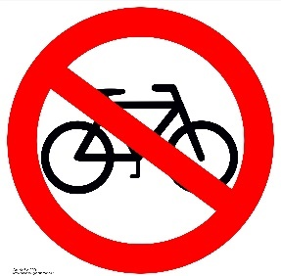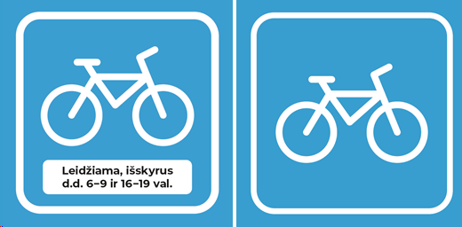
- Passenger Satisfaction QR code solution (to be installed by the Carrier during the Contract execution according to the template provided by the Authorized Body).

- Table. Requirements applicable to the interior decoration/labelling of the vehicle
- Marking - indicating the storage location of fire extinguishers. Marking shall be not smaller than 130x130 mm). | 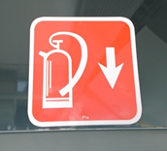
- Marking the capacity of public transport. Marking shall be not smaller than, e.g. 200x130 mm). | 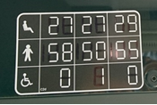
- Recommended markings - must not distract the driver when in English or Lithuanian (diameter e.g. 130 mm). | 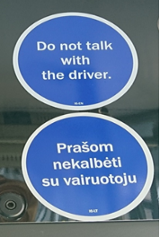
- Marking - indicating the location of the first aid kit in the vehicle (2 pcs.):  - one to be affixed in the driver's cab (size, e.g. 50x50 mm);  - the second one on the driver's cab, on the side of the passengers (size, e.g. 130x130 mm). | 
- Marking - marking the emergency exit shall be placed at each emergency door opening mechanism inside the vehicle, in English and Lithuanian (size, e.g. 65x130 mm). | 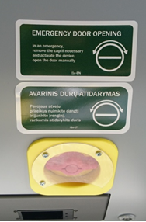
- Marking — marking the emergency exit windows, a double-sided sticker to be applied to the emergency exit windows (the image is visible inside and outside the vehicle). The stickers to be applied at the edge of the window at eye level, and on the sunroofs of the vehicle (size, e.g., 127x127 mm). | 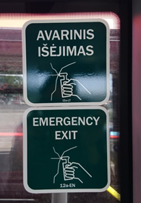
- Information stickers - to mark the spaces for seniors, passengers with small children, disabled passengers, passenger transportation and other special places adjusted for passengers. These stickers must be affixed close to specific locations, in areas that are clearly visible to passengers (e.g., above the windows or on the landing below the window, in Lithuanian and in English (diameter, e.g. 130 mm). | 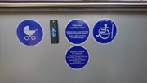
- Information stickers to mark windows that open: transparent stickers to be affixed to opening vents inside the vehicle, the information on the stickers to be provided in Lithuanian and English (e.g., 65x130 mm). | 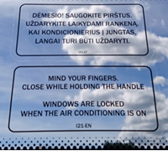

    - Mandatory internal vehicle decoration/passenger information
      - The Authorized Body shall be responsible for the production at its own expense of appropriate and high quality information stickers, posters referred to in clause 1.18.1.9 and for submission thereof to the Carrier.
      - If the vehicle decal/passenger information devices are damaged, defaced or otherwise lost its presentable appearance, the Carrier shall replace them at its own expense within 3 days after the date of handover of the sticker/poster by the Authorized Body to the Carrier.
      - The Authorized Body shall be responsible for handing over the stickers/posters described in 1.18.1.9 to the Carrier's responsible staff in accordance with the deeds of transfer and acceptance. The Carrier shall be obliged to attach the decals/ posters in the vehicles within a maximum period of 30 calendar days from the date of signing the deed of transfer and acceptance.
      - Should the Authorized Body instruct to change the incorrect decoration/means of informing passengers in individual vehicles, the Carrier must do so at its own expense no later than within 30 calendar days from the date of delivery of new posters/stickers by the Authorized Body to the Carrier.
      - If the Authorized Body instructs the Carrier to change the decoration/passenger information on all the Carrier's vehicles, the Carrier must agree in writing with the Authorized Body the timing of the changes of decoration. This period may not exceed 60 calendar days.
      - The Authorized Body must provide new stickers/posters within 30 calendar days after being informed of the need for the labelling measures.
      - The Carrier must continuously monitor the technical condition and quantity of the decals/passenger information devices on all its vehicles and in case of deficiencies or irregularities, must inform the Authorized Body within 1 day of the need for additional markings.
      - Requirements for the vehicle interior decoration and labelling
        - Information frames (2 in total) or single stickers (900x210 mm) (see the fig. below) shall be affixed in the cabin of the public transport vehicle, in a place clearly visible to passengers (above the windows, at the doors of the first and second axle); they shall indicate: The rules for the use of road passenger transport (or an extract thereof) and other information approved by Vilnius City Municipality:
- The name and contact details of the Carrier;
- The name and the contact details of the Authorized Body;
- The name and the contact details of the municipality that issued the authorisation to carry passengers on the public transport route;
- The garage number of the vehicle;
- The ways and means of purchasing tickets;
- The amount of the fine for travelling without a ticket;
- Other relevant information.

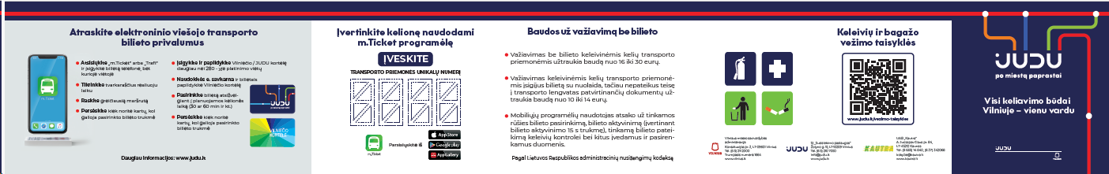
Figure 25. Example of an information sticker

        - In the interior of the public transport vehicle, on the outside of the driver's cab, there shall be a price and method of purchase for tickets sold on board (260x220 mm) and a quiet zone sticker (150x100 mm).
        - Information frames (2 in total) or single stickers (2 in total) (900x210 mm) indicating the rules for the use of road passenger transport approved by the municipality (or an extract thereof) shall be affixed in the cabin of the public transport vehicle, in a place clearly visible to passengers (above the windows, at the doors of the first and second axle).
        - In the passenger compartment of a public transport vehicle, stickers on the glass side of the driver's compartment must show the prices and methods of purchase of tickets sold on board (size of the sticker, e.g. 260x220 mm); quiet zone (sticker size e.g. 150x100 mm).
  - Requirements for the decoration of vehicles on public holidays
    - Without further instruction from the Authorized Body, vehicles shall be decorated with flags on the Day of the Restoration of the State of Lithuania - 16 February, the Day of the Restitution of Independence of Lithuania - 11 March, the Day of the State (the Coronation of King Mindaugas of Lithuania) - 6 July.
  - Public transport passenger services
    - Requirements for the driver's image and behaviour (wearing a uniform of a standard approved by the Authorized Body)
    - The Carrier must ensure that the driver wears a clean uniform. The driver's daily work uniform shall consist of:
- A long-sleeved jumper;
- A waistcoat;
- Short-sleeved shirts;
- Long-sleeved shirts;
    - The requirements for the driver’s uniform are provided in Table 3.
Table 3. Requirements for the Carrier's driver’s uniform.
Requirements | Colour, marking
- Jumper and waistcoat colour (a sample jumper/ waistcoat attached). The colour of the jumper and waistcoat shall be dark blue PANTONE 19-3922 TPX (or close to it). | 
- The jumper and waistcoat must be a classic style V-neck.  - The Carrier's logo must be embroidered on the front left side of the jumper and waistcoat.  - A label embroidered with the Vilnius City logo must be sewn on the right sleeve of the jumper, 6 cm below the shoulder line. Size of the stamp: width - 5 cm, height - 4 cm. | 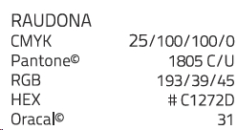  
- Shirt colour (or close to it): | 
- The shirt must be classic, straight cut, with one pocket on the left side.  - The right sleeve must bear the Vilnius City logo in colour.  - Vilnius city logo embroidered on the right sleeve - 6 cm. Below the shoulder line. The Vilnius stamp is monochrome. The size of the stamp is 5 cm wide and 4 cm high. | 
    - The Carrier must ensure that drivers wear a neatly groomed hairstyle, a clean, pressed uniform and clean, neat and closed shoes with a heel of no more than 5 cm during the working hours, in both warm and cold seasons.
    - The Carrier must ensure that drivers wear a short-sleeved or long-sleeved uniform shirt in the warm season, and a shirt and a sweater/waistcoat in the cold season.
  - Requirements for the Carrier's drivers during the service
    - The Carrier must ensure that drivers look aesthetically pleasing when on duty: they must wear a clean uniform (the requirements for the driver's uniform are set out in point 1.20.3), wear a neat hairstyle, wear clean, closed shoes with a heel of no more than 5 cm, both in hot and cold weather. Except where the driver is required to wear footwear specially adapted for the driver.
    - The Carrier must ensure that drivers are familiar with the Municipality's Rules for the Transportation of Passengers and Luggage and must comply with the Road Traffic Regulations. The Carrier also undertakes to have a Passenger Service Standard approved and agreed with the Authorized Body and to ensure systematic periodic passenger service training for drivers. Particular attention must be paid to the training of new drivers and to the re-training of drivers who breach the Passenger Service Standard.The Carrier must ensure that the driver, when interacting with passengers, speaks calmly, clearly and in a courteous tone, patiently answers passengers' questions, and provides any other relevant information relating to the public transport service.
    - The Carrier must ensure that the Driver follows the route and public transport schedule provided by the Authorized Body.
    - The Carrier must ensure that, in the event of a change of route, the driver informs passengers of the change, of the new route and of the possibility of alighting at the nearest public transport stop for those passengers for whom the changed route is unsuitable to continue their journey.
    - The Carrier must ensure that the Driver stops at all stops on the route, including stops where there are no passengers.
    - The Carrier must ensure that any deviation from the route is agreed by the Carrier's driver with the Traffic Management Centre. Conversations between the Carrier's drivers and the Traffic Management Centre staff will be recorded by the Authorized Body.
    - The Carrier must ensure that drivers who notice damage to a public transport stop (e.g. a broken road sign at a stop, broken glass in the passenger waiting pavilion, a torn public transport schedule, etc.) report it to the Traffic Management Centre of the Authorized Body.
    - In the event of a vehicle breakdown, the Carrier must ensure that drivers notify passengers immediately and, after receiving information from the Traffic Management Centre, inform passengers when the next vehicle on the same route will arrive.
    - The Carrier must ensure that, before departure, the driver checks that the correct route name, number and direction and the stops on the route are displayed on the vehicle's exterior and interior displays in the passenger compartment.
    - The Carrier must ensure that the driver inspects the passenger compartment of the vehicle on arrival at the terminal stop of the route, and collects any objects, rubbish, etc. left by passengers. In the event of finding items left by passengers or if other passengers bring the items found, the Carrier must ensure that they are collected and that the items found are reported and delivered for storage. The Carrier must have a procedure for information on the collection of lost and found from the Carrier.
    - The Carrier shall ensure that drivers inspect the passenger compartment at the terminal stop of the route and, in the event of any new damage to the interior of the vehicle (graffiti, scratches, damage to the seats, handrails and other obvious defects), shall inform the Carrier's person in charge of the damage, and that the Carrier shall record the damage in the Vehicle Inspection Information System (VIRS) and inform the Authorized Body.
    - The Carrier must ensure that at the terminal stop of the route, the driver does not keep the door of the passenger compartment open to prevent the entry of hot air during the warm season and cold air during the cold season.
    - The Carrier must ensure that during a pandemic or epidemic, the driver ventilates the vehicle compartment at the terminal stop of the route by opening all the passenger service doors.
    - The Carrier must ensure that drivers check that the e-ticketing equipment is working when they arrive at the terminal stop of the route. The Carrier must ensure that if the driver notices that the e-ticketing equipment is not working, he/she reports this to the Carrier's responsible persons, and if a new e-ticketing system is introduced, he/she reports the non-functioning or malfunctioning of the e-ticketing system to the Authorized Body's Traffic Management Centre.
    - The Carrier must ensure that drivers obey the Road Traffic Regulations. If there is a public transport lane ("A lane") on the route, the Carrier must ensure that the driver drives on this lane. The driver can only temporarily leave the public transport lane if there is an obstacle in that lane that needs to be avoided.
    - The Carrier must ensure that, when entering and leaving a public transport stop, the driver stops/starts the vehicle in such a way as to avoid discomfort to passengers. In the event of a situation where sudden braking is required, the Carrier must ensure that the driver asks the passengers if they are uninjured, if assistance is needed and, if they are injured, immediately calls the emergency services and informs the Traffic Management Centre of the incident.
    - The Carrier must ensure that the driver reports obstacles on the road (e.g. parked cars at a public transport stop) to the Traffic Management Centre. When reporting this information to the Traffic Management Centre of the Authorized Body, the make, colour and state plate number of the car must be provided.
    - The Carrier must ensure that the driver presents the documents required by law at the request of the control officer of the Authorized Body.
    - The Carrier must ensure that drivers carry out the work of officials or persons authorised to control passengers in public transport and that they allow persons carrying out the public transport control function of the Authorized Body to check passengers' tickets on board the vehicle.
  - Requirements for the start/end of the journey, stopping at stops and disembarking/embarking passengers
    - The Carrier must ensure that, at a stop, the driver approaches the boarding area as close as possible to the bus stop, but not more than 30 cm away. Where there is no passenger boarding area, the Carrier must ensure that drivers stop at the kerb in accordance with the requirements of the Road Traffic Regulations. Doors for boarding/alighting passengers shall only be opened when the vehicle has come to a complete stop.
    - The Carrier must ensure that passengers board through all doors, including the first door. Disembarkation takes place through all but the front door. Disabled passengers, passengers with small children, pregnant women and elderly passengers have the right to alight at the front door if necessary. Passengers can also disembark through the front door when the vehicle is full.
    - The Carrier must ensure that the driver pays attention to the passengers in the cabin when approaching "On Demand" stops and that if a passenger in the cabin has pressed the STOP button or has indicated that he/she wishes to alight at the next "On Demand" stop, the driver must stop. The Carrier must ensure that, when approaching an “On Demand” Stop, the driver notes whether there are any passengers waiting to be picked up. When passengers are at a stop, it is necessary to stop and board them.
    - The Carrier must ensure that the driver makes it possible for passengers to change between vehicles on the route. At a stop, drivers must make sure that all passengers on the other route have managed to transfer to the vehicle they are driving.
    - The Carrier must ensure that the driver makes sure that all passengers have boarded/alighted the bus before closing the passenger service doors.
  - Requirements for serving persons with disabilities
    - The driver of the Carrier must pay special attention to passengers with disabilities: he/she must help them to board/alight the vehicle.
    - The Carrier must ensure that the driver, if he/she notices that a person with reduced mobility is waiting at a public transport stop, drives as close as possible to the edge of the entrance of the stop, tilts the vehicle or, if this is not sufficient, lowers the ramp and assists the person with reduced mobility to board the vehicle in a comfortable and safe way. When asked which stop the passenger plans to alight at and when he/she reaches it, the driver must help the passenger to alight the bus.
    - The Carrier must ensure that if the driver notices that a blind or partially sighted person is waiting at a public transport stop, he or she must, if necessary, help the person to board and sit down safely, inform him or her which route he or she is on, and ask him or her which stop he or she wishes to alight at. When the passenger reaches the required stop and does not alight, the driver shall inform the passenger that he/she has arrived at his/her designated stop.
  - The driver of the Carrier is entitled to do the following during working hours:
    - disembark passengers without a ticket or who refuse to buy a ticket;
    - refuse to accept or alight at the nearest stop passengers who are drunk, intoxicated by psychoactive substances (drugs, medicines, other intoxicating substances), wearing dirty clothes or carrying baggage that is prohibited for carriage;
    - politely and respectfully ask passengers to behave properly in the vehicle, i.e. not to make noise, not to consume alcoholic beverages, not to litter (pick up litter and take it away), not to spit on or otherwise damage the surfaces of the vehicle, and to comply with any other obligations set out in these Rules and other legal acts;
    - call the police and inform the Authorized Body's Traffic Management Centre if passengers do not comply with the rules laid down by law and refuse to leave the vehicle.
  - The driver of the Carrier is not allowed to do the following during working hours:
    - carrying persons in the driver's cab of the vehicle;
    - talking to bystanders;
    - smoking, vaping on the vehicle or close to it,
    - talking on a mobile phone without a hands-free device while driving;
    - eating, watching videos, browsing and talking loudly on the phone, listening to music (so that it can be heard in the passenger compartment y) while driving;
    - keep personal and other belongings out of sight of passengers.
  - Coordinating communication with the Carrier (complaints, press releases)
    - The Authorized Body shall prepare written, visual and audio notices and transmit them to the Carrier for distribution by the Carrier.
    - In order to ensure a smooth and unified communication on public transport issues to the media and other interested parties, the following rules of cooperation between the Authorized Body and the Carrier shall be established:
      - Once a month, joint meetings between the communication teams of the Authorized Body and the Carrier shall be organised to discuss the topics to be covered and possible points of cooperation, both in external and internal communication.
      - The Carrier's communication representatives shall inform the Head of Communications of the Authorized Body and the Public Relations Department of Vilnius City Municipality at least 5 working days in advance for all topics they initiate (articles, press releases) related to the public passenger carriage services and/or the Contract to be performed.
      - The communication representatives of the Authorized Body shall regularly forward to the Carrier's communication representatives on social networks the information and requests received, to which the Carrier undertakes to reply, comment and provide an answer within a maximum of 2 working days. The Carrier shares requests/comments addressed to the Authorized Body on social networks.
      - The Carrier's communication representatives shall inform the Head of Communications of the Authorized Body or other person responsible for communication (and, where appropriate, the responsible department of Vilnius City Municipality) of comments to the media that may have an impact on the broader public transport context (which will not necessarily be linked to a particular carrier). The Carrier's communication representatives shall also inform and coordinate "more sensitive", politically contextualised media comments and crisis communication actions with the Communication Manager of the Authorized Body or other person responsible for communication.
      - The Carrier's communicators shall use the signs, symbols, logos provided by the Authorized Body to describe/identify Vilnius mobility services (including public transport services) in their publicity topics and social media communications. The use of signs, symbols and logos in visual communication shall be in accordance with the rules of the Authorized Body's Brand Book. In the event of questions about a specific use case, the Carrier's communications representatives shall consult with and obtain the prior approval of the Communication and Marketing Managers of the Authorized Body. The Authorized Body shall have the right to amend and/or establish new rules for the use of signs, symbols and logos by informing thereof the Carrier at least 60 (sixty) calendar days before the amendments come into effect. The Carrier must take into account and comply with the revised rules on the use of signs, symbols and logos.
    - Procedures for dealing with complaints, reports, requests and passenger issues:
      - Complaints, reports, requests, passenger service issues related to the Carrier's direct activities (e.g. driver behaviour, driving style, etc.) shall be examined and answered by the responsible persons of the Authorized Body.
      - Other complaints, reports, requests, passenger service issues not related to the Carrier's direct activities are dealt with by the Authorized Body. The Authorized Body shall have the right to request additional information from the Carrier in order to investigate the complaint and the Carrier shall provide the information within a specified time limit, which shall not exceed 2 (two) working days.
      - The Authorized Body may require the Carrier to prove the validity/unfoundedness of the complaint received by providing documents/video evidence to substantiate the unfoundedness of the complaint. The burden of proving the unfoundedness of a complaint received, by providing documents and/or other data to substantiate the unfoundedness of the complaint, is on the Carrier.
      - Complaints about the activity or omission of the Authorized Body, submitted in accordance with the procedure established by the Law on Public Administration of the Republic of Lithuania, shall be examined by representatives of the Municipality. The Carrier and the Authorized Body shall provide all information and assistance to the Municipality in the handling of complaints.
    - Rules for receiving complaints and notifications
      - The Carrier shall forward to the Authorized Body, by e-mail or other means, complaints, notifications, requests, on passenger service topics or other topics for which the Authorized Body is responsible, no later than within 2 (two) working days after receipt of the document.
      - The Carrier shall forward to the Authorized Body, by e-mail or other means, complaints, notifications, requests, on passenger service topics or other topics for which the Authorized Body is responsible, no later than within 2 (two) working days.
      - The Carrier must keep a register of complaints, enquiries and other communications received. If necessary, the Authorized Body may request annual/quarterly/monthly statistics on enquiries received and other data.
    - Breakdown of publicity topics
      - The Authorized Body shall publish, disseminate and comment to the media on topics related to the overall transport system in the city, the renewal and progress of public transport in the city (without specifying specific carriers), passenger information, the quality of public transport services, ticket pricing and changes, the presentation of public transport in the context of the Sustainable Mobility Plan, mobility and others.
      - In case of any questions regarding the commenting/distribution of questions, the sender is consulted by the Public Relations Department of Vilnius City Municipality and the advisors.
      - All the topics publicised by the Authorized Body shall be adapted and publicised by the Carrier as required and in a more specific way for its own specific contribution.
      - The Carrier shall publicise and disseminate to the media and comment on topics related to the Carrier's own specific activities/procurement (where it is not about the general progress of public transport in the city, but about the Carrier's own activities), organisation of work, employee relations, driver relations, employer image, events or incidents on the Carrier's buses, maintenance of the buses, and innovations initiated by the Carrier in particular, among others.
    - Internal communication rules (Communication teams from the Authorised Bodies and the Carrier work together in specific ways to organise joint activities for drivers). The following activities are foreseen and may be supplemented in the course of the project):
      - Quarterly (or on demand) meetings with the brigadiers to present 1-2 of the most relevant topics in the context of urban transport and sustainable mobility, with discussions and Q&A sessions. The format of the meeting may vary.
      - Carrier representatives are involved in meetings organised by the Authorized Body with the most active public transport enthusiasts, communities and trade union representatives.
      - The Authorized Body shall provide the Carrier with relevant information to drivers about its activities and news, and the Carrier shall communicate this information to drivers in a format agreed upon as appropriate for the specific case (oral, visual communication, etc.).
  - Safety and health requirements for drivers and passengers of the Carrier and insurance for the Carrier and passengers
    - Safety requirements for drivers and passengers of the Carrier
      - The Carrier must ensure the safe carriage of passengers and luggage in the vehicle and the safe boarding and alighting of the passenger from the vehicle. The Carrier shall be liable for damage caused to the health, life or luggage of a passenger during the carriage of the passenger in the vehicle or during the passenger's boarding or alighting from the vehicle, unless there is evidence that the damage is due to the fault of the passenger himself/herself or of the fault of the other road user in the traffic accident which caused the damage to the passenger. The Municipality and the Authorized Body will not compensate for any damage caused by the Carrier to a passenger during the carriage of the passenger in the vehicle, or during the passenger's entry or exit from the vehicle.
      - The Carrier shall ensure that its drivers are made aware of the risks that may arise in the carriage of passengers and luggage by means of the vehicle, including risks related to the driving of the vehicle, meteorological conditions, the behaviour of passengers and other persons, the specific needs of passengers, and boarding and alighting of passengers. The Carrier must educate and inform drivers on the effective management of such risks, provide instructions to drivers and take other measures to ensure that the risks are effectively managed.
      - Carrier drivers must be attentive and react appropriately to information provided by passengers about the situation inside the vehicle. If a passenger reports that the driver has noticed suspicious objects left in the cabin, persons behaving in an atypical manner (including aggressive, drunk or otherwise intoxicated persons) or persons whose health or life is threatened, drivers must assess the situation as quickly as possible, and, if they determine that the passenger's safety is real, to inform the relevant special services and the Traffic Management Centre of the situation.
      - If a passenger informs the driver of the Carrier that a child or adult has been spotted: (i) has visible bruising and/or injuries characteristic of a beating; (ii) talks or refers to domestic or family violence; (iii) behaves inappropriately with another person in the vehicle, including acts of a sexual nature (with particular attention to such acts by an adult with an apparently underage person); (iv) is visibly frightened, in a state of panic or shock; the driver or controller shall immediately report any such sighting to the Traffic Management Centre, which shall record the information/data and, if necessary, pass it on to the relevant authorities.
      - The Authorized Body may issue additional guidance on how to deal with observations of persons referred to in points 1.27.1.3 and 1.27.1.4 of this Annex.
    - Carrier and passenger insurance requirements
      - The Carrier shall ensure that all vehicles used for the provision of public passenger transport services are insured with compulsory insurance against civil liability of the vehicle operators in accordance with the requirements of the Law on Compulsory Insurance of Civil Liability of the Vehicle Operators of the Republic of Lithuania (Žin., 2001, No 56-1977; 2007, No 61-2340).
      - The Carrier must ensure the validity of passenger accident insurance or other insurance covering passengers' property interests in respect of life, health and property throughout the period of operation of the public passenger transport service. The minimum amount of such insurance must be €500,000 for all insured events in a calendar year. The Carrier shall provide the Authorized Body with a certificate (policy) of such insurance within 1 (one) working day upon request by the Authorized Body.

Municipality Authorized body Carrier

_______________________ _______________________ _______________________

