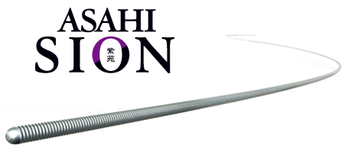
Durable tip with outstanding shape retention
Possible to treat multiple lesions with one wire.
Advanced torque performance even in extreme tortuosity
Easier vessel selectivity, even after an acute angle.
Flexible shaft and atraumatic tip
Employ the wire in a variety of situations stess-free
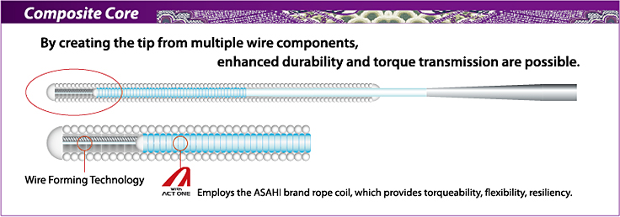
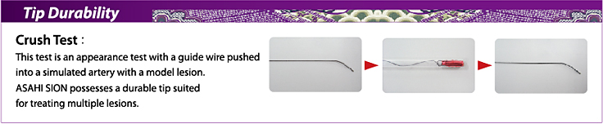
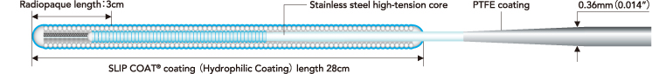
  Product
  Catalog No.
  Diameter
  Usable Length
  Spring Coil Length
  Radiopaque Length
  Tip Shape

ASAHI SION
  AHW14R001S
  AHW14R301S
  0.36mm
  (0.014inch)
  0.36mm
  (0.014inch)
  180cm
  300cm
  28cm
  28cm
  3cm
  3cm
  Straight
  Straight

FRONTLINE CASES
ASAHI SION,
Route / PROWATER flex,
Rinato / PROWATER,Soft, Light,
Fielder, Fielder FC,
Fielder XT

TORTUOUS ANATOMY
ASAHI SION,
Route / PROWATER flex,
Fielder, Fielder FC,
Fielder XT
Grand Slam
ASAHI SION,
Fielder, Fielder FC,
Fielder XT

CONTROLLED DRILL
ULTIMATE bros 3
Miracle 3 / MIRACLE bros 3
Miracle 4.5 / MIRACLE bros 4.5
Miracle 6 / MIRACLE bros 6
Miracle 12 / MIRACLE bros 12
Intermediate / MEDIUM

PENETRATION TECHNIQUE
Conquest / CONFIANZA
Conquest Pro / CONFIANZA PRO
Conquest Pro 12 / CONFIANZA PRO 12
Miracle 12 / MIRACLE bros 12

SLIDING TECHNIQUE
Fielder, Fielder FC, Fielder XT

RETROGRADE APPROACH
Fielder, Fielder FC, Fielder XT

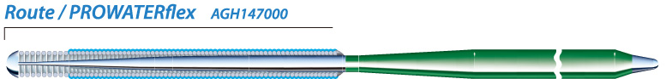
- ●Tip load ............................... 0.8 g
- ●Tip radiopacity .................... 3 cm
- ●SLIP COAT® coating over the spring coil
- ●PTFE coating over the shaft
First choice guidewire featuring a soft tip with good shaping memory and excellent guidewire trackability. Sufficient support for delivery of most interventional devices.

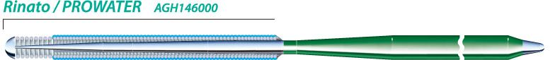
- ●Tip load ............................... 0.8 g
- ●Tip radiopacity .................... 3 cm
- ●SLIP COAT® coating over the spring coil
- ●PTFE coating over the shaft
First choice guidewire with floppy tip and moderate core wire support. Excellent maneuverability and good support for device delivery.

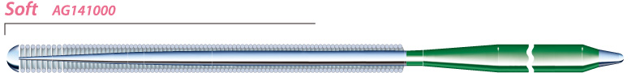
- ●Tip load ............................... 0.7 g
- ●Tip radiopacity .................... 3 cm
- ●PTFE coating over the shaft
Basic frontline guidewire with floppy tip and non hydrophilic coating to ensure optimal tactile feedback.

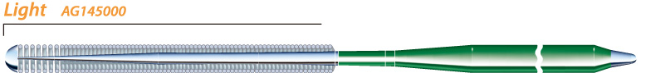
- ●Tip load ............................... 0.5 g
- ●Tip radiopacity .................... 3 cm
- ●PTFE coating over the shaft
Basic frontline guidewire with a flexible core and good torqueability for distal side branch selection.

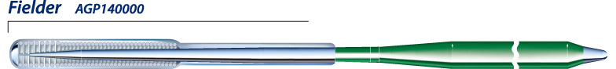
- ●Tip load ............................... 1.0 g
- ●Tip radiopacity .................... 3 cm
- ●Polymer sleeve length ..... 22 cm
- ●SLIP COAT® coating over the spring coil
- ●PTFE coating over the shaft
A polymer sleeve guidewire, providing advanced slip performance and trackability.

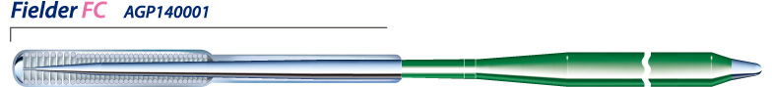
- ●Tip load ............................... 0.8 g
- ●Tip radiopacity .................... 3 cm
- ●Polymer sleeve length ..... 20 cm
- ●SLIP COAT® coating over the spring coil
- ●PTFE coating over the shaft
Fine Control over challenging tortuous vessels and highly stenosed lesions. Polymer sleeve provides advanced slip performance with superior torque and support.

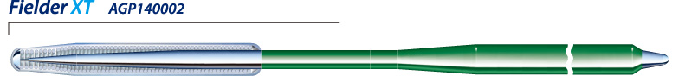
- ●Tip load ............................... 0.8 g
- ●Tip radiopacity .................. 16 cm
- ●Polymer sleeve length ..... 16 cm
- ●Tip outer diameter ...... 0.23 mm（0.009 inch）
- ●SLIP COAT® coating over the spring coil
- ●PTFE coating over the shaft
Polymer sleeve, providing excellent lubricity and trackability in tortuous vessels. The tapered tip provides extreme precision for the treatment of complex lesions such as sub-total occlusions and long diffused lesions.

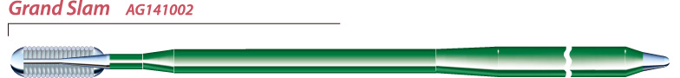
- ●Tip load ............................... 0.7 g
- ●Tip radiopacity .................... 4 cm
- ●PTFE coating over the shaft
Stiff wire shaft provides extra support for delivery of interventional devices in extreme cases.


Compatible with all PTCA Guide Wires.
*Extension is「 ASAHI Extension Wire Extension」.

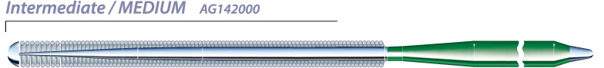
- ●Tip load ............................... 3.0 g
- ●Tip radiopacity .................... 3 cm
- ●PTFE coating over the shaft
First choice wire for chronic occlusion cases.

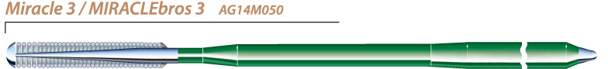
- ●Tip load ............................... 3.0 g
- ●Tip radiopacity .................. 11 cm
- ●PTFE coating over the shaft
First choice wire for chronic occlusion cases.The core wire and distal coil are designed to resist great force thus lowering the chances of getting trapped in a lesion.

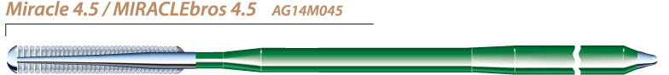
- ●Tip load ............................... 4.5 g
- ●Tip radiopacity .................. 11 cm
- ●PTFE coating over the shaft
A step up in tip stiffness from the Miracle 3.

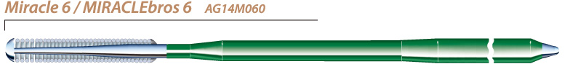
- ●Tip load ............................... 6.0 g
- ●Tip radiopacity .................. 11 cm
- ●PTFE coating over the shaft
A step up in tip stiffness from the Miracle 4.5. The wire has a tip load of 6g and has high driving force against tight lesions.

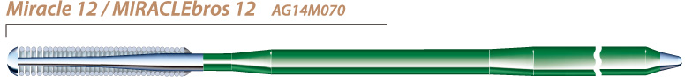
- ●Tip load ............................. 12.0 g
- ●Tip radiopacity .................. 11 cm
- ●PTFE coating over the shaft
A tip load of 12g. It is indicated for complex chronic occlusion cases such as thick, hard fibrous caps and calcification.

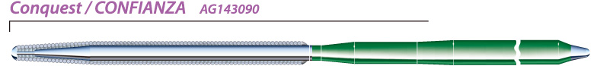
- ●Tip load ............................... 9.0 g
- ●Tip radiopacity .................. 20 cm
- ●Tip outer diameter ...... 0.009 inch (0.23 mm)
- ●PTFE coating over the shaft
Non hydrophilic coated and tapered to 0.009"(0.23mm) at the tip. The 9g stiff, tapered tip helps to engage micro channels and to penetrate highly stenosed lesions.

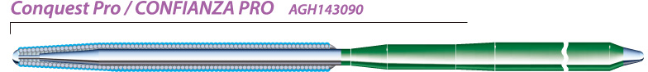
- ●Tip load ............................... 9.0 g
- ●Tip radiopacity .................. 20 cm
- ●Tip outer diameter ...... 0.23 mm (0.009 inch)
- ●SLIP COAT® coating over the spring coil
- ●PTFE coating over the shaft
Similar structure and tip stiffness as Conquest with SLIP COAT® coating for lubricity. The distal tip is not coated to allow it to catch on the entry point of the lesions.

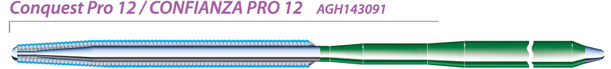
- ●Tip load ............................. 12.0 g
- ●Tip radiopacity .................. 20 cm
- ●Tip outer diameter ...... 0.23 mm (0.009 inch)
- ●SLIP COAT® coating over the spring coil
- ●PTFE coating over the shaft
A tapered tip with 12g tip load. For penetration of calcification and proximal or distal thick, fibrous caps.
  Product
  Catalogue No.
  Diameter
  (inch (mm))
  Radiopaque Segment
  Spring Coil Length (cm)
  Length (cm)
  Tip Shape

ASAHI SION
  AHW14R001S
  AHW14R301S
  0.36(0.014)
  0.36(0.014)
  180
  300
  28
  28
  3
  3
  Straight
  Straight

Route / PROWATER flex
  AGH147000
  AGH147300
  AGH147000J
  0.36（0.014）
  0.36（0.014）
  0.36（0.014）
  3
  3
  3
  20
  20
  20
  180
  300
  180
  Straight
  Straight
  J

Rinato
  AGH146000
  AGH146300
  AGH146000J
  AGH146300J
  0.36（0.014）
  0.36（0.014）
  0.36（0.014）
  0.36（0.014）
  3
  3
  3
  3
  20
  20
  20
  20
  180
  300
  180
  300
  Straight
  Straight
  J
  J

Soft
  AG141000
  AG141300
  AG141000J
  0.36（0.014）
  0.36（0.014）
  0.36（0.014）
  3
  3
  3
  30
  30
  30
  180
  300
  180
  Straight
  Straight
  J

Light
  AG145000
  AG145300
  AG145000J
  0.36（0.014）
  0.36（0.014）
  0.36（0.014）
  3
  3
  3
  20
  20
  20
  180
  300
  180
  Straight
  Straight
  J

Fielder
  AGP140000
  AGP140300
  AGP140000J
  0.36（0.014）
  0.36（0.014）
  0.36（0.014）
  3
  3
  3
  12
  12
  12
  180
  300
  180
  Straight
  Straight
  J

Fielder FC
  AGP140001
  AGP140301
  AGP140001J
  0.36（0.014）
  0.36（0.014）
  0.36（0.014）
  3
  3
  3
  11
  11
  11
  180
  300
  180
  Straight
  Straight
  J

Fielder XT
  AGP140002
  AGP140302
  0.014 / 0.009
  (0.23 / 0.36)
  0.014 / 0.009
  (0.23 / 0.36)
  16
  16
  16
  16
  190
  300
  Straight
  Straight

Intermediate / MEDIUM
  AG142000
  AG142300
  AG142000J
  0.36（0.014）
  0.36（0.014）
  0.36（0.014）
  3
  3
  3
  30
  30
  30
  180
  300
  180
  Straight
  Straight
  J

ULTIMATEbros 3
  AHW14S003S
  AHW14S303S
  AHW14S003J
  AHW14S303J
  0.36 （0.014）
  0.36 （0.014）
  0.36 （0.014）
  0.36 （0.014）
  180
  300
  180
  300
  11
  11
  11
  11
  11
  11
  11
  11
  Straight
  Straight
  J-Tip
  J-Tip

Miracle 3 / MIRACLE bros 3
  AG14M050
  0.36（0.014）
  11
  11
  180
  Straight

Miracle 4.5 / MIRACLE bros 4.5
  AG14M045
  0.36（0.014）
  11
  11
  180
  Straight

Miracle 6 / MIRACLE bros 6
  AG14M070
  0.36（0.014）
  11
  11
  180
  Straight

Miracle 12 / MIRACLE bros 12
  AG14M060
  0.36（0.014）
  11
  11
  180
  Straight

Conquest / CONFIANZA
  AG143090
  0.009 / 0.014
  (0.23 / 0.36)
  20
  20
  180
  Straight

Conquest Pro / CONFIANZA PRO
  AGH143090
  0.009 / 0.014
  (0.23 / 0.36)
  20
  20
  180
  Straight

Conquest Pro 12 / CONFIANZA PRO 12
  AGH143091
  0.009 / 0.014
  (0.23 / 0.36)
  20
  20
  180
  Straight

Grand Slam
  AG141002
  AG141302
  AG141002J
  0.36 (0.014)
  0.36 (0.014)
  0.36 (0.014)
  4
  4
  4
  4
  4
  4
  180
  300
  180
  Straight
  Straight
  J

*Extension
  AG149001
  0.36 (0.014)
  －
  －
  165
  －

ASAHI RG3
  AHW10S302S
  0.26 （0.010）
  330
  8
  3
  Straight
- *Conquest Pro 8-20 is not CE approved.
- *Extension is「 ASAHI Extension Wire Extension」.
- Not all products and shapes are available in all markets. Please check availability with your sales representative.
- SLIP COAT® is a trademark of Angiotech Biocoatings Corporation.

