SUPPLEMENT TO THE AGREEMENT NO. 1.
FOR TRAFFIC LIGHT CONTROL SOFTWARE, IT’S INSTALLATION, MAINTENANCE,
ADDITIONAL SERVICES AND SUPPLY OF INTERSECTION CONTROLLERS
SALE AND PURCHASE AGREEMENT NO. 2025-SUT-132
2026 m. ____________ ___ d.
Vilnius

The Municipal company “SUSISIEKIMO PASLAUGOS“, legal entity code 124644360, represented by its director, acting in accordance with the company's articles of association (hereinafter referred to as the "Buyer"),
and
UAB ”Fima“, legal entity code 12128969, and CROSS Zlín, a.s., legal entity code 60715286, represented by (hereinafter referred to as the "Supplier"),
hereinafter referred to as the Buyer and the Supplier together as the "Parties" and each separately as a "Party",

Taking into account that:
- On July 25, 2025 The Buyer and the Supplier signed Purchase and Sale Agreement No. 2025-SUT-132 (hereinafter referred to as the “Agreement“) for Traffic light control software, it’s installation, maintenance, additional services and supply of intersection controllers;
- During the performance of the Agreement, technical obstacles arose that prevent the implementation of the Public Transport Priority (hereinafter referred to as “PTP”) module in accordance with the requirements of Chapter IV. b. (points 25-33) of the Technical Specifications of the Agreement;
- From 24 September 2025, negotiations took place between the Buyer and the Supplier regarding the implementation scenarios for the submitted PTP module (integrating data from the Buyer's Ridango AVL system), and negotiations began with Ridango representatives regarding the improvement of the Ridango AVL system (Agreement No. 2025-SUT-132, meeting protocol No. 2025-8-7 of 24 September 2025, points 3.3 and 3.4);
- During negotiations with Ridango representatives (September 24, 2025 – October 23, 2025), the Supplier was unable to implement the PTP module until final confirmation was received from the Buyer that the Ridango AVL system would be upgraded in accordance with the scenario presented by Supplier.
- During negotiations with Ridango representatives (24 September 2025 – 23 October 2025), it became clear that the Ridango AVL system cannot provide data on PT measures (vehicle position) required for the effective operation of the PTP module in real time (at a frequency of 1-2 seconds) due to the long latency of 9 seconds in the Ridango AVL system. On 23 October 2025, the Buyer notified the Supplier of the situation.
- On October 23, 2025, The Supplier confirmed in a letter that the data on the position of public transport vehicles received after 9 seconds is unsuitable for the effective operation of the PTP module and the prompt prioritization of public transport vehicles.
- The Buyer, together with the entire project team, sought a solution for implementing an appropriate PTP module solution that would be effective in real time and give priority to public transport at the right time. After consulting with GPS equipment supplier TELTONIKA, the Buyer found a new solution and presented the concept of a new PTP module to the Supplier on 28 October 2025. The Supplier confirmed that such a solution could be implemented (Agreement No. 2025-SUT-132, meeting protocol No. 2025-8-13 of 5 November 2025, point 3.4).
- On 2025-12-08, the Buyer received a letter from the Supplier requesting an extension of the deadline for the installation of the PTP module without delaying the deadline for the installation of other System modules.
- Point 21.2.3 of the General Conditions (hereinafter referred to as the “GC”) of the Agreement provides for the possibility to suspend the Agreement due to unforeseen goods, services, and/or works related to the purchased object, the need for which became apparent only during the performance of the Agreement;
- Point 21.3 of the GC of the Agreement stipulates that the suspension of the supply of Goods (or part thereof) due to the circumstances specified in point 21.2 of the GC shall not exceed 3 (three) months.
- The duration of the traffic light control software installation services is 6 months, i.e. until 07/02/2026 (inclusive). Taking into account the period from 24 September 2025 to 23 October 2025, when, due to objective circumstances beyond the Supplier's control, the Supplier was actually unable to fulfill its obligations, and in accordance with clause GC 21.2.3 of the Agreement, it is appropriate to suspend the implementation of the PTP module services provided for in points 25-33 of Chapter IV. b. of the Technical Specifications of the Agreement for a period of 30 calendar days, without suspending the term for the provision of all other System module implementation services provided for in the Technical Specifications.
- In a letter dated 19 December 2025, the Supplier confirmed that it agreed to the Buyer's proposal to suspend the PTP module implementation services for 30 calendar days.
- In order to ensure that the procurement objective is fully achieved, it is appropriate to amend points 1.2 and 26-30 and 32 of the Technical Specifications of the Agreement, providing for a new technical solution. The amendment to the Technical Specifications only changes the architecture of the solution (software implementation), but the principle and functionality of the solution remain essentially unchanged. The new technical solution is not cheaper than the solution envisaged at the time of the procurement, according to which the Supplier had to take over the Ridango data prepared by the Contractor and integrate it into the new system. Under the new solution, the Buyer creates interfaces for its own data collection, combines data from different Buyer systems into a single environment, and only then will the PTP functionality be implemented. Given that the new solution requires greater human and time resources, it is considered to be more cost-effective than the solution envisaged at the time of purchase. Security aspects (both in terms of traffic and information technology) remain unchanged.
- Point 20.1 of the GC of the Agreement stipulates that the terms and conditions of the Agreement may be amended during the term of the Agreement if such amendment is provided for in the Agreement and/or is possible in accordance with the provisions of the Public Procurement Law;
- Point 20.2. of the GC of the Agreement provides that amendments to the Agreement shall be formalized by the Parties entering into an Supplement to Agreement;
- Article 89(1) of the Public Procurement Law provides that a procurement contract or preliminary contract may also be amended during its term in accordance with this law without conducting a new procurement procedure, where the amendment is not substantial, as provided for in paragraph 4 of this article

The Parties, in accordance with points 20.1, 20.2, 21.3, and 21.2.3 of the GC of the Agreement, and Article 89(1) of the Public Procurement Law of the Republic of Lithuania, have concluded this supplement to the Agreement (hereinafter referred to as the “Supplement to the Agreement”):
- Suspend the implementation of the PTP module for the provision of traffic light control software installation services for 30 (thirty) calendar days, without suspending the provision of installation services for all other System modules specified in the technical specifications.
- It is hereby determined that the deadline for the implementation of the VTP module for the provision of traffic light control software installation services is 9 March 2026 (inclusive).
- Amend point 1.2 of the technical specifications to read as follows:
„1.2 A public transport priority module, capable of accepting the data provided by the Customer about the movement of public transport, must be installed in the System. Detailed requirements for the functionality and data integration of the public transport priority module are presented in Chapter IV.b.“
- Amend point 26 of the technical specifications to read as follows:
„26. The Supplier's installed System shall automatically call the Customer server and the Supplier shall ensure the integration of the data received from the Customer server into the PTP module of the System.
26.1. The data combined on the Customer's server is obtained from Teltonika GPS devices and the Customer's server Pikas. The combined data (vehicleId, routeId, tripId, recvTsMs, deviceTsMs, delaySeconds, latE7, lonE7, speed, geohash6, geohash7) is stored on the Customer's Redpanda data transfer platform. The data on the Customer's platform is updated every 1 second.
26.2. The Supplier shall retrieve the encrypted data from the Customer's Redpanda data transfer platform, filter the data, and decrypt it. A more detailed description of the Customer's data generation, updating, and storage mechanism shall be provided by the Customer during the implementation of the System.“
- Amend point 27 of the technical specifications to read as follows:
„27. The PTP module of the System must support the following basic Customer provided data: vehicleId, routeId, tripId, recvTsMs, deviceTsMs, delaySeconds, latE7, lonE7, speed, geohash6, geohash7.“
- Amend point 28 of the technical specifications to read as follows:
„28. Data is stored in Protobuf binary format. The Customer shall provide the data structure in .json format for clarity:
{
"v": 1,
"vehicleId": 4191,
"routeId": "2G",
"tripId": "2G-06",
"recvTsMs": 1767187084710,
"deviceTsMs": 1767187083000,
"delaySeconds": 27,
"latE7": 546729566,
"lonE7": 252215533,
"hdop": 14,
"angle": 252,
"speed": 0,
"geohash6": "u99zjb",
"geohash7": "u99zjbv"
}“
- Amend point 29 of the technical specifications to read as follows:
„29. The Customer is responsible for generating data in the Redpanda platform every 1 second. The Supplier is responsible for retrieving the data from the Customer Redpanda platform, using the data and prioritising the PT. The PTP module shall process the data received from the Customer’s Redpanda platform and send a priority command to the controller no later than within 2 seconds”
- Amend footnote No. 4 to point 30 of the technical specifications to read as follows:
„The creation and fulfilment of the criteria and conditions of the PTP module depends on the type of data transmitted from the Customer Redpanda platform.“
- Amend Figure 1 in point 32 of the technical specifications to read as follows:

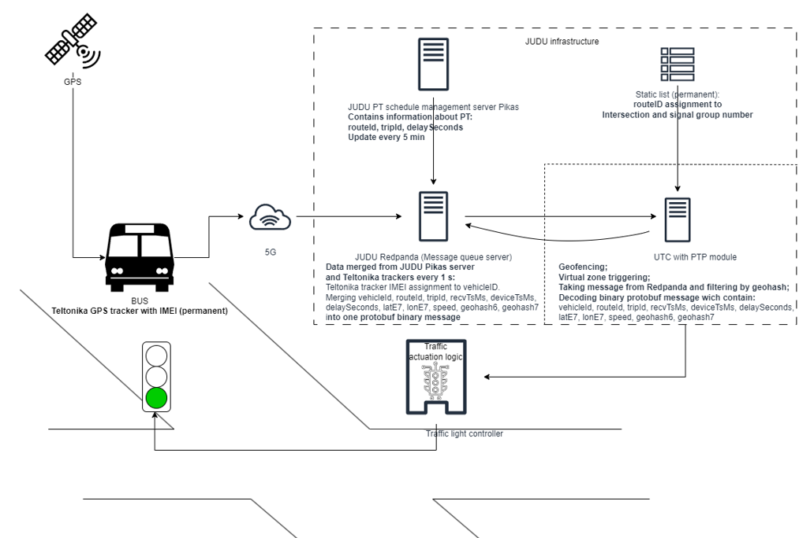
- The other terms and conditions of the Agreement remain unchanged.
- This Supplement to the Agreement shall enter into force on the date of its signing and shall become an integral part of the Agreement.
- The Supplement to the Agreement shall enter into force upon its signing.
- This Supplement to the Agreement is made in Lithuanian and English, in 2 (two) copies of equal legal force, 1 (one) for each Party. In the event of any conflict between the terms of the Agreement in Lithuanian and English, the Lithuanian version of the Agreement shall prevail.
- The Parties hereby confirm that they have read the Supplement to the Agreement, understood its content and consequences, accepted it as consistent with their objectives, and signed it on the date indicated above.
- Annex No. 1 to the Supplement to the Agreement – Comparative table of Technical specifications.
- Addresses and other details of the Parties

Buyer: | Supplier:
Municipal company “SUSISIEKIMO PASLAUGOS”  Legal entity code: 124644360  Address: Laisvės pr. 10A, LT-04215, Vilnius  Telephone: +370 5 210 7050  E-mail: info@judu.lt  Current account: LT14 7044 0600 0764 2185  VAT payer’s code: LT246443610 | UAB “Fima”  Legal entity code: 12128969  Address: Žirmūnų g. 139, LT-09120 Vilnius  Telephone: +370 5 236 3535  E-mail: info@fima.lt  Current account: LT35 7044 0901 0334 8941  VAT payer’s code: LT212896917
Annex 1
Comparative table of technical specifications

Technical specifications, point 1.2:
1.2. A public transport priority module, capable of accepting the data provided by the Customer about the movement of public transport vehicles from Ridango AVL system installed in the Customer's infrastructure, must be installed in the System. Detailed requirements for the functionality and data integration of the public transport priority module are presented in Chapter IV.b.
Replaced and worded as follows:
1.2. A public transport priority module, capable of accepting the data provided by the Customer about the movement of public transport, must be installed in the System. Detailed requirements for the functionality and data integration of the public transport priority module are presented in Chapter IV.b.

Technical specifications, point 26:
26. The Supplier's installed System shall automatically call the Ridango AVL API and the Supplier shall ensure the integration of the data received from the Ridango AVL System into the PTP module of the System.
26.1. GPS data from AVL is transmitted using API, PUSH method, at set interval (1-30 s, currently is5 s). If necessary, the Customer will contact Ridango to change the data transmission interval to a minimum of 1 s.
26.2. Data from AVL can also be received via API, using GET method. Must be able to configure the receive frequency.
26.3. Data from AVL can also be received via API, using GET method. Must be able to configure the receive frequency.
Replaced and worded as follows:
26. The Supplier's installed System shall automatically call the Customer server and the Supplier shall ensure the integration of the data received from the Customer server into the PTP module of the System.
26.1. The data combined on the Customer's server is obtained from Teltonika GPS devices and the Customer's server Pikas. The combined data (vehicleId, routeId, tripId, recvTsMs, deviceTsMs, delaySeconds, latE7, lonE7, speed, geohash6, geohash7) is stored on the Customer's Redpanda data transfer platform. The data on the Customer's platform is updated every 1 second.
26.2. The Supplier shall retrieve the encrypted data from the Customer's Redpanda data transfer platform, filter the data, and decrypt it. A more detailed description of the Customer's data generation, updating, and storage mechanism shall be provided by the Customer during the implementation of the System.

Technical specifications, point 27:
27. The PTP module of the System must support the following basic data of the Ridango AVL system: public vehicle identification number, position (coordinates), date, time, route number.
Replaced and worded as follows:
27. The PTP module of the System must support the following basic Customer provided data: vehicleId, routeId, tripId, recvTsMs, deviceTsMs, delaySeconds, latE7, lonE7, speed, geohash6, geohash7.

Technical specifications, point 28:
28. The Customer shall provide the data structure for the Ridango AVL API:
Ridango response:
{
"id": 289,
"registrationNumber": "3038",
"internalNumber": "KBBxxx",
"lastUpdateTime": "2025-01-22T13:34:04.406Z",
"incidentOn": false,
"direction": 271.82,
"directionSnapped": 263.6326,
"assetType": null,
"drivingStatus": "IDLING",
"communicationStatus": "NORMAL",
"routeStatus": "ON_ROUTE",
"latitude": 54.680084666666666,
"longitude": 25.417521000000004,
"latitudeSnapped": 54.67998039525881,
"longitudeSnapped": 25.41754112651155,
"routeId": 15647,
"tripId": "1363354213255713978",
"distanceOnRoute": 14448,
"distanceOnRoutePercentage": 0.98619294,
"speed": 0.0,
"gpsSpeed": 0.0,
"routeName": "115",
"routeDestination": "Antakalnis–Rokantiškės–Parko—Linksmoji g.",
"routeVariant": "1",
"routeLenght": 14651.16375853587,
"driver": {
"id": 1031,
"code": "3269",
"fullName": "Last name First name",
"alternativeFullName": null
}
Replaced and worded as follows:
28. Data is stored in Protobuf binary format. The Customer shall provide the data structure in .json format for clarity:
{
"v": 1,
"vehicleId": 4191,
"routeId": "2G",
"tripId": "2G-06",
"recvTsMs": 1767187084710,
"deviceTsMs": 1767187083000,
"delaySeconds": 27,
"latE7": 546729566,
"lonE7": 252215533,
"hdop": 14,
"angle": 252,
"speed": 0,
"geohash6": "u99zjb",
"geohash7": "u99zjbv"
}

Technical specifications, point 29:
29. The Customer is responsible for generating data in the Ridango AVL system every 1 second. The Supplier is responsible for retrieving the data from the Ridango AVL system, using the data and prioritising the PT. PTP module must process the data received from Ridango AVL system and send the priority assignment command to the controller no later than within 1 s.
Replaced and worded as follows:
29. The Customer is responsible for generating data in the Redpanda platform every 1 second. The Supplier is responsible for retrieving the data from the Customer Redpanda platform, using the data and prioritising the PT. The PTP module shall process the data received from the Customer’s Redpanda platform and send a priority command to the controller no later than within 2 seconds.

Technical Specifications, footnote No. 4 to point 30:
The creation and fulfilment of the criteria and conditions of the PTP module depends on the type of data transmitted from the Ridango AVL system. If the absence of a particular data type in the Ridango AVL API (e.g. if no PT delay or other PT schedules data is transmitted via the Ridango AVL API) does not oblige the Supplier to fulfil the requirements for the PTP module in relation to the prioritisation of a delayed PT , but it shall remain possible to fulfil all the requirements of the PTP module in the event of additional data types appearing in the Ridango AVL API interface.
Replaced and worded as follows:
The creation and fulfilment of the criteria and conditions of the PTP module depends on the type of data transmitted from the Customer Redpanda platform.
Technical specifications, point 32, figure 1:
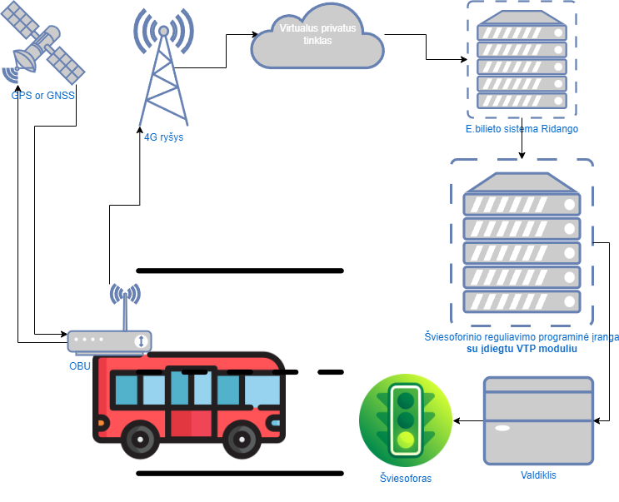
Replaced and worded as follows:

