To whom it may concern: Tranås 2015-04-28

Dear Sir/Madam,

We hereby confirm that company UAB SK Impex Service Center, Dental Department, Mildos 6, Vilnius 10311, Lithuania, is an official dealer of Kerr and Spofa products in Lithuania.

Yours Sincerely,

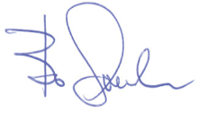

KERR
Bo Svenler
Country Manager Nordic & Baltic
Kerr Nordic
Box 427
HamnParken 2
SE-573 25, Tranås SWEDEN
office: +46 140 687 34/35
fax: +46 140 687 01
email: Bo.Svenler@kerrhawe.com
website: www.kerrdental.eu
Your practice is our inspiration™

